1. Question: After analyzing the graphs of the downloaded time series, comment on the covariance-stationarity properties of both prices and returns. Do prices look like a stationary process? Why? What about the returns? Why?

*The prices do not look like have a stationary process because don’t have a constant variance in long of the time. It indicates follow an explosive process due its unitary root certainly is larger than one, taking its no-contemporaneous covariances are different of zero. While the returns apparently are stationary processes, once it has constant variance about of the mean.*

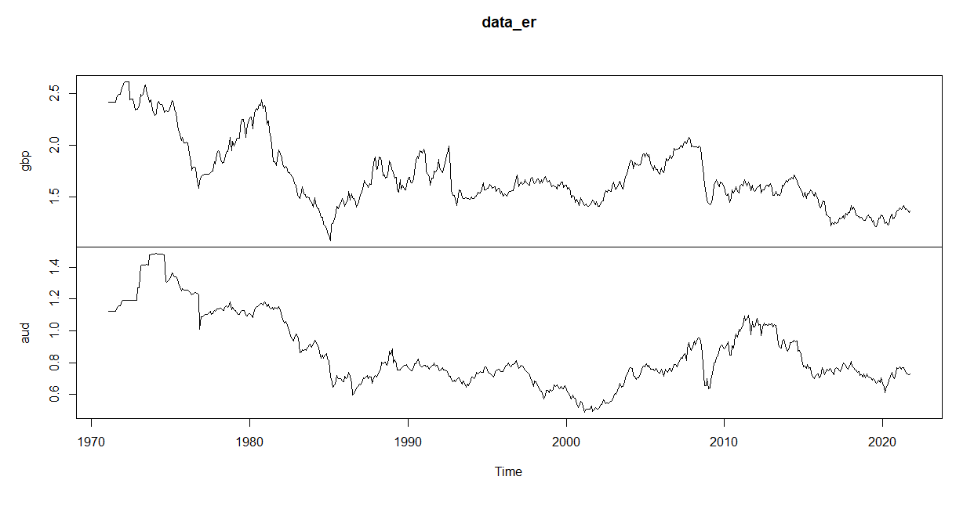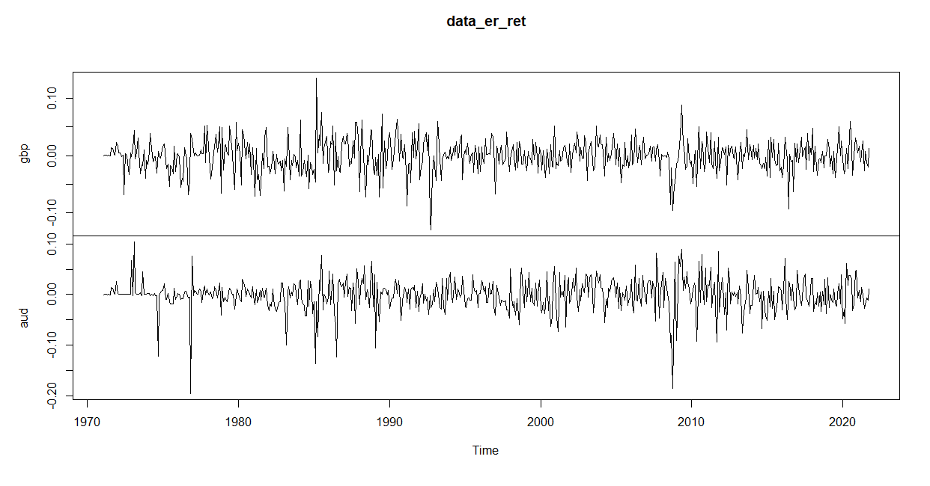

1. Then, based on a 5% level test, can you conclude that prices are stationary processes? Are exchange rate returns stationary?

*Evaluating the results, we can see that prices aren’t stationary processes while the returns are because their probabilities are 99% as shown in the table below:*

|  |
| --- |
| data_er.aud is a non-stationary process because it has P-valor 0.61 >5% |
| data_er.gbp is a non-stationary process because it has P-valor 0.18 >5% |
| data_er_ret.aud is a Stationary process with probability 99% (P-valor < 1%) |
| data_er_ret.gbp is a Stationary process with probability 99% (P-valor < 1%) |

1. Is there cointegration at the 5% level? Which test statistic has superior power in a small sample? and why?

*Yes. Is there cointegration at 1% level conforming the trace statistic and the maximum eigenvalue statistic.*

|  |  |  |  |  |  |  |
| --- | --- | --- | --- | --- | --- | --- |
|  | **r** | **trace** | **Trace_pval** | **Trace_pval_T** | **Eigen** | **Eigen_pval** |
| 1 | 0 | 468.9158 | <0.001 | <0.001 | 259.2702 | <0.001 |
| 2 | 1 | 209.6456 | <0.001 | <0.001 | 209.6456 | <0.001 |

1. Forecasting and Trading Models.

