Part1: user table parctice

* Create a new database called Practice_DB.

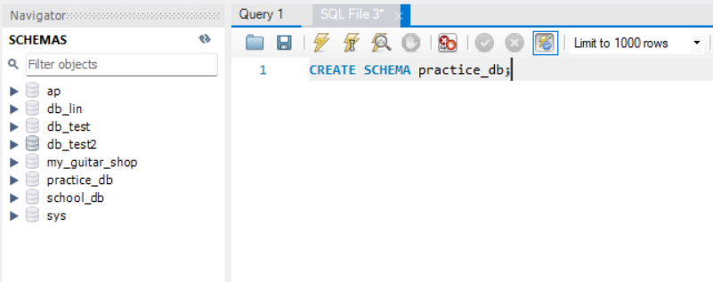

* Switch to the Practice_DB database and Create a table named users with the following columns:

id: INT, Primary Key, Auto Increment

lastname: VARCHAR(255), Not Null

firstname: VARCHAR(255)

age: INT, Default = 20

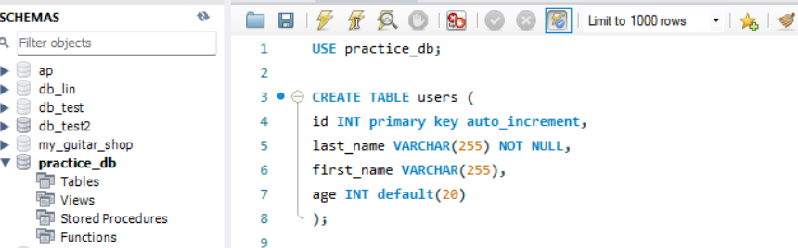

* Show all tables in the database.
* Describe the structure of the users table.

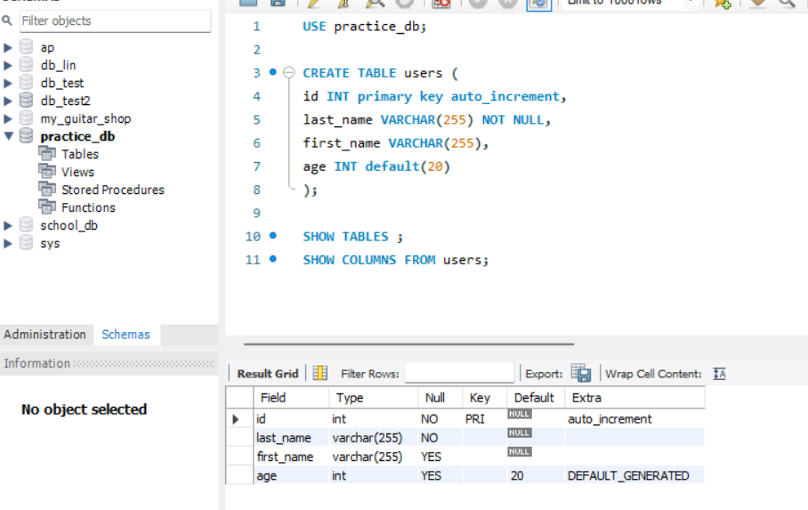

* Add a new column called email of type VARCHAR(255).

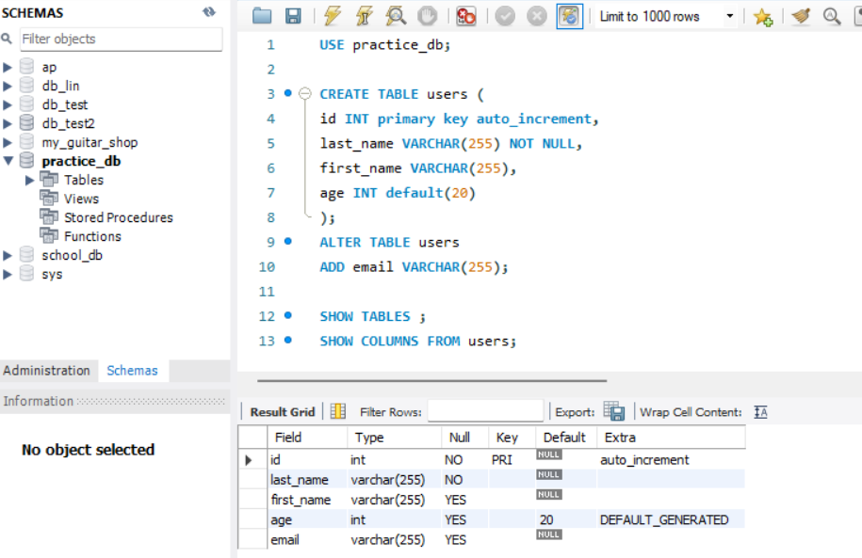

* Modify the email column to be NOT NULL.

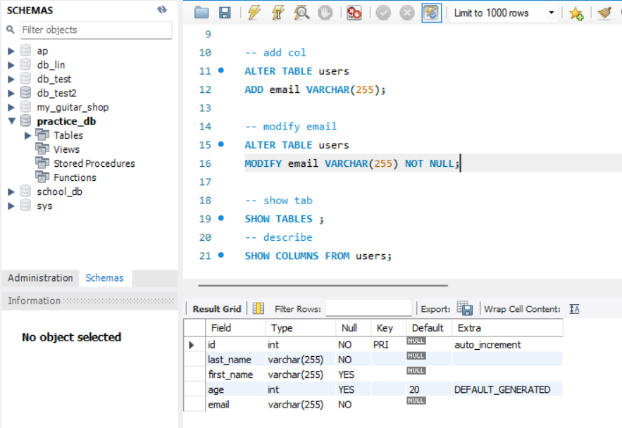

* Rename the column email to user_email.

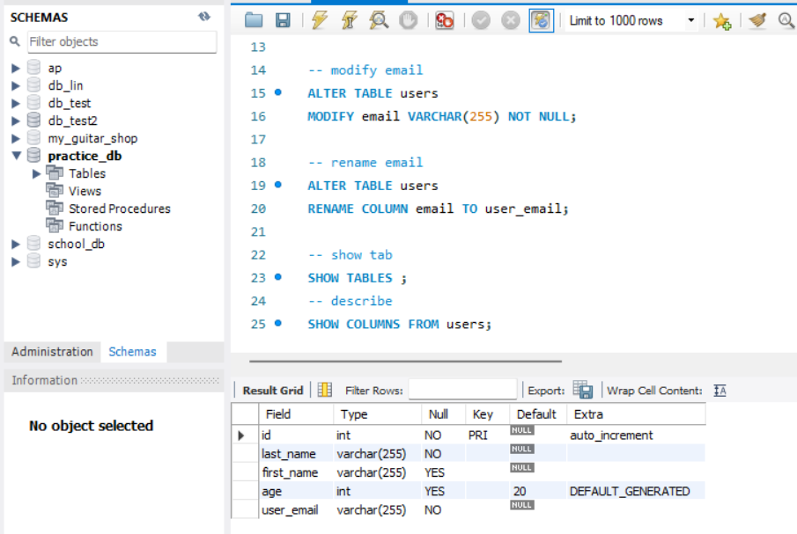

* Delete the column user_email.

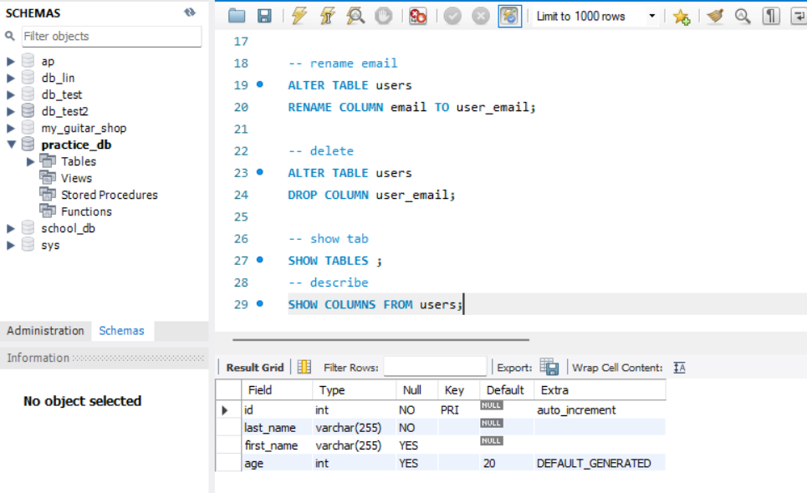

* Drop the users table.

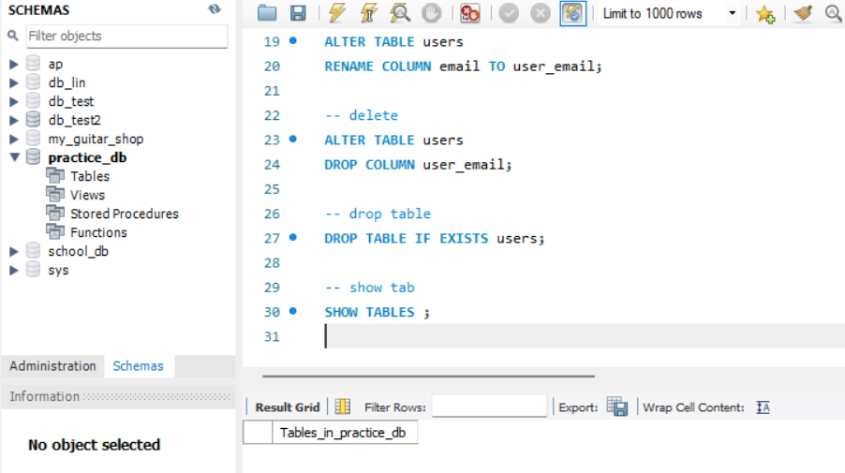

* Drop the Practice_DB database.

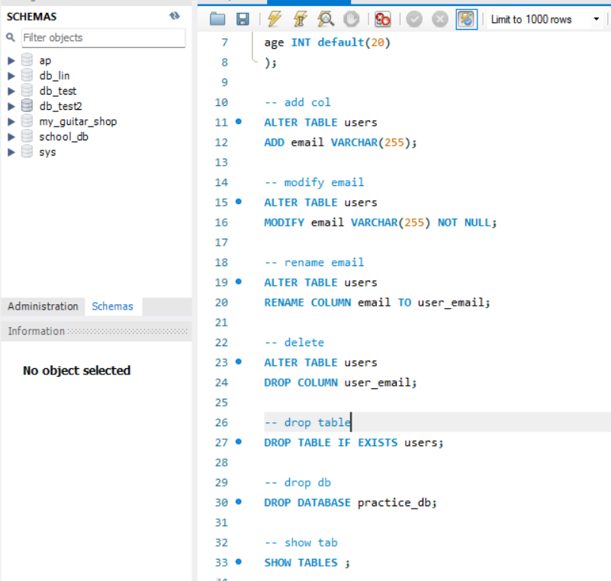

Part 2: Bonus – Posts Table Practice and Show all data from the posts table.

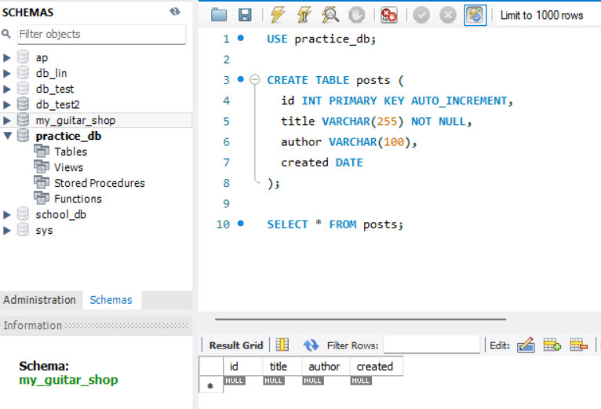

* Display only id, title, and author where id = 1.

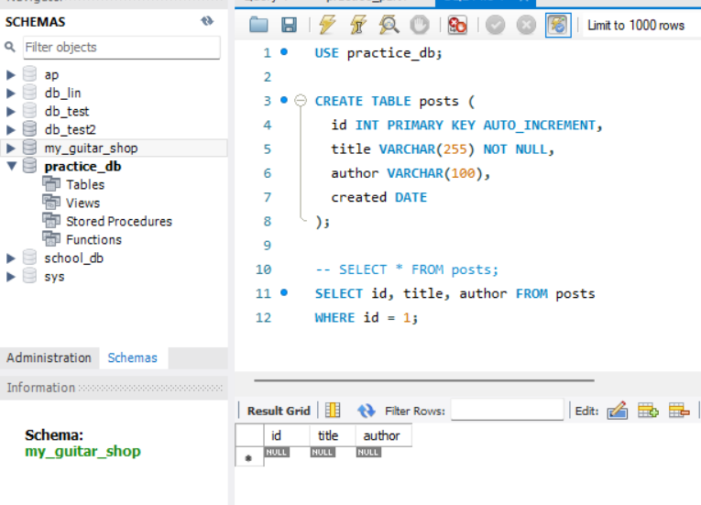

* Insert two new posts into the posts table:

Post 1: Title = 'First Post', Author = 'Alice', Created = '2023-01-01'

Post 2: Title = 'Second Post', Author = 'Bob', Created = '2023-01-02'

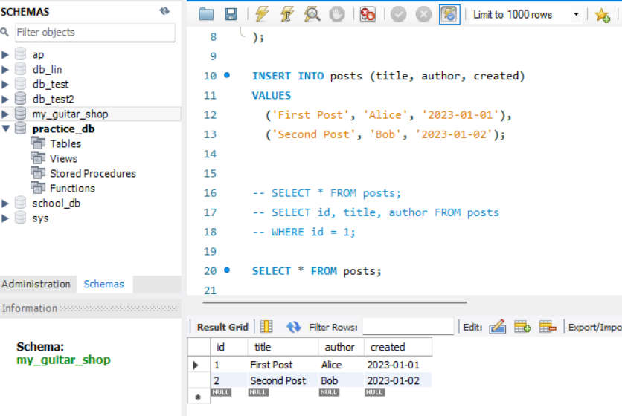

* Update the post with id = 1:
* Change title to 'Updated Post' and created date to '2023-01-05'.

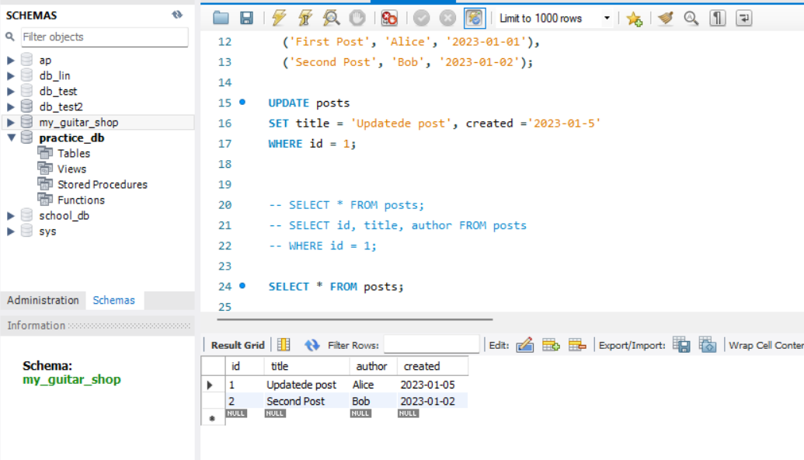

* Delete all posts written by 'Bob'.

