1. Create a database name “School_DB”

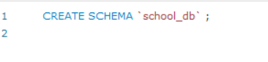

2&3 Use school_DB to create two table is students have attribute (id Name, Birthday and Age) and teachers have attribute (id, Name, Birthday, Course_name), Check the table in the database and Check both tables attributes to make sure it is found.

* Students

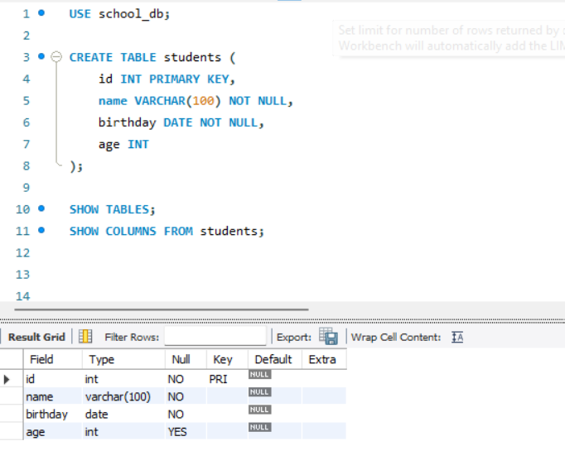

* Teachers
* 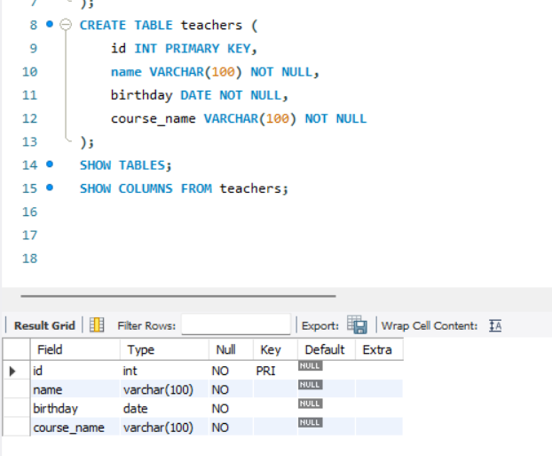

4. In table students I want to add one more column name Province

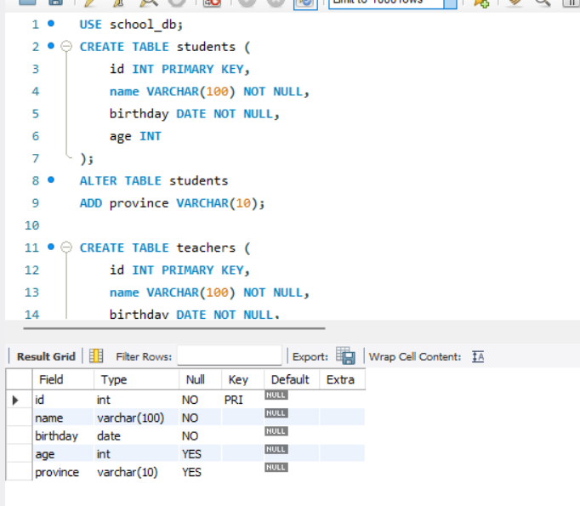

5. Rename column Birthday to address on table teachers

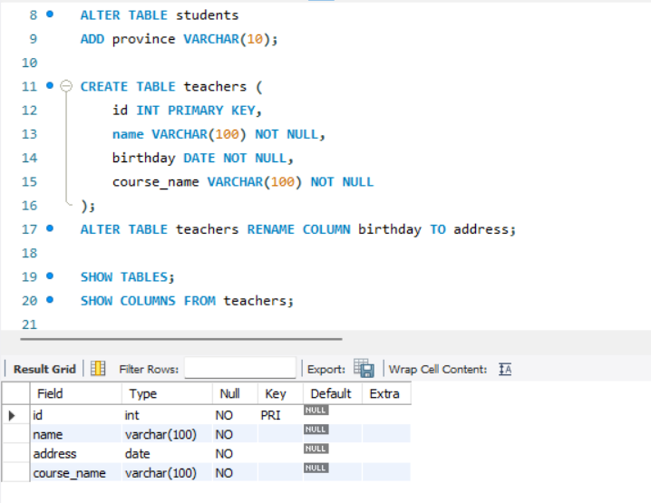

6. Remove both table and check it again in your database

