* **Elevador:**

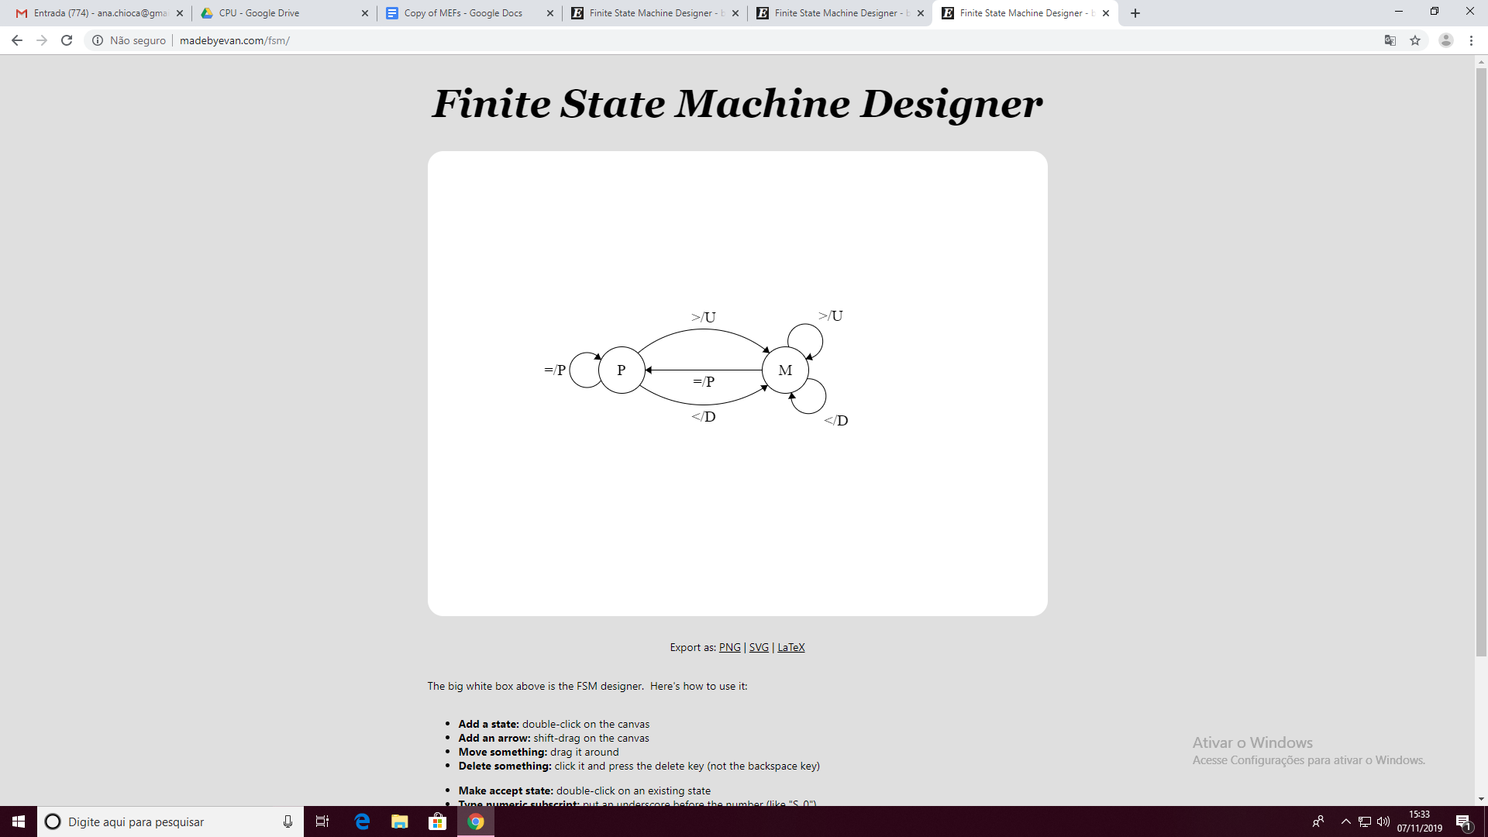

|  |  |  |  |
| --- | --- | --- | --- |
| Estados | Andar + | Andar - | Andar = |
| P | M/U | M/D | P/P |
| M | M/U | M/D | P/P |

* **Refrigerante:**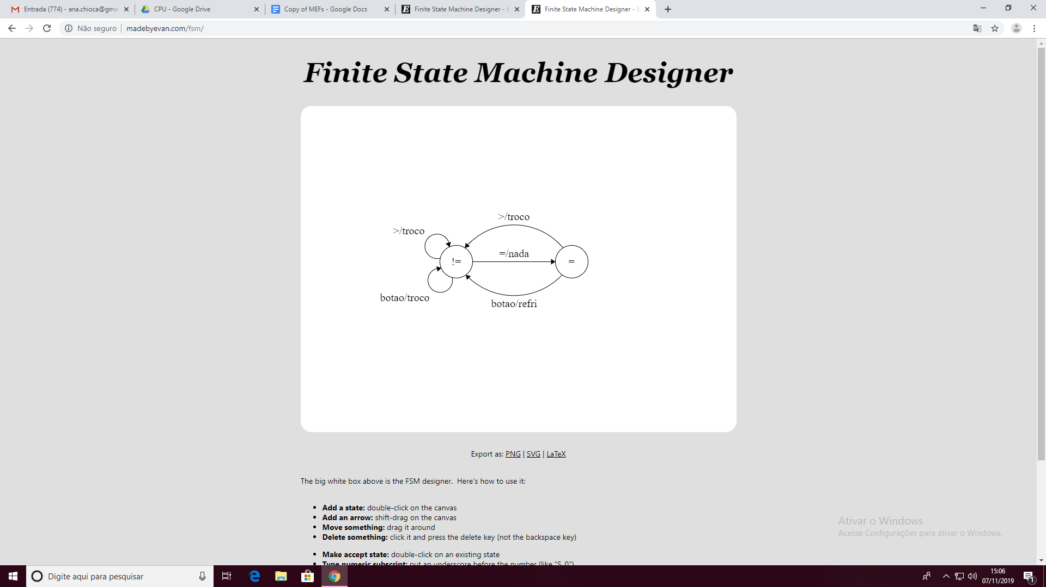

|  |  |
| --- | --- |
| Entrada |  |
| nada | 00 |
| botao | 01 |
| = 1 real | 10 |
| > 1 real | 11 |

|  |  |
| --- | --- |
| Saída |  |
| refri | 11 |
| troco | 10 |
| nada | 00 |

|  |  |  |  |  |
| --- | --- | --- | --- | --- |
| Estado atual | 00 | 01 | 10 | 11 |
| < 1 real | </00 | </10 | =/00 | </10 |
| 1 real | =/00 | </11 | =/00 | </10 |

<http://madebyevan.com/fsm/>

