Aim:
The aim of my project is to write a program which when given a date, will give the Cartesian coordinates of each planet in relation to the sun and then provide a graphical representation of this.

Theory:
Predicting the position of the planets in space at a specific date is important in the astrophysics community, as it is necessary to the timing of sending space probes, satellites and future space missions into space. As discussed by Jeremy Jones from NASA in the article “How do space probes navigate large distances with such accuracy and how do the mission controllers know when they’ve reached their target?” in the Scientific American, they need to combine our knowledge of the position and speed of a probe, location from which those measurements are taken and an accurate model of the solar system and the motion of a probe are all necessary to get the probe to it’s desired location.

Calculating the orbit of a planet is based on a combination of physics laws. Kepler’s laws are used as the base, and combined with the Newtonian laws of physics, however there are perturbations that you need to account for to be accurate long term, mainly the gravitational influence of other planets (Butikov, 2014). For the purpose of my project I am not accounting for perturbations as the complexity of the mathematics becomes significantly greater.

There are a number of ways to represent the position of the planets in space, but for the purpose of my project I am using the ecliptic system, as it is the most common used for the purpose of predicting the positions of the planets in space. Using the rectangular coordinates we get x, y, z coordinates we can easily use to create a graph (as opposed to the spherical coordinates) (Soffel & Langhans, 2013). The ecliptic system uses the Sun as the centre of a sphere commonly referred to as the “Celestial Sphere” with an “Ecliptic Equator” along the plane of the Earth’s orbit (Milone & Wilson, 2014).

To understand the mathematics used to calculate the positions of the planets, I need to define a number of terms. All below definitions are based on the descriptions given by Paul Schlyter in his paper “Computing planetary positions – a tutorial with worked examples”:
- Perihelion – The point in it’s orbit at which the planet is furthest from the Sun
- Longitude – “Is counted countersunwise along the Ecliptic” and measured in degrees. So essentially if looking down on the Ecliptic Equator, how many degrees counter-clockwise from the reference point the planet is
- Latitude – Is how far north or south of the Ecliptic Equator the planet is, measured in degrees
- Vernal Point – Is the point at which Latitude and Longitude are 0 degrees
- Ascending Node – The point along the Ecliptic Equator that the planet moves from a negative Latitude to a positive Latitude

The Orbital Elements also based on the definitions given by Paul Schlyter in his paper “Computing planetary positions – a tutorial with worked examples”:
- Semi-Major Axis – Refers to the size of the planets orbit
- Eccentricity – Refers to how far from circular the orbit is
- Inclination – Is the tilt of the orbit relative to the Ecliptic Equator measured in degrees
- Longitude of Ascending Node – The angle of the Ascending Node along the Ecliptic Equator from the Vernal Point
- The Argument of Perihelion – “The angle of the Ascending Node to the Perihelion along the orbit”
- Mean Anomaly – Is how far in degrees the planet is from Perihelion with 0 degrees being at Perihelion
- True Anomaly – “The angle from Perihelion to the planet as seen from the Sun”
- Eccentric Anomaly – An additional angle to work out the position in the orbit
- Radius Vector – The planets distance from the Sun

The only element missing is time. Time needs to be converted into a singular number to be used in the equations, there are a number of ways to do this, however for the purpose of the equations I am using we are using a time scale, which is a day number from 01/01/2000 at 00:00 TDT (Terrestrial Dynamic Time) (Schlyter).

To convert from the Gregorian calendar to our time scale, you need to calculate the following equation from “Computing planetary positions – a tutorial with worked examples” by Paul Schlyter:
- Time Scale = 367*YYYY – (7*(Y + ((MM + 9)/12)))/4 + (275*MM)/9 + DD – 730530

We now have all of the elements needed to calculate the positions of the planets. Each planet will have different values for each element. Below we have a table of how to calculate each element for each planet based on the table from Paul Schlyter’s “Computing planetary positions – a tutorial with worked examples”:

Mercury | Equation
Longitude of Ascending Node (degrees) | 48.3313 + 3.24587*10^(-5) *Time scale
Inclination (degrees) | 7.0047 + 5.00*10^(-8) *Time scale
Argument of Perihelion (degrees) | 29.1241 + 1.01444*10^(-5) *Time scale
Semi-Major Axis (AU) | 0.387098
Eccentricity (AU) | 0.205635 + 5.59*10^(-10) *Time scale
Mean Anomaly (degrees) | 168.6562 + 4.0923344368 *Time scale

Venus | Equation
Longitude of Ascending Node (degrees) | 76.6799 + 2.46590*10^(-5) *Time scale
Inclination (degrees) | 3.3946 + 2.75*10^(-8) *Time scale
Argument of Perihelion (degrees) | 54.8910 + 1.38374*10^(-5) *Time scale
Semi-Major Axis (AU) | 0.723330
Eccentricity (AU) | 0.01671022 – 1.302*10^(-9) *Time scale
Mean Anomaly (degrees) | 48.0052 + 1.6021302244 *Time scale

Earth | Equation
Longitude of Ascending Node (degrees) | 0
Inclination (degrees) | 0
Argument of Perihelion (degrees) | 282.9404 + 4.70935*10^(-5) *Time scale
Semi-Major Axis (AU) | 1
Eccentricity (AU) | 0.01671 – 1.151*10^(-9) *Time scale
Mean Anomaly (degrees) | 356.047 + 0.985069 *Time scale

Mars | Equation
Longitude of Ascending Node (degrees) | 49.5574 + 2.11081*10^(-5) *Time scale
Inclination (degrees) | 1.8497 - 1.78*10^(-8) *Time scale
Argument of Perihelion (degrees) | 286.5016 + 2.92961*10^(-5) *Time scale
Semi-Major Axis (AU) | 1.523688
Eccentricity (AU) | 0.093405 + 2.516*10^(-9) *Time scale
Mean Anomaly (degrees) | 18.6021 + 0.524020776 *Time scale

Jupiter | Equation
Longitude of Ascending Node (degrees) | 100.4542 + 2.76854*10^(-5) *Time scale
Inclination (degrees) | 1.3030 - 1.557*10^(-7) *Time scale
Argument of Perihelion (degrees) | 273.8777 + 1.64505*10^(-5) *Time scale
Semi-Major Axis (AU) | 5.20256
Eccentricity (AU) | 0.048498 + 4.469*10^(-9) *Time scale
Mean Anomaly (degrees) | 19.8950 + 0.0830853001 *Time scale

Saturn | Equation
Longitude of Ascending Node (degrees) | 113.6634 + 2.38980*10^(-5) *Time scale
Inclination (degrees) | 2.4886 – 1.081*10^(-7) *Time scale
Argument of Perihelion (degrees) | 339.3939 + 2.97661*10^(-5) *Time scale
Semi-Major Axis (AU) | 9.55475
Eccentricity (AU) | 0.055546 – 9.499*10^(-9) *Time scale
Mean Anomaly (degrees) | 316.9670 + 0.0334442282 *Time scale

Uranus | Equation
Longitude of Ascending Node (degrees) | 74.0005 + 1.3978*10^(-5) *Time scale
Inclination (degrees) | 0.7733 + 1.9*10^(-8) *Time scale
Argument of Perihelion (degrees) | 96.6612 + 3.0565*10^(-5) *Time scale
Semi-Major Axis (AU) | 19.18171 – 1.55*10^(-8) *Time scale
Eccentricity (AU) | 0.047318 + 7.45*10^(-9) *Time scale
Mean Anomaly (degrees) | 142.5905 + 0.011725806 *Time scale

Neptune | Equation
Longitude of Ascending Node (degrees) | 131.7806 + 3.0173*10^(-5) *Time scale
Inclination (degrees) | 1.7700 – 2.55*10^(-7) *Time scale
Argument of Perihelion (degrees) | 272.8461 – 6.027*10^(-6) *Time scale
Semi-Major Axis (AU) | 30.05826 + 3.313*10^(-8) *Time scale
Eccentricity (AU) | 0.008606 + 2.15*10^(-9) *Time scale
Mean Anomaly (degrees) | 260.2471 + 0.005995147 *Time scale

Now we can put together all of our information to work out the position of each planet using the following steps as described by Paul Schlyter’s “Computing planetary positions – a tutorial with worked examples”.
- Run the date you want through the Time Scale equation
- Apply the Time Scale to the planet you want to find the position of
- Normalise all of the elements in degrees
- Work out the Eccentric Anomaly in degrees, multiple iterations are required for accuracy, I will be using 1 iteration for the purpose of my program:
  - Eccentric Anomaly (0) = Mean Anomaly + (180/pi)*Eccentricity*sin(Mean Anomaly)*(1+Eccentricity*cos(Mean Anomaly))
  - Eccentric Anomaly (1) = Eccentric Anomaly (0) – (Eccentric Anomaly (0) - (180/pi)*Eccentricity*sin(Eccentric Anomaly (0)) – Mean Anomaly) / (1 – Eccentricity*cos(Eccentric Anomaly (0)))
- Work out the position of the planet within it’s own orbit:
  - Planet’s Plane (x) = Semi-Major Axis * (cos(Eccentric Anomaly) – Eccentricity)
  - Planet’s Plane (y) = Semi-Major Axis * sqrt(1 – Eccentricity^2) * sin(Eccentric Anomaly)
- Use that to work out the Radius Vector (AU) and True Anomaly (degrees):
  - Radius Vector = sqrt(Planet’s Plane (x)^2 + Planet’s Plane (y)^2)
  - True Anomaly = atan2(Planet’s Plane (y), Planet’s Plane (x))

- Finally we use these to find the position of the planet on the Celestial Sphere using Cartesian coordinates:
  - Ecliptical (x) = Radius Vector * (cos(Longitude of Ascending Node) * cos(True Anomaly + Argument of Perihelion) – sin(Longitude of Ascending Node) * sin(True Anomaly + Argument of Perihelion) * cos(Inclination))
  - Ecliptical (y) = Radius Vector * (sin(Longitude of Ascending Node) * cos(True Anomaly + Argument of Perihelion) + cos(Longitude of Ascending Node) * sin(True Anomaly + Argument of Perihelion) * cos(Inclination))
  - Ecliptical (z) = Radius Vector * sin(True Anomaly + Argument of Perihelion) * sin(Inclination)

Program description:
The program itself is easy to use, asking the user only for a date, and then doing the rest on its’ own. Calculating the x, y and z positions of each planet in space using a function for each, and displaying them together on one graph, which will end up with a 3-D representation of each planet in relation to the Sun as the centre in space.

I will have a function for each the below:
- Year, Month and DayChecker: Checks each element of the date input by the user is valid for the function
- TimeScaler: Converting Gregorian date to the Time Scale
- Mercury-NeptuneElements: A function for each planet to calculate each element for the date given by the user
- Normaliser: Normalises the elements in degrees
- CoordinateFinder: Calculates steps 4 - 7

Main program pseudo code:
- Introduction of the function
- Ask the user for a year then run it through the YearChecker to ensure validity
- Then a month then run it through the MonthChecker to ensure validity
- Then the day then run it through the DayChecker to ensure validity
- (The three are done separately to create each as an individual variable and avoid date layout confusion by the user)
- Run the date through TimeScaler
- Run the number from the TimeScaler first through MercuryElements
- Then the data from MercuryElements through the Normaliser
- And then through CoordinateFinder
- Display results
- Add results to graph
- Apply “hold on” so further planets are on the same graph
- Repeat for each planet
- Add the Sun to the graph at (0, 0, 0) as the reference point

To see a copy of the code, please see the Appendix at the end of this report.

Testing the program:
I want to test each element of the program.

- Starting with the YearChecker. I want to see how it deals with a non-number, a number outside my range and a non-integer:
>> PlanetsPositionGivenDate
Enter a year between 1900 and 2099 numerically in YYYY form: a
Error using input
Undefined function or variable 'a'.

Error in PlanetsPositionGivenDate (line 17)
Year=input('Enter a year between 1900 and 2099 numerically in YYYY form: ');

Enter a year between 1900 and 2099 numerically in YYYY form: -2
The year entered is not valid. Must be between 1900 and 2099
Please enter a year between 1900 and 2099 in YYYY form: 3000
The year entered is not valid. Must be between 1900 and 2099
Please enter a year between 1900 and 2099 in YYYY form: 2000
Enter the month numerically between 1 and 12:
- The code then successfully runs

- Next MonthChecker. I want to see again how it deals with a non-number, a number outside the range and a non-integer:
Enter the month numerically between 1 and 12: a
Error using input
Undefined function or variable 'a'.

Error in PlanetsPositionGivenDate (line 22)
Month=input('Enter the month numerically between 1 and 12: ');

Enter the month numerically between 1 and 12: -2
The month entered was invalid. Must be between 1 and 12
Enter the month numerically between 1 and 12: 15
The month entered was invalid. Must be between 1 and 12
Enter the month numerically between 1 and 12: 10.2
The month entered was invalid. Must be an integer
Enter the month numerically between 1 and 12:
- The code then successfully runs

- Then the Daychecker.
  - I want to test for the same things as for year and month, but I also want to test if it’s accurate for leap years:
>> PlanetsPositionGivenDate
Enter a year between 1900 and 2099 numerically in YYYY form: 2000
Enter the month numerically between 1 and 12: 2
Enter the day of the month numerically: a
Error using input
Undefined function or variable 'a'.

Error in PlanetsPositionGivenDate (line 27)
Day=input('Enter the day of the month numerically: ');

Enter the day of the month numerically: 2.5
The day entered was invalid. Must be an integer
Enter the day of the month numerically: -2
The day entered was invalid.
Enter the day of the month numerically between 1 and 29: 50
The day entered was invalid.
Enter the day of the month numerically between 1 and 29: 29
- The code then successfully runs

  - Then if I try February 29 a non-leap year:
>> PlanetsPositionGivenDate
Enter a year between 1900 and 2099 numerically in YYYY form: 2001
Enter the month numerically between 1 and 12: 2
Enter the day of the month numerically: 29
The day entered was invalid.
Enter the day of the month numerically between 1 and 28: 28
- The code then successfully runs

  - If I try a month that contains 31 days:
>> PlanetsPositionGivenDate
Enter a year between 1900 and 2099 numerically in YYYY form: 2000
Enter the month numerically between 1 and 12: 1
Enter the day of the month numerically: 50
The day entered was invalid.
Enter the day of the month numerically between 1 and 31: 31
- The code then successfully runs

  - If I try a month that contains 30 days:
>> PlanetsPositionGivenDate
Enter a year between 1900 and 2099 numerically in YYYY form: 2000
Enter the month numerically between 1 and 12: 4
Enter the day of the month numerically: 31
The day entered was invalid.
Enter the day of the month numerically between 1 and 30: 30
- The code then successfully runs

- Now the input is definitely within a reason range we can let the program run. I now want to make sure that the output is accurate. My end product will only output a graph as a visual representation of where the planets are in space (as the actual coordinates are meaningless to a casual user), I have added a display function for the purpose of checking the accuracy of the program.
In his paper “Computing planetary positions – a tutorial with worked examples” on which this program is based, Paul Schlyter uses 19 April 1990 at the test date for his examples which yields the following results for Mercury:

X=-0.367821
Y=0.061084
Z=0.038699

While my program outputs:
>> PlanetsPositionGivenDate
Enter a year between 1900 and 2099 numerically in YYYY form: 1990
Enter the month numerically between 1 and 12: 4
Enter the day of the month numerically: 19
Mercury coordinates: -0.36598 0.065684 0.038907

The slight difference appears to be because Matlab rounds more than the original, but the numbers are close enough to be correct (within 0.05).

- Finally an example of the program running as intended for the test date:
>> PlanetsPositionGivenDate
Enter a year between 1900 and 2099 numerically in YYYY form: 1990
Enter the month numerically between 1 and 12: 4
Enter the day of the month numerically: 19
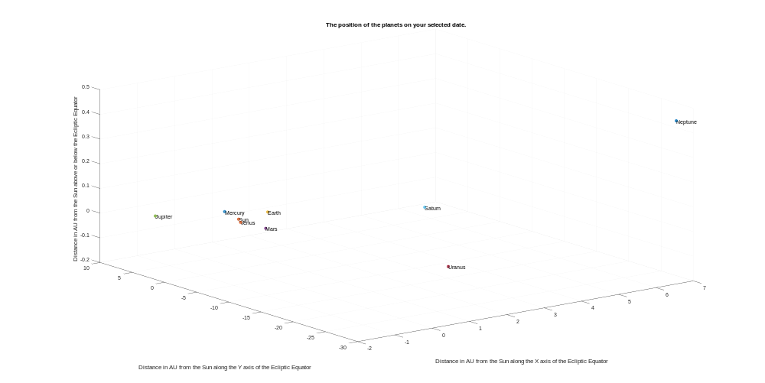

  - Given the 3 dimensional nature of space the distances between planets can appear skewed due to depth.
- Another example showing today 01/06/18:
>> PlanetsPositionGivenDate
Enter a year between 1900 and 2099 numerically in YYYY form: 2018
Enter the month numerically between 1 and 12: 06
Enter the day of the month numerically: 01
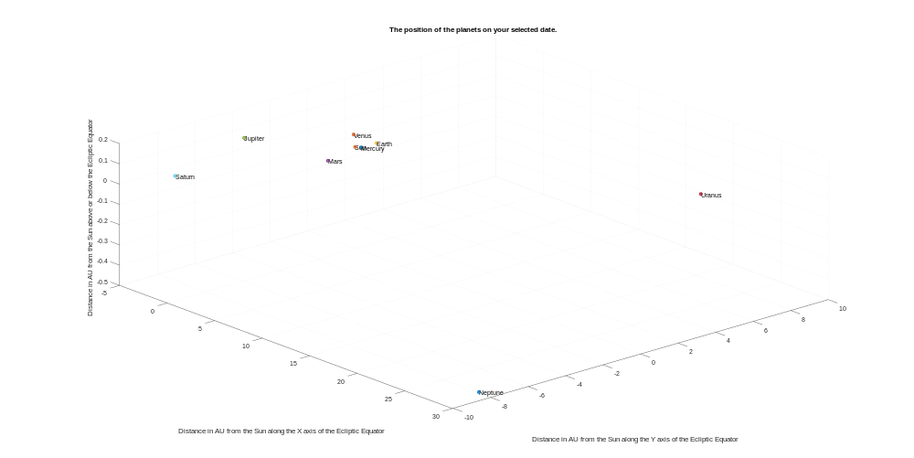

- A third example looks into the future, 31/12/2099:
>> PlanetsPositionGivenDate
Enter a year between 1900 and 2099 numerically in YYYY form: 2099
Enter the month numerically between 1 and 12: 12
Enter the day of the month numerically: 31

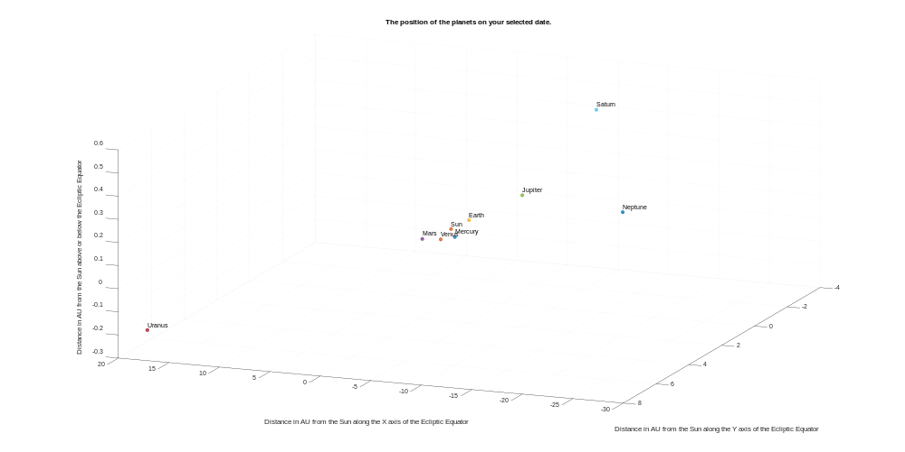

References:
How do space probes navigate large distances with such accuracy and how do the mission controllers know when they’ve reached their target? Scientific American, Mar 27, 2006.
https://www.scientificamerican.com/article/how-do-space-probes-navig/

Motions of celestial bodies : computer simulations, Eugene Butikov, Institute of Physics (Great Britain), Bristol [England], 2014.

Space-Time Reference Systems, Michael Soffel & Ralf Langhans, Springer Berlin Heidelberg, Berlin [Germany], 2013.

Solar System Astrophysics, Eugene F. Milone & Wiliam J.F. Wilson, Springer, New Yrok [USA] 2nd edition, 2014.

Computing planetary positions – a tutorial with worked examples, Paul Schlyter, Stjarnkimlen, Stockholm [Sweden]

Appendix:
- Main program (PlanetsPositionGivenDate):
function PlanetsPositionGivenDate ()
%Written by Lisa Luff 16167920 29/05/18
%Modifed 30/05/18
%NPSC1001 Final Lab Project
%Main program
%The purpose of this program is to give the rectangular ecliptic
%coordinates and a graph representing the position in the celestial sphere
%of each planet given a Gregorian date input by the user
%The program will do this by calling on a number of function also created
%by me for the purpose of this project

%Starting by asking the user what date they want the data for. Asking day,
%month and year separately is to avoid confusion regarding how to input the
%data as there are many ways to enter dates and to check each element of
%the date is correct, relative to each other

Year=input('Enter a year between 1900 and 2099 numerically in YYYY form: ');

%I will run the input through a checker to make sure it is valid
CheckedYear=YearChecker(Year);

Month=input('Enter the month numerically between 1 and 12: ');

%Run the month through it's checker to ensure validity
CheckedMonth=MonthChecker(Month);

Day=input('Enter the day of the month numerically: ');

%Run the day through it's checker for validity
CheckedDay=DayChecker(CheckedYear, CheckedMonth, Day);

%The program uses a time scale rather than the Gregorian date format, so
%this information will be run through a function to convert this to Time
Time=TimeScaler(CheckedDay, CheckedMonth, CheckedYear);

%This value for time then needs to be applied to the different equations
%for each planet and we will then display the x, y, z coordinates and place
%a point on the map for each planet
MercuryCoordinates=MercuryCoordinateFinder(Time);
clf;
scatter3(MercuryCoordinates(1), MercuryCoordinates(2), MercuryCoordinates(3),...
'filled');
title('The position of the planets on your selected date.');
xlabel('Distance in AU from the Sun along the X axis of the Ecliptic Equator');
ylabel('Distance in AU from the Sun along the Y axis of the Ecliptic Equator');
zlabel('Distance in AU from the Sun above or below the Ecliptic Equator');
text(MercuryCoordinates(1), MercuryCoordinates(2), MercuryCoordinates(3),...
'Mercury');
hold on

VenusCoordinates=VenusCoordinateFinder(Time);
scatter3(VenusCoordinates(1), VenusCoordinates(2), VenusCoordinates(3),...
'filled');
text(VenusCoordinates(1), VenusCoordinates(2), VenusCoordinates(3),...
'Venus');
hold on

EarthCoordinates=EarthCoordinateFinder(Time);
scatter3(EarthCoordinates(1), EarthCoordinates(2), EarthCoordinates(3),...
'filled');
text(EarthCoordinates(1), EarthCoordinates(2), EarthCoordinates(3),...
'Earth');
hold on

MarsCoordinates=MarsCoordinateFinder(Time);
scatter3(MarsCoordinates(1), MarsCoordinates(2), MarsCoordinates(3),...
'filled');
text(MarsCoordinates(1), MarsCoordinates(2), MarsCoordinates(3),...
'Mars');
hold on

JupiterCoordinates=JupiterCoordinateFinder(Time);
scatter3(JupiterCoordinates(1), JupiterCoordinates(2), JupiterCoordinates(3),...
'filled');
text(JupiterCoordinates(1), JupiterCoordinates(2), JupiterCoordinates(3),...
'Jupiter');
hold on

SaturnCoordinates=SaturnCoordinateFinder(Time);
scatter3(SaturnCoordinates(1), SaturnCoordinates(2), SaturnCoordinates(3),...
'filled');
text(SaturnCoordinates(1), SaturnCoordinates(2), SaturnCoordinates(3),...
'Saturn');
hold on

UranusCoordinates=UranusCoordinateFinder(Time);
scatter3(UranusCoordinates(1), UranusCoordinates(2), UranusCoordinates(3),...
'filled');
text(UranusCoordinates(1), UranusCoordinates(2), UranusCoordinates(3),...
'Uranus');
hold on

NeptuneCoordinates=NeptuneCoordinateFinder(Time);
scatter3(NeptuneCoordinates(1), NeptuneCoordinates(2), NeptuneCoordinates(3),...
'filled');
text(NeptuneCoordinates(1), NeptuneCoordinates(2), NeptuneCoordinates(3),...
'Neptune');
hold on

%The Sun is always at the centre of the ecliptic coordinate system and
%therefore always at [0, 0, 0]
SunCoordinates=[0, 0, 0];
scatter3(SunCoordinates(1), SunCoordinates(2), SunCoordinates(3),...
'filled');
text(SunCoordinates(1), SunCoordinates(2), SunCoordinates(3),...
'Sun');

- YearChecker:
function CheckedYear=YearChecker(Year)
%Written by Lisa Luff 16167920 30/05/18
%NPSC1001 Final Lab Project
%Function called on by main function
%The purpose of this program is to check that the year input from the user
%is valid for the purpose of the program

%I want to make sure the number is between
%1900 and 2099, the limit I have chosen for the PlanetPositionGivenDate
%program as I have not accounted for perturbations,
%and to make sure it is an integer

YearLoopContinue=1;
while YearLoopContinue==1
if (1900>Year)||(Year>2099)
disp('The year entered is not valid. Must be between 1900 and 2099');
Year=input('Please enter a year between 1900 and 2099 in YYYY form: ');
YearLoopContinue=1;
elseif mod(Year, 1)~=0
disp('The year entered is not valid. Must be an integer.');
Year=input('Please enter a year between 1900 and 2099 in YYYY form: ');
YearLoopContinue=1;
else
YearLoopContinue=0;
end
end

CheckedYear=Year;

- MonthChecker:
function CheckedMonth=MonthChecker(Month)
%Written by Lisa Luff 16167920 30/05/18
%NPSC1001 Final Lab Project
%Function called on by main function
%The purpose of this program is to check that the month input from the user
%is valid for the purpose of the program

%I want to check the month given is an integer, and
%make sure it's between 1 and 12
MonthLoopContinue=1;
while MonthLoopContinue==1
if (1>Month)||(Month>12)
disp('The month entered was invalid. Must be between 1 and 12');
Month=input('Enter the month numerically between 1 and 12: ');
MonthLoopContinue=1;
elseif mod(Month, 1)~=0
disp('The month entered was invalid. Must be an integer');
Month=input('Enter the month numerically between 1 and 12: ');
MonthLoopContinue=1;
else
MonthLoopContinue=0;
end
end

CheckedMonth=Month;

- DayChecker:
function CheckedDay=DayChecker(CheckedYear, CheckedMonth, Day)
%Written by Lisa Luff 16167920 30/05/18
%Modified 31/05/18
%NPSC1001 Final Lab Project
%Function called on by main function
%The purpose of this program is to check that the day input from the user
%is valid for the purpose of the program

%I want to check that the day entered is an integer but also that
%it is within the possible number of days for each month
DayLoopContinue=1;
while DayLoopContinue==1
if mod(Day, 1)~=0
disp('The day entered was invalid. Must be an integer');
Day=input('Enter the day of the month numerically: ');
DayLoopContinue=1;
elseif (CheckedMonth==1)||(CheckedMonth==3)||(CheckedMonth==5)||...
(CheckedMonth==7)||(CheckedMonth==8)||(CheckedMonth==10)...
||(CheckedMonth==12);
if (1>Day)||(Day>31)
disp('The day entered was invalid.');
Day=input('Enter the day of the month numerically between 1 and 31: ');
DayLoopContinue=1;
else
DayLoopContinue=0;
end
elseif CheckedMonth==2
if mod(CheckedYear-1900, 4)==0
if (1>Day)||(Day>29)
disp('The day entered was invalid.');
Day=input('Enter the day of the month numerically between 1 and 29: ');
DayLoopContinue=1;
else
DayLoopContinue=0;
end
elseif (1>Day)||(Day>28)
disp('The day entered was invalid.');
Day=input('Enter the day of the month numerically between 1 and 28: ');
DayLoopContinue=1;
else
DayLoopContinue=0;
end
elseif (CheckedMonth==4)||(CheckedMonth==6)||(CheckedMonth==9)...
||(CheckedMonth==11);
if (1>Day)||(Day>30)
disp('The day entered was invalid.');
Day=input('Enter the day of the month numerically between 1 and 30: ');
DayLoopContinue=1;
else
DayLoopContinue=0;
end
else
DayLoopContinue=0;
end
end

CheckedDay=Day;

- TimeScaler:
function Time=TimeScaler(CheckedDay, CheckedMonth, CheckedYear)
%Written by Lisa Luff 16167920 29/05/18
%Modifed 30/05/18
%NPSC1001 Final Lab Project
%Function called on by main function
%The purpose of this program is to convert from Gregorian calendar inputs
%into the time scale used for the PlanetsPositionGivenDate function

Time=367*CheckedYear-(7*(CheckedYear+((CheckedMonth+9)/12)))/4+...
(275*CheckedMonth)/9+CheckedDay-730530;

- MercuryCoordinateFinder:
function MercuryCoordinates=MercuryCoordinateFinder(Time)
%Written by Lisa Luff 16167920 29/05/18
%NPSC1001 Final Lab Project
%Function called on by main function
%The purpose of this program is to apply time to the orbital elements of
%Mercury, ensure the values in degrees are normalised and then run them
%through a function or equations to evaluate the coordinates of the
%planet at that time in the celestial sphere using rectangular
%ecliptic coordinates

%If the variable name ends in D, it is in degrees
%If the varibale name ends in AU, is is measured in AU
LongitudeofAscendingNodeD=Normaliser(48.3313+3.24587*10^(-5)*Time);
InclinationD=Normaliser(7.0047+5.00*10^(-8)*Time);
ArgumentofPerihelionD=Normaliser(29.1241+1.01444*10^(-5)*Time);
SemiMajorAxisAU=0.387098;
EccentricityAU=0.205635+5.59*10^(-10)*Time;
MeanAnomalyD=Normaliser(168.6562+4.0923344368*Time);

%Now to run these values through the equations which will output cartesian
%coordinates for Mercury
MercuryCoordinates=CoordinateFinder(LongitudeofAscendingNodeD, ...
InclinationD, ArgumentofPerihelionD, SemiMajorAxisAU, ...
EccentricityAU, MeanAnomalyD);

- VenusCoordinateFinder:
function VenusCoordinates=VenusCoordinateFinder(Time)
%Written by Lisa Luff 16167920 30/05/18
%NPSC1001 Final Lab Project
%Function called on by main function
%The purpose of this program is to apply time to the orbital elements of
%Venus, ensure the values in degrees are normalised and then run them
%through a function or equations to evaluate the coordinates of the planet at that time
%in the celestial sphere using rectangular ecliptic coordinates

%If the variable name ends in D, it is in degrees
%If the varibale name ends in AU, is is measured in AU
LongitudeofAscendingNodeD=Normaliser(76.6799+2.46590*10^(-5)*Time);
InclinationD=Normaliser(3.3946+2.75*10^(-8)*Time);
ArgumentofPerihelionD=Normaliser(54.8910+1.38374*10^(-5)*Time);
SemiMajorAxisAU=0.723330;
EccentricityAU=0.01671022-1.302*10^(-9)*Time;
MeanAnomalyD=Normaliser(48.0052+1.6021302244*Time);

%Now to run these values through the equations which will output cartesian
%coordinates for Venus
VenusCoordinates=CoordinateFinder(LongitudeofAscendingNodeD, InclinationD, ArgumentofPerihelionD, SemiMajorAxisAU, EccentricityAU, MeanAnomalyD);

- EarthCoordinateFinder:
function EarthCoordinates=EarthCoordinateFinder(Time)
%Written by Lisa Luff 16167920 30/05/18
%NPSC1001 Final Lab Project
%Function called on by main function
%The purpose of this program is to apply time to the orbital elements of
%Earth, ensure the values in degrees are normalised and then run them
%through a function or equations to evaluate the coordinates of the planet at that time
%in the celestial sphere using rectangular ecliptic coordinates

%If the variable name ends in D, it is in degrees
%If the varibale name ends in AU, is is measured in AU
LongitudeofAscendingNodeD=0;
InclinationD=0;
ArgumentofPerihelionD=Normaliser(282.9404+4.70935*10^(-5)*Time);
SemiMajorAxisAU=1;
EccentricityAU=0.01671-1.151*10^(-9)*Time;
MeanAnomalyD=Normaliser(356.047+0.985069*Time);

%Now to run these values through the equations which will output cartesian
%coordinates for Earth
EarthCoordinates=CoordinateFinder(LongitudeofAscendingNodeD, InclinationD, ArgumentofPerihelionD, SemiMajorAxisAU, EccentricityAU, MeanAnomalyD);

- MarsCoordinateFinder:
function MarsCoordinates=MarsCoordinateFinder(Time)
%Written by Lisa Luff 16167920 30/05/18
%NPSC1001 Final Lab Project
%Function called on by main function
%The purpose of this program is to apply time to the orbital elements of
%Mars, ensure the values in degrees are normalised and then run them
%through a function or equations to evaluate the coordinates of the planet at that time
%in the celestial sphere using rectangular ecliptic coordinates

%If the variable name ends in D, it is in degrees
%If the varibale name ends in AU, is is measured in AU
LongitudeofAscendingNodeD=Normaliser(49.5574+2.11081*10^(-5)*Time);
InclinationD=Normaliser(1.8497-1.78*10^(-8)*Time);
ArgumentofPerihelionD=Normaliser(286.5016+2.92961*10^(-5)*Time);
SemiMajorAxisAU=1.523688;
EccentricityAU=0.093405+2.516*10^(-9)*Time;
MeanAnomalyD=Normaliser(18.6021+0.524020776*Time);

%Now to run these values through the equations which will output cartesian
%coordinates for Mars
MarsCoordinates=CoordinateFinder(LongitudeofAscendingNodeD, InclinationD, ArgumentofPerihelionD, SemiMajorAxisAU, EccentricityAU, MeanAnomalyD);

- JupiterCoordinateFinder:
function JupiterCoordinates=JupiterCoordinateFinder(Time)
%Written by Lisa Luff 16167920 30/05/18
%NPSC1001 Final Lab Project
%Function called on by main function
%The purpose of this program is to apply time to the orbital elements of
%Jupiter, ensure the values in degrees are normalised and then run them
%through a function or equations to evaluate the coordinates of the planet at that time
%in the celestial sphere using rectangular ecliptic coordinates

%If the variable name ends in D, it is in degrees
%If the varibale name ends in AU, is is measured in AU
LongitudeofAscendingNodeD=Normaliser(100.4542+2.76854*10^(-5)*Time);
InclinationD=Normaliser(1.3030-1.557*10^(-7)*Time);
ArgumentofPerihelionD=Normaliser(273.8777+1.64505*10^(-5)*Time);
SemiMajorAxisAU=5.20256;
EccentricityAU=0.048498+4.469*10^(-9)*Time;
MeanAnomalyD=Normaliser(19.8950+0.0830853001*Time);

%Now to run these values through the equations which will output cartesian
%coordinates for Jupiter
JupiterCoordinates=CoordinateFinder(LongitudeofAscendingNodeD, InclinationD, ArgumentofPerihelionD, SemiMajorAxisAU, EccentricityAU, MeanAnomalyD);

- SaturnCoordinateFinder:
function SaturnCoordinates=SaturnCoordinateFinder(Time)
%Written by Lisa Luff 16167920 30/05/18
%NPSC1001 Final Lab Project
%Function called on by main function
%The purpose of this program is to apply time to the orbital elements of
%Saturn, ensure the values in degrees are normalised and then run them
%through a function or equations to evaluate the coordinates of the planet at that time
%in the celestial sphere using rectangular ecliptic coordinates

%If the variable name ends in D, it is in degrees
%If the varibale name ends in AU, is is measured in AU
LongitudeofAscendingNodeD=Normaliser(113.6634+2.38980*10^(-5)*Time);
InclinationD=Normaliser(2.4886-1.081*10^(-7)*Time);
ArgumentofPerihelionD=Normaliser(339.3939+2.97661*10^(-5)*Time);
SemiMajorAxisAU=9.55475;
EccentricityAU=0.055546-9.499*10^(-9)*Time;
MeanAnomalyD=Normaliser(316.9670+0.0334442282*Time);

%Now to run these values through the equations which will output cartesian
%coordinates for Saturn
SaturnCoordinates=CoordinateFinder(LongitudeofAscendingNodeD, InclinationD, ArgumentofPerihelionD, SemiMajorAxisAU, EccentricityAU, MeanAnomalyD);

- UranusCoordinateFinder:
function UranusCoordinates=UranusCoordinateFinder(Time)
%Written by Lisa Luff 16167920 30/05/18
%NPSC1001 Final Lab Project
%Function called on by main function
%The purpose of this program is to apply time to the orbital elements of
%Uranus, ensure the values in degrees are normalised and then run them
%through a function or equations to evaluate the coordinates of the planet at that time
%in the celestial sphere using rectangular ecliptic coordinates

%If the variable name ends in D, it is in degrees
%If the varibale name ends in AU, is is measured in AU
LongitudeofAscendingNodeD=Normaliser(74.0005+1.3978*10^(-5)*Time);
InclinationD=Normaliser(0.7733+1.9*10^(-8)*Time);
ArgumentofPerihelionD=Normaliser(96.6612+3.0565*10^(-5)*Time);
SemiMajorAxisAU=19.18171-1.55*10^(-8)*Time;
EccentricityAU=0.047318+7.45*10^(-9)*Time;
MeanAnomalyD=Normaliser(142.5905+0.011725806*Time);

%Now to run these values through the equations which will output cartesian
%coordinates for Uranus
UranusCoordinates=CoordinateFinder(LongitudeofAscendingNodeD, InclinationD, ArgumentofPerihelionD, SemiMajorAxisAU, EccentricityAU, MeanAnomalyD);

- NeptuneCoordinateFinder:
function NeptuneCoordinates=NeptuneCoordinateFinder(Time)
%Written by Lisa Luff 16167920 30/05/18
%NPSC1001 Final Lab Project
%Function called on by main function
%The purpose of this program is to apply time to the orbital elements of
%Neptune, ensure the values in degrees are normalised and then run them
%through a function or equations to evaluate the coordinates of the planet at that time
%in the celestial sphere using rectangular ecliptic coordinates

%If the variable name ends in D, it is in degrees
%If the varibale name ends in AU, is is measured in AU
LongitudeofAscendingNodeD=Normaliser(131.7806+3.0173*10^(-5)*Time);
InclinationD=Normaliser(1.7700-2.55*10^(-7)*Time);
ArgumentofPerihelionD=Normaliser(272.8461-6.027*10^(-6)*Time);
SemiMajorAxisAU=30.05826+3.313*10^(-8)*Time;
EccentricityAU=0.008606+2.15*10^(-9)*Time;
MeanAnomalyD=Normaliser(260.2471+0.005995147*Time);

%Now to run these values through the equations which will output cartesian
%coordinates for Neptune
NeptuneCoordinates=CoordinateFinder(LongitudeofAscendingNodeD, InclinationD, ArgumentofPerihelionD, SemiMajorAxisAU, EccentricityAU, MeanAnomalyD);

- Normaliser:
function NormalisedVariable=Normaliser(VariabletobeNormalised)
%Written by Lisa Luff 16167920 30/05/18
%NPSC1001 Final Lab Project
%Function called on by main function
%The purpose of this program is to normalise values in degrees that fall
%outside the 0-360 degree range to within that range

%To do this I am setting up a while loop as how far from within range can
%vary greatly, so I want it to run as many times as necessary to bring it
%within range

%It can also be greater or less than the range, in which case would effect
%whether you add or minus 360 degrees to bring it within range, so I will
%use an if/else statement to take this into account

while (0>VariabletobeNormalised)||(VariabletobeNormalised>360);
if 0>VariabletobeNormalised;
VariabletobeNormalised=VariabletobeNormalised+360;
elseif VariabletobeNormalised>360;
VariabletobeNormalised=VariabletobeNormalised-360;
end
end

NormalisedVariable=VariabletobeNormalised;

- CoordinateFinder:
function PlanetaryCoordinates=CoordinateFinder(LongitudeofAscendingNodeD, ...
InclinationD, ArgumentofPerihelionD, SemiMajorAxisAU, ...
EccentricityAU, MeanAnomalyD)
%Written by Lisa Luff 16167920 30/05/18
%NPSC1001 Final Lab Project
%Function called on by main function
%The purpose of this program is to run the values of planetary elements at
%a given point in time through a number of equations to output the
%coordinates of the planet in the celestial sphere

%The equations use trigonometry, which MatLab will automatically calculate
%in radians, however I require the answer to be in degrees. MatLab has a
%version of each of the trigonometry functions that is just the function
%ending in d which will calculate it in degrees, that is why all the
%functions end in d

%First we will calculate the Eccentric Anomaly in degrees. Multiple
%interations are necessary for accuracy. I am only doing 1 iteration for
%the purpose of this program
EccentricAnomalyD=MeanAnomalyD+(180/pi)*EccentricityAU*sind(MeanAnomalyD)*...
(1+EccentricityAU*cosd(MeanAnomalyD));
EccentricAnomalyD=EccentricAnomalyD-(EccentricAnomalyD-(180/pi)*...
EccentricityAU*sind(EccentricAnomalyD)-MeanAnomalyD)/...
(1-EccentricityAU*cosd(EccentricAnomalyD));

%Next we calculate where in it's orbit the planet is
PlanetsPlaneX=SemiMajorAxisAU*(cosd(EccentricAnomalyD)-EccentricityAU);
PlanetsPlaneY=SemiMajorAxisAU*sqrt(1-EccentricityAU^2)*...
sind(EccentricAnomalyD);

%We now use this to find the planets current Radius Vector in AU and True
%Anomaly in degrees
RadiusVectorAU=sqrt(PlanetsPlaneX^2+PlanetsPlaneY^2);
TrueAnomalyD=atan2d(PlanetsPlaneY, PlanetsPlaneX);

%Finally we can use these to calculate the coordinates of the planet in the
%celestial sphere
EclipticPlaneX=RadiusVectorAU*(cosd(LongitudeofAscendingNodeD)*...
cosd(TrueAnomalyD+ArgumentofPerihelionD)-...
sind(LongitudeofAscendingNodeD)*...
sind(TrueAnomalyD+ArgumentofPerihelionD)*cosd(InclinationD));
EclipticPlaneY=RadiusVectorAU*(sind(LongitudeofAscendingNodeD)*...
cosd(TrueAnomalyD+ArgumentofPerihelionD)+...
cosd(LongitudeofAscendingNodeD)*...
sind(TrueAnomalyD+ArgumentofPerihelionD)*cosd(InclinationD));
EclipticPlaneZ=RadiusVectorAU*sind(TrueAnomalyD+ArgumentofPerihelionD)*...
sind(InclinationD);

%We want the output of the coordinates to be a vector
PlanetaryCoordinates=[EclipticPlaneX, EclipticPlaneY, EclipticPlaneZ];

