

StudyTrack Android Release Guide
  - Feature overview and installation guide
StudyTrack helps students organise coursework, keep track of weekly classes and revise from one Android app. This guide explains the main features and how to install the signed APK once it is available.

Release details
Platform: Android 8.0 or later
Package: com.studytrack.app
Distribution: Signed APK from GitHub Actions
Release status: Confirm the version and download link against the successful release build before sharing.

What you can do
Plan assignments, tests and exams by subject. See deadlines and classes together, get phone reminders, review flashcards and track study progress. You can also ask the AI assistant for explanations or suggested tasks.

About the visuals
The cover uses the StudyTrack launcher logo. The guide includes screenshots captured in StudyTrack. Personal details are masked on the Home and Profile screens.

Dashboard and progress
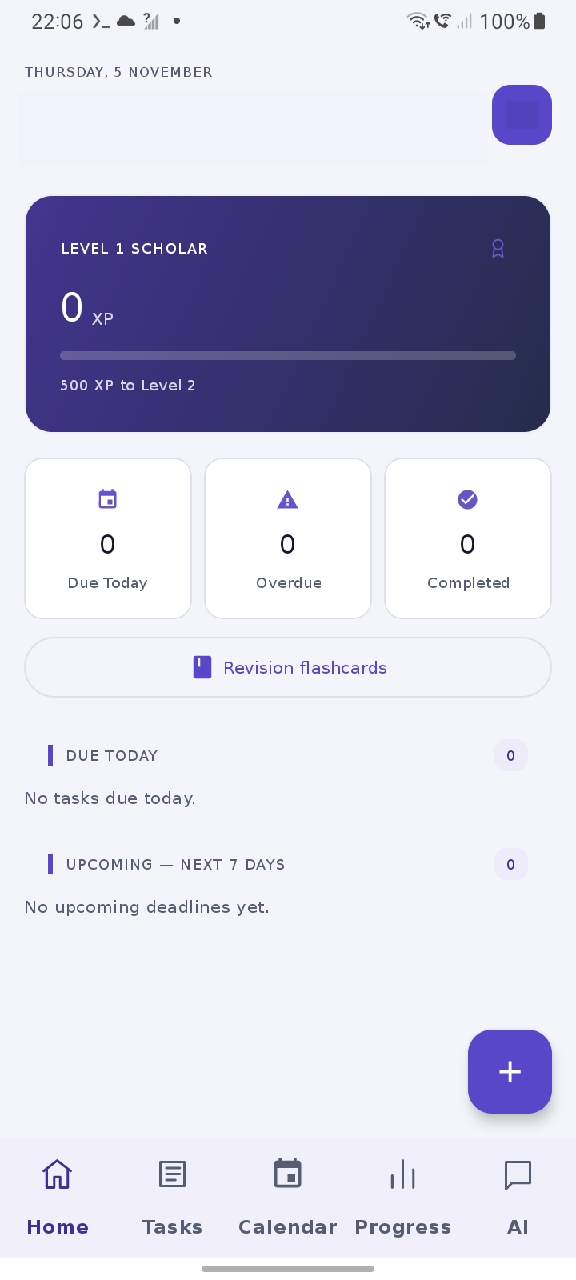  Home · App screenshot | 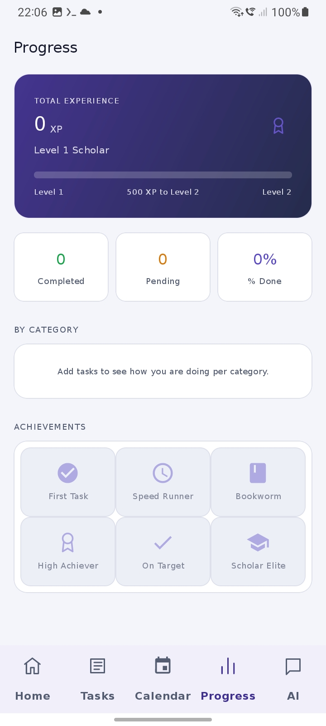  Progress · App screenshot

Dashboard and progress
Open Home to see what is due today, overdue or coming up. The Progress tab tracks completed work, XP, levels and achievement badges.

Subjects and tasks
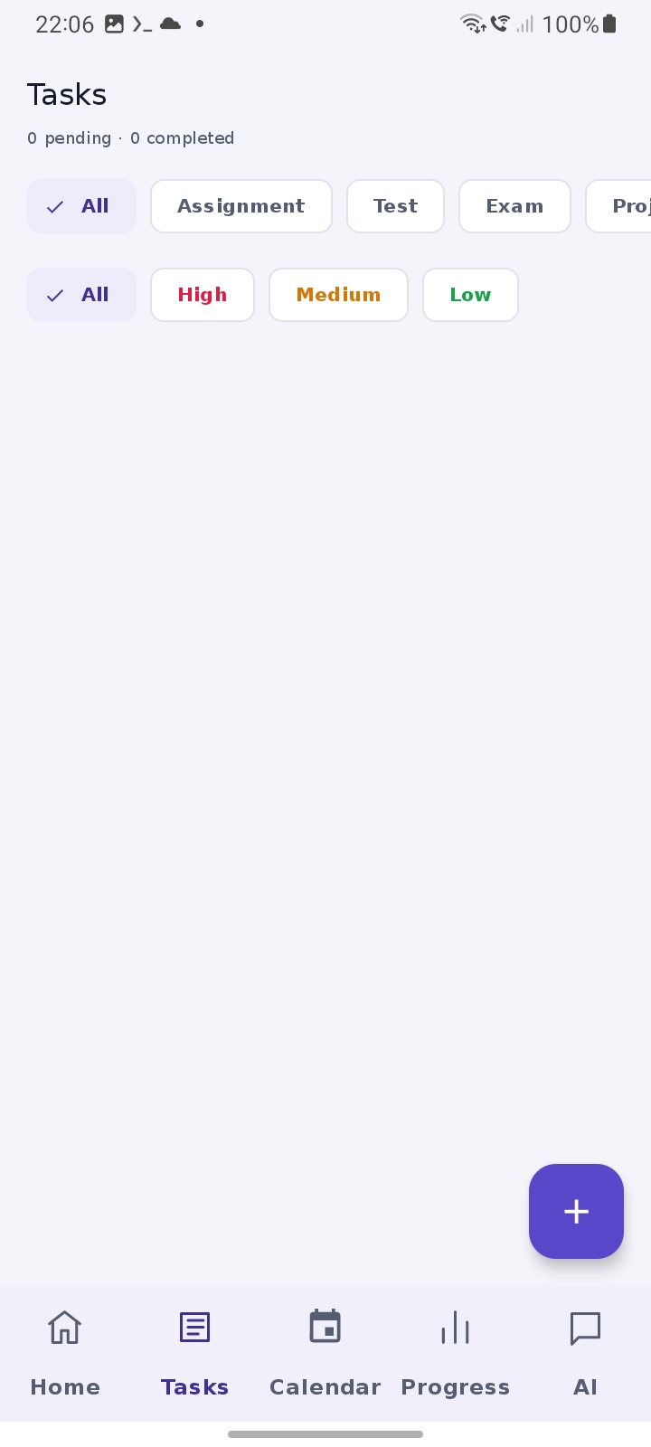  Tasks · App screenshot | 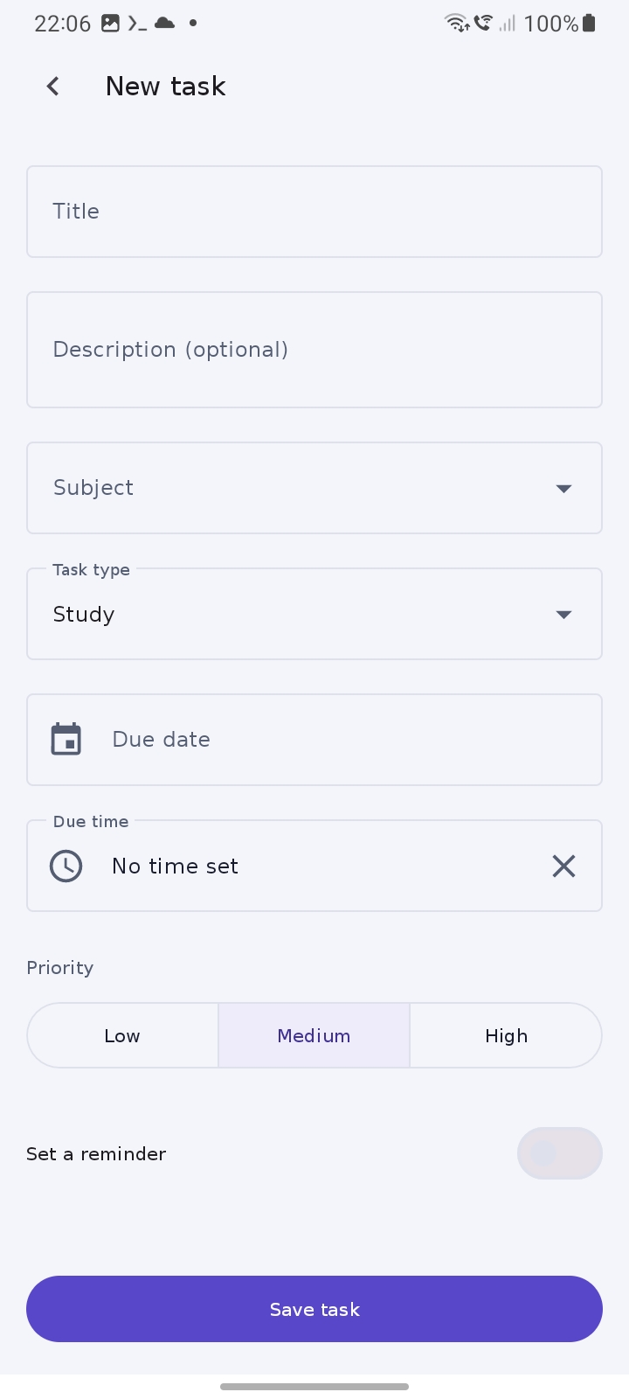  New task · App screenshot

Create and organise tasks
Create subjects to group coursework. Add assignments, tests, exams or study tasks with a due date and priority. Edit or delete tasks as plans change and mark finished work complete.

Calendar and timetable
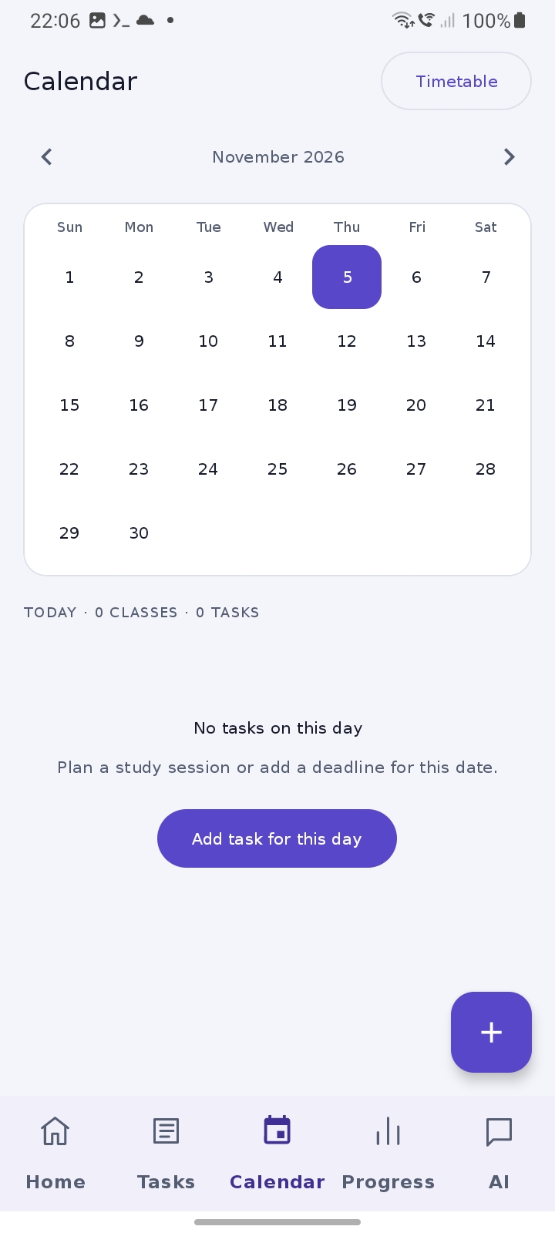  Calendar · App screenshot | 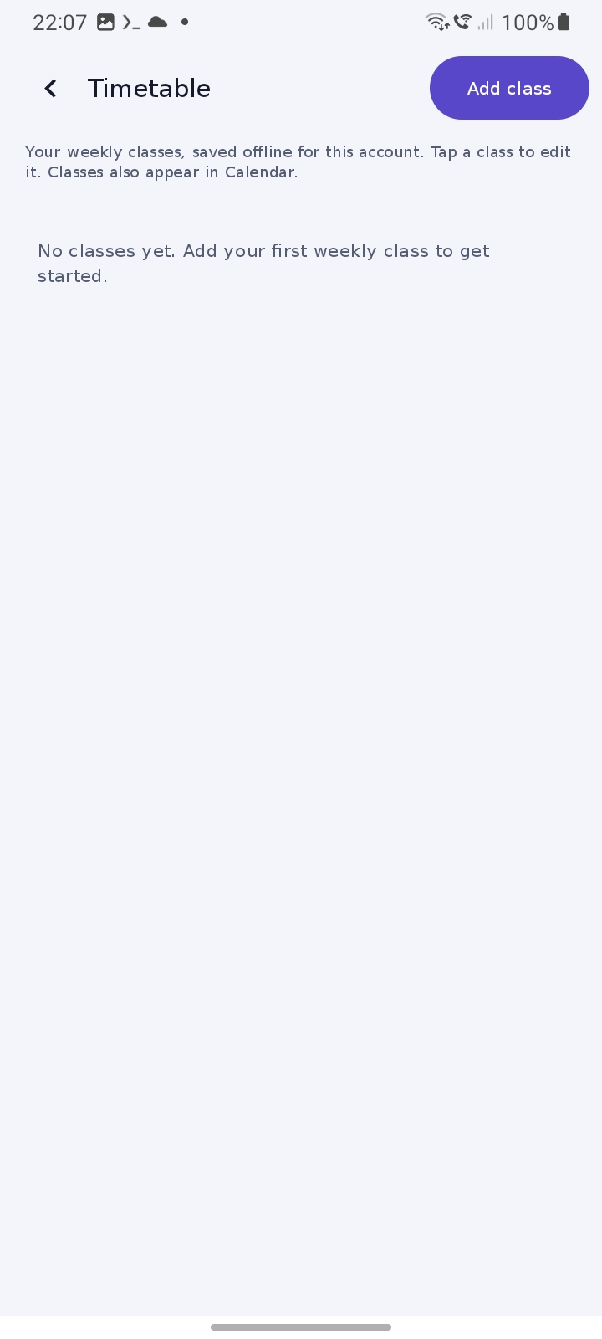  Timetable · App screenshot

Calendar and timetable
Calendar brings deadlines and classes together. Open Calendar → Timetable to add a weekly class with a weekday, start and end times, term dates and optional venue or lecturer.

Weekly classes and flashcards
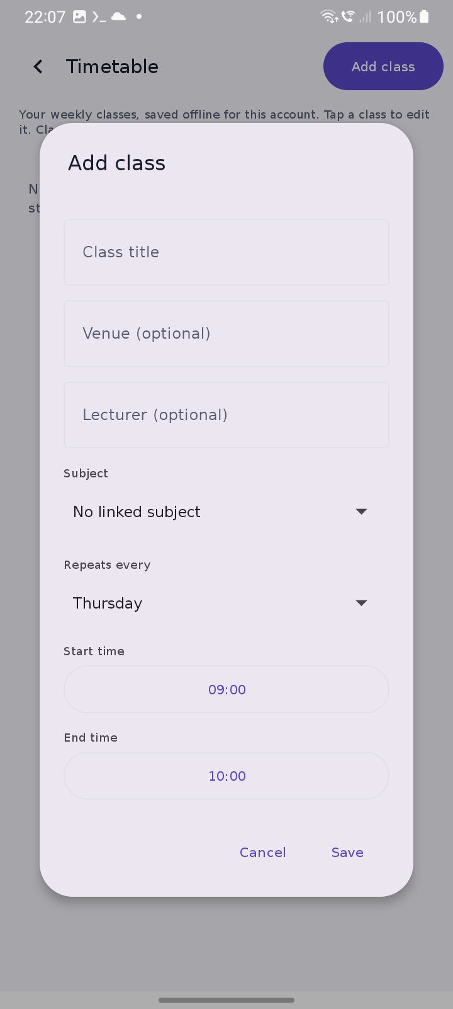  Add class · App screenshot | 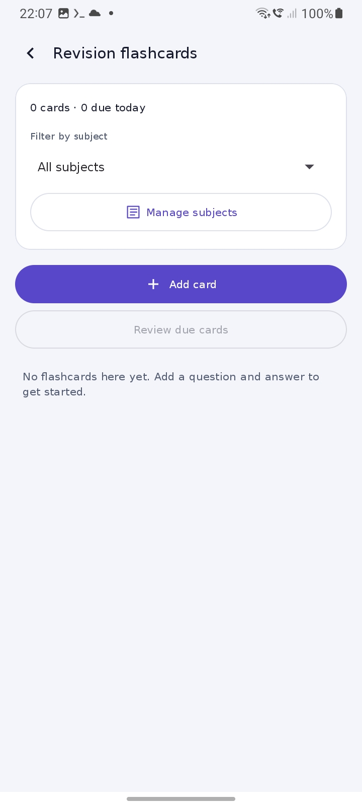  Revision flashcards · App screenshot

Flashcards
Open Home → Revision flashcards to create question-and-answer cards by subject. Reveal an answer and rate your recall Again, Hard or Easy to set the next review date.

Study help and settings
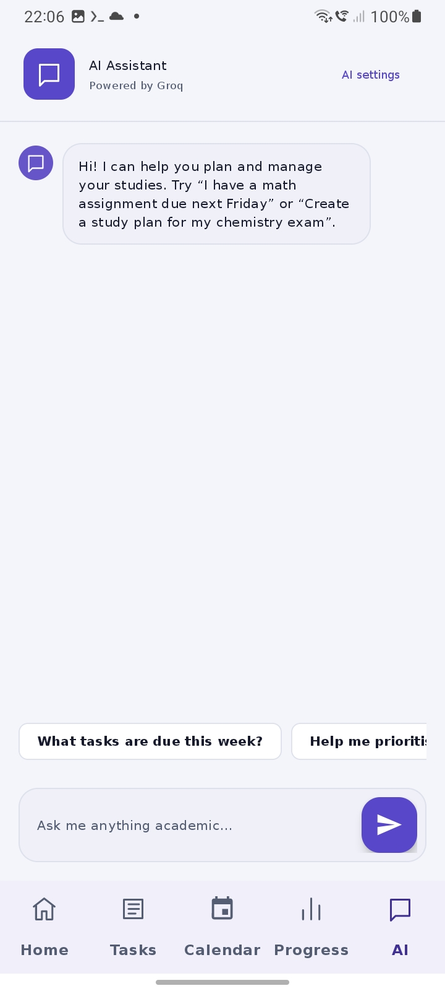  AI Assistant · App screenshot | 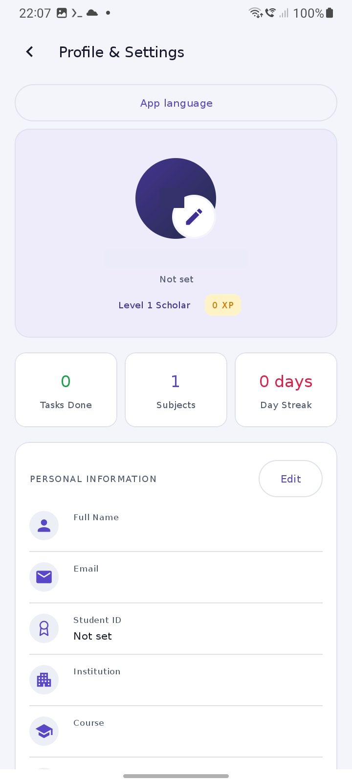  Profile and Settings · App screenshot

AI study assistant
Use the AI tab for study explanations and task suggestions. Review, edit or reject suggestions before saving them as tasks. AI requires internet access and a Groq key configured under AI settings.

Reminders and preferences
Tasks alert at the saved time or one hour before their deadline. Weekly classes alert 15 minutes before they start. Under Profile → Reminder delivery settings, allow notifications and enable precise timing if available. Profile also controls appearance and app language.

Installation and release checks

Install the signed APK
Open StudyTrack’s Android CI page and select a successful release build. Download StudyTrack-release-apk from Artifacts, extract the ZIP, then open app-release.apk on your Android phone. Follow Android’s installation prompt.

Update an existing installation
Install over the existing app when the release uses the same signing certificate and a higher version code. Keep the existing installation in place to preserve local study data.

Sign in and use StudyTrack offline
Sign in with email and password or Google. StudyTrack stores study data on the device for the signed-in account. Tasks and subjects can sync when a compatible backend is configured. Timetable entries and flashcards are device-only and uninstalling removes them.

Check before sharing
Record the version, build date and artifact link. Install the release APK on a test phone and verify Google sign-in, task creation, weekly timetable, flashcard review and reminder delivery with the app closed.

Release links
Repository: https://github.com/LMS147/StudyTrack
Android CI: https://github.com/LMS147/StudyTrack/actions/workflows/android-ci.yml

