8/21/2024

Mashaole Zabylon Letsoalo

WEDE5020_POE_PART3

ST10436200 Letsoalo Mashaole

Table of Contents

Website Choice 3

Website Assets 4

Logos and Images 4

Graphics and Design 4

Resizing and Cropping Images 5

Stock Videos and Animations 6

Website Pages and Content 7

1. Homepage 7

2.About Us 7

3. Products 7

4. Blog 8

5. Contact Us 8

Part 2 9

1.Improvements in the Process document 9

2.Improvements on the Website 9

1.Home Page 9

2.About us Page 9

3.Products Page 10

4.Blog Page 10

5.Contact Us Page 11

6. Shopping Cart Page (cart.html) 11

7. Checkout Page (checkout.html) 12

Part 3 13

1. Improvements in the Process document 13

2. Improvements on the Website 13

1.Home Page 13

2.About us Page 13

3.Products Page 14

4.Blog Page 14

5.Contact Us Page 15

6. Shopping Cart Page (cart.html) 16

7. Checkout Page (checkout.html) 16

3.Functionality 16

1. Product Page (**products.js**) 16

2.Shopping Cart(**cart.js**) 18

CheckOut Page(**check out.js**) 20

4. SOE 23

List of References 25

# Website Choice

Sweet Delights is a boutique bakery that specialises in handcrafted cakes, pastries, and bread produced with the finest ingredients. The bakery takes pride in its distinctive flavours, stunning designs, and dedication to quality. The website will function as an online shopfront, exhibiting the bakery's products, conveying the story behind the brand, and giving an easy way for clients to make orders and get in touch.

Sweet Delights is a boutique bakery that celebrates the art of baking via its beautiful selection of cakes, pastries, and bread. Our bakery is committed to using only the best ingredients, ensuring that every bite is a delicious experience. Sweet Delights caters to every taste with classic flavours and unique inventions. Our website will be an excellent venue for showcasing our items, with high-quality photographs and thorough explanations that highlight the artistry behind each piece. Customers will be able to browse our menu, place orders for pickup or delivery, and even have their cakes personalised for special occasions. The website will also have a blog where we will post baking techniques, recipes, and behind-the-scenes anecdotes from our kitchen. By designing an entertaining and user-friendly website, Sweet Delights aims to reach a wider audience and make it easier for customers to enjoy our delicious creations.

# Website Assets

### Logos and Images

1. **Logo Creation:**
   * **Canva**: Canva Logo Maker allows users to design logos with pre-built templates and extensive customization options.
   * **LogoMaker**: A simple tool that helps users create logos in minutes using AI-driven design tools.
   * **Looka**: An AI-powered platform that allows users to generate professional-looking logos quickly.
   * **Hatchful by Shopify**: A free logo creation tool with industry-specific templates and customization.
   * **Tailor Brands**: Provides personalized logo designs and branding tools based on user preferences and industry.
2. **High-Quality Images:**
   * **Unsplash**: A vast collection of free, high-quality stock images.
   * **Pexels**: Offers free images and videos with no attribution required, perfect for both personal and commercial use.
   * **Pixabay**: A resource with over a million high-quality free stock images, videos, and vectors.
   * **Burst by Shopify**: A free stock photo site created specifically for entrepreneurs with business-focused content.
   * **Picjumbo**: A platform that provides high-quality images for personal or commercial use without restrictions.

### Graphics and Design

1. **Infographics and Visual Content:**
   * **Canva**: Comprehensive design tool offering templates for infographics, social media graphics, and presentations.
   * **Adobe Spark (now Adobe Express)**: A powerful tool to create social graphics, web pages, and short videos.
   * **Piktochart**: Specialized in creating infographics, reports, and presentations with ease.
   * **Venngage**: Provides a wide variety of templates to help create professional infographics quickly.
   * **Visme**: A platform for designing presentations, infographics, charts, and other visual content.
   * **Easel.ly**: A simple tool for creating infographics with pre-made templates.
2. **Illustration and Vector Graphics:**
   * **Vectr**: A free, simple yet powerful vector graphics editor that works both online and offline.
   * **Inkscape**: Open-source software for creating professional vector designs and illustrations.
   * **Gravit Designer**: A full-featured vector graphic design app available online or as a desktop app.
   * **Crello (now VistaCreate)**: A graphic design tool similar to Canva, offering templates for all types of visuals.
   * **Blender**: Open-source 3D creation suite, ideal for advanced graphic design, modeling, and animation.

### Resizing and Cropping Images

1. **Online Tools:**
   * **Pixlr**: An advanced browser-based image editing tool, offering cropping, resizing, and photo enhancement features.
   * **Fotor**: Known for easy editing, including resizing, cropping, and adding effects to images.
   * **BeFunky**: A user-friendly tool offering basic and advanced photo editing, resizing, and cropping.
   * **ResizeImage.net**: Specializes in fast, simple image resizing and cropping directly in your browser.
   * **Photopea**: A free online image editor with advanced features similar to Adobe Photoshop.
   * **Kapwing**: An all-in-one editor for videos, images, and GIFs, providing resizing and cropping capabilities.

### Stock Videos and Animations

1. **Free Stock Videos:**
   * **Pexels Videos**: A collection of free stock videos available for both personal and commercial use.
   * **Videvo**: Provides free stock footage and motion graphics for projects.
   * **Mixkit**: A free gallery of high-quality video clips, music tracks, and sound effects.
   * **Coverr**: A platform with a curated selection of free stock videos for commercial and personal use.
   * **Videezy**: Offers free and premium stock videos with various licenses.
2. **Video Editing and Animation:**
   * **Animoto**: Create videos from photos, video clips, and music with customizable templates.
   * **Biteable**: An easy-to-use platform for creating professional-looking videos and animations.
   * **Renderforest**: A video and animation tool for creating logo animations, explainer videos, and intros.
   * **Powtoon**: Specialized in animated video creation, ideal for presentations, explainers, and education.
   * **Kapwing**: In addition to photo editing, this platform provides powerful tools for editing and resizing videos.

# Website Pages and Content

### 1. Homepage

* Logo: Sweet Delights logo at the top left corner.
* Strapline / Slogan: “Baking Happiness, One Bite at a Time.”
* Navigation Links: Links to About Us, Products, Blog, and Contact Us pages.
* Full-width Photo: A high-quality image of a beautifully decorated cake.
* Summary of Main Activities: Brief introduction to Sweet Delights and what makes our bakery special.
* Featured Products: Thumbnails and short descriptions of best-selling items.
* Basic Contact Info: Phone number, email address, and physical address.
* Social Media Links: Icons linking to Sweet Delights’ social media profiles.
* Copyright / Year: © 2024 Sweet Delights. All rights reserved.

### 2.About Us

* Our Story: A detailed narrative about the history and mission of Sweet Delights.
* Meet the Team: Photos and bios of the key team members.
* Our Values: Information about the bakery’s commitment to quality, sustainability, and community.
* Testimonials: Quotes from satisfied customers.
* Logo: Sweet Delights logo at the top left corner.
* Strapline / Slogan: “Baking Happiness, One Bite at a Time.”
* Navigation Links: Links to About Us, Products, Blog, and Contact Us pages

### 3. Products

* Product Categories: Links to different categories like Cakes, Pastries, Bread, and Custom Orders.
* Individual Product Pages: Photos, descriptions, prices, and customization options for each product.
* Special Offers: Information about any ongoing promotions or discounts.
* Logo: Sweet Delights logo at the top left corner.
* Strapline / Slogan: “Baking Happiness, One Bite at a Time.”
* Navigation Links: Links to About Us, Products, Blog, and Contact Us pages

### 4. Blog

* Latest Posts: Summaries and links to the most recent blog entries.
* Categories: Links to different blog categories like Recipes, Baking Tips, Behind the Scenes, and Events.
* Search Bar: A search function to help users find specific posts.
* Subscribe: A form for users to subscribe to the blog newsletter.
* Logo: Sweet Delights logo at the top left corner.
* Strapline / Slogan: “Baking Happiness, One Bite at a Time.”
* Navigation Links: Links to About Us, Products, Blog, and Contact Us pages

### 5. Contact Us

* Contact Form: A form for users to send inquiries or feedback.
* Location Map: An embedded Google Map showing the bakery’s location.
* Operating Hours: Information about the bakery’s opening and closing times.
* Additional Contact Info: Phone number, email address, and social media links.
* Logo: Sweet Delights logo at the top left corner.
* Strapline / Slogan: “Baking Happiness, One Bite at a Time.”
* Navigation Links: Links to About Us, Products, Blog, and Contact Us pages

# Part 2

### 1.Improvements in the Process document

1. Updated table of contents
2. Updated list of Website Asserts

## 2.Improvements on the Website

### 1.Home Page

1. Header and Navigation:

* Enhanced hover effects for better interactivity.
* Consistent colour scheme for links.

1. Responsive Design:

* Media queries for adjusting layout and font sizes on smaller screens.

1. Main Section

* Grid Layout for Bestsellers
* Responsive Design
* View More Button: Each product now has a "View More" button that links to product pages.

### 2.About us Page

1. Header and Navigation:

* Enhanced hover effects for better interactivity.
* Consistent colour scheme for links.

1. Main Sections:

* Added rounded corners and shadows to sections for a card-like effect.
* Improved spacing between headings and paragraphs for better readability.

1. Team Section:

* Used flexbox for better alignment of team member images and text.
* Ensured uniformity in the presentation of team member details.

1. Values Section:

* Clear list format for values to enhance readability.

1. Testimonial Section:

* Styled blockquotes for visual distinction.

1. Call to Action:

* Highlighted the CTA button with hover effects to encourage user interaction.

1. Responsive Design:

* Media queries for adjusting layout and font sizes on smaller screens.

### 3.Products Page

1. Header and Navigation:

* Enhanced hover effects for better interactivity.
* Consistent colour scheme for links.

1. Responsive Design:

* Media queries for adjusting layout and font sizes on smaller screens.

1. Main Section:

* **Product Grid Layout**: It's best to organize the products in a grid layout for better readability and design aesthetics.
* **Buttons Styling**: Make the "Add to Cart" buttons more visually appealing.
* **Consistency in Image Sizing**: Standardize image sizes to maintain a uniform look across product categories.

### 4.Blog Page

1.**Header and Navigation**:

* Consistent branding with the logo and navigation links.
* Improved spacing and layout for better accessibility.

1. **Main Content Layout**:

* Centred layout with a maximum width for better readability.
* Unified padding and margin for sections to create a clean look.

1. **Search Bar**:

* Styled to use flexbox for a more responsive design.
* Included placeholder text for guidance.

1. **Latest Posts Section**:

* Enhanced article styling with borders and padding for better visual separation.
* Added post metadata for clarity on publication dates and authorship.

1. **Categories Section**:

* Simplified and clear list format to enhance navigation.
* Styled links for better interaction feedback.

1. **Subscribe Section**:

* Emphasized with a distinct background color for visual distinction.
* Styled form for consistency with the rest of the page.

### 5.Contact Us Page

1. **Header and Navigation**:

* Consistent styling with the "About Us" page for branding continuity.

1. **Main Section**:

* Centred layout for the main content with a maximum width for improved readability.
* Rounded corners and shadows for a modern look.

1. **Contact Form**:

* Clear focus states on input fields to enhance accessibility.
* Smooth transitions for input and button states for better user experience.
* Improved spacing around form elements for a cleaner look.

1. **Map Section**:

* Ensured the map is responsive and fits well within the layout.

1. **Operating Hours and Additional Info**:

* Clean formatting for additional contact details and operating hours.

1. **Footer**:

* Consistent footer design to match the header, enhancing overall page coherence.

1. **Responsive Design**:

* Media queries ensure elements adjust well on smaller screens.

### 6. Shopping Cart Page (cart.html)

* **Purpose**: Shows items the customer has added to their cart, with options to adjust quantities or proceed to checkout.
* **Features**:
  + **Cart Item List**: Displays each item with its name, image, price, quantity, and subtotal.
  + **Cart Total**: Shows the total cost of items in the cart.
  + **Quantity Adjustment**: Buttons to increase or decrease item quantities.
  + **Clear Cart Button**: Empties the cart with a single click.
  + **Proceed to Checkout Button**: Redirects to the checkout page.

### 7. Checkout Page (checkout.html)

* **Purpose**: Finalizes the order process, allowing customers to review and confirm their order.
* **Features**:
  + Placeholder text for now; intended for future integration with a payment system or order summary.
  + **Back to Products Button**: Takes the customer back to the products page if they wish to continue shopping.

# Part 3

### 1. Improvements in the Process document

* Updated list of Website Asserts
* Added two new Pages
  + 1. Shopping Cart
    2. . Checkout

## 2. Improvements on the Website

### 1.Home Page

1. Header and Navigation:

* Enhanced hover effects for better interactivity.
* Consistent colour scheme for links.

1. Responsive Design:

* Media queries for adjusting layout and font sizes on smaller screens.

1. Main Section

* Grid Layout for Bestsellers
* Responsive Design
* View More Button: Each product now has a "View More" button that links to product pages.

### 2.About us Page

1. Header and Navigation:

* Enhanced hover effects for better interactivity.
* Consistent colour scheme for links.

1. Main Sections:

* Added rounded corners and shadows to sections for a card-like effect.
* Improved spacing between headings and paragraphs for better readability.

1. Team Section:

* Used flexbox for better alignment of team member images and text.
* Ensured uniformity in the presentation of team member details.

1. Values Section:

* Clear list format for values to enhance readability.

1. Testimonial Section:

* Styled blockquotes for visual distinction.

1. Call to Action:

* Highlighted the CTA button with hover effects to encourage user interaction.

1. Responsive Design:

* Media queries for adjusting layout and font sizes on smaller screens.

### 3.Products Page

1. Header and Navigation:

* Enhanced hover effects for better interactivity.
* Consistent colour scheme for links.

1. Responsive Design:

* Media queries for adjusting layout and font sizes on smaller screens.

1. Main Section:

* **Product Grid Layout**: It's best to organize the products in a grid layout for better readability and design aesthetics.
* **Buttons Styling**: Make the "Add to Cart" buttons more visually appealing.
* **Consistency in Image Sizing**: Standardize image sizes to maintain a uniform look across product categories.

1. Features:

* Links to view more product details if needed.
* Pagination or filters (optional for large product inventories).

### 4.Blog Page

1.**Header and Navigation**:

* Consistent branding with the logo and navigation links.
* Improved spacing and layout for better accessibility.

2. **Main Content Layout**:

* Centred layout with a maximum width for better readability.
* Unified padding and margin for sections to create a clean look.

**3. Search Bar**:

* Styled to use flexbox for a more responsive design.
* Included placeholder text for guidance.

4. **Latest Posts Section**:

* Enhanced article styling with borders and padding for better visual separation.
* Added post metadata for clarity on publication dates and authorship.

5. **Categories Section**:

* Simplified and clear list format to enhance navigation.
* Styled links for better interaction feedback.

6. **Subscribe Section**:

* Emphasized with a distinct background color for visual distinction.
* Styled form for consistency with the rest of the page.

### 5.Contact Us Page

1. **Header and Navigation**:

* Consistent styling with the "About Us" page for branding continuity.

1. **Main Section**:

* Centred layout for the main content with a maximum width for improved readability.
* Rounded corners and shadows for a modern look.

1. **Contact Form**:

* Clear focus states on input fields to enhance accessibility.
* Smooth transitions for input and button states for better user experience.
* Improved spacing around form elements for a cleaner look.

1. **Map Section**:

* Ensured the map is responsive and fits well within the layout.

1. **Operating Hours and Additional Info**:

* Clean formatting for additional contact details and operating hours.

1. **Footer**:

* Consistent footer design to match the header, enhancing overall page coherence.

1. **Responsive Design**:

* Media queries ensure elements adjust well on smaller screens.

1. **JavaScript Functionality**:

* Ensures the form captures input and processes submission.

### 6. Shopping Cart Page (cart.html)

1. **Purpose**: Shows items the customer has added to their cart, with options to adjust quantities or proceed to checkout.
2. **Features**:
   1. **Cart Item List**: Displays each item with its name, image, price, quantity, and subtotal.
   2. **Cart Total**: Shows the total cost of items in the cart.
   3. **Quantity Adjustment**: Buttons to increase or decrease item quantities.
   4. **Clear Cart Button**: Empties the cart with a single click.
   5. **Proceed to Checkout Button**: Redirects to the checkout page.

### 7. Checkout Page (checkout.html)

* **Purpose**: Finalizes the order process, allowing customers to review and confirm their order.
* **Features**:
  + Placeholder text for now; intended for future integration with a payment system or order summary.
  + **Back to Products Button**: Takes the customer back to the products page if they wish to continue shopping.

## 3.Functionality

### 1. Product Page (**products.js**)

1. **Initialize Cart from localStorage**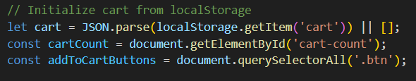

**• cart** is set by retrieving the stored cart data from **localStorage** (if it exists) and parsing it from JSON format back to a JavaScript array. If there’s no saved cart data, an empty array (**[])** is assigned instead.

**• cartCount** and **addToCartButtons** are constants:

* **cartCount** refers to an element in the header that displays the number of items in the cart.
* **addToCartButtons** selects all elements with the class .**btn**, which are the "Add to Cart" buttons for each product.

2. **Update the Cart Count in the Header**

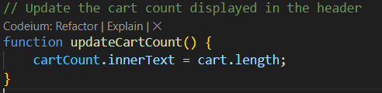

This function sets the text content of **cartCount** to the length of the **cart** array, representing the number of items in the cart.

3. **Handle "Add to Cart" Button Click**

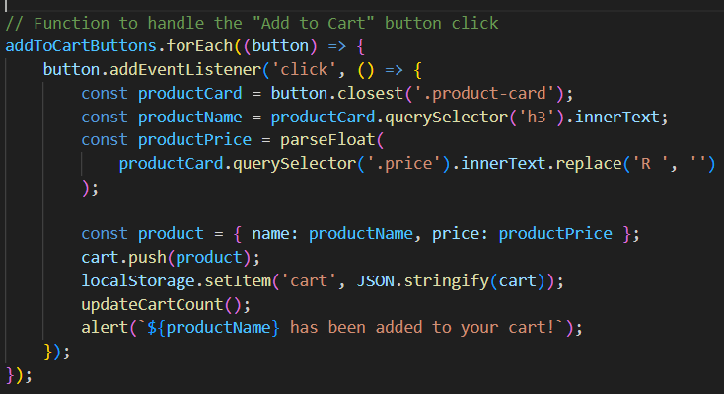

This loops over each "**Add to Cart**" button (**addToCartButtons**) and adds an event listener:

* When a button is clicked:
  1. **Identify Product Info**:
     + The **button.closest('.product-card'**) locates the nearest .product-card element containing the product details.
     + **productName** and **productPrice** are extracted from the product card:
       - **productName:** Extracts the product name from the **<h3>** element.
       - **productPrice:** Gets the price from the **.price** element and removes "R " to parse it as a number.
  2. **Add Product to Cart**:
     + A product object with the name and price is created and added to the cart array.
     + The updated cart array is saved back to **localStorage** in JSON format, updating the stored data.
  3. **Update UI**:
     + **updateCartCount()** is called to refresh the cart count display.
     + An alert notifies the user that the item was successfully added to the cart.

4. **Initialize Cart Count on Page Load**



This final line calls **updateCartCount()** once to ensure the correct item count displays when the page first loads, based on items already in the cart.

### 2.Shopping Cart(**cart.js**)

1. **Initialize Cart and Elements**

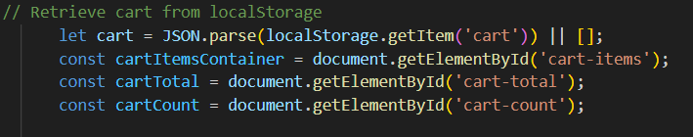

• **cart** retrieves and parses the **cart** data from **localStorage.** If no data exists, an empty array is assigned.

• **cartItemsContainer, cartTotal**, and **cartCount** reference HTML elements where:

* **cartItemsContainer** will display the list of items in the cart.
* **cartTotal** will show the total cart price.
* **cartCount** will display the number of items in the cart.

2. **updateCartDisplay() Function: Display Cart Items and Total**

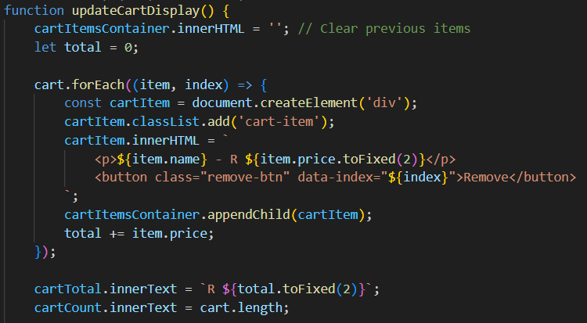

* **Clear Items**: Clears previous items from **cartItemsContainer** to avoid duplication.
* **Loop Through Cart Items**:
  + For each item, it creates a new div (**cartItem)** with the item’s name and price, adding a "Remove" button.
  + Adds each item to the cart display and increments the **total** variable by the item’s price.
* **Display Total and Item Count**:
  + **cartTotal** shows the cart total price, formatted to two decimal places.
  + **cartCount** displays the total number of items in the cart.

**3.Remove Item from Cart**

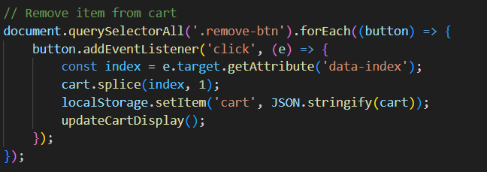

Each "Remove" button has an event listener that:

* **Removes the Item**: Gets the **index** of the item from the button’s **data-index** attribute and removes the item from the **cart** array.
* **Update localStorage**: Saves the updated **cart** array to **localStorage.**
* **Refresh Display**: Calls **updateCartDisplay()** to show the updated cart.

4. **Clear Cart Button**

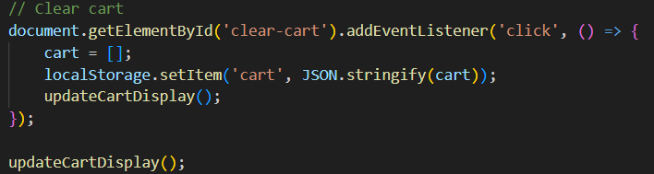

• Clears all items from the **cart** by setting it to an empty array.

• Updates **localStorage** to remove all items and calls **updateCartDisplay()** to reset the cart display.

5. **Checkout Button**

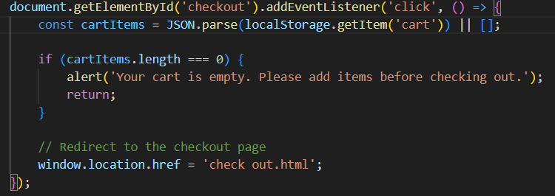

• **Check for Empty Cart**: Retrieves the **cart** from **localStorage.** If empty, it alerts the user and stops the checkout process.

• **Proceed to Checkout**: Redirects the user to **check out.html** if the cart has items.

6. **Initialize Cart Display**



Calls **updateCartDisplay()** on page load to show the cart items and totals based on any previously saved data in **localStorage**.

### CheckOut Page(**check out.js**)

1. **DOM Content Loaded Event**



The code runs only after the HTML content is fully loaded, ensuring elements referenced in the script are accessible.

1. Variable Initialization

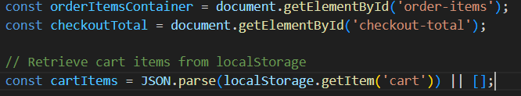

• **orderItemsContainer**: References the HTML element to display each cart item.

• **checkoutTotal**: Refers to the element showing the total checkout amount.

• **cartItems**: Retrieves and parses the cart data from **localStorage.** If the cart is empty, it defaults to an empty array.

1. Check for Empty Cart

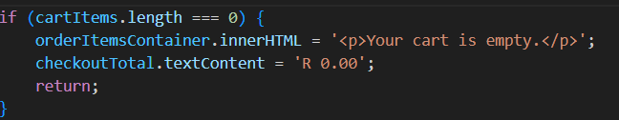

If the cart is empty **(cartItems.length === 0),** a message is displayed, and the total price is set to **R 0.00**. The function returns early, skipping the rest of the code for displaying items.

4. **Calculate and Display Each Cart Item**

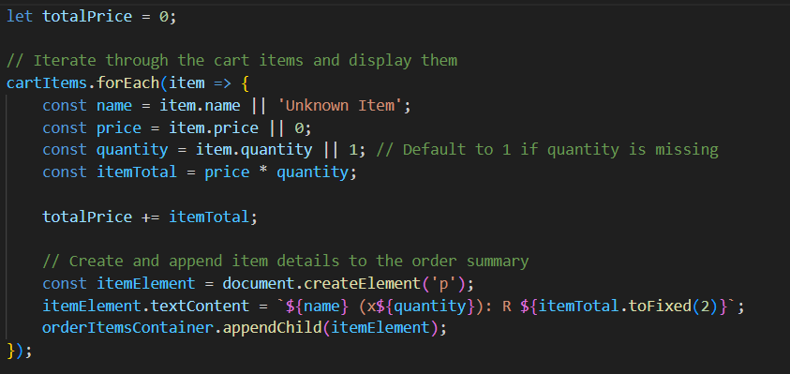

• **totalPrice**: A variable to accumulate the cart’s total price.

• **Loop through cartItems**: Each item is processed, with default values for **name, price,** and **quantity** in case any of these properties are missing.

* **itemTotal**: Calculates the item’s total cost by multiplying the price by the quantity.
* **Accumulate Total**: Adds **itemTotal** to **totalPrice** to keep a running total.
* **Create Item Element**: A new <p> element is created and appended to **orderItemsContainer** to display each item’s details.

5. **Display the Total Price**



This sets **checkoutTotal** to display the total cart value, formatted to two decimal places.

1. **Handle Checkout Form Submission**

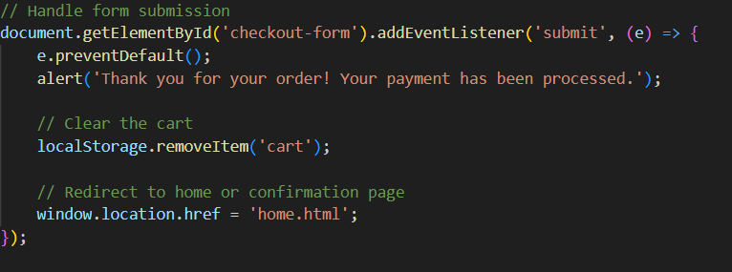

• **Form Submission Handling**: Prevents the default form submission behavior using **e.preventDefault().**

**Alert Confirmation**: Displays a confirmation message thanking the user.

• **Clear Cart**: Deletes the cart data from **localStorage** to reset the cart.

• **Redirect**: Redirects the user to the homepage or a confirmation page after order submission.

### SOE

1. XML Declaration



Specifies the XML version and character encoding.

1. Root **<urlset>** Element



* Defines the XML namespace, which ensures that the file complies with the sitemap protocol.

1. **Individual <url> Entries**

* Each **<url>** entry provides details about a specific page.

For each page, the following details are specified:

* **Location (<loc>)**: Defines the URL of the page.
* **Last Modified (<lastmod>)**: Specifies the last date the page content was modified. This helps search engines understand when the content was last updated, potentially influencing how frequently they revisit the page.
* **Change Frequency (<changefreq>)**: Suggests how often the content of the page is likely to change. Options like **daily, weekly, monthly** are used to guide crawlers on revisiting frequency, but search engines ultimately determine when to crawl.
* **Priority (<priority>)**: Indicates the relative importance of each page within the site on a scale from **0.0 (lowest) to 1.0 (highest).** It helps search engines allocate resources, though it doesn’t guarantee ranking placement.

**Example Explanation of Each Entry**

**Home Page Entry**

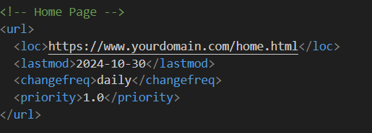

• URL: **https://www.yourdomain.com/home.html**

• Last Modified: **2024-10-30**

• Change Frequency**: daily** (updated often, as it’s the homepage)

• Priority**: 1.0** (most important page, likely to be frequently visited by users)

**Products Page Entry**

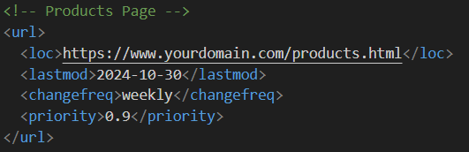

• URL**: https://www.yourdomain.com/products.html**

• Last Modified: **2024-10-30**

• Change Frequency: **weekly** (product information may be updated periodically)

• Priority: **0.9** (important for users and search engines due to the product listings)

# List of References

1. Logo created with Canva:
   * Canva. (2024). Beige and Black Vintage Retro Minimalist Illustrated Bakery Logo

<https://www.canva.com/design/DAGNulyVMwk/TDool2vUO4sNl2m9XpIrgQ/edit>

1. Image from Unsplash:

* Lanty, L. (2018). Naked Wedding Cake with Flower Details <https://unsplash.com/photos/icing-covered-cake-beside-cupcakes-3962cSRPwOo>
* Daener, D. (2017). Baking Away <https://unsplash.com/photos/baked-bread-placed-on-round-white-ceramic-plate-SqP9Om7cAec>
* Razvan, M. (2021). Home-made chocolate diplomat cream eclairs, dusted with powdered sugar. <https://unsplash.com/photos/brown-bread-on-brown-wooden-table-tas-1lvQE6Q>
* Ilham, P. (2023). Fresh homemade artisan loaf of baguette breads on rustic background with copy space. sourdough mini baguette breads. <https://unsplash.com/photos/two-loaves-of-bread-on-a-black-surface-fT5EYbmJlMU>
* Roza, L. (2022). Strawberry Pavlova <https://unsplash.com/photos/a-cake-with-white-frosting-and-strawberries-on-top-Pf8pXy0L1DA>
* Flores, J. (2020). Homemade blueberry muffins <https://unsplash.com/photos/brown-cupcakes-on-white-ceramic-plate-5RQffqRkmWQ>

1. Image from Pexels:
   * Rojas, C. (2021). A Man Assembling a Cake. ‘<https://www.pexels.com/photo/a-man-assembling-a-cake-8477959/>
   * Shvets, A. (2020).Pastry Chef with Face Mask Standing. <https://www.pexels.com/photo/pastry-chef-with-face-mask-standing-5964622/>
   * Kungla, K. (2023). Red Velvet Cake with Caramelised Peanuts, Raspberries And Cream Cheese Frosting. <https://www.pexels.com/photo/red-velvet-cake-with-caramelised-peanuts-raspberries-and-cream-cheese-frosting-18254932/>
   * Dzedyshko, M. (2021). Loaves of bread on napkin. <https://www.pexels.com/search/Sourdough%20Bread/>
   * Pixabay. (2016). Cinnamon Roll on Plate <https://www.pexels.com/photo/cinnamon-roll-on-plate-267308>

GitHub link: [mash147/WEDE5020-POE-PART1 (github.com)](https://github.com/mash147/WEDE5020-POE-PART1)

[mash147/WEDE50220-POE-PART-2 (github.com)](https://github.com/mash147/WEDE50220-POE-PART-2)