1. Run Power shell as Administrator

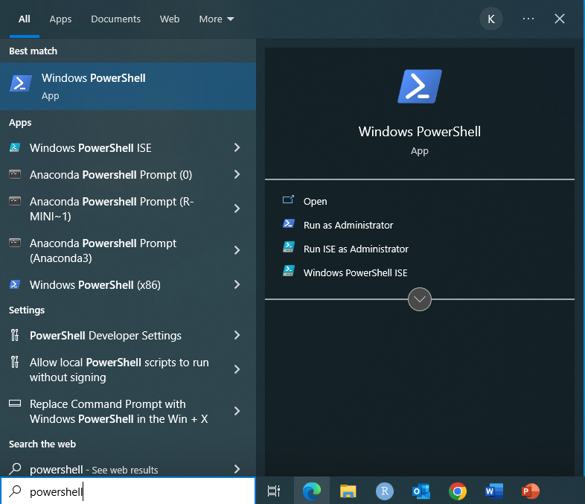

1. Run two commands in PowerShell terminal

$ dism.exe /online /enable-feature /featurename:Microsoft-Windows-Subsystem-Linux /all /norestart

$ dism.exe /online /enable-feature /featurename:VirtualMachinePlatform /all /norestart

1. Download and install the Linux kernel update package ([WSL2 Linux kernel update package for x64 machines](https://wslstorestorage.blob.core.windows.net/wslblob/wsl_update_x64.msi))
2. Set WSL2 as default version in PowerShell terminal

$wsl --set-default-version 2

1. Install Linux distribution from [Microsoft Store](https://aka.ms/wslstore)
   1. Open Microsoft Store and select Ubuntu Linux

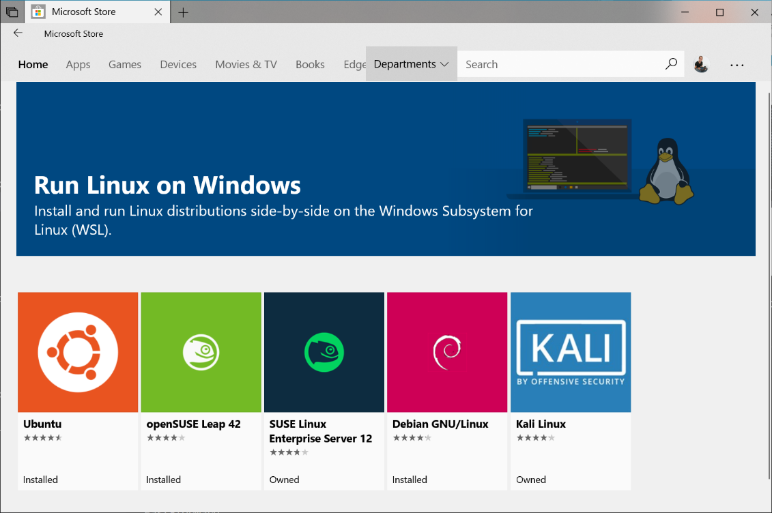

* 1. From the distribution's page, select "Get".

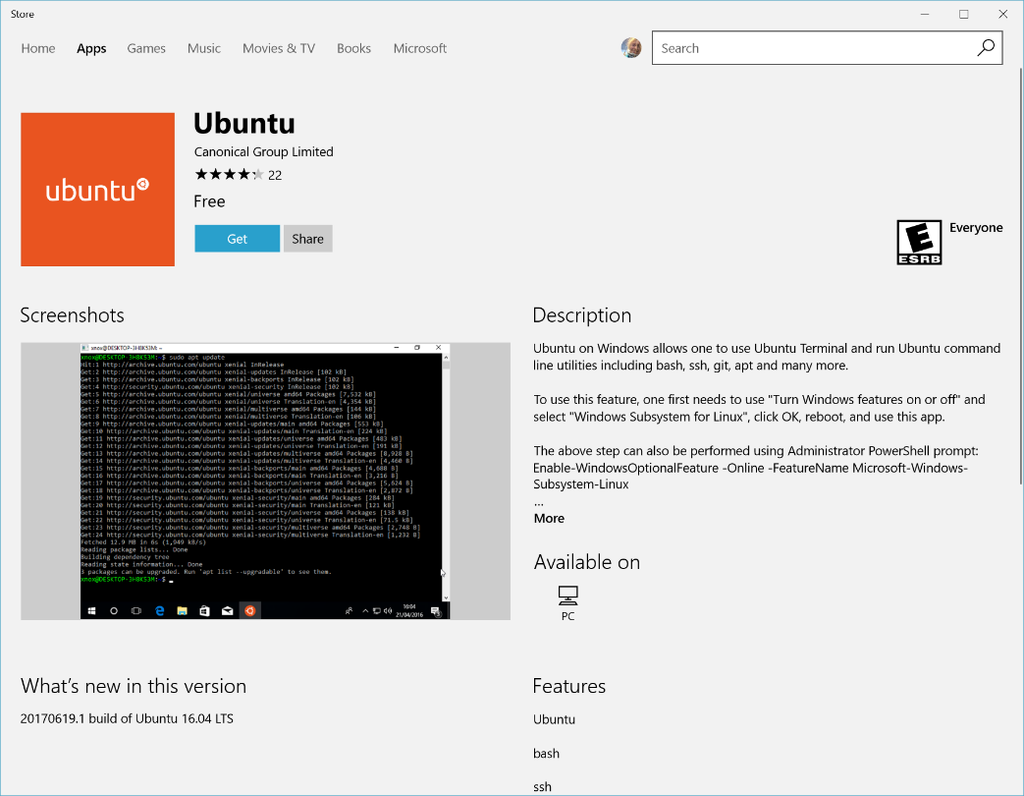

* 1. Create a user account and password for the Linux distribution

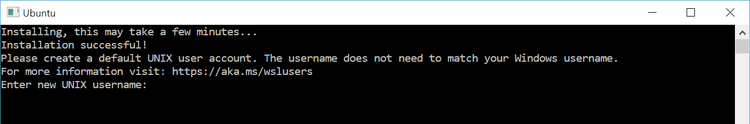

1. Install docker from Docker website ([Docker Desktop | Docker](https://www.docker.com/products/docker-desktop/)).
2. After installing docker, download docker image using command below:

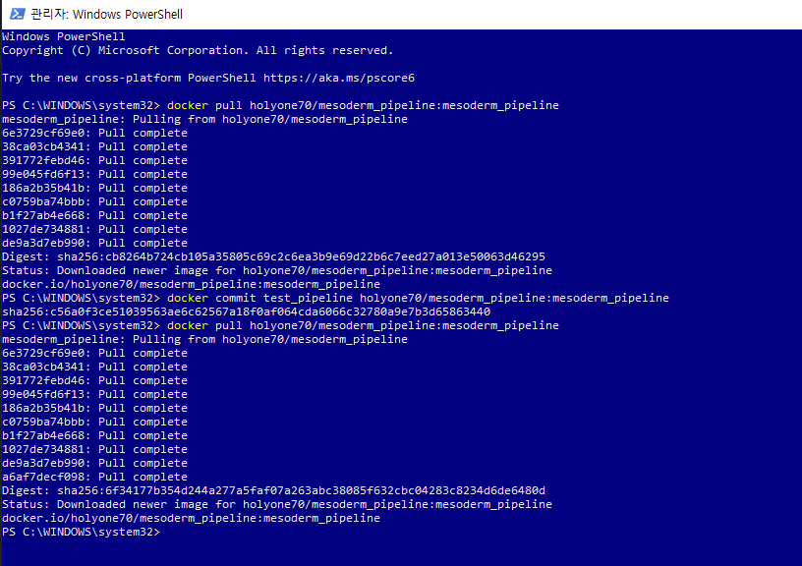docker pull holyone70/mesoderm_pipeline:mesoderm_pipeline

1. Run Docker Desktop, and check the docker image to download
2. Run the docker image

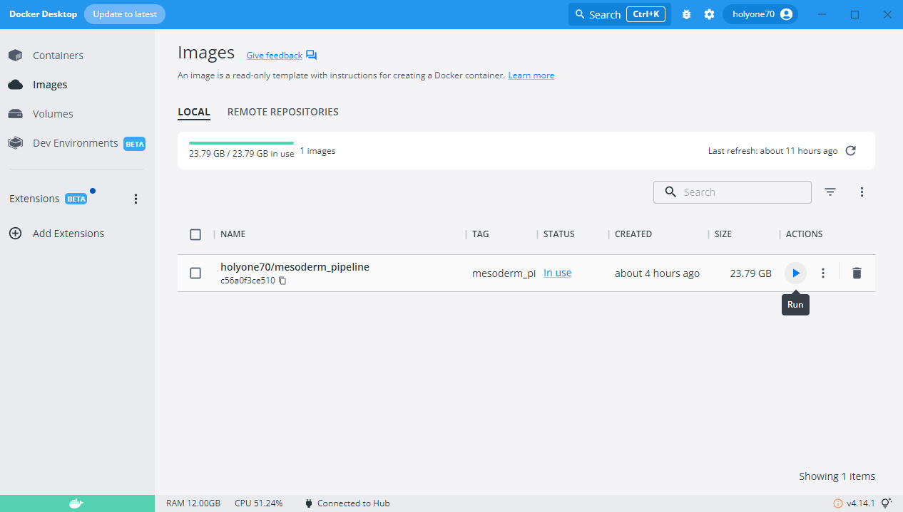

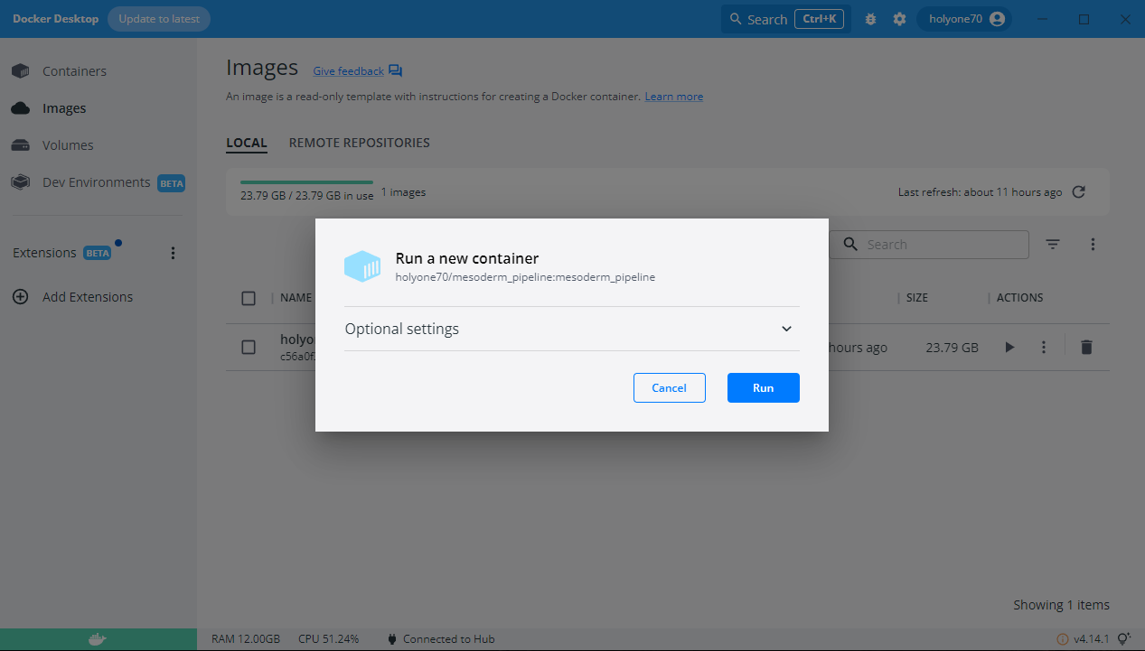

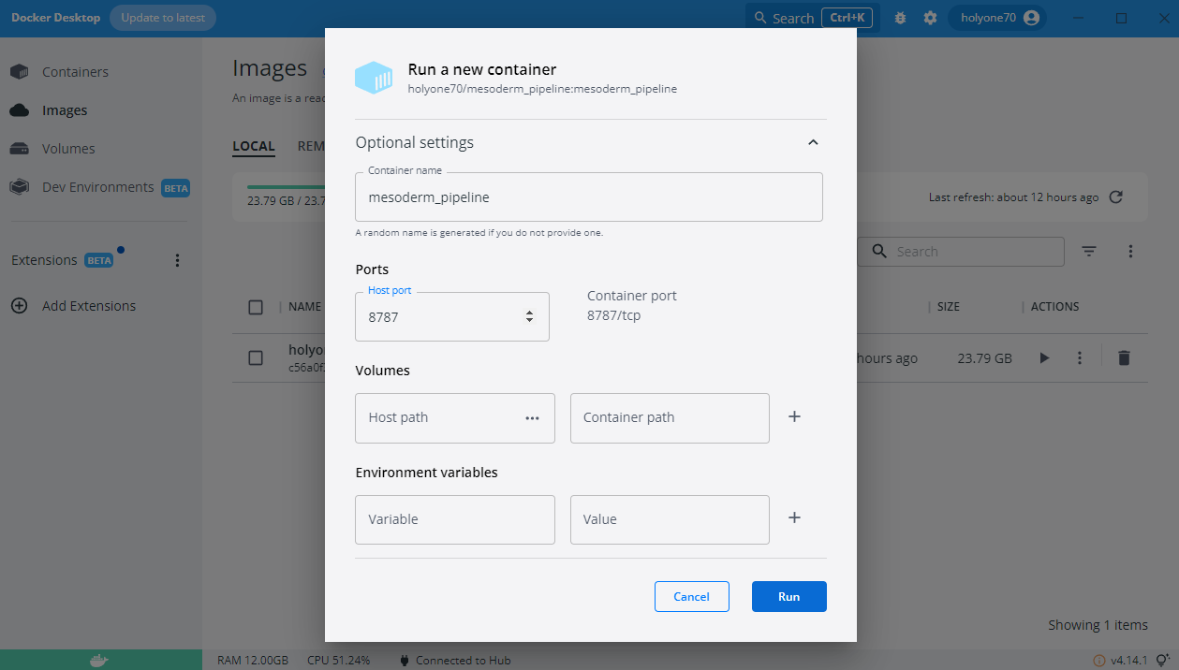

1. Run Docker container
2. Run Rstudio server in Docker container

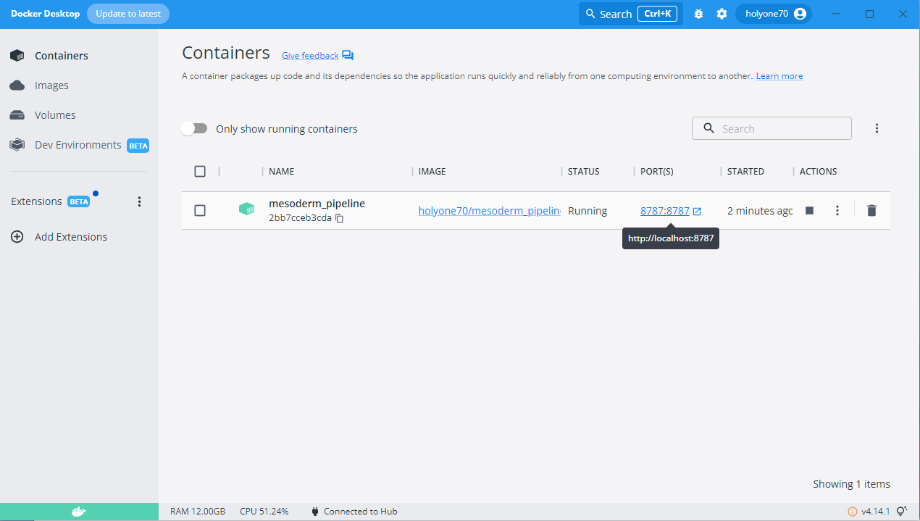

1. Open the terminal

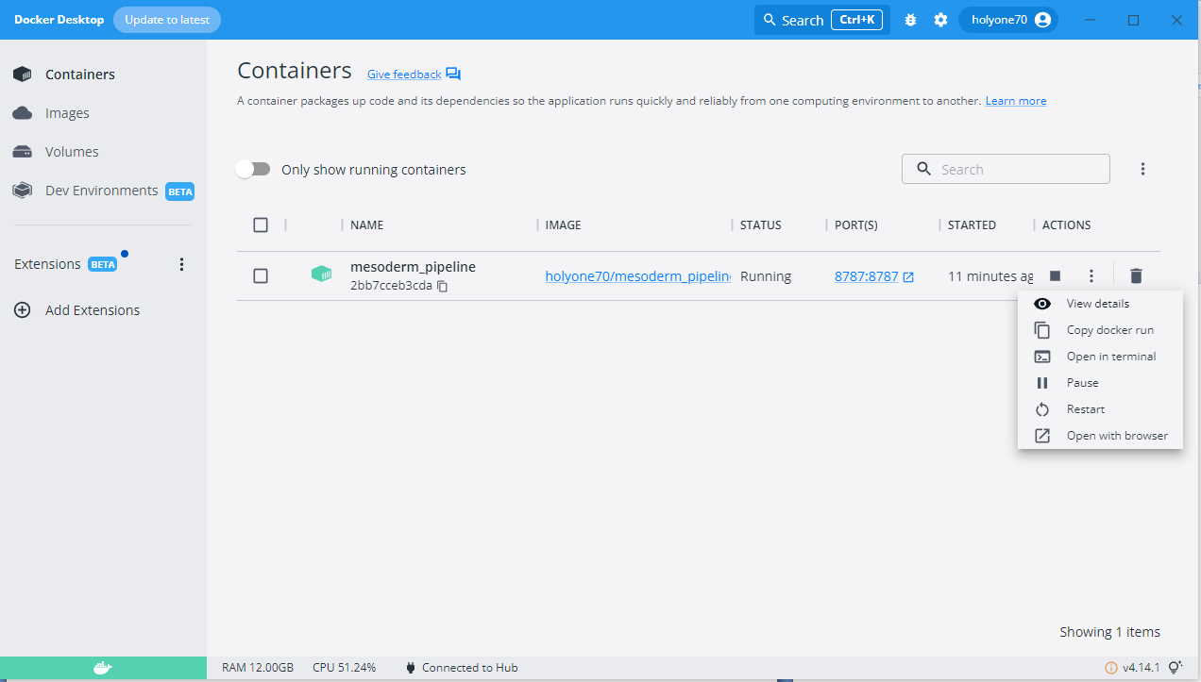

1. Set the password for user rstudio

Sudo passwd rstudio

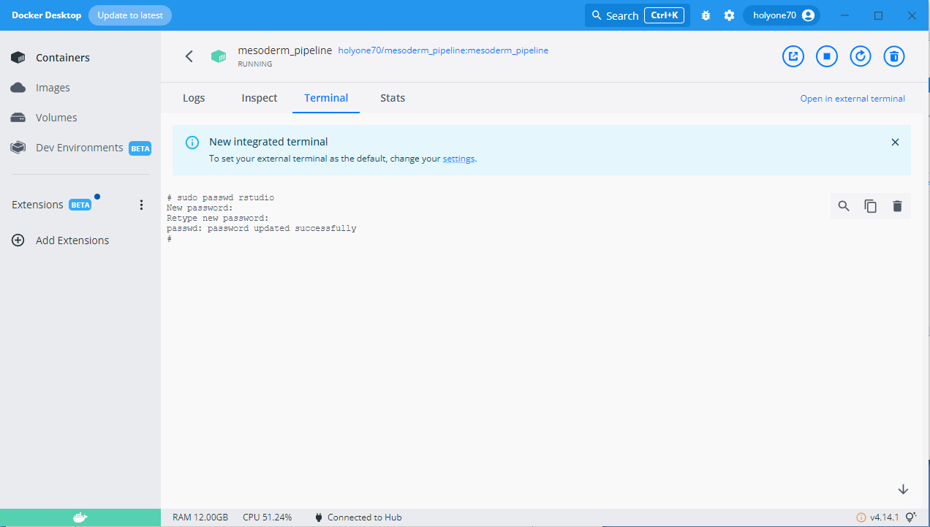

1. Login Rstudio server

