Luke Schipper

2020

USER GUIDE

REVITALIZE APP

**Aim and Audience**

This document is aimed at those who are using the Revitalize system for the first time or need assistance. It will serve as a guide for navigating webpages and making use of some of the features that are available on the website.

Each section of the guide was designed with the assumption that the user is starting on the About Us page of the application.

**Table of Contents**

Revitalize User guide sections

1. The Home Screen View
2. The About Us page
3. The Support pages
4. The Contact Us page
5. Changing the language
6. Signing into user account
   1. Logging out of the user account
7. Accessing the Sidebar
8. Accessing the Profile screen
   1. Viewing/editing profile information
   2. Viewing survey information
   3. Viewing lab value information
9. Accessing the Survey page
   1. Viewing new surveys (Available Surveys)
   2. Taking surveys
   3. Viewing past surveys (Survey History)
   4. Doing Surveys

10) Accessing the lab values page

11) Accessing the Dietary Journal

12) Accessing the Goal Progress

**The Home Screen View**

On this page, once you have landed on the Revitalize App webpage, you will be greeted with the About US, Support, and Contact tabs. To the right of the header tabs will be the Language selector and the Sign In button for which you may use to log into your account.

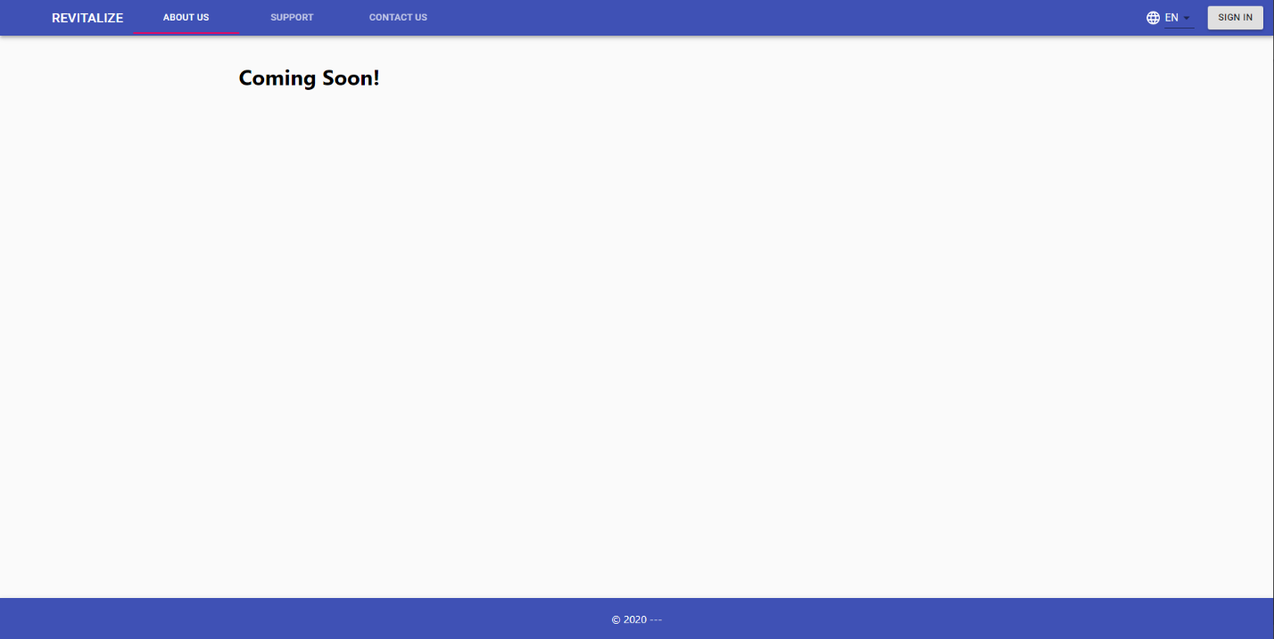

**The About Us Page**

The About Us page doubles as the landing page and is the first visited page on the website when not logged in. The page will contain details of the team behind the website and the goal the website aims to achieve for its clients.



**The Support Page**

The Support Page is positioned beside the About Us page and will possess information on how to get quick support via FAQs and such.

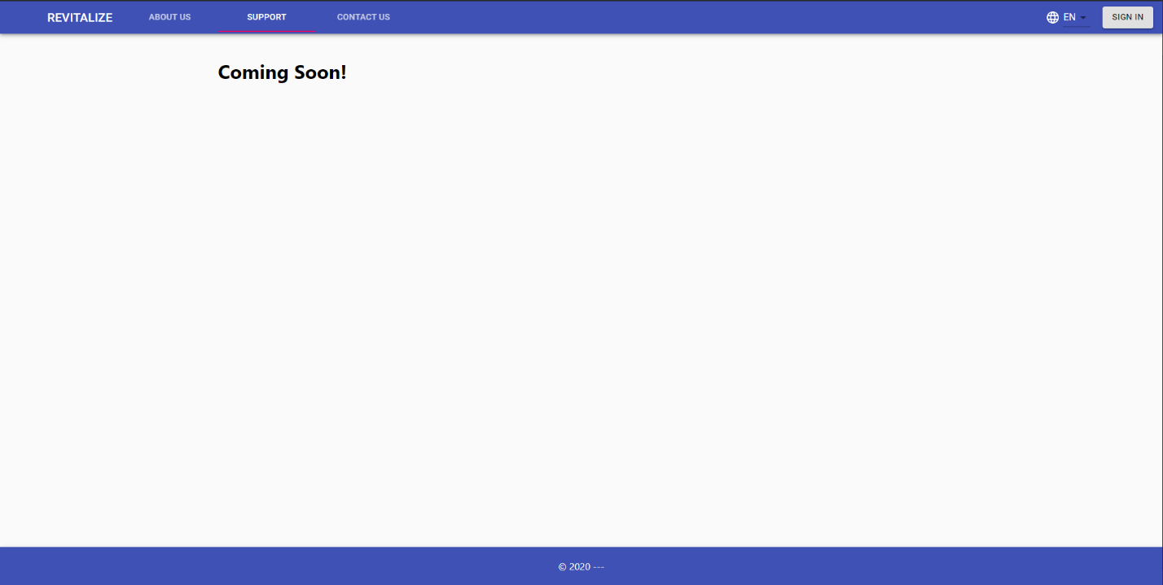

**The Contact Us page**

The Contact Us tab in the header will navigate you to the Contact Us page which will posses the information to call or attain customer support help.

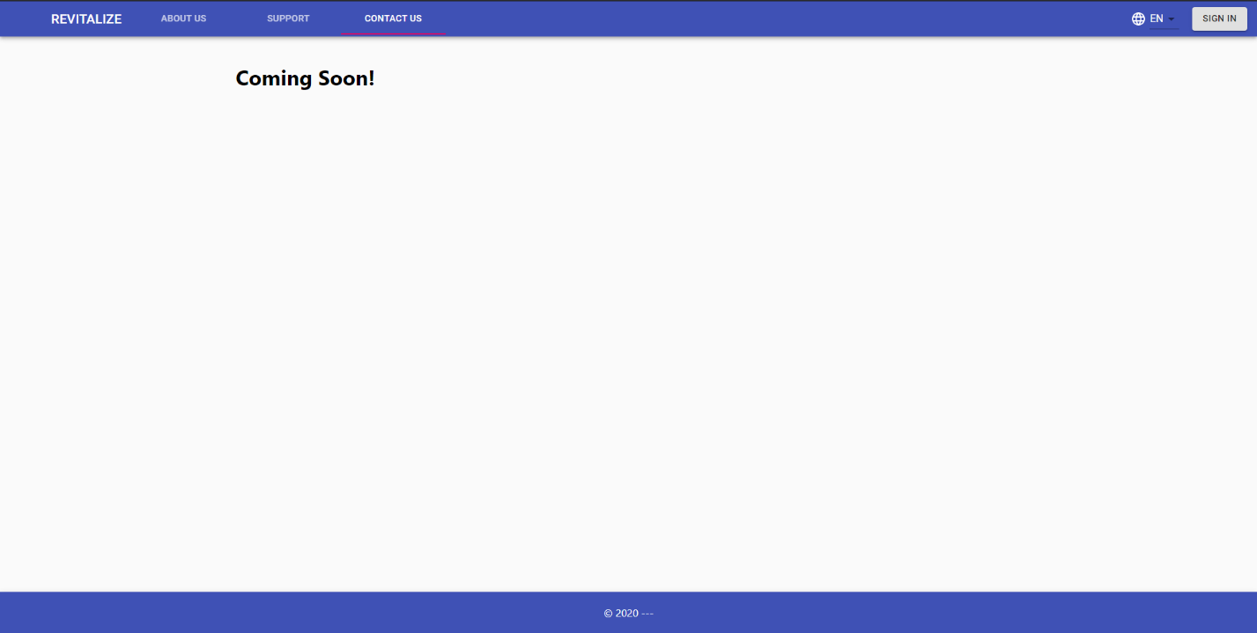

**The Language Selector (Changing the language)**

If English is not your default language, there is a drop down with a language globe icon at the top right corner of the webpage which will assist you with changing your language between the ones that are available.

**Language Selector**

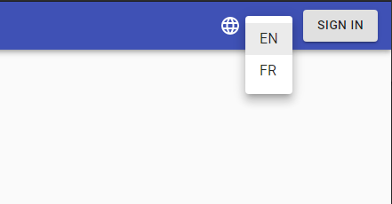

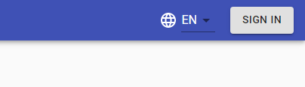

**Signing into your account**

If you already have an account, you will be able to log into your account using the “SIGN IN” button to the top right of your screen.

**Sign in Button**

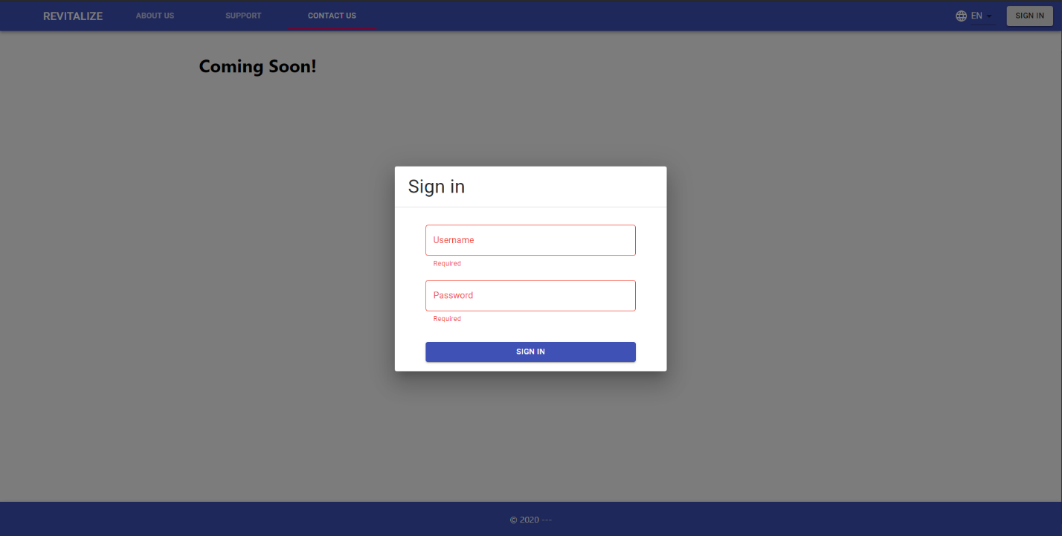It will bring up a popup which will require you to enter in your username and your password and will highlight in red if data is not present in these important fields.

If you input the wrong information into the username and the password when you sign in, you will be met with a notification at the top of the screen stating that you have input in the wrong information.

After you have logged into your account and you wish to log outof the account, you will be able to do so by heading to the top right part of the screen and clicking on the log out link that is present right beside the profile login name. The profile 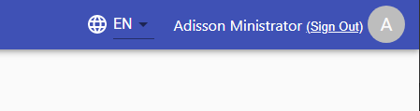name along with the avatar icon will be visible once the user is logged in.

**Sign Out Link**

**Accessing the Sidebar**

The side panel is only visible and accessible to users who are logged in to their account. It looks like 3 horizontal lines and is placed besides the REVITALIZE

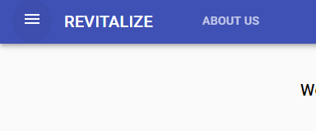name plate at the top left of the page.

**Sidebar**

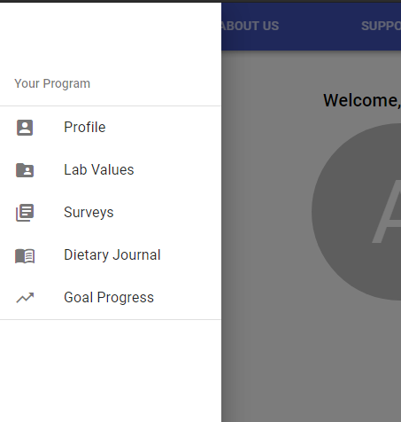In there you will be able to access the “Your Program” view which contains the Profile, Lab Values, Surveys, Dietary Journal and Goal Progress.

**Accessing the Profile Screen**

When you are logged into the system, you will be able to view the Profile page of your account. There you will find your name in the top right corner of the screen with a “sign out” link and Icon. At the centre container of the page you will see your profile icon, your name and your profile information screen which has a drop down to be able to view more information. Below the information panel, you will have a view of your ‘Summary of Lab Values’ and ‘Summary of Surveys’ both of which have links called “see more” which will take you to their main Survey and Lab Value Pages.

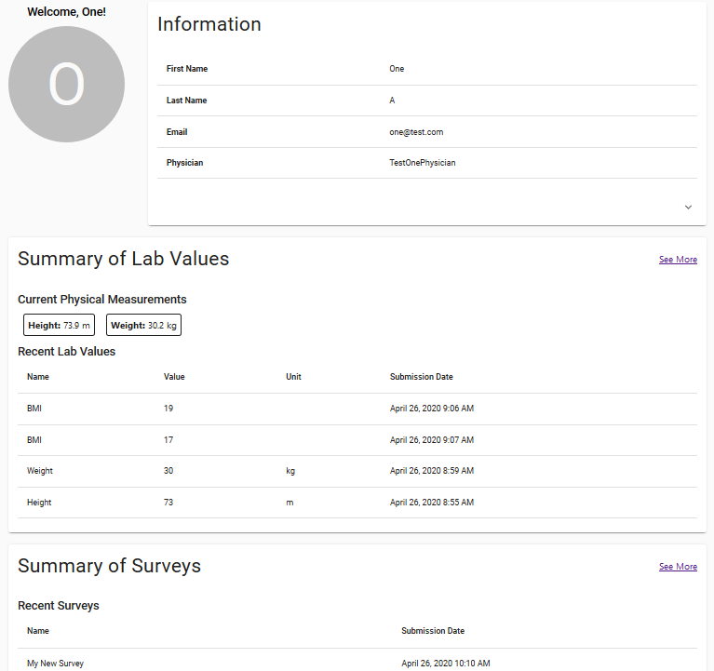

**Accessing the Survey Page**

There are two ways to access the Survey Page, both of which will require you to be logged into your User account to be able to view. You can access the Survey Page by clicking on the “see more” link in the profile page and you can also access the survey page by accessing the side panel to view Your Program and clicking on the Surveys link that is visible. On the Survey page, you will be presented with 2 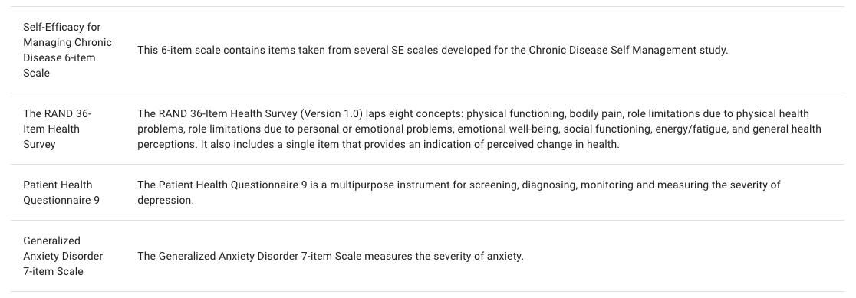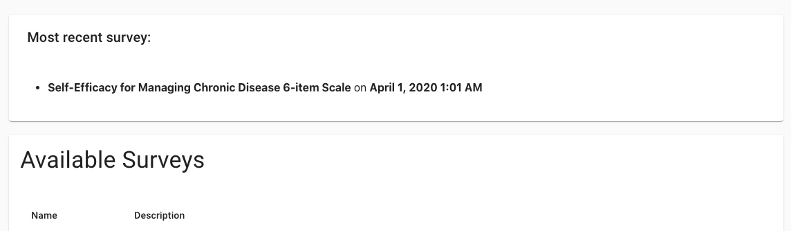tables, one named “Available Surveys” and the other named “Survey History”.

On the “Available Surveys” table, you will be able to see the surveys that are currently available and awaiting your completion. You will also be able to see the “Do Survey” button, this is selectable only after you have selected a survey which you wish to do. The survey will be displayed for you to complete on the screen. When you are done, you will be able to submit the survey, then it will be added to your recent surveys.

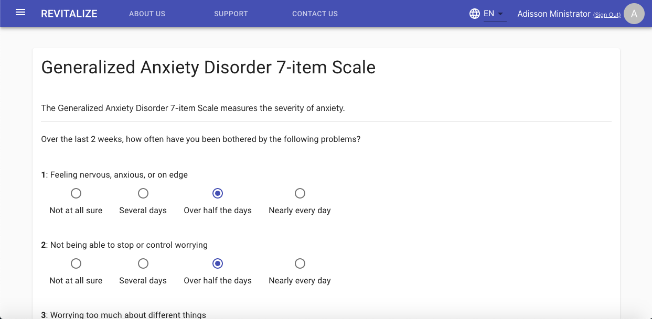

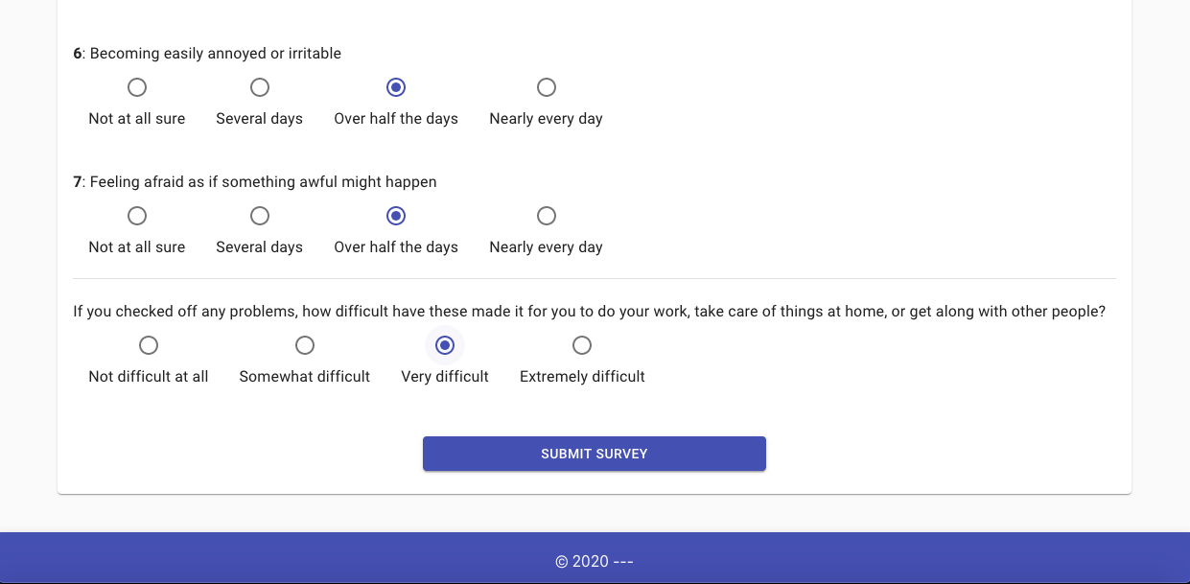

Below the “Available Surveys” table, you will see your “Survey History” table which will you show the surveys that you have completed in the past, but will only show you 5 per page and can be scrolled through at the bottom right of the table.

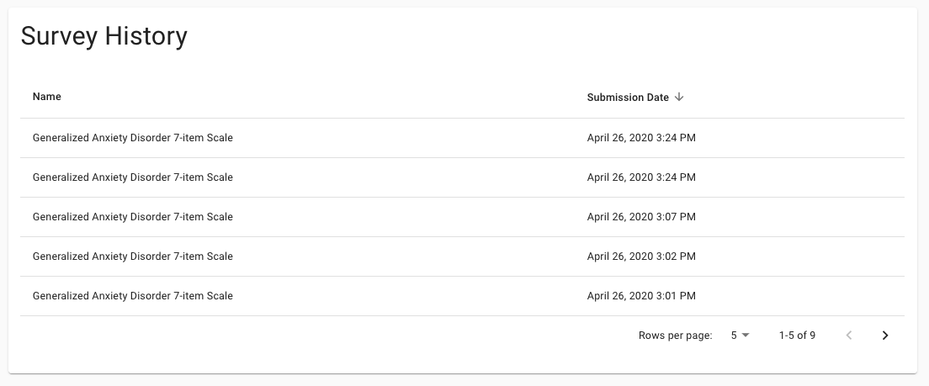

**Accessing the Lab Value page**

There are two ways to access the Lab Value page, both of which will require you to be logged into your User account to be able to view. You can access the Lab Value page by clicking on the “see more” link in the Lab Values table in the Profile page. You can also access the Lab Value Page by heading to the side panel to view Your Program and clicking on the Lab Values link that is visible. On the Lab Value page, you will be able to see your Lab Value History which will show you your recent lab value numbers and statistics, in the form of a graph.

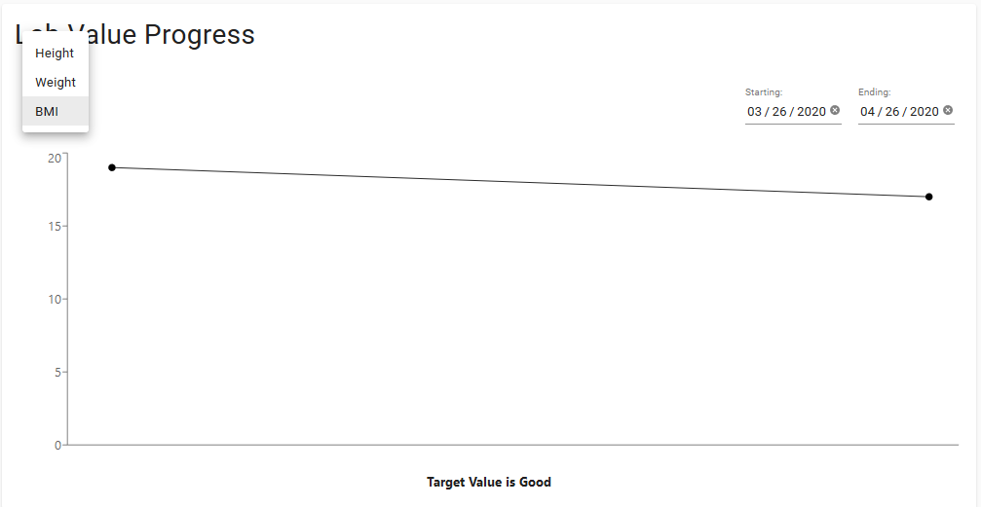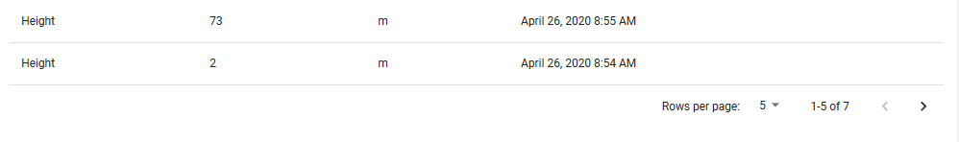

**Accessing the Dietary Journal page**

To access the dietary journal page, you will need to be logged into your user account on the system, after you have done this, the side panel button will be visible to you.

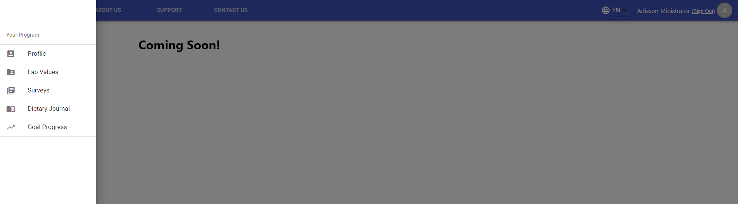From there you can then navigate your way to the Dietary journal page, as shown in the photo below.

**Accessing the Goals Progress page**

To access the Goals Progress page, you will need to be logged into your user account on the system, after you have done this, the side panel button will be visible to you.

From there you can then navigate your way to the Goal Progress page, as shown in the photo below.