Bài 1:

Step 1: Create a network

$ docker network create wordpress-network

Step 2: Create a volume for MariaDB persistence and create a MariaDB container

$ docker volume create --name mariadb_data

$ docker run -d --name mariadb \

--env ALLOW_EMPTY_PASSWORD=yes \

--env MARIADB_USER=bn_wordpress \

--env MARIADB_PASSWORD=bitnami \

--env MARIADB_DATABASE=bitnami_wordpress \

--network wordpress-network \

--volume mariadb_data:/bitnami/mariadb \

bitnami/mariadb:latest

$ docker volume create --name wordpress_data

$ docker run -d --name wordpress \

-p 8080:8080 -p 8443:8443 \

--env ALLOW_EMPTY_PASSWORD=yes \

--env WORDPRESS_DATABASE_USER=bn_wordpress \

--env WORDPRESS_DATABASE_PASSWORD=bitnami \

--env WORDPRESS_DATABASE_NAME=bitnami_wordpress \

--network wordpress-network \

--volume wordpress_data:/bitnami/wordpress \

bitnami/wordpress:latest

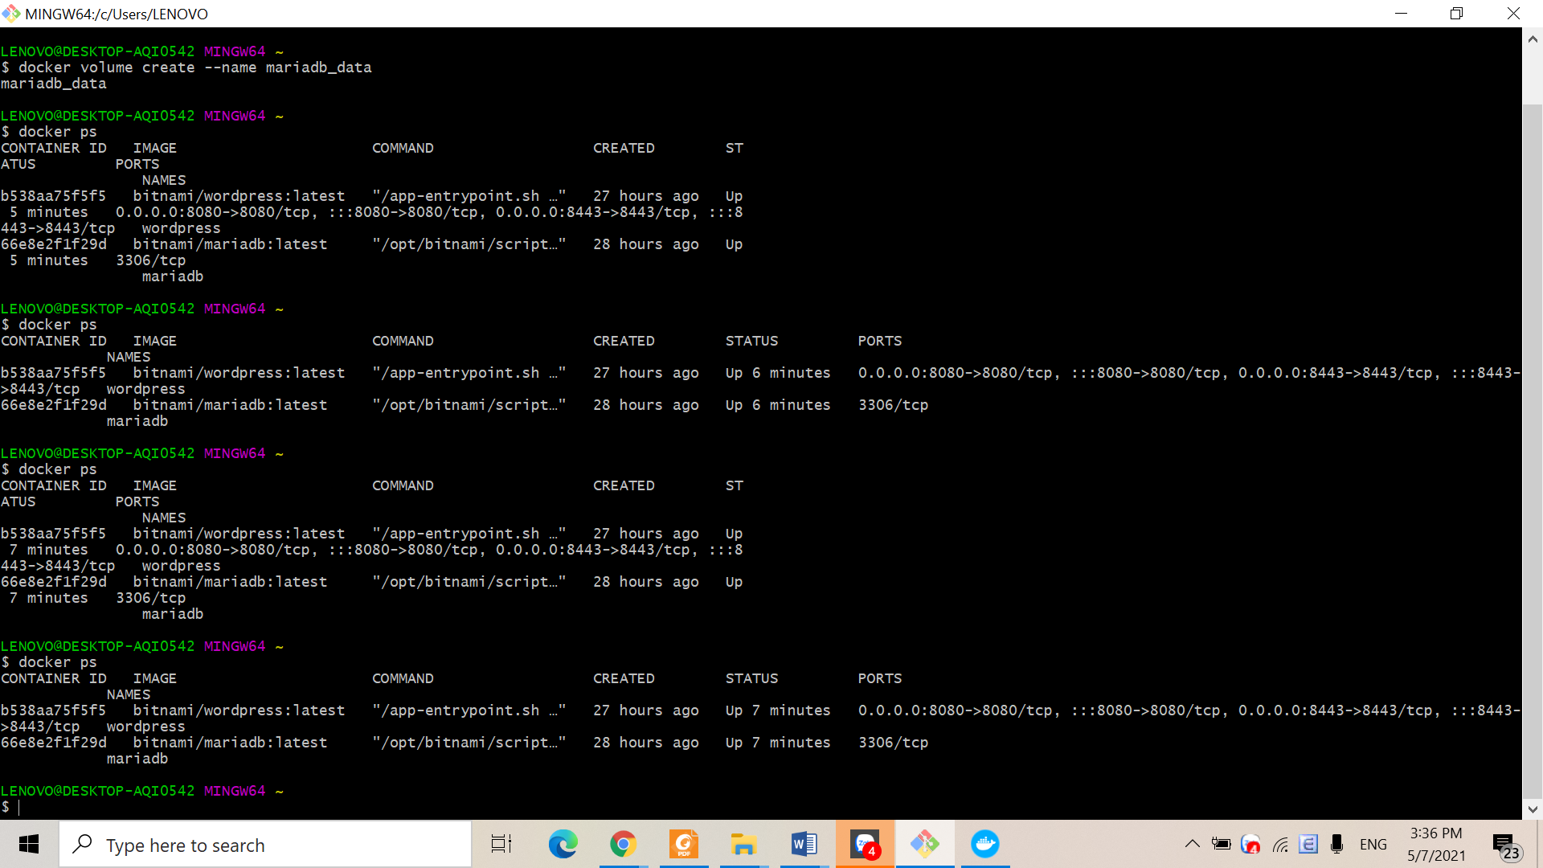

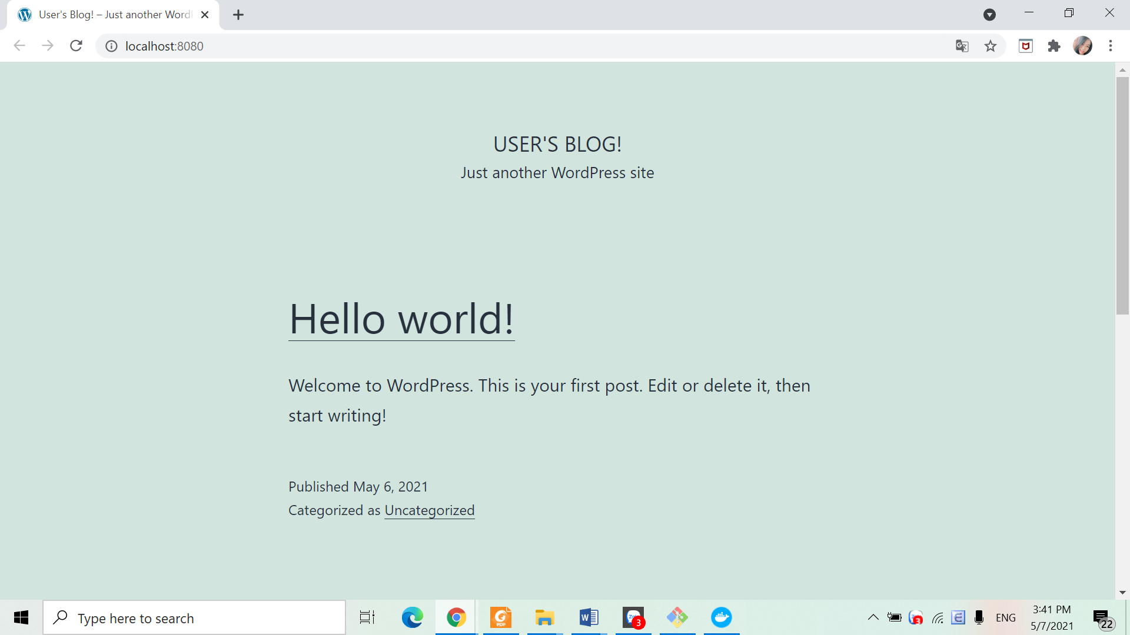

Bài 2:

$ curl -sSL https://raw.githubusercontent.com/bitnami/bitnami-docker-wordpress/master/docker-compose.yml > docker-compose.yml

$ docker-compose up -d

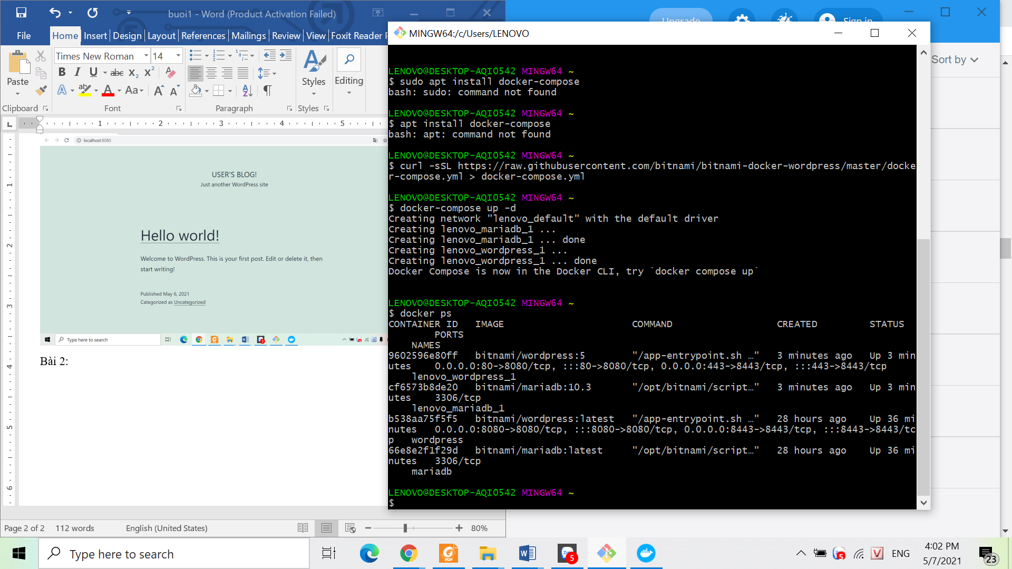 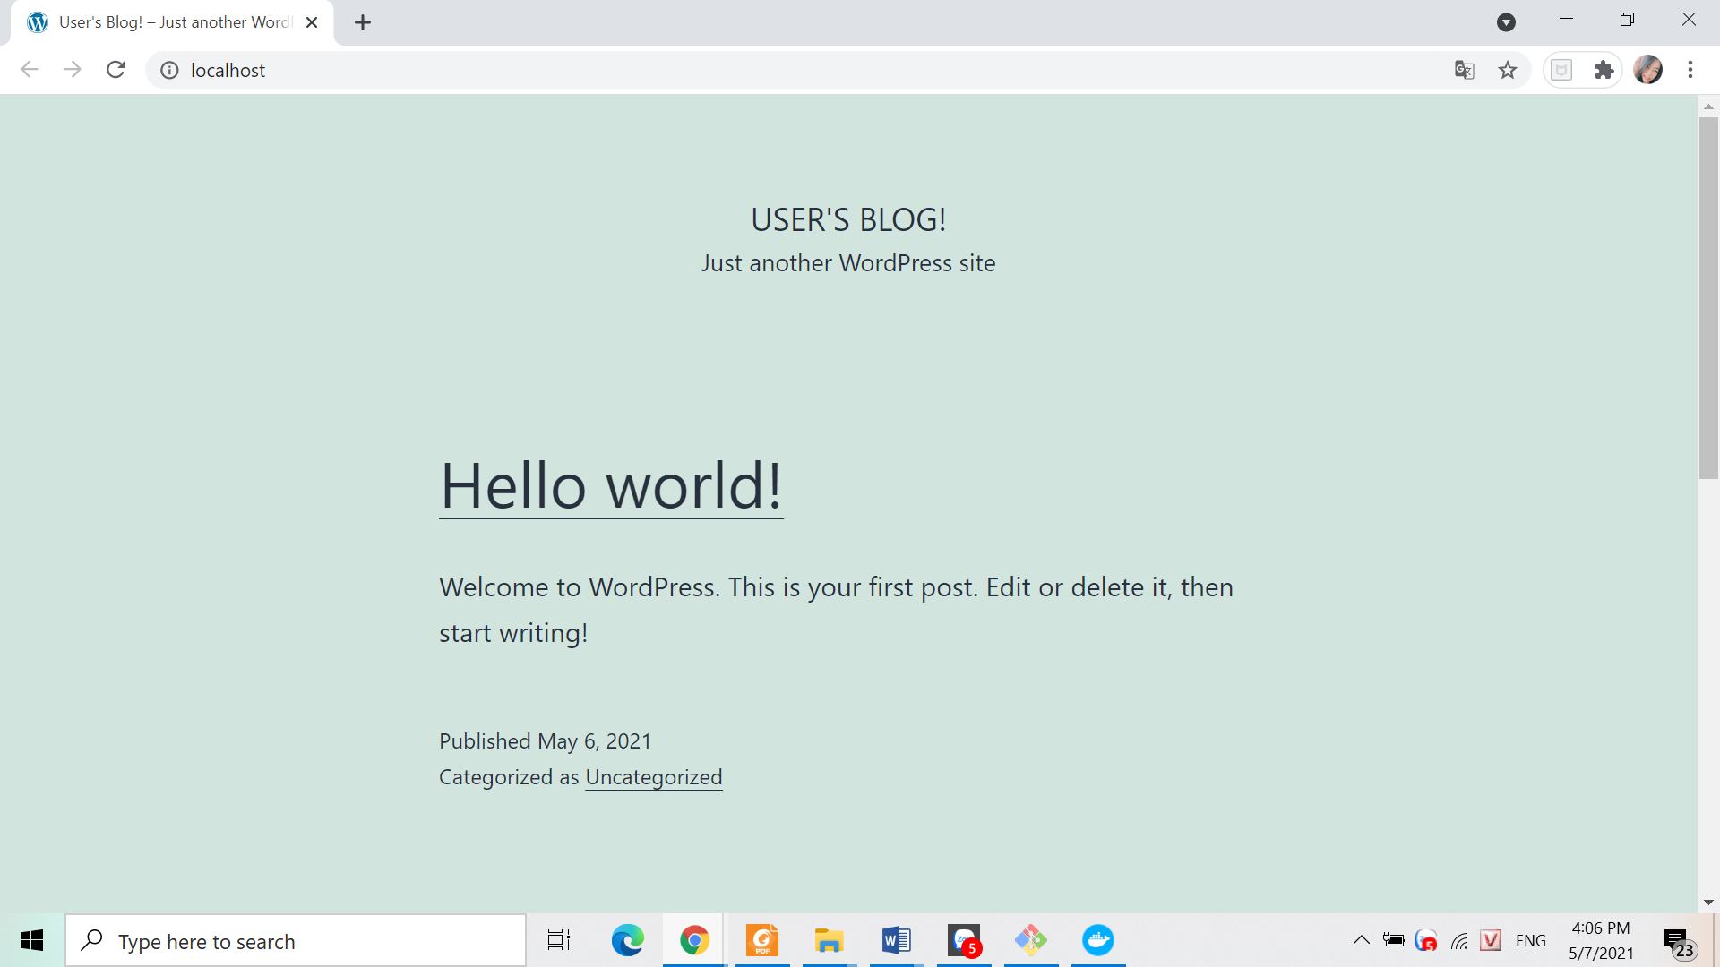

Bài 3: