LMX Cloud
Primer & 12-Month Build Map
Directionally informed by the Heurist Mesh case study · July 2026

Executive Summary
LMX Cloud is Web3-native infrastructure for the autonomous agent economy — not a general AI-infra company, and not a crypto-for-humans product. The wedge: autonomous agents and DAOs structurally can't use hyperscaler billing (no legal entity, no corporate card), so they need infrastructure that's wallet-native and payable per call in stablecoin. Public framing: “AWS for Web3.”
Routing decentralized compute, x402 payment rails, and discovery/directory presence are all commodities already owned by others (DePIN networks, Coinbase's CDP, Bazaar/Agentic Market respectively). What isn't commoditized — and what LMX has actually built — is cryptographic proof of delivery: Merkle-anchored, independently verifiable receipts that a call was fulfilled as specified. LMX's real identity is the settlement-and-proof layer of the agent economy, not a directory and not a payment-rail innovator.
This document lines up where LMX stands today against Heurist — a live, revenue-generating comparable operating in the same x402/agent-marketplace space — and lays out the next 12 months: closing Phase 1, building Phase 2 (resource breadth + a third-party function marketplace), and standing up LMX.Agent as an open framework layer. Target at the 12-month mark: $5K–$10K MRR.

Where LMX Cloud Is Today
Shipped and verified end-to-end:
- Multi-provider inference router — io.net, Akash, Aethir, and Nosana, with health-aware fallback and 30+ model aliases.
- Wallet-native identity — SIWE sign-in, agent-mintable keys from a raw keypair (no email required), USDC funding on Base.
- Verifiable on-chain logs — per-request receipts, Merkle-batch anchoring on Base, a public proof API and CLI.
- x402 per-call payments — verified end-to-end on Base mainnet, dual-path (prepaid balance or pay-per-call).
- MCP server — seven tools, published to the official MCP registry, x402-payable.
- ElizaOS plugin — published to npm, registry PR open and addressed, awaiting maintainer re-review.
Not yet cleared: attorney review of legal drafts (the single highest-leverage open item — zero engineering, longest deferred), and the actual Phase 1 success metric — a real, unprompted x402 payment from a wallet LMX has never seen before.

Case Study Parallel: Heurist
Heurist is a decentralized AI compute network (13,000+ GPU miners) that layers Heurist Mesh — a marketplace of 30+ specialized crypto-intelligence agents, individually priced and callable via x402 — on top of that supply. Roughly $1.4M 2025 revenue on an 11–13 person team, after a $2M seed (Nov 2024) and about two years of partnership-driven distribution. Its real product isn't the agents themselves — it's function-level decomposition: a single underlying agent unbundled into several independently priced, independently discoverable routes, so any consuming agent pays only for the exact capability it needs.
Why it matters here: Heurist validates — with real, external revenue — a thesis LMX had already reasoned to independently (Phase 2 Goal 2, decided 2026-07-11): a wallet-verified provider registers a function with a price and schema, any compatible agent discovers and calls it, payment and delivery proof settle automatically. The marketplace idea isn't new because of Heurist; Heurist is evidence the model is sound, not the source of the idea.
Where LMX diverges deliberately: Heurist behaves like a curated agent catalog (thirty agents Heurist itself built and maintains); LMX is positioning as neutral infrastructure other people's agents transact through — registration is open to any wallet-verified party, including third parties and other agents, not just LMX-authored functions.

Product & Infrastructure Map
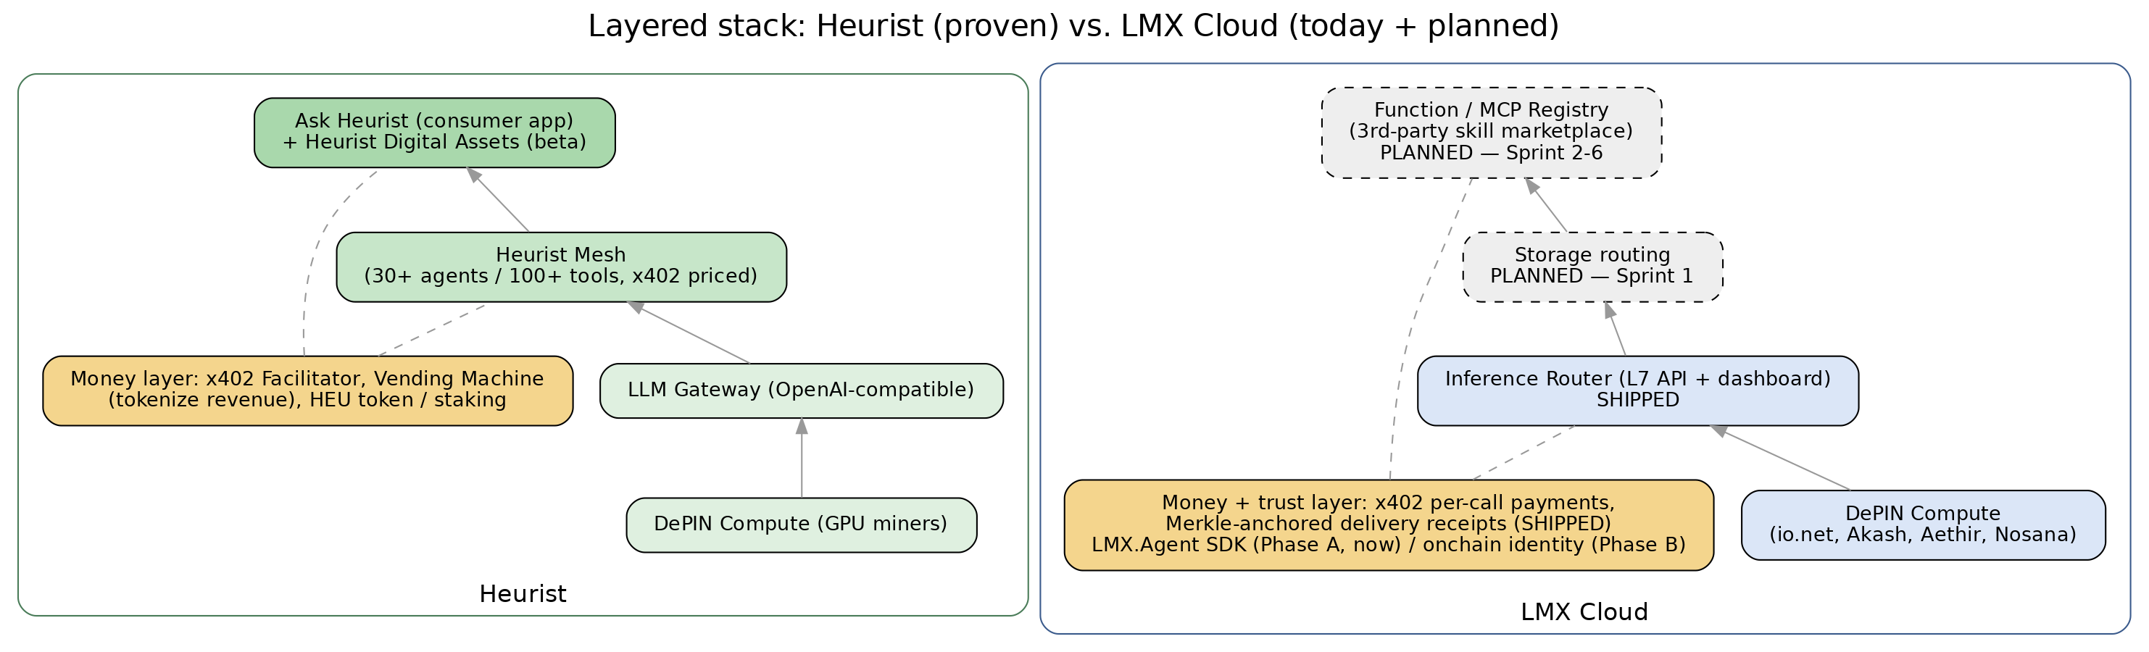
Layered stack comparison — solid fill = shipped/proven, dashed = planned.
LMX's stack mirrors Heurist's shape — compute supply at the base, an API/routing layer above it, a marketplace layer above that — but the money-and-trust layer is where the two diverge most: Heurist monetizes primarily through pay-per-call pricing and a token; LMX's differentiator is the receipt/proof layer sitting alongside payments, which nothing in Heurist's stack has an equivalent of.

Monetization Paths
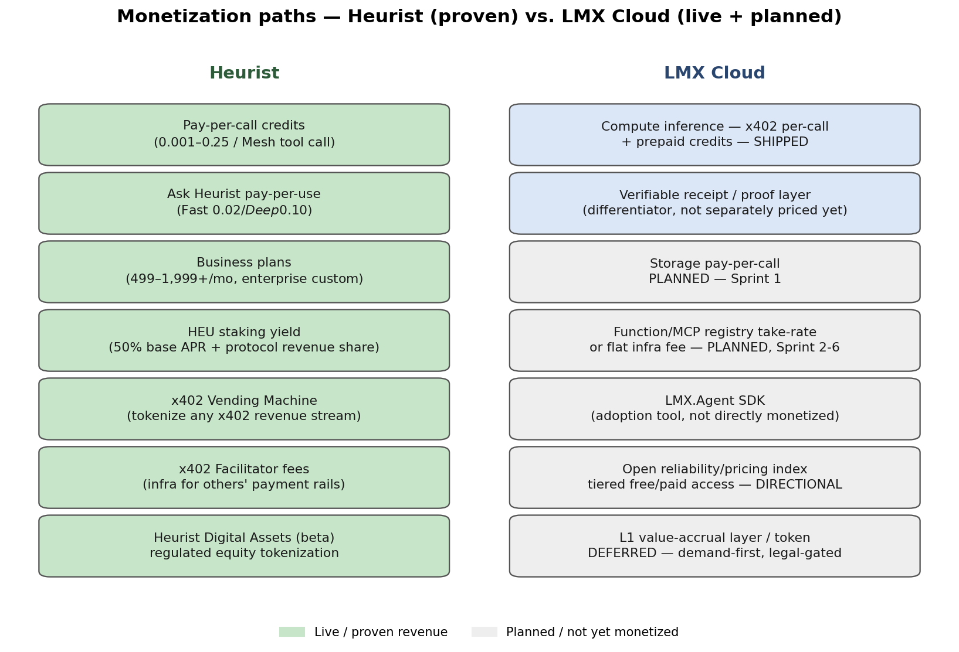
Live (proven) vs. planned revenue lines, LMX mapped against Heurist's actual mix.
Heurist's revenue is already diversified across five real lines (credits, consumer pay-per-use, business plans, staking yield, and revenue-stream tokenization via the Vending Machine). LMX today has exactly one live revenue line — compute inference — and Phase 2 is what adds the next two: storage, and a take-rate or flat fee on third-party marketplace functions. LMX.Agent is deliberately not a revenue line itself — it's an adoption tool, the same role Heurist's own open-source Agent Framework plays for them.

12-Month Build Map
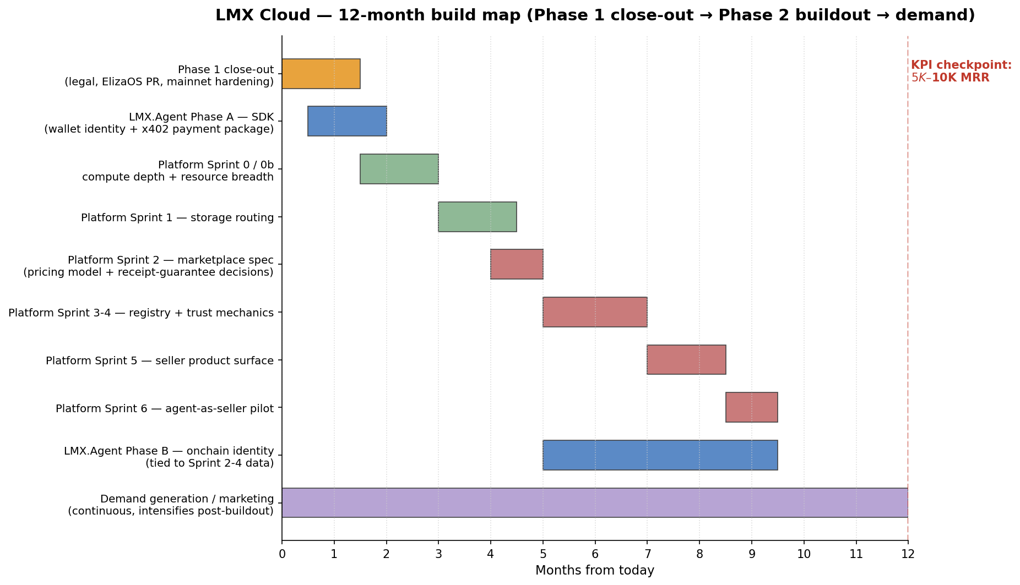
Phase 1 close-out → Phase 2 platform sprints → LMX.Agent phases → KPI checkpoint.

Phase 1 close-out — remaining gates
Gate | Status | Why it matters
Attorney review of legal drafts | In progress — deferred 3x previously; longest-standing, cheapest gate | Blocks responsibly marketing all three Phase 1 channels at once
ElizaOS registry PR (#16397) | Waiting on maintainer re-review + CI approvals — nothing left on LMX's side | Last of the three Phase 1 distribution channels
ElizaOS live-agent end-to-end test | Not started | Only remaining real engineering on Goal 3
x402 mainnet burst/load validation | Proven on Sepolia only | Adversarial validation before real traffic scales
Payment-failure reconciliation | Partial — no refund/credit-back when a provider fails after balance deduct | Trust risk on a stranger's very first paid interaction

Net read: legal is the fastest to clear and the longest deferred — the single highest-leverage action available today, and not an engineering task.

Phase 2 — platform sprints, in order
- Sprint 0 — compute reliability depth. Provider redundancy on the resource already sold. Nosana and Aethir adapters already shipped opportunistically during the pause.
- Sprint 0b — resource-type breadth. Vision and web search shipped; embeddings (deAPI/BGE M3) and image generation queued.
- Sprint 1 — storage routing. Filecoin/Arweave adapter, same x402-plus-receipt pattern already proven on compute.
- Sprint 2 — marketplace definition (scoping only). Resolves the two open questions that actually determine whether the 12-month revenue target is realistic: pricing model (take-rate vs. flat fee) and the third-party receipt-guarantee question.
- Sprint 3 — MCP registry foundations. Manifest schema, wallet-signed self-registration, synthetic test-call gate.
- Sprint 4 — trust mechanics. Refundable USDC bond and slashing in place of human review; delisting/dispute flow.
- Sprint 5 — seller product surface. Listing dashboard, in-MCP discovery, health monitoring on listed functions.
- Sprint 6 — agent-as-seller pilot. One real agent-authored function listed and transacted end-to-end — proof of the thesis, not a volume milestone.

LMX.Agent — phased, parallel track
Phase A (now, doesn't wait on the Phase 2 gate): a thin, framework-agnostic open package generalizing two things already built and proven — the agent-mintable wallet pattern from Web3-1, and the hardened x402 payment client already written for the ElizaOS plugin (spend caps, challenge validation, chain allowlisting, timeouts). Deliberately not a full agent runtime — building a competitor to ElizaOS/LangChain/Google ADK would pull LMX into a crowded space with no connection to its actual moat.
Phase B (gated with Phase 2 Sprint 2–4): onchain identity/reputation for agents, ERC-8004-style — the same “reputation/trust-scoring” line already named and deferred in the roadmap, revisited once the registry has real multi-resource transaction volume to make the data meaningful.

12-month KPI targets
Checkpoint | Transaction volume | Revenue | Social / marketplace traction
Phase 1 unpause trigger | 1 unprompted payment, wallet LMX has never seen | Not meaningful yet | Not meaningful yet — plumbing proof point
Early Phase 2 (~3 mo. after unpause) | 5–20 distinct paying wallets/week; low hundreds of x402 calls/mo. | $50–$500/mo. | 1–3 third-party functions listed; small real community
End of Phase 2 (~12 mo. target) | Low hundreds of distinct paying wallets/week; tens–low hundreds of thousands of calls/mo. | $5K–$10K MRR | Double-digit active third-party listings in the registry

Calibrated against Heurist (bigger team, two extra years — so this is deliberately a fraction of their trajectory, not parity) and against CDP Bazaar's network-wide volume (~$50M cumulative across 480K+ agents — a single new, narrow listing takes a sliver of that long tail, not a proportional share). Treat these as planning targets to falsify quickly, not a forecast.

Immediate Next Steps
- Get the legal drafts in front of an attorney — today, zero engineering, unblocks marketing all three Phase 1 channels.
- Ship the payment-failure reconciliation fix — the one live correctness gap that could damage a stranger's first paid interaction.
- Start LMX.Agent Phase A — the SDK, in parallel, since it's explicitly ungated.
- Hold Phase 2 platform sprints behind the two real gates: attorney review clears, and one real unprompted stranger payment lands.
- When Phase 2 buildout is declared “done,” verify that means the open questions (pricing model, receipt guarantee) are actually resolved — not just that six sprints are checked off — before shifting fully into marketing mode.

