LMX ECOSYSTEM PRIMER
Resources, Tools, Agent Framework, and Demo Agents — One Stack, Explained
July 27, 2026

Overview
LMX Cloud's agent ecosystem is one coherent four-layer stack, not four separate initiatives. Each layer is built on the one beneath it, and each layer is also how that lower layer gets monetized. The goal of this primer is to make that stack legible in one place: what each layer is, what it's for, how they compound into each other, and what's deliberately not being built yet.
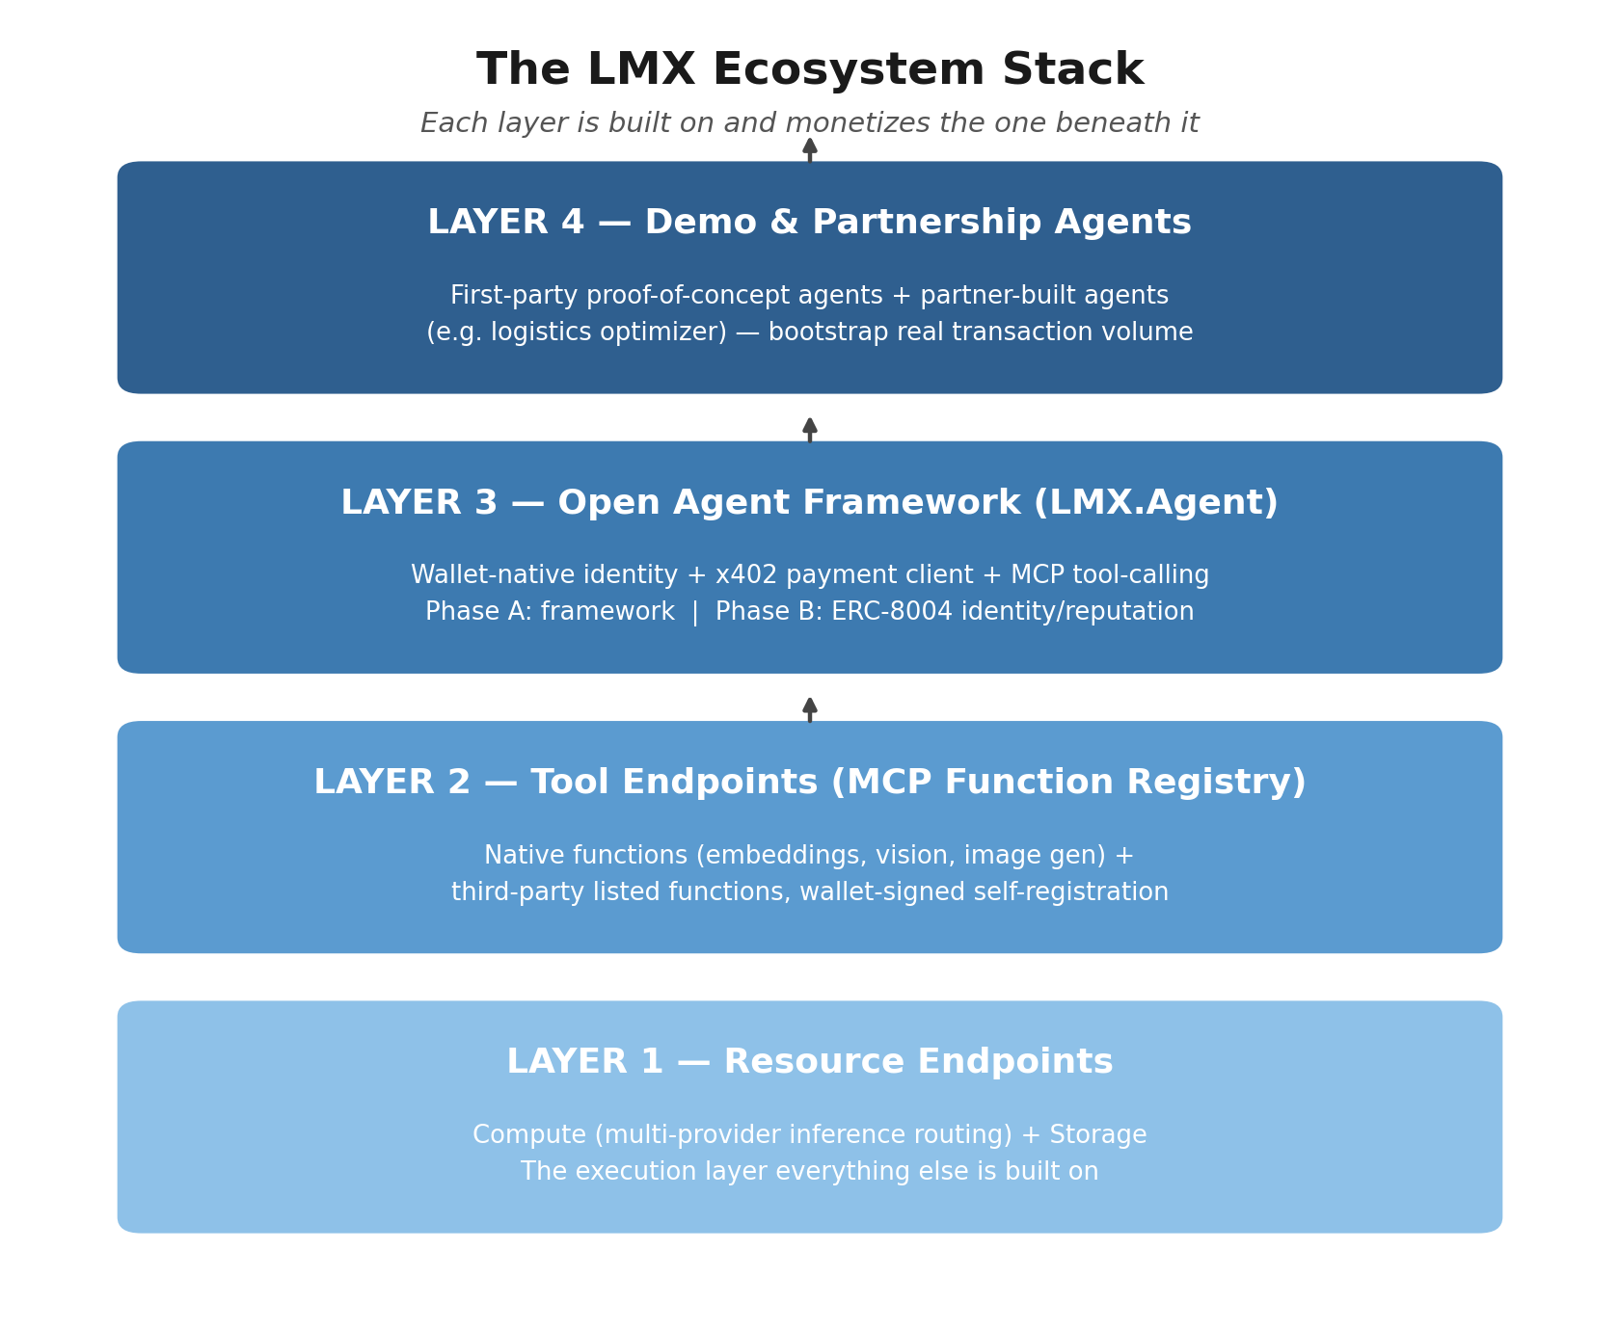
Figure 1 — The four-layer stack. Higher layers are built on, and drive usage of, the layers below them.

Layer 1 — Resource Endpoints
The execution layer: multi-provider compute routing (inference across io.net, Akash, and additional networks as they're added) today, with storage routing (Filecoin/Arweave) planned next. This is the existing core product — the thing LMX already sells, already prices per call via x402, and already has real settled transactions against on Base.
Every other layer exists to drive more volume through this one, or to make this layer's routing claims verifiable to a stranger who has never transacted with LMX before.

Layer 2 — Tool Endpoints (the MCP Function Registry)
A registry of callable functions exposed over MCP: LMX-native tools (embeddings, vision, image generation) alongside third-party-authored functions. Listing is wallet-signed and self-serve — no human review — gated only by a mechanical synthetic test call at registration and a refundable USDC bond, slashed on verified bad behavior.
The defining idea here, and the thing that differentiates this from every comparable product surveyed (CDP Bazaar, x402bazaar.org, RelAI): a listed seller doesn't have to be a company. An agent that's good at a task can list its own function and sell it to other agents — agents as first-class citizens, not just buyers.

Layer 3 — Open Agent Framework (LMX.Agent)
An open framework a developer uses to build their own agent, wallet-identified and payment-ready from line one — no signup, no API key request, no human in the loop. It generalizes three things LMX already built for its own product into a standalone tool:
- Wallet identity — reusing the existing SIWE / raw-keypair mint flow, so an agent can self-mint a session with just a private key.
- Payment client — the hardened x402 logic already shipped (spend caps, challenge validation, Permit2 scoped to canonical Base USDC, timeouts) becomes the framework's core payment module, not a one-off plugin.
- MCP-native tool calling — the agent speaks MCP generically, so LMX's own registry is one of many servers it can call, not a proprietary walled tool catalog.
It ships in two phases. Phase A is the lightweight framework itself — demand-generation, doesn't wait on any gate, can start now. Phase B adds an onchain identity/reputation layer (ERC-8004-style), fed by receipts LMX already generates (Merkle-anchored delivery receipts from Web3-2) — reputation for close to free, because the proof-of-delivery infrastructure already exists. Phase B stays behind the Phase 2 gate (attorney review clears, plus a real unprompted stranger payment).

Layer 4 — Demo & Partnership Agents
Agents built on LMX's own stack, calling LMX's own resource and tool endpoints, that exist to solve the marketplace's cold-start problem: no developer lists into an empty registry, and no developer builds an agent to call a registry with no sellers in it. Two forms:
- First-party demo agents — reference implementations LMX builds itself, scoped explicitly as proof-of-concept and marketing content, never given exclusive tools or pricing a third party couldn't also get.
- Partnership agents — the stronger form. Example: a consultant building a logistics optimizer, built as an agent on LMX's stack and listed on the registry. This is a genuine third party using the framework, not LMX competing with the ecosystem it's recruiting — and because logistics optimization is a recurring operational tool, it generates real, repeat, unprompted transaction volume, which is the exact signal Phase 1 already treats as the definition of done.
The open risk to manage deliberately: if a first-party agent quietly becomes the platform's best-earning product, that's a signal the third-party ecosystem thesis isn't working — not a win to lean into.

How It Compounds — The Registry Liquidity Flywheel
Not every part of this stack compounds. Framework downloads and provider count are additive — useful, but linear. The one loop that is genuinely exponential is registry liquidity backed by real reputation: a real transaction produces a verified receipt, the receipt strengthens an agent's onchain reputation, stronger reputation makes that agent worth transacting with unprompted, which pulls in the next buyer or seller who wouldn't otherwise have bothered — and that new participant generates more transactions.
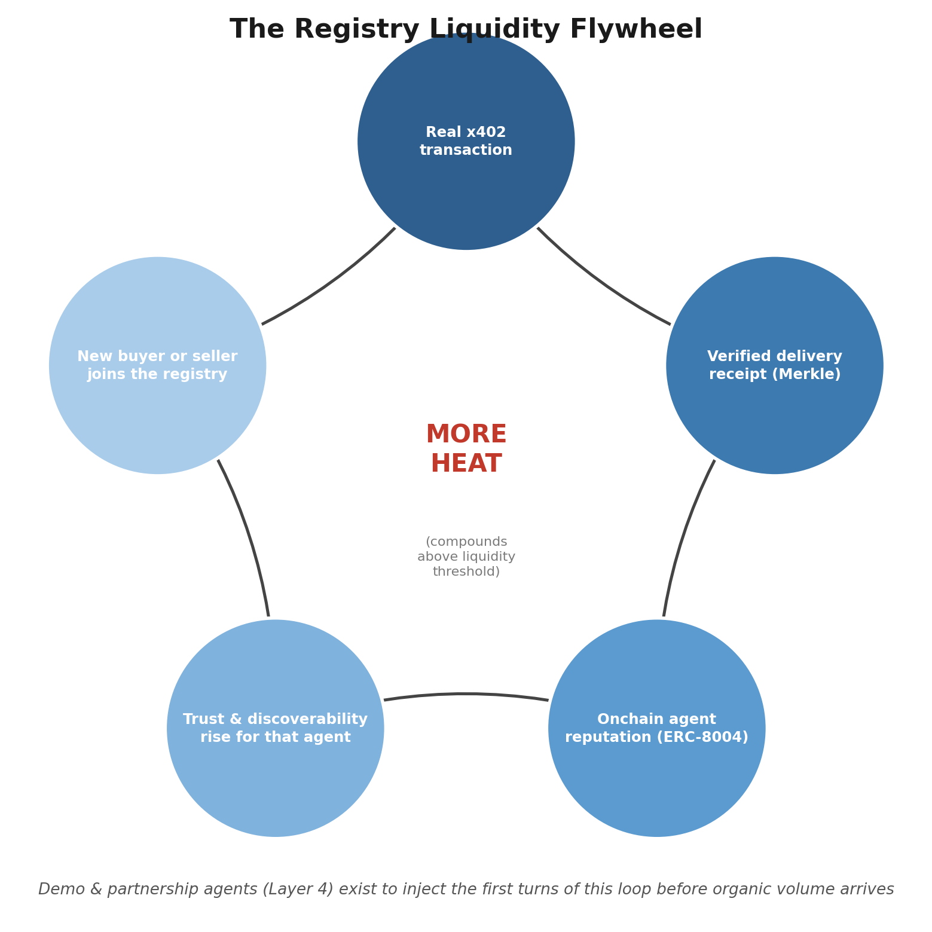
Figure 2 — The liquidity flywheel. Below a threshold of real activity, this behaves like linear effort; above it, participation starts pulling itself in.
Layer 4 agents exist specifically to inject the first turns of this loop before organic third-party volume shows up. The open item this raises, still unresolved: what specific number marks 'past cold start' — some minimum count of distinct wallets transacting weekly, not a vibe.

Monetization by Layer
Layer | What generates revenue | Status
1 — Resource endpoints | Per-call inference/storage spread (existing router margin) | Live
2 — Tool endpoints (registry) | Take-rate vs. flat infra fee on third-party function calls | Open question — unresolved
3 — Agent framework | Not monetized directly — framework is free; it funnels spend into Layers 1-2 by default | Design in progress
4 — Demo/partnership agents | Real transaction volume + receipts that make Layer 2/3 reputation credible | Bootstrap mechanism, not a revenue line itself
The framework itself (Layer 3) is not a revenue line — it has to be free to compete with ElizaOS and Heurist on distribution. The real monetization question is whether a swappable default (an agent can point its model/tool calls anywhere) is enough, or whether reputation lock-in (Layer 3 Phase B) is the actual moat, since an agent that routes around LMX to save a fraction of a cent loses its accumulating trust history to do it.

Deliberately Deferred — Data Permissioning
A fifth layer has been discussed but is explicitly not being scoped yet: permissioned, owned, monetizable data sitting underneath an agent (e.g., a client's own logistics data). The instinct is directionally right — but it's the same problem AWS didn't solve until 13 years after launch (Data Exchange), specifically because trust/billing/identity had to be fully proven first and because no working anti-redistribution model exists once a buyer has paid for one query.
It's also a structurally different primitive than anything in Layer 2 today: a normal registry listing is public (any payer can call it), while data permissioning is a private, revocable grant to a specific requester — an access-control system, not a schema field. Named here so it isn't lost, and deliberately held until Layers 1-4 have proven the simpler thesis first.

Open Questions on the Table
- What number defines 'past cold start' for the registry liquidity flywheel?
- Revenue model at Layer 2: take-rate on transactions vs. a flat infra fee?
- Which demo-agent candidate ships first — and is it chosen for product merit or for receipt-generating call volume?
- How is the self-competition risk (Layer 4 agents out-earning third parties) actually monitored, not just named?
- For data permissioning: is 'the data' the client's own input, or value the agent generates from running — since these have different ownership answers?

