Examples from LWIR-IQA and TIIQAD datasets

Examples from the LWIR-IQA and TIIGAD datasets are given in this file. Each image shows two quality scores: the first value corresponds to the subjective score (MOS) collected from human observers, and the second value corresponds to the objective score predicted by NestConvNeXt-IQA. Higher scores indicate better image quality.

1) LWIR-IQA dataset

Image | 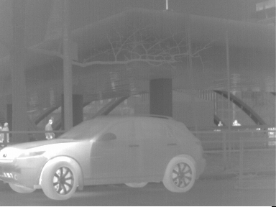 | 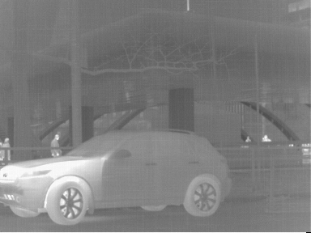 | 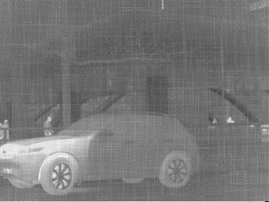
Name | IMG_09_NU (1).bmp | IMG_09_NU (2).bmp | IMG_09_NU (4).bmp
MOS | 4.645 | 4.516 | 2.226
NestConvNeXt | 4.691 | 4.435 | 2.344

Image | 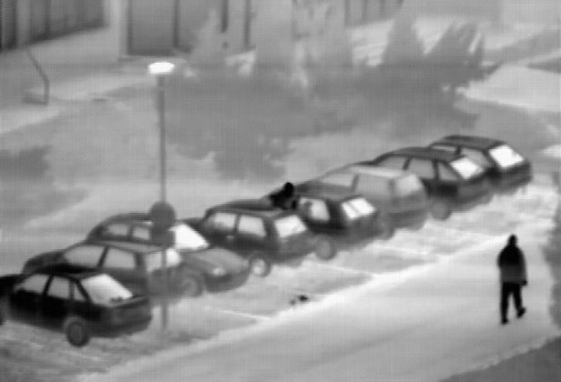 | 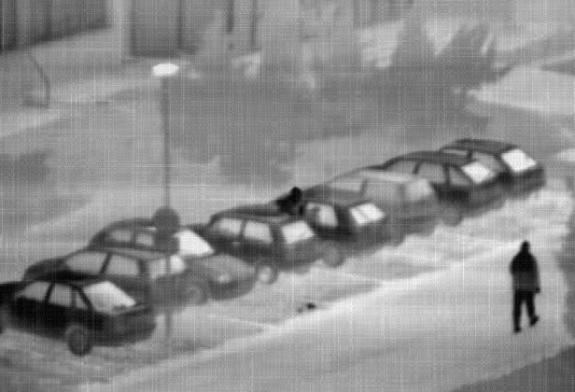 | 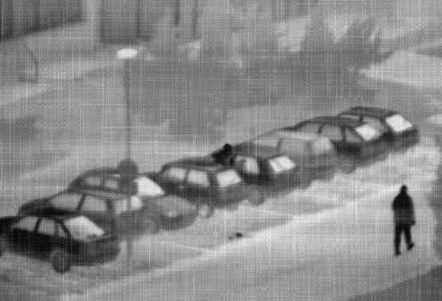
Name | IMG_20_NU (1).bmp | IMG_20_NU (3).bmp | IMG_20_NU (4).bmp
MOS | 3.742 | 2.613 | 2.129
NestConvNeXt | 3.749 | 2.681 | 2.162

Image | 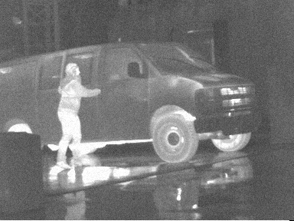 | 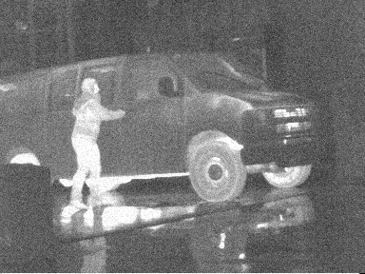 | 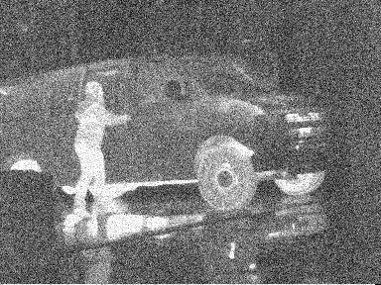
Name | IMG_12_AWGN (1).bmp | IMG_12_AWGN (2).bmp | IMG_12_AWGN (5).bmp
MOS | 4.677 | 4.484 | 2.290
NestConvNeXt | 4.442 | 4.416 | 2.618

Image | 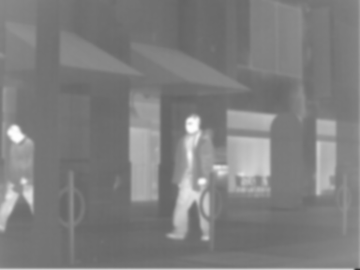 | 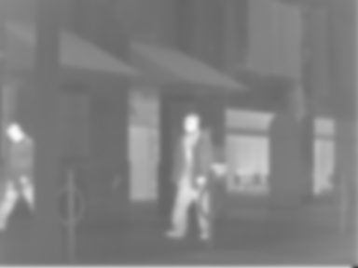
Name | IMG_10_BLU (2).bmp | IMG_10_BLU (4).bmp
MOS | 4.226 | 2.871
NestConvNeXt | 4.376 | 2.708

Image | 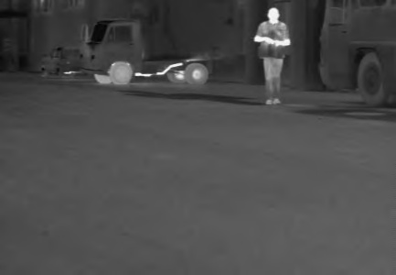 | 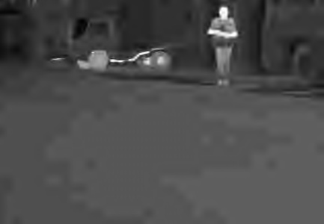
Name | IMG_07_J2K (1).bmp | IMG_07_J2K (5).bmp
MOS | 4.194 | 1.548
NestConvNeXt | 4.205 | 1.635

Image | 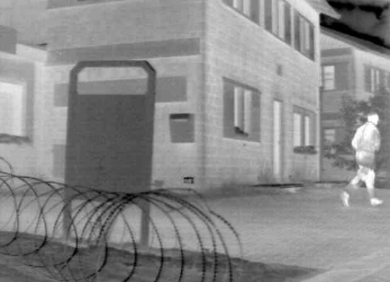 | 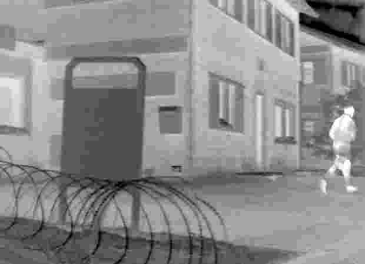
Name | IMG_18_JPG (1).bmp | IMG_18_JPG (4).bmp
MOS | 3.161 | 1.419
NestConvNeXt | 3.223 | 1.658

2) TIIQAD dataset

Image | 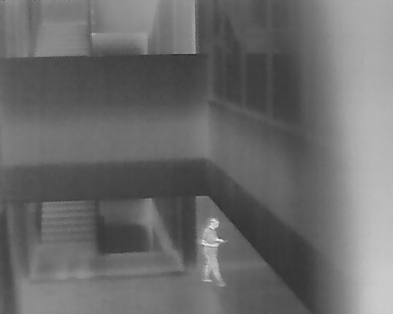 | 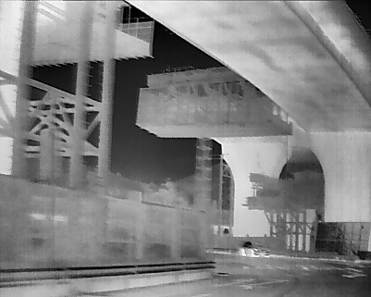 | 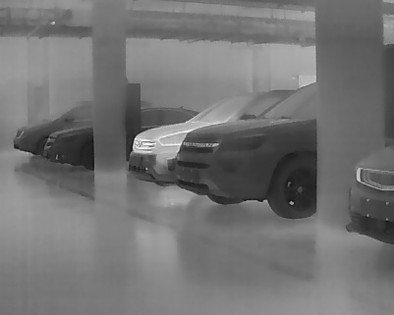
Name | 138.jpg | 1508.jpg | 952.jpg
MOS | 2.637 | 2.837 | 2.947
NestConvNeXt | 2.677 | 2.923 | 2.913

Image | 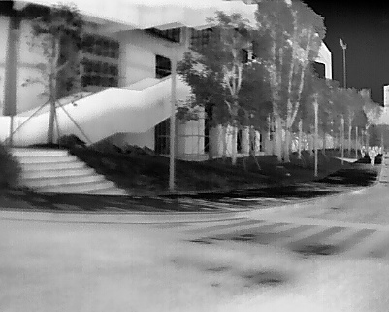 | 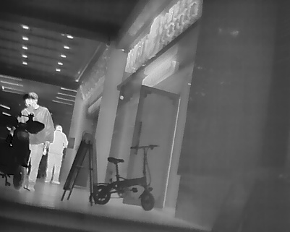 | 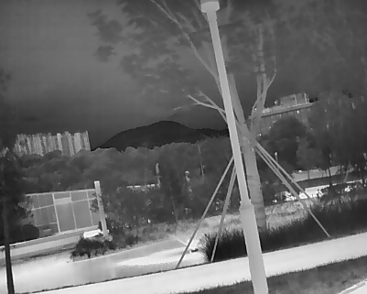
Name | 1445.jpg | 1022.jpg | 1002.jpg
MOS | 3.034 | 3.094 | 3.102
NestConvNeXt | 3.005 | 3.064 | 3.098

Image | 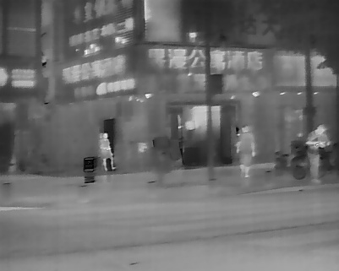 | 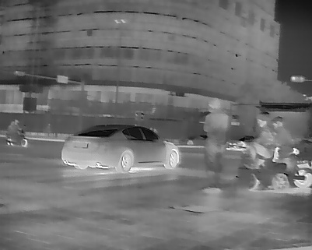 | 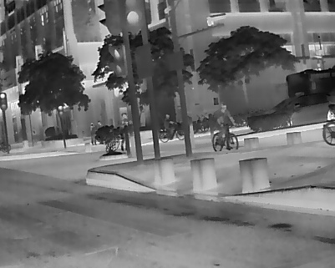
Name | 248.jpg | 253.jpg | 413.jpg
MOS | 2.516 | 2.898 | 3.449
NestConvNeXt | 2.614 | 2.876 | 3.254

Image | 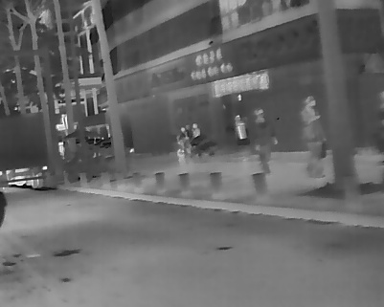 | 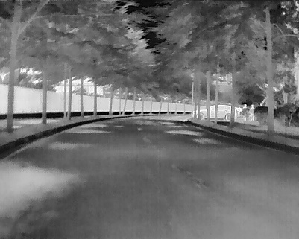 | 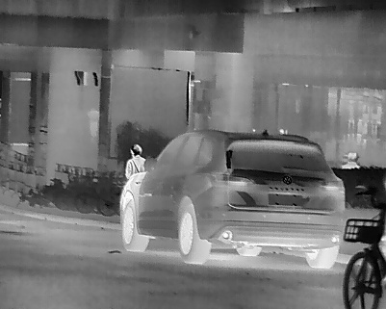
Name | 450.jpg | 2248.jpg | 1039.jpg
MOS | 2.514 | 3.034 | 3.111
NestConvNeXt | 2.750 | 2.942 | 3.053

Image | 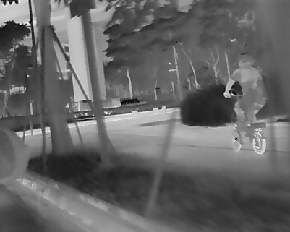 | 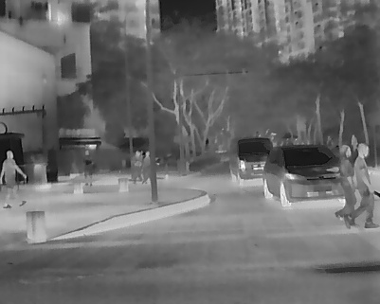 | 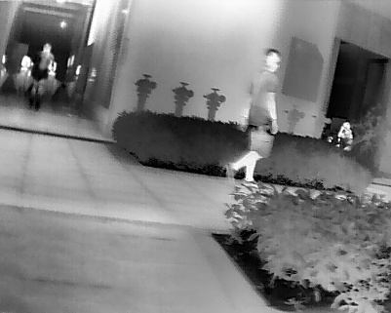
Name | 421.jpg | 224.jpg | 2289.jpg
MOS | 2.766 | 2.903 | 3.034
NestConvNeXt | 2.768 | 2.800 | 2.948

