**Photovoltaic Power Matching**

**Leander Merbecks**

*Find this project on* [*Github*](Github)

# Abstract

# Introduction

In this document optimization of a photovoltaic (PV) system will be performed. The motivation for the project is that while PV power systems have become readily available lately [CITATION NEEDED] their power output is strictly bounded to the irradiance of the individual panels and modules. This leads to a power production characteristic that is not constant but varies over time. The characteristics shape over time depends heavily on the orientation of the PV panel as well as other secondary factors like shadows, weather and temperature [CITATION NEEDED]. Similar to the unsteady characteristic of the PV power system the power demand characteristic of residential homes is also non stationary. There is, however, little influence one can take on the shape of the demand characteristic of residential homes.

The similarity between the power production and power demand characteristics coupled with the possibility of changing one of the characteristics shape motivates the search for an optimal PV system with regards to power matching. I.e. the system whose power production characteristic matches the most with the power demand characteristic. From this point it is also possible to extend into more sophisticated optimizations by valuing the produced energy and also incorporating the possibility of power storage.

In the resulting optimization problem the main decision variables are the orientation of the PV panels that make up the PV power system. In this context orientation means both the tilt of the panel against the horizontal plane as well as the azimuth of the panel in the horizontal plane. The angles at the panel are illustrated in Figure 1.

N

S

W

x

y

x

z

Figure 1: Tilt and azimuth of a PV panel

# Modeling

To match the power characteristics of a PV power system to a power demand curve we first need to define a model that can compute these power characteristics based on driving design variables.

For modeling the supply system we can follow the path of the power from the sun to the individual PV panel to a battery and then into the system. The demand system is modeled after real world data.

The system is modeled for the fall equinox of 2024 at 22nd of September 2024. The model can be extended and adapted to other dates but the equinox was chosen to keep computational demands low and obtain results that are closest to what is expected over a year.

The systems location on earth is also an important parameter. As the demand system data is based on real data the (approximate) location of the demand system that created this data is used as system location. The location coordinates are given in Table 1.

Table 1: System location information

|  |  |
| --- | --- |
| Variable | Value |
| Identifier | Essen, Germany |
| Latitude |  |
| Longitude |  |
| Elevation |  |

# Sun Model

For the sun model we create vectors that point to the suns position in the sky from the system location. The instantaneous elevation and azimuth of the sun can be used to create the normal vector for the solar rays. The angles are shown in Figure 2.

S

N

E

W

x

z

y

Figure 2: Angles for the sun normal

Because the coordinate frame was defined with x pointing north, y pointing west, and z making the frame a right hand frame the

The normal vector is defined by:

The elevation and azimuth of the sun are time dependent and thus this model requires ephemeris data of the sun for all investigated times relative to a position on earth.

Astropy [1] [2] [3] is a python library that makes high precision ephemeris data available in python programs. Using this library the sun azimuth and elevation at any time can be determined. The resulting paths for the fall equinox of 2024 are shown in Figure 3.

Ein Bild, das Text, Reihe, Diagramm, Zahl enthält.

Figure 3: Azimuth and elevation at September equinox of 2024

# PV Panel

To build a model for a PV power system the influence of orientation on the power production needs to be understood. A simplified model that is claimed to be sufficient for the purposes of this document is to model the power production in dependance of the maximum power of a panel under direct sunlight and the angle of incidence between the panels (front) normal and the incoming sun light [CITATION NEEDED]. Under these assumptions the power production can be calculated using the following equation:

To calculate the angle of incidence between the incoming solar light rays and the normal of the front panel surface two vectors are defined. One for the solar light rays direction and one for the surface normal. Both vectors are normalized to length one. Figure 2 shows the two vectors and their interaction to form the angle of incidence.



Figure 4: Normal vector and solar light ray vector.

The coordinate frame for all further vectors in this document will be a east north up frame centered around the location of the PV power system. Note that the azimuth is reversed for this frame as the mathematical positive direction is from north to west but the azimuth is measured from north to east. The figure moreover illustrates that the azimuth and tilt of the panel can be used to define its normal vector in 3D space. The definition follows this equation:

Having defined the relevant normal vectors the angle between the vectors, that is the angle of incidence for the panel, can be calculated using 3D algebra:

Here the operator denotes the dot product. We can omit the denominator of the equation as the normal vectors have a length of one per definition.

# PV System Model

Now the power for each panel is defined and the power of the entire PV system can be described as the sum of all individual panels in that system.

The first part of the model is done. We now need to find ways to get the azimuth and elevation of the sun at a given location on earth and a specific time. We will use a library for this.

# Load

For the model we still need the power demand characteristic of a residential home. Data for this project was provided by Andreas Merbecks which can be seen in Figure 4. The data was recorded using a power surveillance system in a residential house in Essen, Germany. We will therefore use this location for determining the sun position.

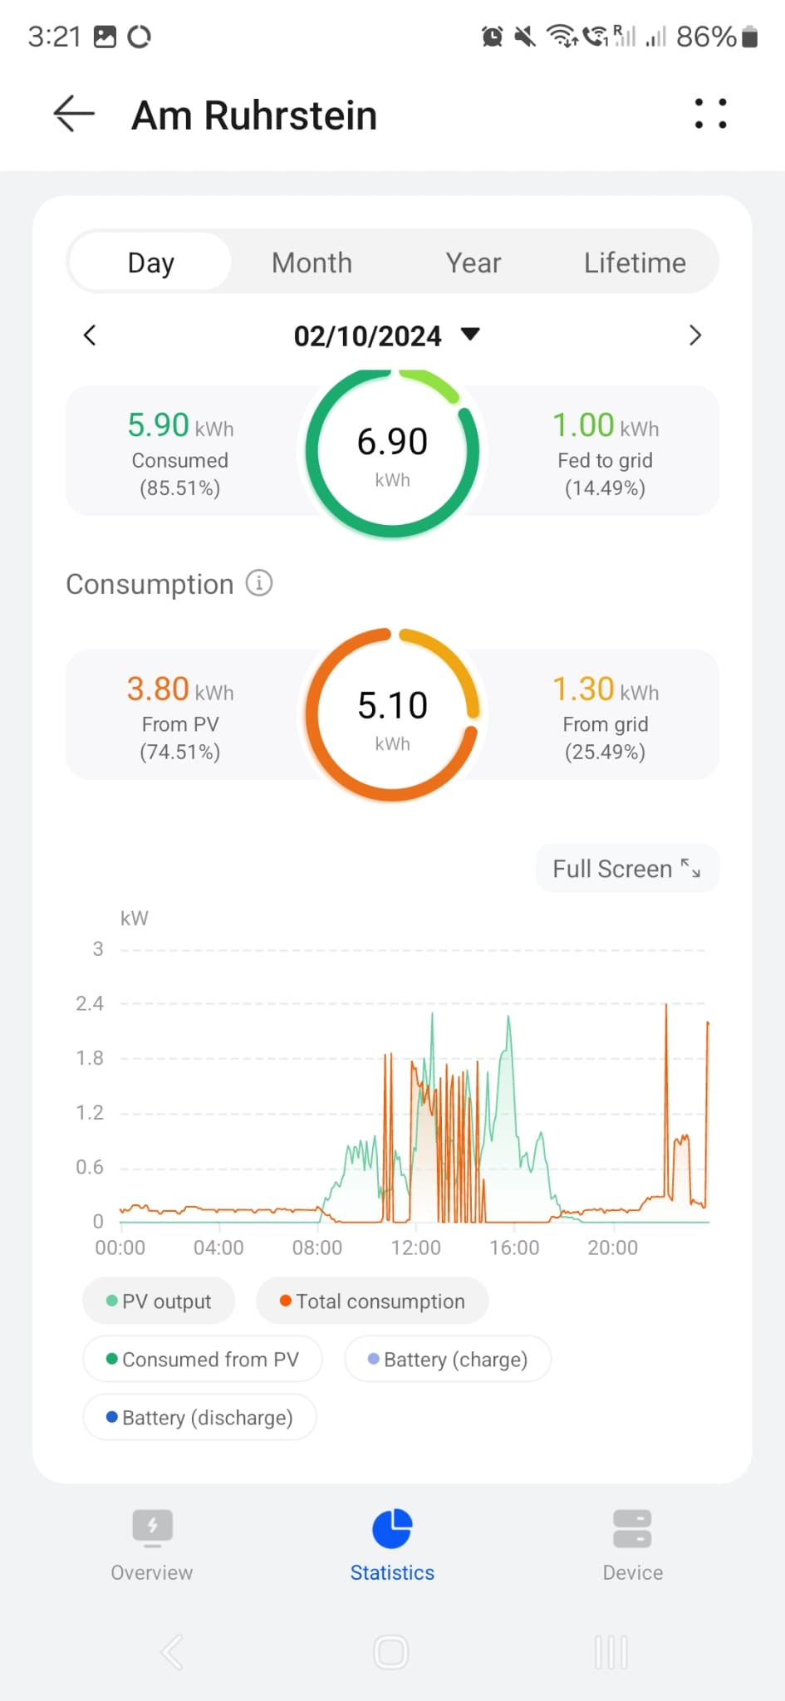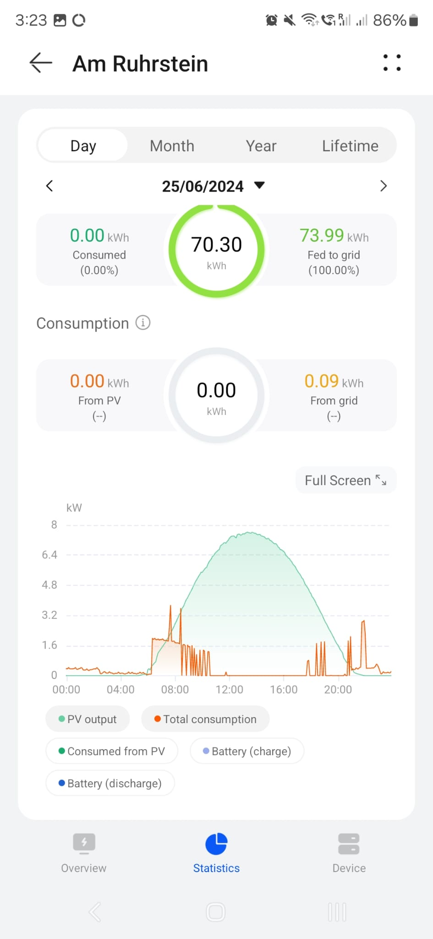

Figure 5: Reference data for the power demand characteristics of a residential home.Source: Andreas Merbecks

There are two different characteristics available and the mean of all the characteristics will be used for this project. For this the data is first digitalized using [WEBPLOTDIGITIZER]. Subsequently the for each time of day the maximum of the two characteristics is taken to generate a worst case power demand characteristic. The resulting power demand characteristic of this residential home can be seen in Figure 5

Ein Bild, das Text, Diagramm, Reihe, Screenshot enthält.

Figure 6: Worst case power demand characteristic.

To best match the power production characteristic to the demand of power we use the mean absolute percentage error as a measure. We can then optimize all of this

# Optimization

# Objective function

# Optimization algorithm

# Results

Stuff I recovered from clipboard:

-        If the combined power is  the PVS supplies too little power to cover demands and the battery should be drained, if enough charge is present. Because the battery power cannot be directly formulated we first define a potential power :

Ein Bild, das Schrift, Screenshot, Grafiken, Text enthält.

A discharge increment is defined next:



Now another condition has to be evaluated:

o   If the battery charge in the previous time step  we may drain the battery and the battery power is:



The battery charge can also be updated:



o   Otherwise the battery power is set to zero and the charge is not changed:

  




the PVS supplies more power than needed and the battery can be charged.

  


Ein Bild, das Text, Reihe, Diagramm, Zahl enthält.
Ein Bild, das Text, Reihe, Diagramm, Zahl enthält.

Ein Bild, das Text, Reihe, Diagramm, Zahl enthält.

Ein Bild, das Schrift, Typografie, Text, Grafiken enthält.



Ein Bild, das Text, Reihe, Diagramm, Zahl enthält.

* 1. **Battery**





Ein Bild, das Text, Diagramm, Reihe, Zahl enthält.

Things we cann add:

* Better power demand as a mean of a lot of dates.
* Optimization for the entire year not only one day
* Change of objective into a cost function or value function e.g.
  + The retail price of electricity is much lower than the „import“ price. This could be turned into a measure for „wins“ i.e. if the solar power is not enough we buy the excess. If the power matches we do not sell. If we produce to much power we sell the excess. Does this represent the value of the power match? Not really as a power match means we do not gain anything... grrrrr
  + Net present value maybe also including cost for batteries
* Addition of batteries that can shift the power curve a bit. But this should be penalized as batteries are very expensive.