What product that makes us the most money (qty*price) (1)

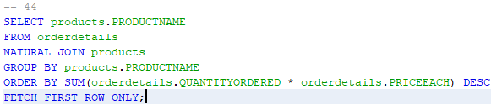

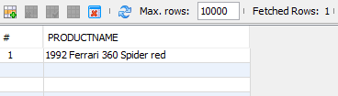

List the product lines and vendors for product lines **which** are supported by < 5 vendors (3)

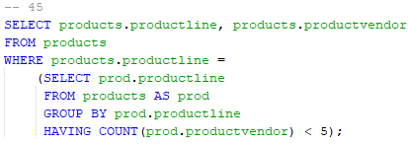

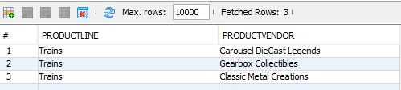

List the products in the product line with the most number of products (38)

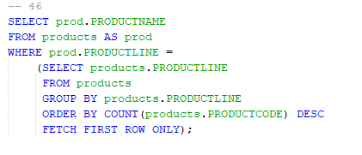

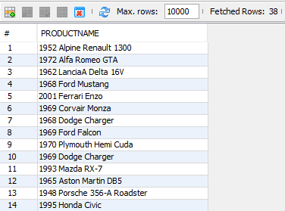

Find the first name and last name of all customer contacts whose customer is located in the same state as the San Francisco office. (11)

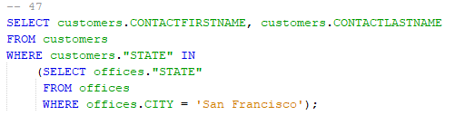

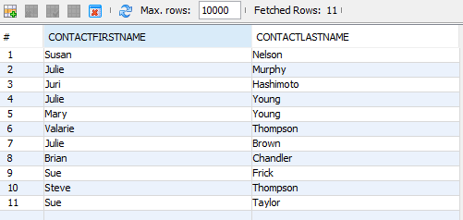

What is the customer and sales person of the highest priced order? (1)

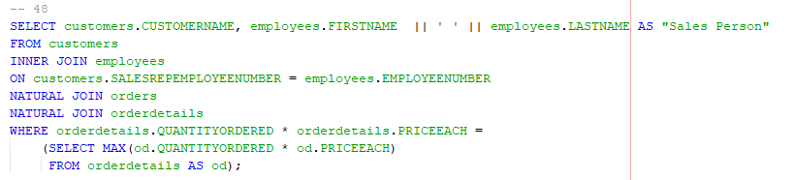

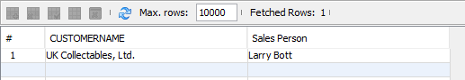

What is the order number and the cost of the order for the most expensive orders? Note that there could be more than one order which all happen to add up to the same cost, and that same cost could be the highest cost among all orders. (1)

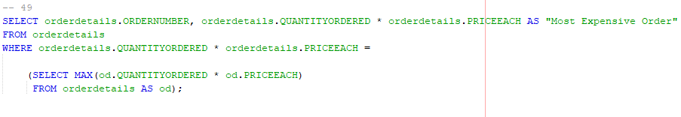

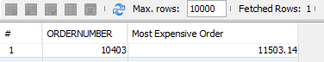

What is the name of the customer, the order number, and the total cost of the most expensive orders? (1)

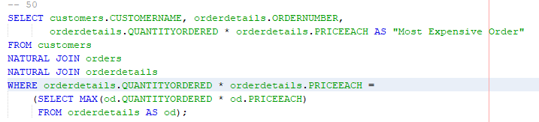

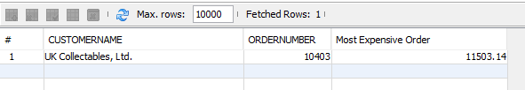

Perform the above query using a view. (1)

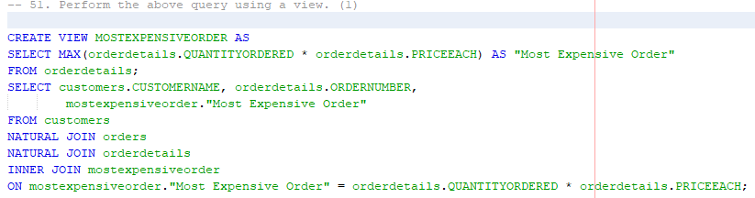

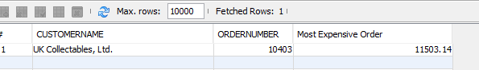

Show all of the customers who have ordered at least one product with the name “Ford” in it, that “Dragon Souveniers, Ltd.” has also ordered. List them in reverse alphabetical order, and do not consider the case of the letters in the customer name in the ordering. Show each customer no more than once. (61)

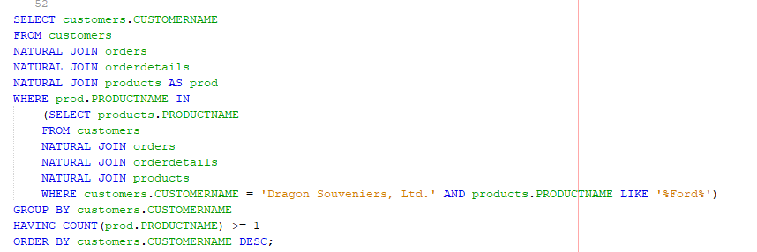

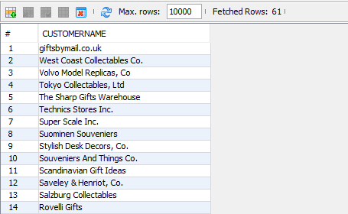

Which products have an MSRP within 5% of the average MSRP across all products? List the Product Name, the MSRP, and the average MSRP ordered by the product MSRP. (14)

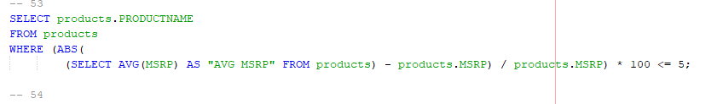

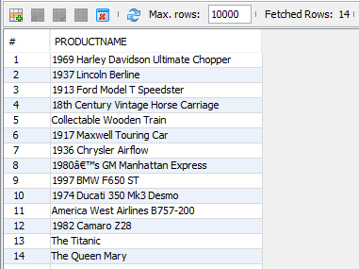

List all the customers who have never made a payment on the same date as another customer. Order by customer name. (57)

