SQL Practice Questions 37-43

1. List all customers who didn't order in 2015 (78)

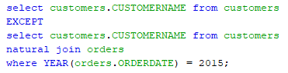

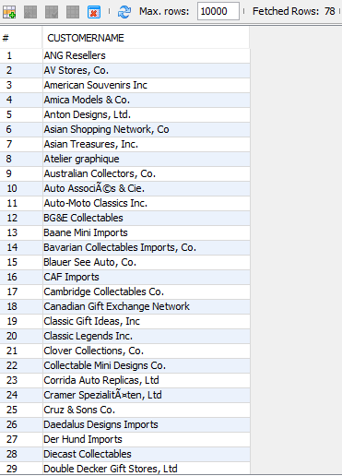

38) List all people that we deal with (employees and customer contacts). Display contact first name, contact last name, company name for the customers. For the employees, display their first name, last name, and just the literal ‘Employee’ for the employees. Returns 145 rows.

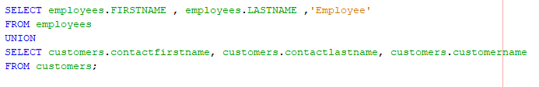

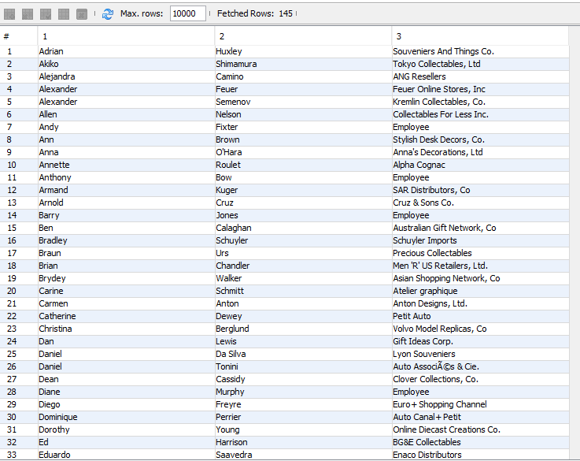

40) List the states and the country that the state is part of that have customers but not offices, offices but not customers, or both one or more customers and one or more offices all in one query. Designate which state is which with the string 'Customer', 'Office', or 'Both'. If a state falls into the “Both” category, do not list it as a Customer or an Office state. Order by the country, then the state. Give the category column (where you list ‘Customer’, ‘Office’, or ‘Both’) a header of “Category” and exclude any entries in which the state is null. (19)

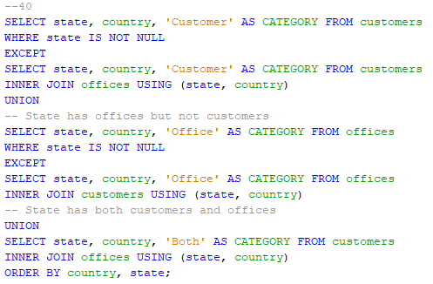

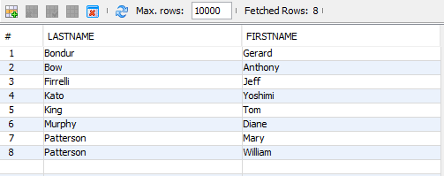

41) List the Product Code and Product name of every product that has never been in an order in which the customer asked for more than 48 of them. Order by the Product Name. (8)

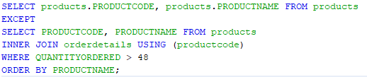

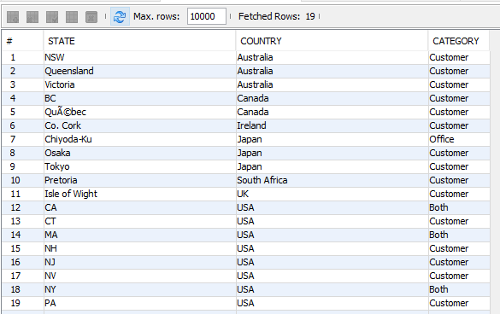

42) List the customer name of any customer who ordered any products from either of the two product lines ‘Trains’ or ‘Trucks and Buses’. Do not use an “or”. Instead perform a union. Order by the customer’s name. (61)

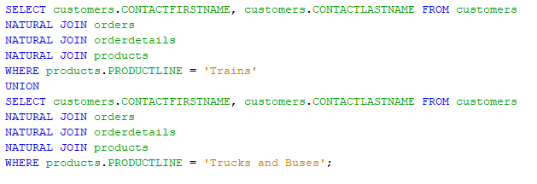

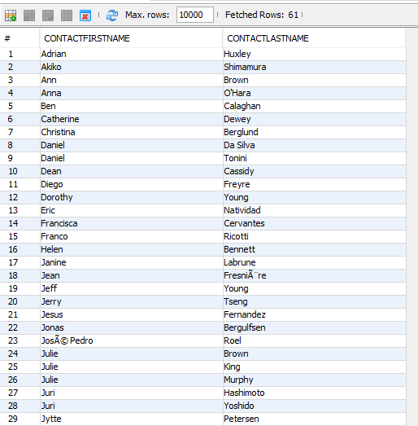

43) List the name of all customers who do not live in the same state and country with any other customer. Do not use a count for this exercise. Order by the customer name.

This returns 17 if you convert the null states to something like ‘N/A’ and it returns 10 if you exclude all customers with no state value at all.

