**Exercise**

**Open history of your browser & Choose 3 websites from your browsing history**

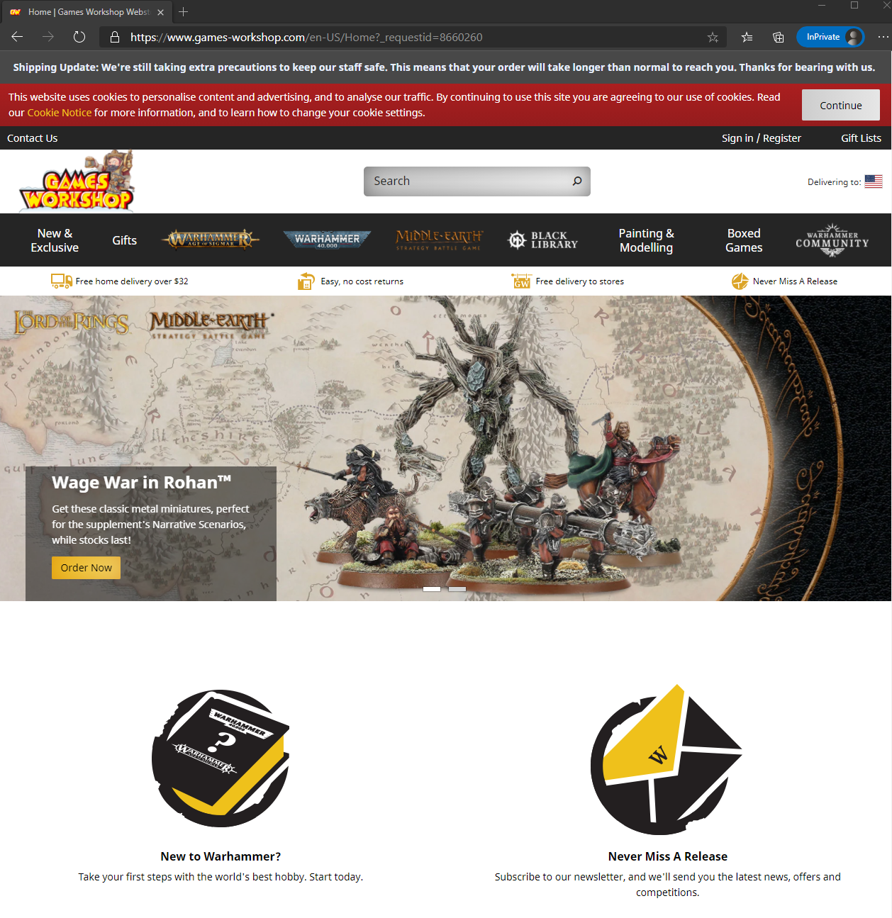

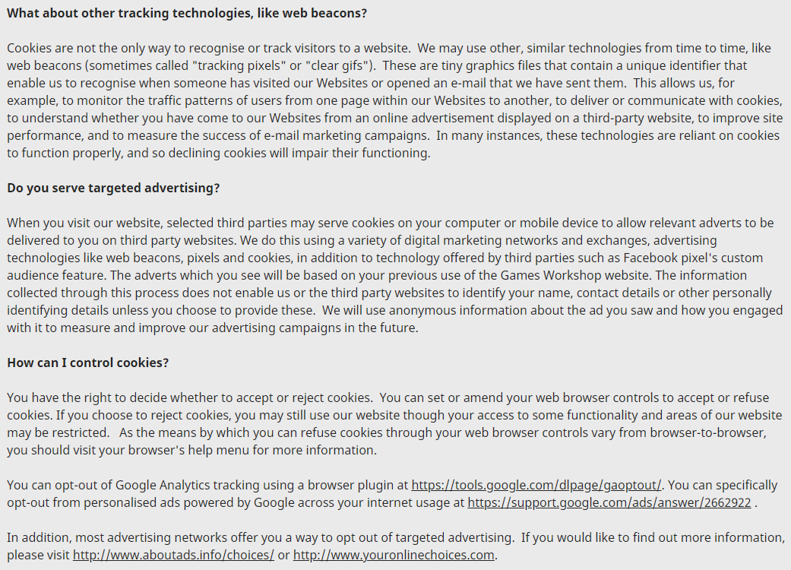



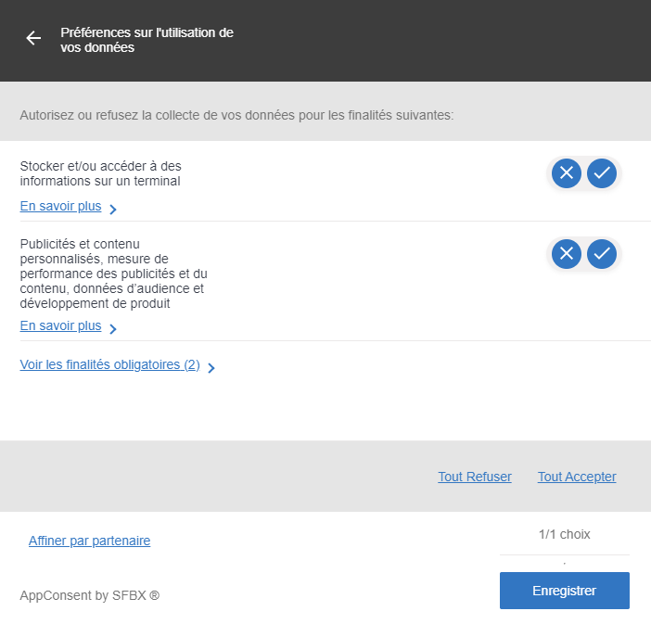

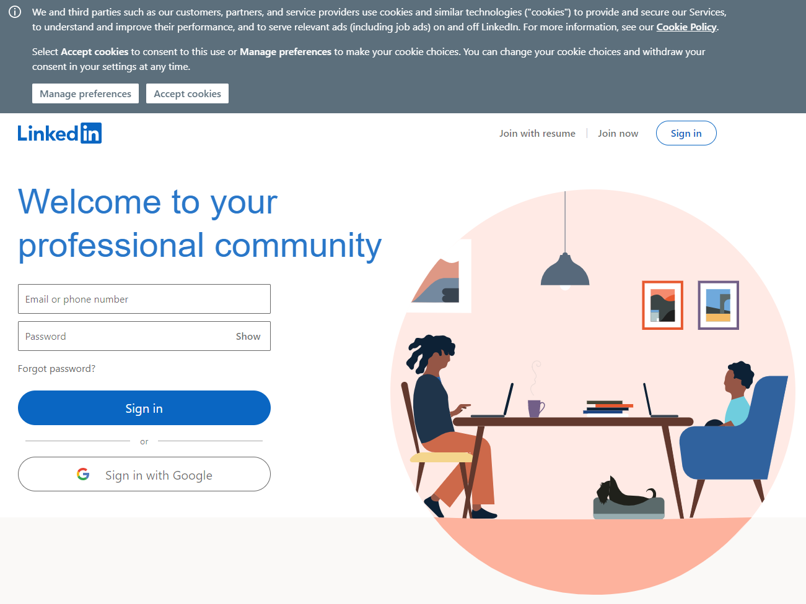

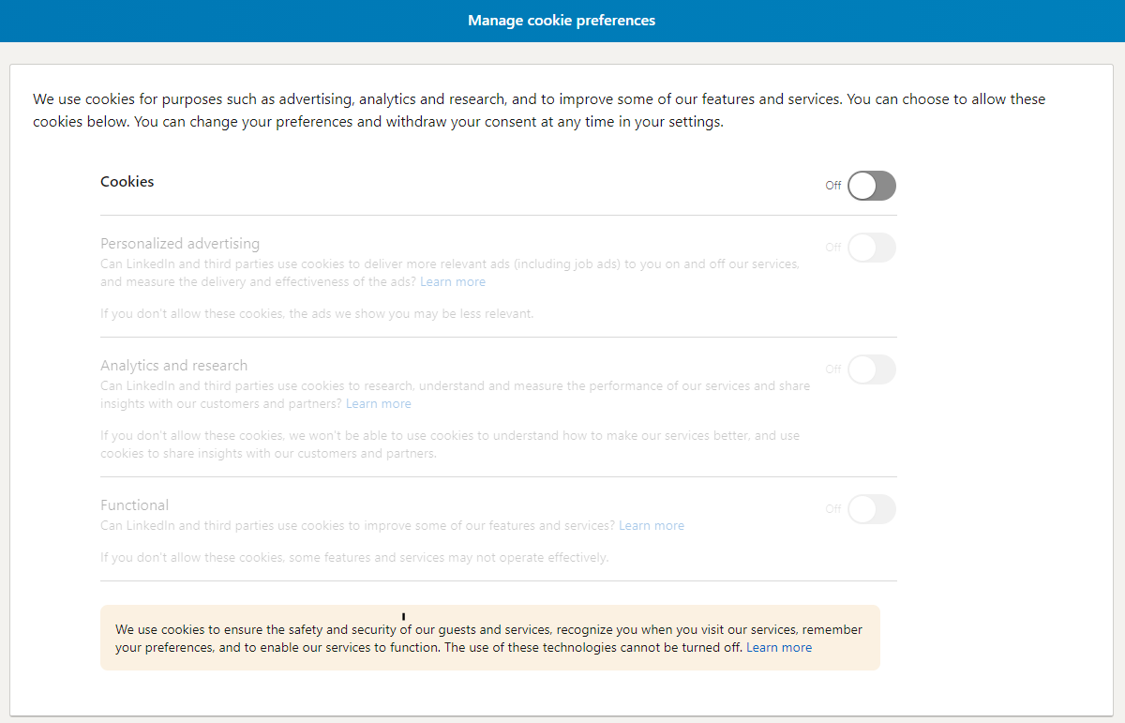

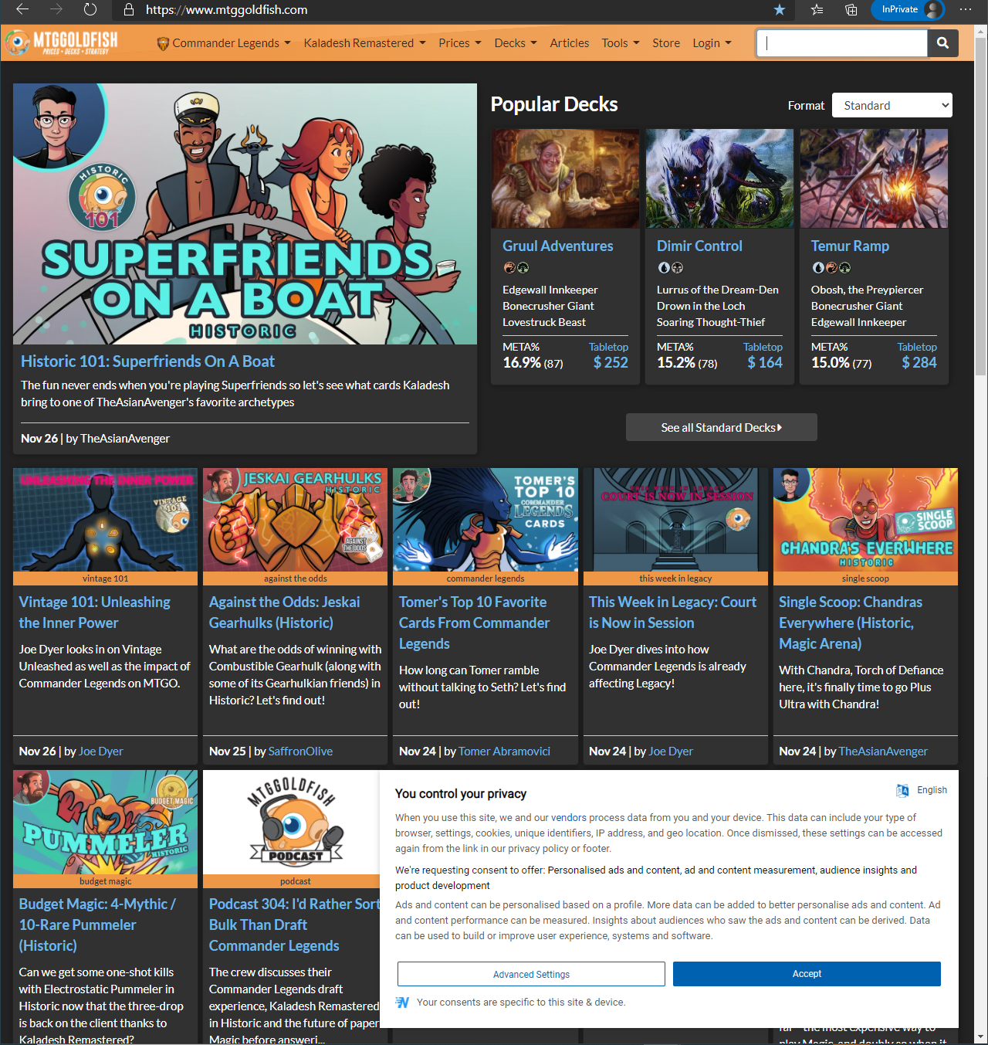

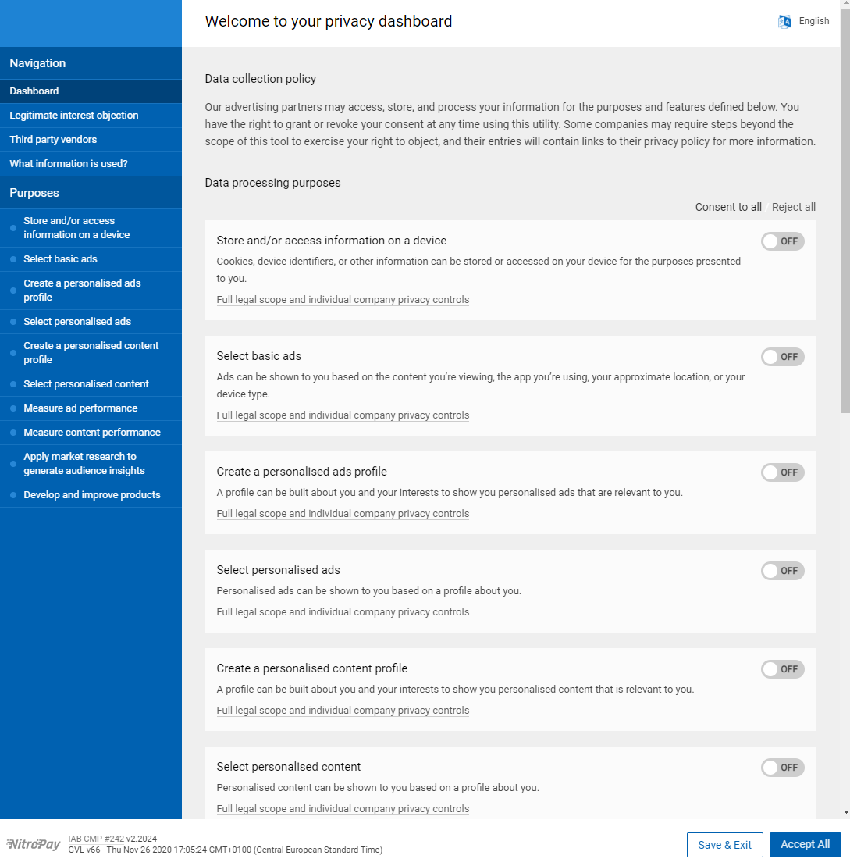

**Open these 3 websites in a private/incognito window**

aaaaa

**Is there a consent banner? Does it comply with elements of valid consent?**

1. **Free**
2. **Specific**
3. **Informed**
4. **Unambiguous**

aaaaa

**Check the slides to validate your analysis**

aaaaa

**Write 2-page report with your analysis**

aaaaa