Lab 5.2 – Building and Testing MLB classification models
https://github.com/LMuschenheim/Lab-5.1

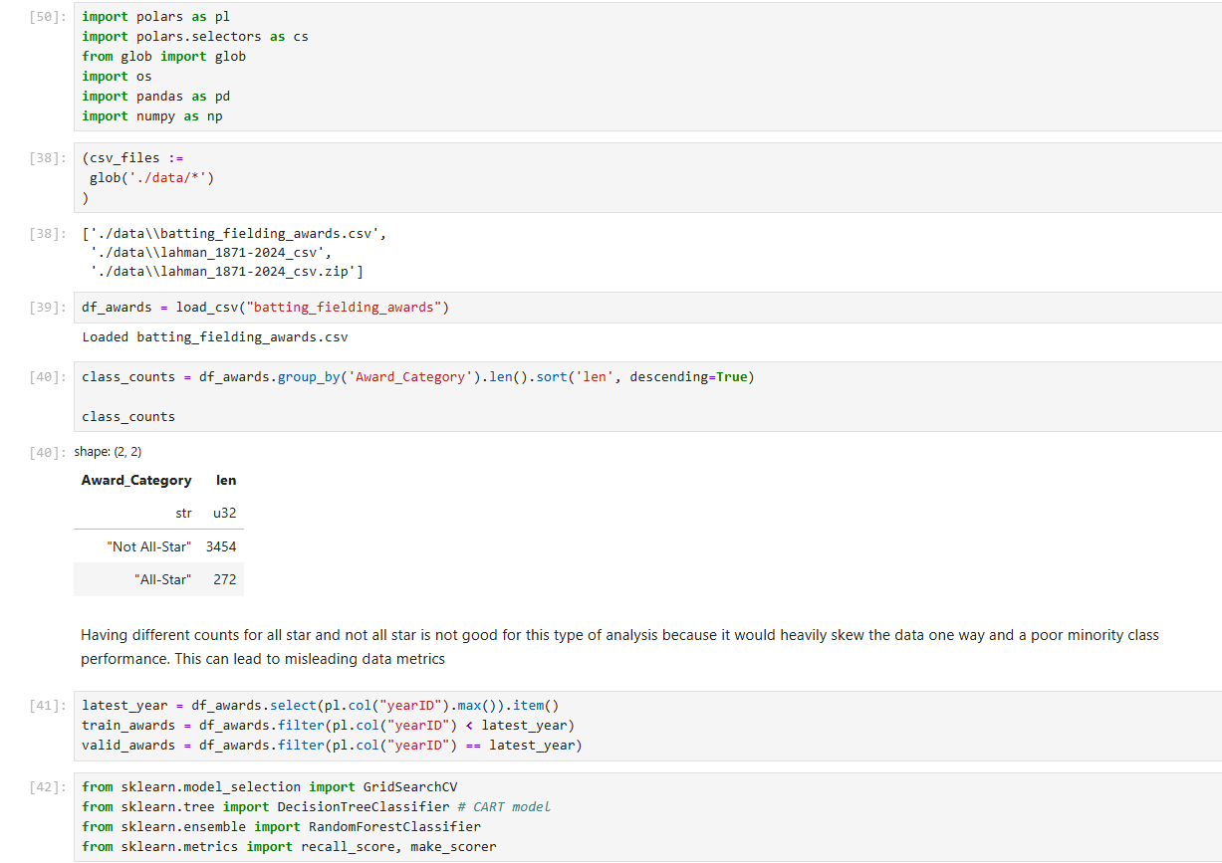
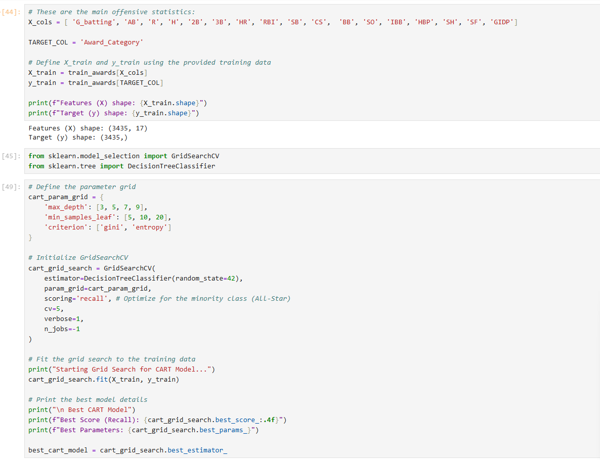
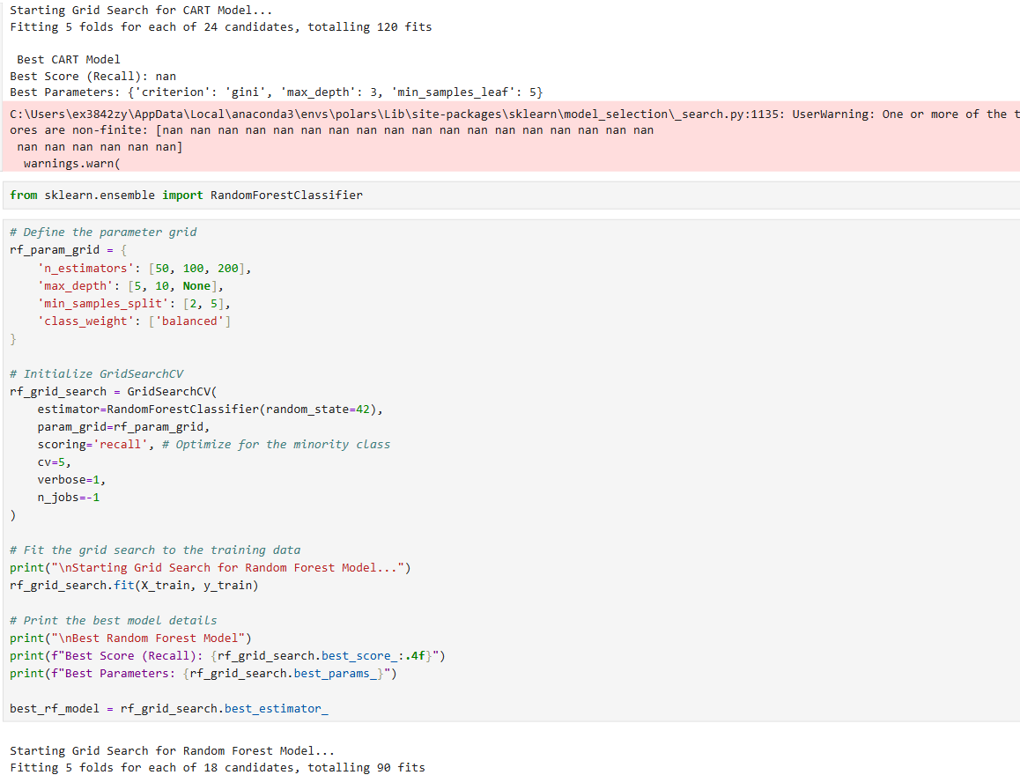
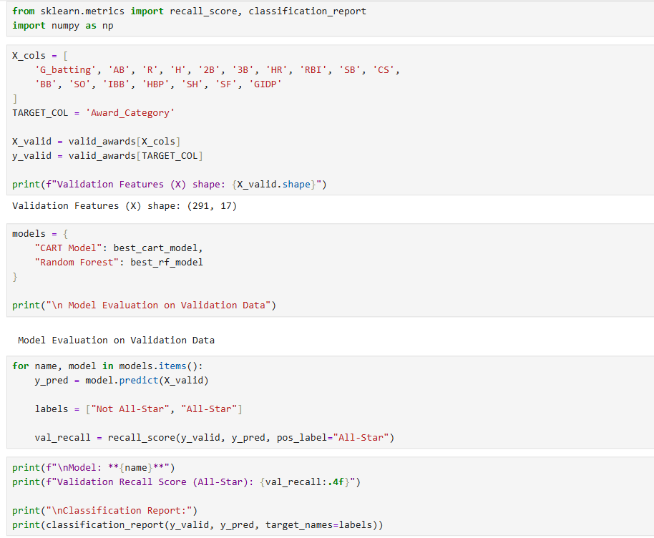
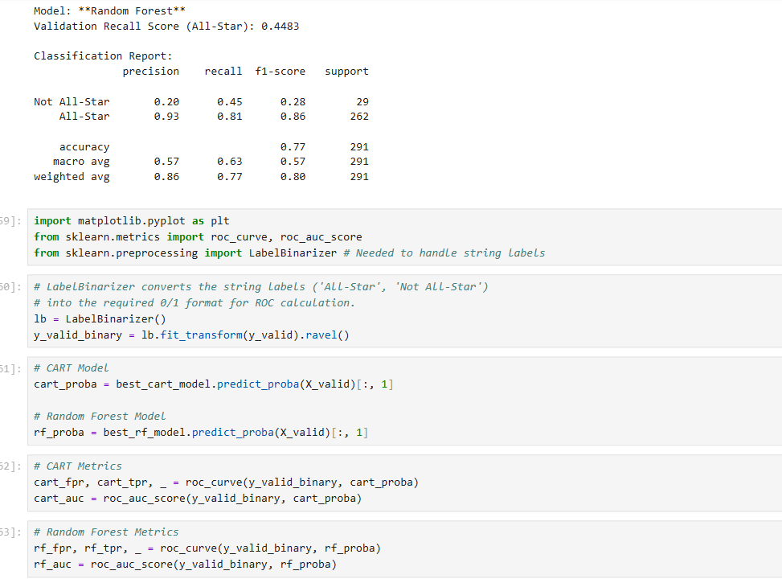
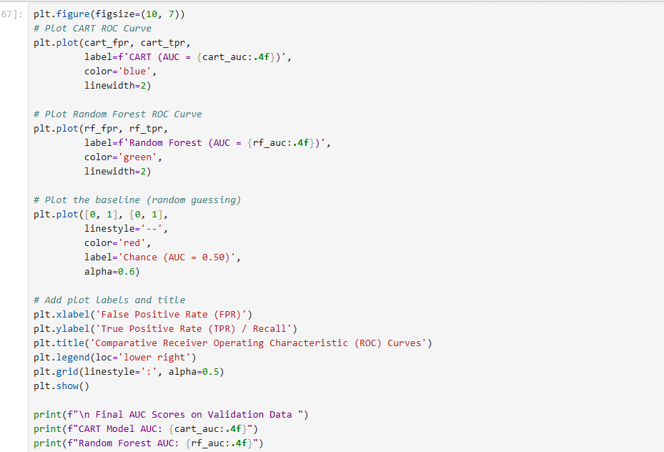
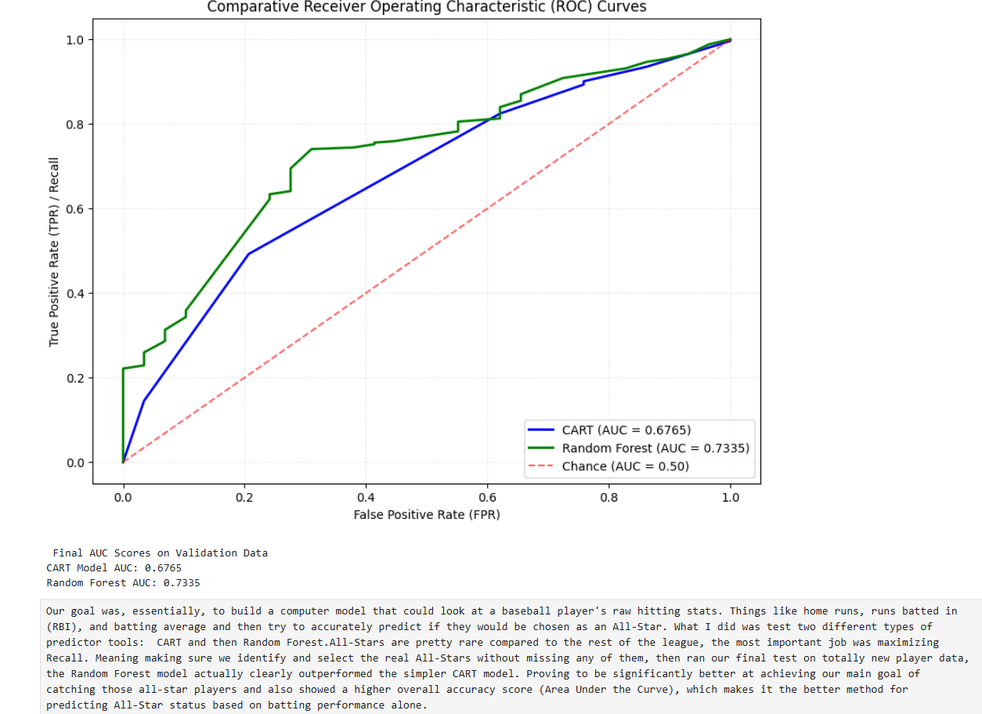

In this lab, we continue the work of the previous by building and testing various machine learning models for our two primary objectives, provided below.

Classification problem. How well can we predict whether an MLB outfielder’s all-star status based on their batting and fielding statistics?

Tasks. Perform each of the following tasks before constructing the two data sets.

- Verify by grouping and counting that the two classes are very unbalanced.
  - Provide some evidence in a section of your notebook.
  - Include a discussion about the issues with classification for unbalanced problems and suggest one or more solutions.
- Start by separating the validation data (most recent complete year) and training data (previous years) into two data frames. Set the validation data aside for the final evaluation.
- Perform a grid search to find the best model for each of the following models using the training data. Model classes:
  - CART model, and
  - Random Forests.
- In each case (CART & Random Forests), validate the winning model by testing its performance on the validation data. This section should include comparative ROC curves for both to the winning models.
- Write up a short report summarizing your findings.

