Lab 5.3 – Data Management for MLB baseball regression problem.
https://github.com/LMuschenheim/Lab-5.1

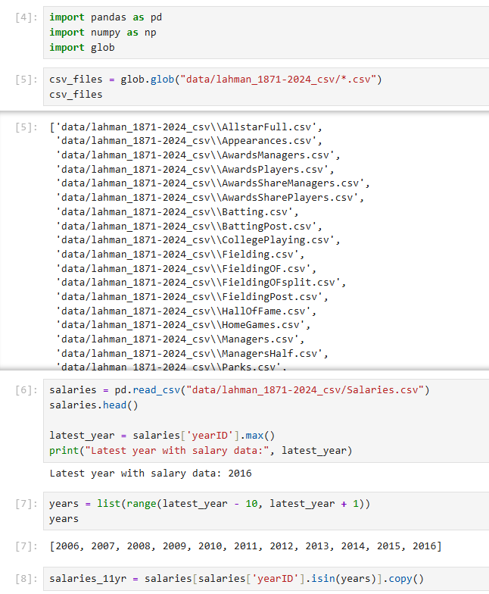
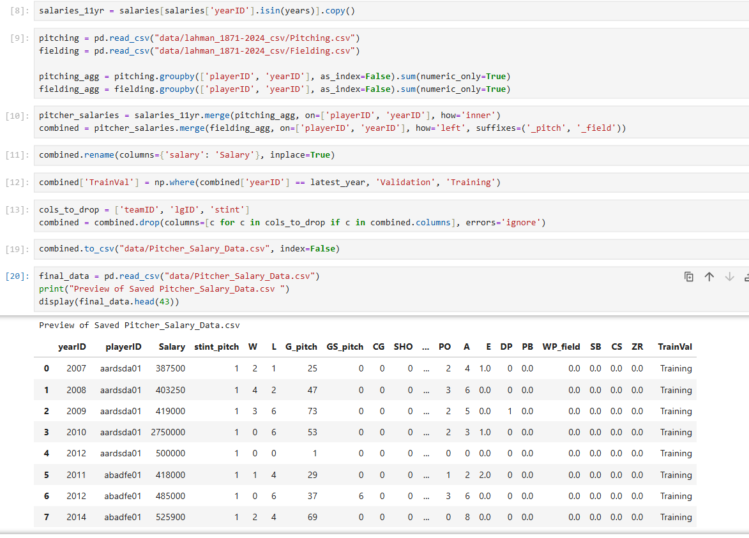

In this lab, we will construct a data set that will be used to build tree-based regression models related to MLB baseball.

Regression problem. How well can pitching and fielding statistics help predict a pitcher’s salary.

Initial Tasks. Perform each of the following tasks before constructing the two data sets.

- Create a lab 5.3 Python jupyter notebook in the root directory of the module 5 lab repository,
- Use glob to verify that you have the pitching, fielding, and salaries tables downloads, and
- Explore the Salaries.csv file to determine the latest year with salary data.

Construct the Salary dataset. Our goal is to build a single data set covering 11 years including the most recent year with salary data as well as a decade of previous data. The table will have one row per player-year and needs to contain the following

- The cases will be all pitchers from the years determined above.
- The target column is the pitcher’s yearly salary, which can be found in the Salaries.csv file.
- The features for this problem will be a combination the pitching and fielding statistics found in the respective files. Be sure to perform a grouped aggregation to combine data for all players that were traded (e.g., had multiple stints in a year).
- We will also want to create a Training-Validation column, which will be marked as Validation for the most recent complete season and Training otherwise.

