Lab 5.4 – Building and Testing MLB regression models
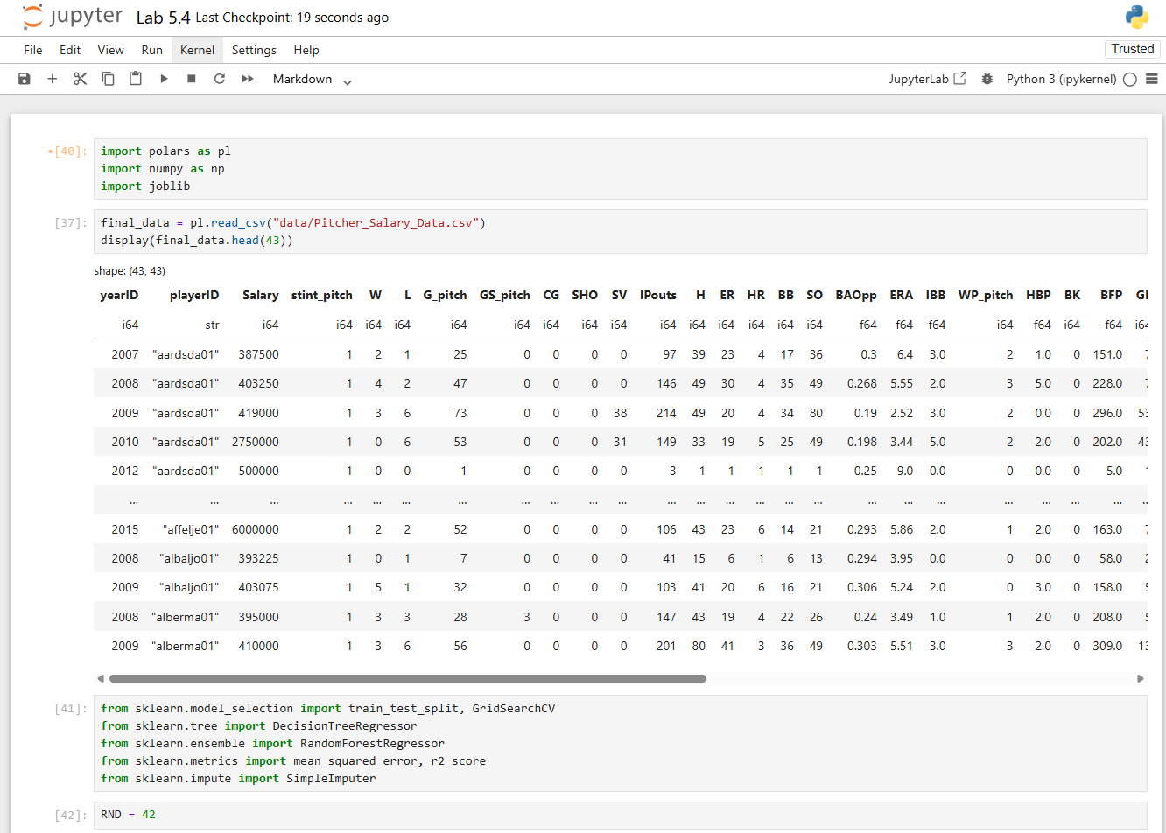
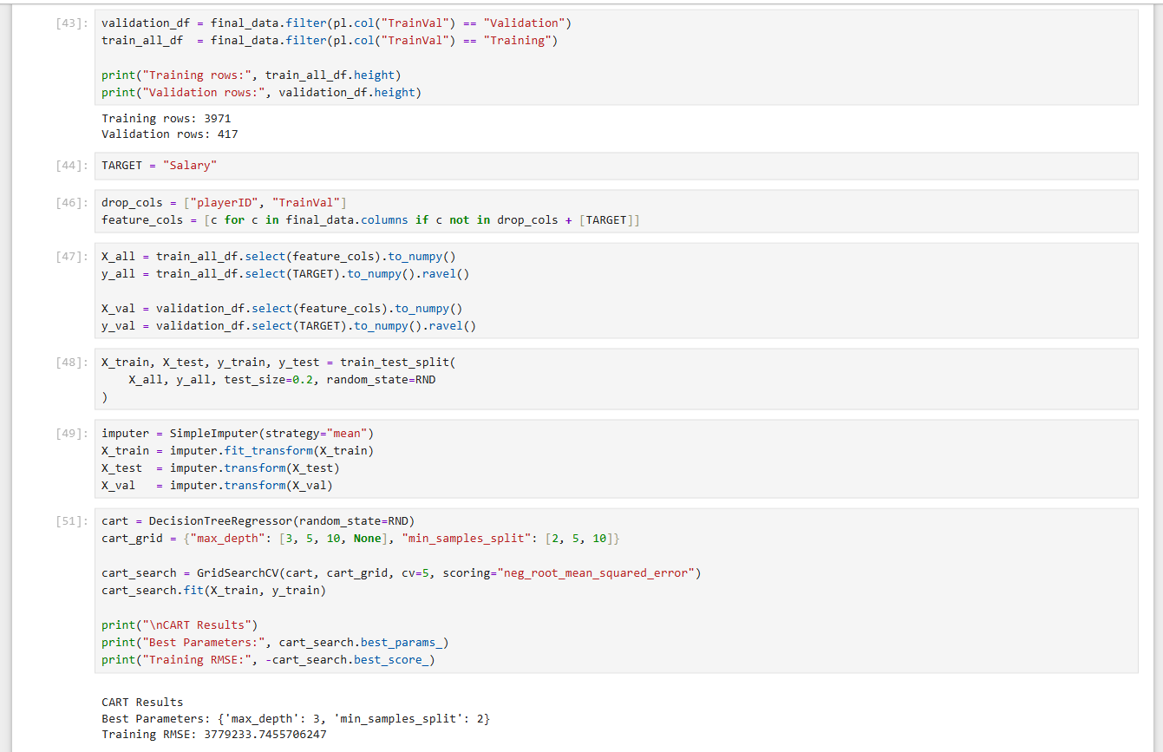
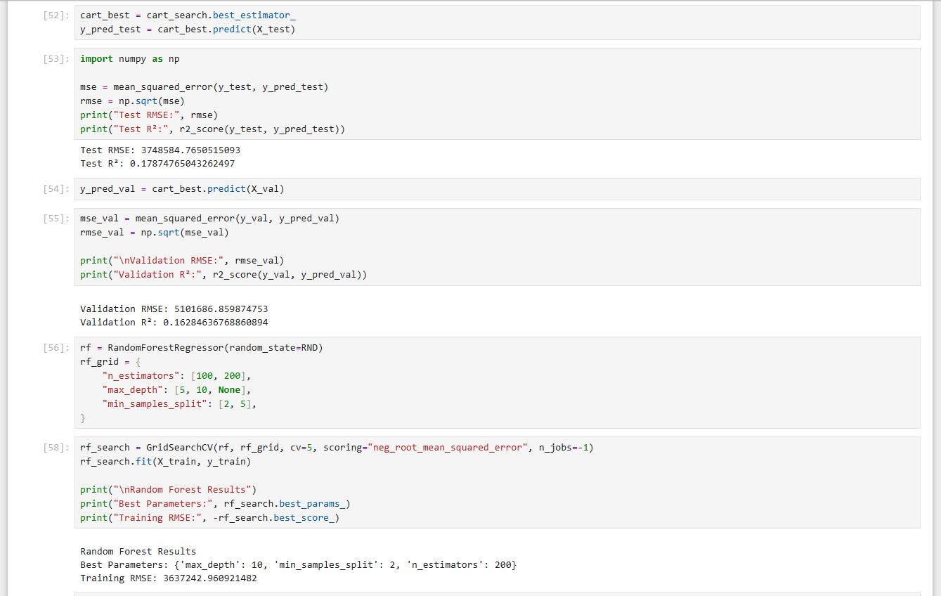
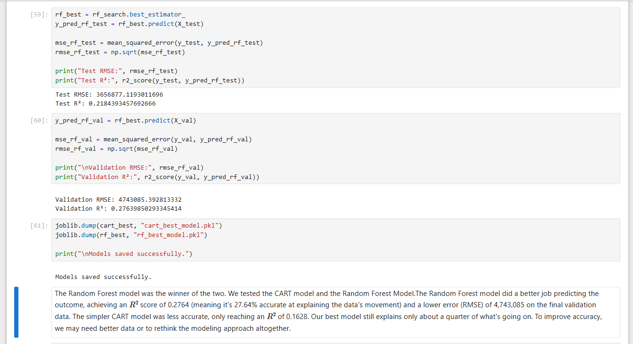

In this lab, we complete the work of the previous by building and testing various machine learning models for our two primary objectives, the second is provided below.

Regression problem. How well can pitching and fielding statistics help predict a pitcher’s salary.

Tasks. Perform each of the following tasks before constructing the two data sets.

- Start by separating the validation data (most recent complete year) and training data (previous years) into two data frames. Set the validation data aside for the final evaluation.
- Split the training set into a training and test set using the appropriate sklearn function.
- Perform a grid search to find the best model for each of the following models using the training data. Model classes:
  - CART model, and
  - Random Forests.
- In each case (CART & Random Forests), validate the winning model by testing its performance on the validation data.
- Write up a short report summarizing your findings.

