Homework 5 - STAT 613

Lindsay Beyak

3/5/2021

#### Exercise 1

See below for the code to find the mean of the rates of return.

Stockreturns <- c(-8.36, 1.63, -2.27, -2.93, -2.70,   
 -2.93, -9.14, -2.64, 6.82, -2.35,   
 -3.58, 6.13, 7.00, -15.25, -8.66,  
 -1.03, -9.16, -1.25, -1.22, -10.27,  
 -5.11, -0.80, -1.44, 1.28, -0.65,  
 4.34, 12.22, -7.21, -0.09, 7.34,   
 5.04, -7.24, -2.14, -1.01, -1.41,   
 12.03, -2.53, 4.33, 1.35)  
  
Stockreturns

## [1] -8.36 1.63 -2.27 -2.93 -2.70 -2.93 -9.14 -2.64 6.82 -2.35  
## [11] -3.58 6.13 7.00 -15.25 -8.66 -1.03 -9.16 -1.25 -1.22 -10.27  
## [21] -5.11 -0.80 -1.44 1.28 -0.65 4.34 12.22 -7.21 -0.09 7.34  
## [31] 5.04 -7.24 -2.14 -1.01 -1.41 12.03 -2.53 4.33 1.35

mean(Stockreturns)

## [1] -1.124615

#### Exercise 2

The following shows the standard deviation.

sd(Stockreturns)

## [1] 5.977673

#### Exercise 3

Below is the normal distribution for the proportion of returns that are less than -1.5.

dnorm(x = -1.5, mean = -1.124615, sd = 5.977673)

## [1] 0.06660726

#### Exercise 4

Below is the normal distribution for the proportion of returns that are 70% of the returns.

rv <- qnorm(p = 0.30, mean = -1.124615, sd = 5.977673)   
1 - rv

## [1] 5.25931

#### Exercise 5

The code below shows all the quantiles in the returns as well as the first quantile.

quantile(Stockreturns)

## 0% 25% 50% 75% 100%   
## -15.250 -3.255 -1.410 1.490 12.220

quantile(Stockreturns, 0.25)

## 25%   
## -3.255

#### Exercise 6

The boxplot for the returns is shown in comparison to the normal distribution.

boxplot(Stockreturns)

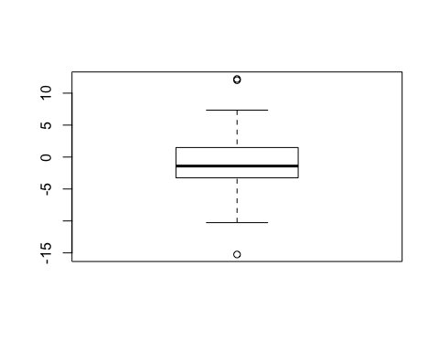

normdist <- rnorm(39, mean = -1.124615, sd = 5.977673)  
boxplot(Stockreturns, normdist, main = "Boxplot & Normal Distribution", names = c("Stockreturns", "Normal"), col = c("Light Blue", "Pink"))

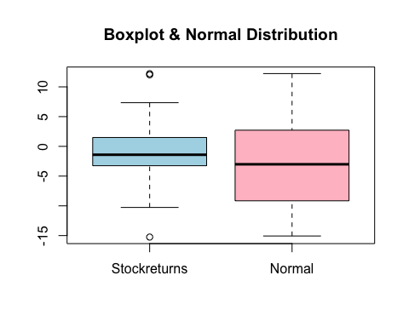

#### Exercise 7

H(0) : population mean = -1.124615 H(A) : population mean does not equal -1.124615

#### Exercise 8

The code for the p value and confidence interval is shown for the t test below.

t.test(Stockreturns, normdist, mu = -1.124615, var.equal = FALSE,)

##   
## Welch Two Sample t-test  
##   
## data: Stockreturns and normdist  
## t = 1.8451, df = 74.986, p-value = 0.06897  
## alternative hypothesis: true difference in means is not equal to -1.124615  
## 95 percent confidence interval:  
## -1.336276 4.400872  
## sample estimates:  
## mean of x mean of y   
## -1.124615 -2.656913

#### Exercise 9

Based on the results above, the p value is 0.2057 which is less than 0.5. Therefore, we cannot reject the Null hypothesis.