Homework 9

Lindsay Beyak

4/9/2021

library(tidycensus)  
library(tidyverse)  
library(dplyr)  
library(ggplot2)

#### *#1*

Below is the key assigned to me to use.

census_api_key("afc449cdf30a2917a2db3ebdc69a598978d3871c")

## To install your API key for use in future sessions, run this function with `install = TRUE`.

install = TRUE

#### *#2* a)

a15 <- load_variables(2015, "acs5", cache = TRUE)  
  
view(a15)  
ca <- get_acs(geography = "county",   
 variables = c(medincome = "B01001A_011"),   
 state = "CA", year = 2015)

## Getting data from the 2011-2015 5-year ACS

ca

## # A tibble: 58 x 5  
## GEOID NAME variable estimate moe  
## <chr> <chr> <chr> <dbl> <dbl>  
## 1 06001 Alameda County, California medincome 51644 667  
## 2 06003 Alpine County, California medincome 50 26  
## 3 06005 Amador County, California medincome 1809 72  
## 4 06007 Butte County, California medincome 9962 128  
## 5 06009 Calaveras County, California medincome 1927 74  
## 6 06011 Colusa County, California medincome 1147 79  
## 7 06013 Contra Costa County, California medincome 42756 605  
## 8 06015 Del Norte County, California medincome 1629 90  
## 9 06017 El Dorado County, California medincome 8609 141  
## 10 06019 Fresno County, California medincome 34979 714  
## # … with 48 more rows

#### *#2* b)

over30k <- ca %>%  
 filter(estimate > 30000)   
  
over30k %>% arrange(desc(estimate))

## # A tibble: 13 x 5  
## GEOID NAME variable estimate moe  
## <chr> <chr> <chr> <dbl> <dbl>  
## 1 06037 Los Angeles County, California medincome 375435 2332  
## 2 06073 San Diego County, California medincome 150891 1008  
## 3 06059 Orange County, California medincome 126819 1152  
## 4 06065 Riverside County, California medincome 92346 1004  
## 5 06071 San Bernardino County, California medincome 80925 1160  
## 6 06085 Santa Clara County, California medincome 63036 879  
## 7 06067 Sacramento County, California medincome 56066 553  
## 8 06001 Alameda County, California medincome 51644 667  
## 9 06013 Contra Costa County, California medincome 42756 605  
## 10 06075 San Francisco County, California medincome 42307 542  
## 11 06029 Kern County, California medincome 42121 575  
## 12 06111 Ventura County, California medincome 41155 557  
## 13 06019 Fresno County, California medincome 34979 714

#### *#2* c)

over30k %>% filter(estimate == 51644)

## # A tibble: 1 x 5  
## GEOID NAME variable estimate moe  
## <chr> <chr> <chr> <dbl> <dbl>  
## 1 06001 Alameda County, California medincome 51644 667

#### *#2d* d)

ggplot(over30k, aes(estimate, colour = "pink")) +  
 geom_boxplot()

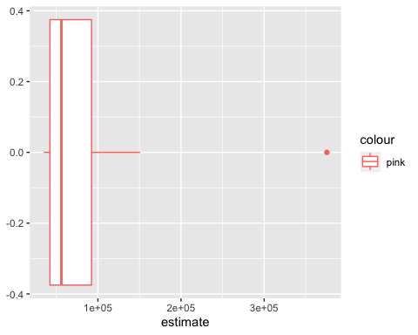

#### *#2* e)

over30k %>%  
 mutate(NAME = gsub(" County, California", "", NAME)) %>%  
 ggplot(aes(x = estimate, y = reorder(NAME, estimate))) +  
 geom_errorbarh(aes(xmin = estimate - moe, xmax = estimate + moe)) +  
 geom_point(color = "pink", size = 3) +  
 labs(title = "Median income for White Males Ages 35 to 44",  
 subtitle = "2015 American Community Survey",  
 y = "",  
 x = "ACS estimate (bars represent margin of error)")

