OPERATIONAL SENSE

Database Architecture
& Entity Relationship Design
M04 | Logical Design Package | Version 1.2

Document control | Value
Workstream | Operational Sense — EPIC 02
Owner | Ashi Jain (M04)
Intended users | M05 PostgreSQL Schema & Constraints; M06 Asset Hierarchy & Metadata; Groups 1, 3 and 4
Version / date | 1.2 / 24 October 2026
Status | Revised for Group 1 alignment review
Source baseline | Industrial Knowledge Base G1 workbook

1. Purpose and design boundary
This document defines the proposed logical data model for Operational Sense. It identifies entities, attributes, primary and foreign keys, relationship cardinalities, integrity rules and mappings from the G1 workbook. The design separates reusable domain reference data from individual troubleshooting scenarios and from real asset records.
The model supports the current synthetic troubleshooting corpus and leaves explicit extension points for the agreed equipment hierarchy, asset criticality assessments, FMEA records, source traceability, review history and future AI & Retrieval metadata.

In scope
- Logical entities and key attributes; primary-key and foreign-key intent.
- Relationships, cardinality and referential-integrity rules.
- Mapping from workbook sheets/fields to proposed database entities.
- Design decisions, assumptions, unresolved dependencies and cross-group review requests.

Outside this deliverable
- PostgreSQL DDL, migrations, indexes, triggers and production loading scripts (M05 implementation).
- Production asset onboarding and final hierarchy seed records (M06 / Group 1).
- Embedding generation, vector search, API, UI and deployment.
- Domain approval of synthetic scenarios, failure taxonomy, criticality scoring or FMEA ratings.

2. Source workbook audit
This design is based on the supplied G1 workbook. The counts below are reproducible checks of the workbook structure; they do not indicate that the technical content has been approved.
Check | Observed result | Design consequence
Worksheets | 18 | 18 worksheets in the workbook.
Troubleshooting cases | 50 | 50 rows in Import_View; IDs are unique in this snapshot.
Case distribution | 17 centrifugal pump; 17 three-phase induction motor; 16 rotary screw air compressor cases | The 50 cases cover three equipment classes.
Diagnostic steps | 350 | 350 rows in Diagnostic_Steps; IDs are unique in this snapshot.
Taxonomy gaps | 11 | Source quality report flags 11 cases without a taxonomy code.
Ambiguous mappings | 13 | Mapping_Validation flags 13 ambiguous mappings.
Expert validation | 50 pending | Verification_Records has pending overall decisions; no reviewer sign-off is recorded.
Source URL verification | Not run | Data_Quality_Report says URL validation was not performed.
Data handling note: The source workbook identifies all troubleshooting cases as synthetic scenarios. Equipment models are illustrative; do not load these examples as real plant assets or treat suspected causes as confirmed root causes.

3. Logical model overview
The model is organized into asset hierarchy; troubleshooting cases and diagnostic steps; failure taxonomy and case mappings; source/reference data; and review/assessment records. The ERD views are split for legibility. Relationship cardinalities and join rules are defined in Section 5 and the Relationships worksheet.

3.1 Core case and hierarchy model
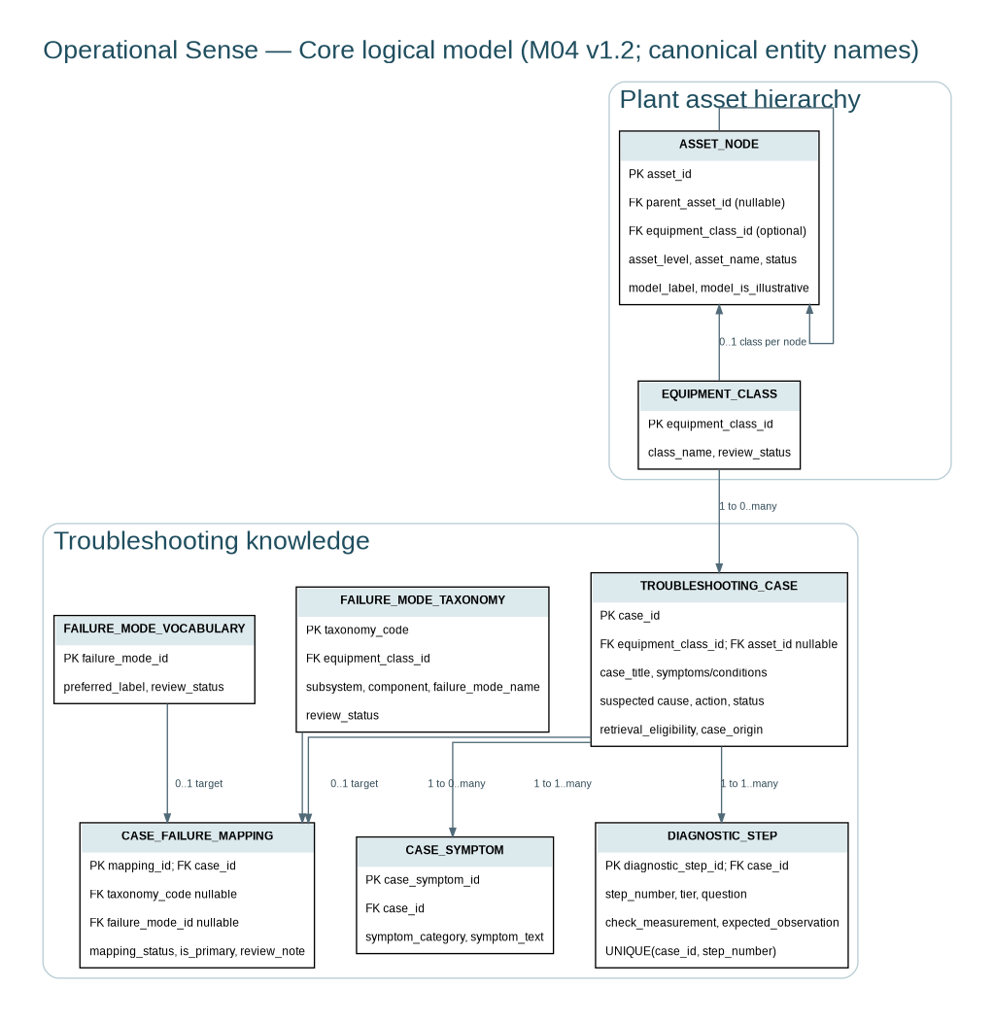

3.2 Source, safety and review relationships
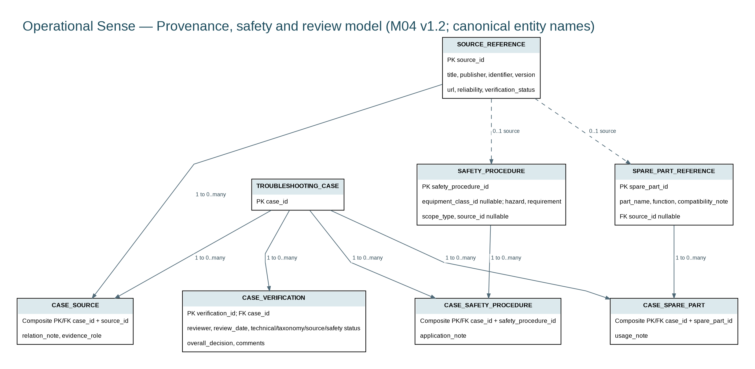

3.3 Asset criticality, FMEA and measurement relationships
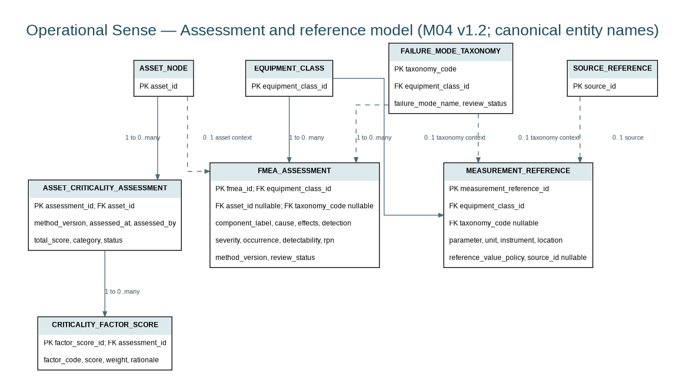

4. Entity catalogue
Entity | Responsibility | Primary key | Source / status
EQUIPMENT_CLASS | Controlled equipment-class list | equipment_class_id | Equipment_Reference; Import_View
ASSET_NODE | Plant/Area/System/Equipment/Component hierarchy node | asset_id | No populated asset register in workbook; future hierarchy
ASSET_CRITICALITY_ASSESSMENT | Versioned criticality assessment for an asset | assessment_id | Asset Criticality Framework dependency; not populated in workbook
CRITICALITY_FACTOR_SCORE | One scored factor within an assessment | factor_score_id | Factor scales/weights pending Group 1 approval
TROUBLESHOOTING_CASE | One troubleshooting scenario, synthetic or later validated | case_id | Import_View; Troubleshooting_Cases
CASE_SYMPTOM | Symptom records associated with a case | case_symptom_id | Import_View symptom fields; controlled vocabulary pending
DIAGNOSTIC_STEP | Ordered diagnostic/check step within a case | diagnostic_step_id | Diagnostic_Steps
FAILURE_MODE_TAXONOMY | Domain taxonomy for equipment/component failure modes | taxonomy_code | Failure_Mode_Taxonomy; Taxonomy_Proposed
FAILURE_MODE_VOCABULARY | Controlled project vocabulary of failure-mode labels | failure_mode_id | Taxonomy_FM_Vocabulary
CASE_FAILURE_MAPPING | Reviewable link from a case to taxonomy/vocabulary concepts | mapping_id | Mapping_Validation; Import_View
FMEA_ASSESSMENT | FMEA assessment for a failure mode in a class/asset/component context | fmea_id | FMEA framework; not a populated case-level table in workbook
SOURCE_REFERENCE | A source, manual, standard or supporting document | source_id | Sources
CASE_SOURCE | Many-to-many link between cases and sources | case_id + source_id | Source IDs in Import_View; Sources
CASE_VERIFICATION | A dated review event for a case | verification_id | Verification_Records; allow history rather than overwrite
MEASUREMENT_REFERENCE | Parameter, unit, instrument and applicability guidance | measurement_reference_id | Measurement_Reference
SPARE_PART_REFERENCE | Reference information for spare parts | spare_part_id | Spare_Parts_Reference
CASE_SPARE_PART | Many-to-many link between cases and spare parts | case_id + spare_part_id | Spare_Parts_Reference; Import_View
SAFETY_PROCEDURE | Reusable safety requirement/procedure | safety_procedure_id | Safety_Procedures
CASE_SAFETY_PROCEDURE | Many-to-many link between cases and safety procedures | case_id + safety_procedure_id | Safety_Procedures; Import_View

5. Relationship and cardinality rules
Cardinality describes how many records may participate in a relationship. “1 : 0..many” means one parent may have zero or many children; each child points back to one parent through its foreign key unless explicitly marked optional.
Relationship | Cardinality | FK / join | Rule
EQUIPMENT_CLASS → ASSET_NODE | 1 : 0..many | ASSET_NODE.equipment_class_id | Classifies equipment-level nodes; null for non-equipment hierarchy levels unless approved otherwise.
ASSET_NODE → ASSET_NODE | parent 0..1 : child 0..many | ASSET_NODE.parent_asset_id | Recursive parent-child hierarchy. Enforce Plant→Area→System→Equipment→Component after Group 1 approval.
EQUIPMENT_CLASS → TROUBLESHOOTING_CASE | 1 : 0..many | TROUBLESHOOTING_CASE.equipment_class_id | Each case has exactly one equipment class in the current corpus.
ASSET_NODE → TROUBLESHOOTING_CASE | 1 : 0..many (case link optional) | TROUBLESHOOTING_CASE.asset_id nullable | Link only when a case genuinely concerns an identified real asset; synthetic scenarios remain unlinked by default.
TROUBLESHOOTING_CASE → CASE_SYMPTOM | 1 : 1..many | CASE_SYMPTOM.case_id | A case can have multiple symptom entries; current import also retains concise symptom text.
TROUBLESHOOTING_CASE → DIAGNOSTIC_STEP | 1 : 1..many | DIAGNOSTIC_STEP.case_id; UNIQUE(case_id, step_number) | Ordered diagnostic workflow; 350 rows currently exist across 50 cases.
TROUBLESHOOTING_CASE → CASE_FAILURE_MAPPING | 1 : 0..many | CASE_FAILURE_MAPPING.case_id | Allows mappings to be provisional, ambiguous, or missing without fabricating a taxonomy link.
FAILURE_MODE_TAXONOMY → CASE_FAILURE_MAPPING | 0..1 target per mapping | CASE_FAILURE_MAPPING.taxonomy_code nullable | Taxonomy target may be null while a known taxonomy gap is under review.
FAILURE_MODE_VOCABULARY → CASE_FAILURE_MAPPING | 0..1 target per mapping | CASE_FAILURE_MAPPING.failure_mode_id nullable | Project-local vocabulary ID is not an ISO code; mapping must remain separately reviewable.
EQUIPMENT_CLASS → FAILURE_MODE_TAXONOMY | 1 : 0..many | FAILURE_MODE_TAXONOMY.equipment_class_id | A class can have many applicable taxonomy entries.
TROUBLESHOOTING_CASE → CASE_SOURCE | 1 : 0..many | CASE_SOURCE.case_id | Bridge table supports multiple sources per case.
SOURCE_REFERENCE → CASE_SOURCE | 1 : 0..many | CASE_SOURCE.source_id | A source may support multiple cases.
TROUBLESHOOTING_CASE → CASE_VERIFICATION | 1 : 0..many | CASE_VERIFICATION.case_id | Versioned review history; no review is treated as approval.
ASSET_NODE → ASSET_CRITICALITY_ASSESSMENT | 1 : 0..many | ASSET_CRITICALITY_ASSESSMENT.asset_id | An asset may be assessed repeatedly over time or methodology versions.
ASSET_CRITICALITY_ASSESSMENT → CRITICALITY_FACTOR_SCORE | 1 : 1..many | CRITICALITY_FACTOR_SCORE.assessment_id | Factor scores are separate so approved factors/weights can evolve without changing the table structure.
EQUIPMENT_CLASS → FMEA_ASSESSMENT | 1 : 0..many | FMEA_ASSESSMENT.equipment_class_id | Class-level FMEA can exist without a live asset; asset-specific assessment is optional.
FAILURE_MODE_TAXONOMY → FMEA_ASSESSMENT | 0..1 : 0..many | FMEA_ASSESSMENT.taxonomy_code nullable | Use only after taxonomy mapping is approved.
EQUIPMENT_CLASS → MEASUREMENT_REFERENCE | 1 : 0..many | MEASUREMENT_REFERENCE.equipment_class_id | Measurement reference is reusable guidance, not a case-specific observed measurement.
SOURCE_REFERENCE → MEASUREMENT_REFERENCE | 0..1 source per reference | MEASUREMENT_REFERENCE.source_id nullable | Retain provenance for measurement guidance where a source is supplied.
TROUBLESHOOTING_CASE → CASE_SPARE_PART | 1 : 0..many | CASE_SPARE_PART.case_id | Bridge supports multiple spare parts per case.
SPARE_PART_REFERENCE → CASE_SPARE_PART | 1 : 0..many | CASE_SPARE_PART.spare_part_id | Spare part may be referenced by multiple cases.
TROUBLESHOOTING_CASE → CASE_SAFETY_PROCEDURE | 1 : 0..many | CASE_SAFETY_PROCEDURE.case_id | Bridge links each case to reusable safety procedures.
SAFETY_PROCEDURE → CASE_SAFETY_PROCEDURE | 1 : 0..many | CASE_SAFETY_PROCEDURE.safety_procedure_id | A safety procedure may apply to multiple cases.
SOURCE_REFERENCE → SPARE_PART_REFERENCE | 0..1 source per part | SPARE_PART_REFERENCE.source_id nullable | Preserve part-reference provenance when available.
SOURCE_REFERENCE → SAFETY_PROCEDURE | 0..1 source per procedure | SAFETY_PROCEDURE.source_id nullable | Prefer a traceable source for each reusable safety requirement.

6. Primary keys, foreign keys and integrity rules
- Use stable source case_id values as TROUBLESHOOTING_CASE primary keys for this seed corpus; do not regenerate IDs on each import.
- Use diagnostic_step_id as DIAGNOSTIC_STEP primary key and enforce UNIQUE(case_id, step_number). A diagnostic step must reference an existing case.
- Use controlled EQUIPMENT_CLASS records; enforce uniqueness on equipment_class_id and, after domain review, on canonical class_name.
- Use ASSET_NODE.parent_asset_id as a self-referencing foreign key. Validate allowed parent-child levels in a constraint or trigger only after Group 1 confirms the hierarchy contract.
- Keep taxonomy_code and failure_mode_id as distinct foreign keys. The project vocabulary ID is not automatically an ISO 14224 code.
- Allow a nullable taxonomy target only when mapping_status and a documented gap/review reason explain the missing link; do not silently discard the gap.
- Use bridge tables for case-to-source, case-to-spare-part and case-to-safety-procedure many-to-many relationships. Composite primary keys should prevent duplicate links.
- Model review as dated CASE_VERIFICATION events so later reviews do not overwrite prior decisions. A blank reviewer/date and PENDING status is not approval.
- Keep criticality and FMEA scoring method versions with each assessment. Store the calculated RPN only after the rating scales and calculation rule are approved.
- Apply ON DELETE RESTRICT for referenced domain/master records by default. Case-child records may use ON DELETE CASCADE only where the team explicitly agrees that child records have no independent retention requirement.
- No numeric alarm threshold should be inferred from generic text; thresholds require an approved OEM specification or site baseline and applicability conditions.

7. Source-to-entity mapping
The accompanying editable workbook contains the complete field-by-field mapping for all Import_View columns and relevant fields from Diagnostic_Steps, Sources, Verification_Records, Measurement_Reference, Spare_Parts_Reference and Safety_Procedures. The summary below shows the primary mappings.
Workbook field(s) | Destination | Mapping rule
Import_View.case_id | TROUBLESHOOTING_CASE.case_id | Direct; preserve source ID.
equipment_class / equipment_class_id | EQUIPMENT_CLASS | Controlled lookup; label and ID must agree.
symptom_category / symptom_reported_hinglish / symptom_structured | CASE_SYMPTOM | Retain original symptom text and structured description.
Tier 1 / Tier 2 / Tier 3 narrative fields | TROUBLESHOOTING_CASE and DIAGNOSTIC_STEP | Keep case summary and ordered step detail distinct.
taxonomy_code / fm_id_vocab / mapping_status | CASE_FAILURE_MAPPING + taxonomy/vocabulary lookups | Keep mapping status, gap and review notes.
source_ref_ids + Sources sheet | CASE_SOURCE + SOURCE_REFERENCE | Preserve reference identity and verification status.
Diagnostic_Steps | DIAGNOSTIC_STEP | Transform source labels to consistent snake_case fields and enforce step ordering.
Verification_Records | CASE_VERIFICATION | Load pending states as pending; never fabricate reviewer approval.
Measurement_Reference | MEASUREMENT_REFERENCE | Keep units, applicability and reference-value policy.
Spare_Parts_Reference / Safety_Procedures | Reference entities + case bridge tables | Normalize reusable reference records and preserve associations.

8. Field and type guidance
The workbook mapping records logical destinations. Physical PostgreSQL types and nullability should be finalized with M05 against the approved Common Data Model. The following are recommended starting types, not a substitute for that review.
Field group | Suggested PostgreSQL type | Constraint / rationale
Identifier fields | TEXT or VARCHAR with explicit length only if agreed | Preserve external IDs such as CASE-PUMP-001 exactly.
Human-readable names and labels | TEXT | Use controlled lookup rows where values must be standardized.
Long explanations / diagnostic instructions | TEXT | Avoid truncation; do not store large narratives in short VARCHAR columns.
Review / lifecycle status | TEXT + CHECK or lookup table | Allowed values must be agreed and documented.
Boolean flags | BOOLEAN | Use actual boolean values, not “Yes/No” strings.
Review dates / event timestamps | DATE / TIMESTAMPTZ | Agree whether date-only or timestamp with timezone is required.
Criticality scores / FMEA ratings | SMALLINT / NUMERIC | Bounds and weights depend on approved rating framework.
RPN | INTEGER or generated calculation | Use only after the S × O × D rule and rating scale are approved.
Flexible source metadata (if unavoidable) | JSONB sparingly | Do not use JSONB as a shortcut for core relationships or filterable fields.

9. Data-quality and ingestion controls
- Pre-load: verify workbook version, required headers, 50 case IDs, unique IDs, allowed equipment classes and source-ID existence.
- Pre-load: validate every diagnostic step references a known case; validate step numbers are positive and unique per case.
- Pre-load: keep original/source wording in provenance fields where normalization changes labels.
- Load: use a transaction and report rejected rows; do not silently coerce malformed values or fill unknown technical facts.
- Post-load: compare row counts to source counts, check foreign-key orphans, verify case-to-step counts and confirm taxonomy gaps remain visible.
- Operational: distinguish structural validity from technical validation. A record can pass field checks and still require expert review.
- Retrieval: keep retrieval_eligibility explicit; synthetic and unreviewed cases should be excluded from any production-facing recommendation path unless the project explicitly approves a labelled demo mode.

9A. Group 1 hierarchy and taxonomy alignment
The Group 1 hierarchy proposal (Draft v0.1) is treated as a review input, not an approved contract. It distinguishes equipment class, equipment type, subsystem, component and failure mode. This is a knowledge taxonomy and must not be conflated with the plant asset hierarchy (Plant → Area → System → Equipment → Component). The two structures should be linked through reviewed mappings rather than forced into a single parent-child chain.

Design treatment for this revision
- Keep ASSET_NODE for the plant asset hierarchy and its site-specific parent-child relationships.
- Keep EQUIPMENT_CLASS / equipment-type references and failure taxonomy as controlled knowledge reference data; map cases and components to them using explicit foreign keys or bridge tables.
- Keep project taxonomy_code separate from failure_mode_id. Do not label project codes as ISO 14224 codes unless a reviewed crosswalk explicitly supports that claim.
- Preserve source identifiers and labels. Do not silently rename taxonomy codes, merge subsystem labels, split composite components or invent missing IDs during ingestion.
- Treat the 11 entries marked proposed in the Group 1 proposal as unapproved; retain their proposal status and owner/review notes.
- Keep synthetic case records and unreviewed mappings ineligible for production recommendations unless a clearly labelled demo mode is explicitly approved.

Open alignment items
Confirm the equipment class/type boundary, proposed subsystem merges, motor taxonomy-code convention, composite component names, pump-versus-driver boundary, and ambiguous case mappings with M01/M02 and Groups 2–3. Confirm structured retrieval filters and metadata with Group 3, and physical schema constraints with M05. No approval is implied by this revision.

9B. Model consistency and revision control
The Entity_Inventory and Relationships worksheets in M04_Entity_Relationship_Reference_v1.2.xlsx are the canonical logical-model reference for this package. The three ERD views and editable sources have been reconciled to use the same entity names and key relationships. Where a decision remains open, the diagram shows the proposed logical relationship and does not imply domain approval.
Canonical naming corrections in this revision include CASE_FAILURE_MAPPING (with separate optional taxonomy_code and failure_mode_id references), FMEA_ASSESSMENT, and MEASUREMENT_REFERENCE. FMEA_ASSESSMENT supports equipment-class context with optional asset and taxonomy context; MEASUREMENT_REFERENCE is equipment-class scoped, with optional taxonomy and source references. These are reference/assessment records, not assertions that real plant measurements or approved FMEA ratings have been supplied.
Version control: the report, reference workbook, ERD exports and editable sources are packaged as M04 v1.2. The exact Common Data Model and JSON Schema versions remain an open cross-group dependency until the approved artifacts and sign-off are recorded. No Common Data Model version is represented as approved by this package.

10. Assumptions and decisions requiring sign-off
ID | Owner | Decision required | Why it matters | Status
Q01 | Group 1 + M06 | Confirm canonical hierarchy levels and whether “Subsystem” is a formal node or descriptive metadata. | Blocks parent-level validation and ASSET_NODE constraints. | Open
Q02 | Groups 1 + 3 + 4 | Provide the agreed Common Data Model artifact and record its exact version plus JSON Schema version; approval must be confirmed by Groups 1, 3 and 4. | Blocks final field contract and acceptance sign-off. M04 does not infer or claim an approved version. | Open
Q03 | Group 3 | Confirm structured retrieval filters, embedding text fields, metadata contract and eligibility rules. | Prevents mismatch with AI & Retrieval pipeline. | Open
Q04 | M05 | Confirm PostgreSQL type conventions, naming, delete/update behavior, indexes and migration constraints. | Needed before physical schema implementation. | Open
Q05 | M06 + Group 1 | Confirm whether current plant/facility/production-line fields are fictional context or should map to asset hierarchy nodes. | Avoids turning synthetic case context into real assets. | Open
Q06 | Group 1 / domain steward | Approve failure taxonomy and project-local vocabulary mappings; resolve ambiguous mappings and taxonomy gaps. | 11 taxonomy gaps and 13 ambiguous mappings are reported by source workbook. | Open
Q07 | Group 1 + M05 | Confirm criticality scoring factors, scales, weightages, and whether assessment history is required in v1. | Assessment schema is intentionally method-versioned. | Open
Q08 | Group 1 + domain reviewer | Confirm FMEA RPN method, scales and interpretation rules before storing calculated RPN. | Avoids embedding unapproved risk scoring logic. | Open
Q09 | M05 + M06 | Confirm identifier strategy for asset nodes and hierarchy uniqueness rules (global vs parent-scoped). | Affects PKs and UNIQUE constraints. | Open
Q10 | Groups 1 + 3 + 4 | Record cross-group decisions and formal approval before marking architecture Approved. | Required by Epic 2 dependency and acceptance criteria. | Open

11. Cross-group handoff
Reviewer | Required feedback
Group 1 — Domain Research | Confirm hierarchy levels, naming conventions, taxonomy labels, failure-mode mappings and criticality/FMEA frameworks.
Group 3 — AI & Retrieval | Confirm metadata filters, embedding text fields, retrieval eligibility contract and schema requirements.
Group 4 — QA / Integration / DevOps | Confirm consistency checks, test evidence, versioning and integration acceptance evidence.
M05 — PostgreSQL Schema & Constraints | Review entity boundaries, PostgreSQL types, PK/FK rules, unique constraints, delete behavior and migration feasibility.
M06 — Asset Hierarchy & Metadata | Confirm asset identifiers, hierarchy-node semantics, component representation and uniqueness scope.

Approval record: No formal sign-off has been supplied. Record each reviewer, decision, date and agreed change in the shared issue or pull request before marking this design approved.
Implementation approval gate: Do not mark M04 Approved until the Common Data Model version, hierarchy contract, taxonomy mappings, retrieval metadata and scoring rules have named owners and recorded decisions. M04 v1.2 is a reconciled review package, not a substitute for those approvals.

12. M04 completion checklist
Deliverable / checkpoint | Status
Entity inventory and purposes | Included
PK/FK intent and relationship cardinality | Included
ERD images and editable source | Included
Workbook-to-entity field mapping | Included in companion workbook
Source-data audit and known quality gaps | Included
Assumptions and cross-group questions | Included
PostgreSQL implementation | M05 responsibility; not part of M04 design artifact
Formal Common Data Model approval | Pending relevant group review

Appendix A. Terms used in this document
Term | Definition
Entity | A category of information stored as a database table.
Attribute | A field/column describing an entity.
Primary key (PK) | A field or field combination that uniquely identifies a row.
Foreign key (FK) | A reference to a row in another table, used to maintain valid connections.
Cardinality | The allowed number of records participating in a relationship.
Bridge table | A table used to connect two entities when each can relate to many records of the other.
Synthetic scenario | An illustrative case, not evidence of an actual industrial incident.
RPN | Risk Priority Number; typically derived from Severity × Occurrence × Detection, subject to the approved FMEA method.
LOTO | Lockout/tagout: an energy-isolation procedure. Site-approved safety procedures take precedence.
Retrieval eligibility | A rule indicating whether a case is allowed into the retrieval/recommendation flow.

