Politehnica University of Timișoara
Faculty of Automation and Computer Science

ALU 8-BIT SIMULATION

Coordinator teacher: Students:
Bozdog Alexandru Nemeș Lică
Remețan Mihnea-Florin
Tănase Elena-Alexandra
Tîrsîna Nicoleta

2’nd Semester, 2024-2025

Table of Contents

- Project Overview
- Development Environment
- Project Phases
  - Design Phase
  - Implementation Phase
  - Testing Phase
- Logisim Architecture Diagrams
- Verilog Code Snippets
- Challenges & Resolutions
- Conclusion

- Project Overview
An Arithmetic Logic Unit (ALU) is a core component of any CPU or digital processing system. It performs arithmetic and logic operations on binary data. In a structural implementation, the ALU is not written using behavioral code like if or case statements, but instead is built using interconnected submodules, such as adders, logic gates, and multiplexers—mimicking actual hardware design.
The purpose is to understand digital arithmetic operations at the gate/module level, implement reusable components, and simulate behavior using both Logisim Evolution (for architecture) and Verilog (for actual simulation).
This project aims to simulate a structurally designed 8-bit ALU in Verilog, integrated with four core arithmetic operations:
- Addition (Ripple Carry Adder)
- Subtraction (2’s Complement via EXOR)
- Multiplication (Booth’s Radix-2 Algorithm)
- Division (Non-Restoring Algorithm)
For addition, we chose the Ripple Carry Adder (RCA) because it is a simple and efficient design for small bit-width operations like 8-bit arithmetic. It uses chained full adders, where the carry-out of each stage is passed to the next, making it easy to implement structurally in Verilog, verifying the overflow case by using an EXOR gate between c7 and c8 carries.
For subtraction, we decided to implement it using the EXOR gate combined with an RCA to perform two’s complement subtraction. This approach is efficient because it reuses the existing adder module, and the EXOR gate allows us to invert the bits of the second operand.
For multiplication and division, we selected Booth's Radix-2 Algorithm and the Non-Restoring Division Algorithm, respectively. These algorithms are relatively simple to implement in Verilog and have a clear, step-based architecture that is easy to understand and follow. Booth’s algorithm effectively handles signed numbers, reducing the number of required additions or subtractions, while Non-Restoring Division simplifies control logic by avoiding multiple restore steps.

- Development Environment
- Logisim Evolution – for architectural design and visual debugging
- Visual Studio Code – for writing and managing Verilog files
- Simulator: GTKWave
- Git – version control
Folder structure:

8-bit-ALU-Simulation-Project/
├── ALU
│ ├── ALU.v
│ ├── ALU_tb.v
├── Control_Unit
│ ├── Control_Unit.v
│ ├── Control_Unit_Structural.v
│ ├── Control_Unit_tb.v
├── Diagram
│ └── Diagram.jpg
├── RCA
│ ├── RCA.v
│ └── fac.v
└── Registers
├── A.v
├── M.v
├── Q.v
├── combinational.v
├── counter.v
├── ffd.v
└── testbenches.v

- Project Phases

- Design Phase

➤ Logisim Architecture Design
Using Logisim Evolution, the 8-bit ALU design was mapped out with separate modules for RCA, A-REGISTER, Q-REGISTER, M-REGISTER, COUNTER, SHIFT REGISTERS, CONTROL UNIT and ALU. These operations are selected via a control unit using a 2-bit variable.

➤ Operations Mapping (via Control Unit)
SEL | OPERATION | MODULES USED
00 | Addition | FAC -> RCA
01 | Subtraction | RCA + EXOR
10 | Multiplication | RCA + A,Q,M, Count
11 | Division | RCA + A,Q,M, Count

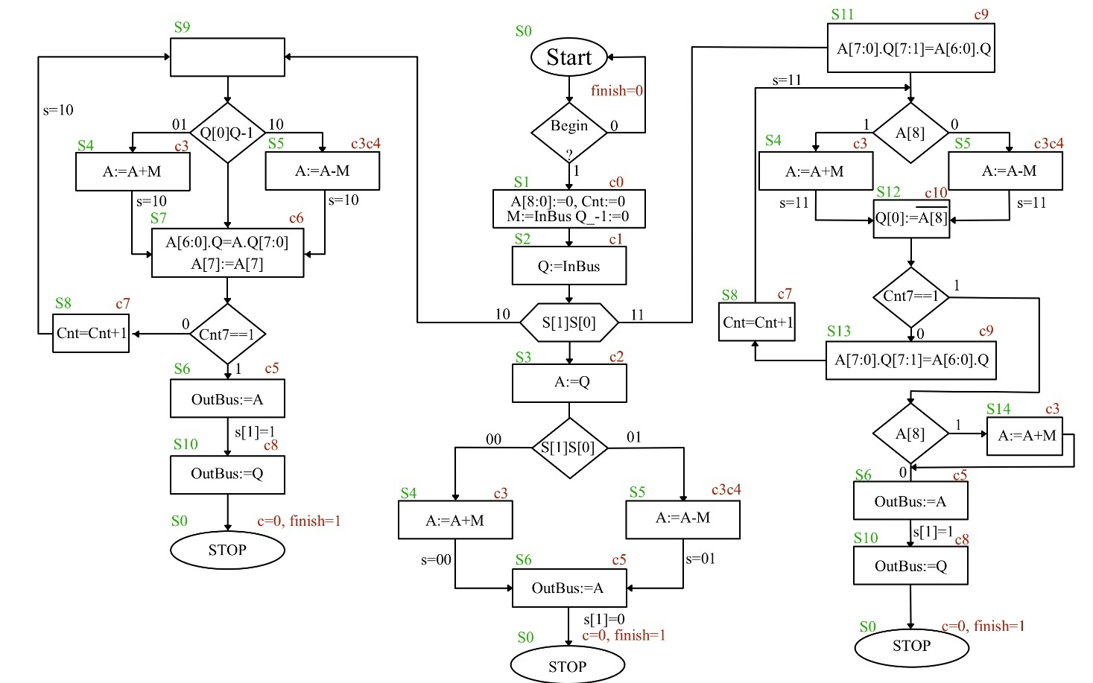
- Implementation Phase

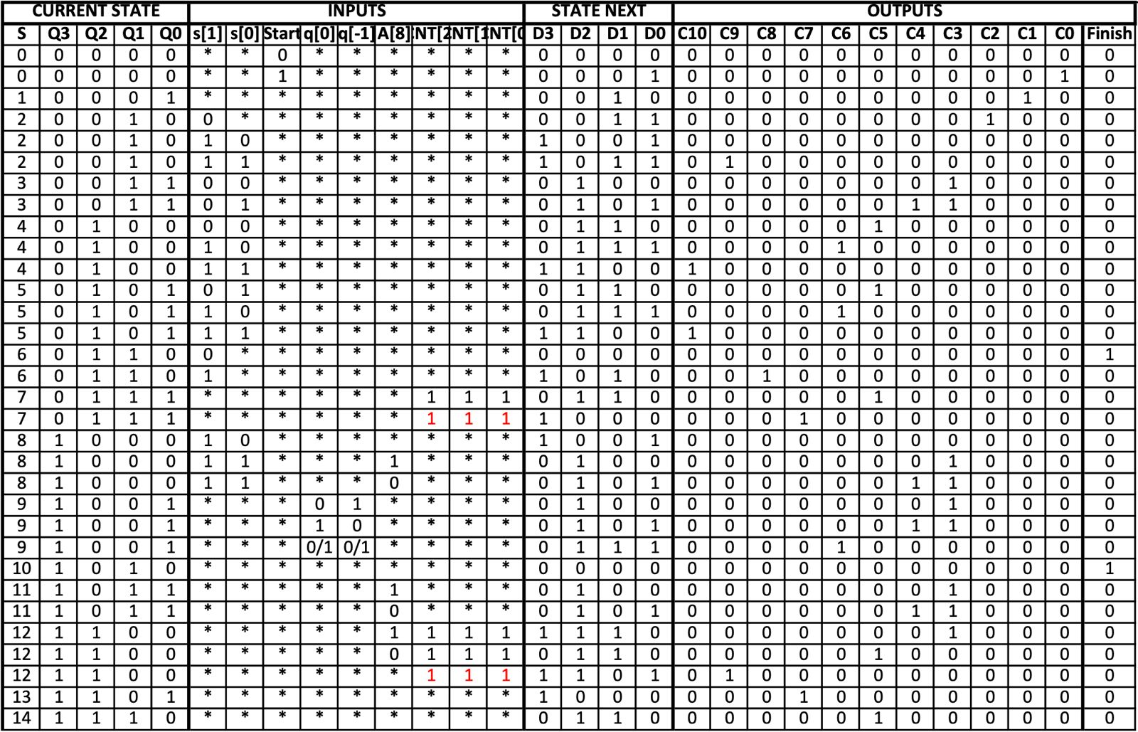
Truth table:

Each module was implemented in Verilog using modular and structural design principles.

✅ Code Example: Ripple Carry Adder (RCA.v)

module fac(

input x,y,ci,

output z,co

);

assign z=x^y^ci;

assign co=(x&y)|(x&ci)|(y&ci);

endmodule

module RCA(

input [8:0]x,y,

input ci,

output [8:0]z,

output co

);

wire w_co[8:0];

genvar i;

generate

for(i=0;i<9;i=i+1)

begin

if(i==0)

fac f(

.x(x[0]),

.y(y[0]),

.ci(ci),

.z(z[0]),

.co(w_co[0])

);

else if(i==8)

fac f(

.x(x[8]),

.y(y[8]),

.ci(w_co[7]),

.z(z[8]),

.co(co)

);

else

fac f(

.x(x[i]),

.y(y[i]),

.ci(w_co[i-1]),

.z(z[i]),

.co(w_co[i])

);

end

endgenerate

endmodule

✅ Code Snippet: ffd.v, A.v, Q.v, M.v, counter.v -> registers

These registers are implemented using data flip-flops and multiplexers.
module ffd (
input clk,rst_b,
input en,d,
output reg q
);

always@(posedge clk or negedge rst_b)
begin
if(!rst_b)
q<=1'b0;
else if(en)
q<=d;
end
endmodule

[…] –some more code

module mux_2s #(
parameter w=4
)(
input [w-1:0]d0,d1,d2,d3,
input [1:0] sel,
output [w-1:0]o
);
assign o=(sel==2'b00) ? d0:
(sel==2'b01) ? d1:
(sel==2'b10) ? d2:
(sel==2'b11) ? d3:{w{1'bz}};

endmodule

[…] – some more code

module A(
input clk,rst_b,
input q7,
input [1:0]sel,
input [8:0]in,
output[8:0]out

);

wire[8:0]mux_wire;

mux_2s#(.w(1)) m0(.d0(out[0]),.d1(out[1]),.d2(q7),.d3(in[0]),.sel(sel),.o(mux_wire[0]));
mux_2s#(.w(1)) m1(.d0(out[1]),.d1(out[2]),.d2(out[0]),.d3(in[1]),.sel(sel),.o(mux_wire[1]));
mux_2s#(.w(1)) m2(.d0(out[2]),.d1(out[3]),.d2(out[1]),.d3(in[2]),.sel(sel),.o(mux_wire[2]));
mux_2s#(.w(1)) m3(.d0(out[3]),.d1(out[4]),.d2(out[2]),.d3(in[3]),.sel(sel),.o(mux_wire[3]));
mux_2s#(.w(1)) m4(.d0(out[4]),.d1(out[5]),.d2(out[3]),.d3(in[4]),.sel(sel),.o(mux_wire[4]));
mux_2s#(.w(1)) m5(.d0(out[5]),.d1(out[6]),.d2(out[4]),.d3(in[5]),.sel(sel),.o(mux_wire[5]));
mux_2s#(.w(1)) m6(.d0(out[6]),.d1(out[7]),.d2(out[5]),.d3(in[6]),.sel(sel),.o(mux_wire[6]));
mux_2s#(.w(1)) m7(.d0(out[7]),.d1(out[7]),.d2(out[6]),.d3(in[7]),.sel(sel),.o(mux_wire[7]));
mux_2s#(.w(1)) m8(.d0(out[8]),.d1(out[8]),.d2(out[8]),.d3(in[8]),.sel(sel),.o(mux_wire[8]));

ffd f0(.clk(clk),.rst_b(rst_b),.en(1'b1),.d(mux_wire[0]),.q(out[0]));
ffd f1(.clk(clk),.rst_b(rst_b),.en(1'b1),.d(mux_wire[1]),.q(out[1]));
ffd f2(.clk(clk),.rst_b(rst_b),.en(1'b1),.d(mux_wire[2]),.q(out[2]));
ffd f3(.clk(clk),.rst_b(rst_b),.en(1'b1),.d(mux_wire[3]),.q(out[3]));
ffd f4(.clk(clk),.rst_b(rst_b),.en(1'b1),.d(mux_wire[4]),.q(out[4]));
ffd f5(.clk(clk),.rst_b(rst_b),.en(1'b1),.d(mux_wire[5]),.q(out[5]));
ffd f6(.clk(clk),.rst_b(rst_b),.en(1'b1),.d(mux_wire[6]),.q(out[6]));
ffd f7(.clk(clk),.rst_b(rst_b),.en(1'b1),.d(mux_wire[7]),.q(out[7]));
ffd f8(.clk(clk),.rst_b(rst_b),.en(1'b1),.d(mux_wire[8]),.q(out[8]));

endmodule

Note: Q, M Register are implemented similarly!

module counter (
input clk,rst_b,c_up,
output [2:0]out
);

ffd f0(.clk(clk),.rst_b(rst_b),.en(c_up),.d(~out[0]),.q(out[0]));
ffd f1(.clk(clk),.rst_b(rst_b),.en(c_up),.d(out[0]^out[1]),.q(out[1]));
ffd f2(.clk(clk),.rst_b(rst_b),.en(c_up),.d(out[2]&(~out[1]) | out[2]&(~out[0]) | (~out[2])&out[1]&out[0]),.q(out[2]));
endmodule

✅ Control Unit (Control_Unit.v)

module Control_Unit(
input clk,rst_b,
input [1:0]s,
input start,q0,q_1,a_8,
input [2:0]cnt,
output [10:0]c,
output finish
);

wire [3:0] qout;
ffd f3(.clk(clk),.rst_b(rst_b),.en(1'b1),
.d(
~qout[3]&~qout[2]&qout[1]&~qout[0]&s[1]&~s[0]
| ~qout[3]&~qout[2]&qout[1]&~qout[0]&s[1]&s[0]
| ~qout[3]&qout[2]&~qout[1]&~qout[0]&s[1]&s[0]
| ~qout[3]&qout[2]&~qout[1]&qout[0]&s[1]&s[0]
| ~qout[3]&qout[2]&qout[1]&~qout[0]&s[1]
| ~qout[3]&qout[2]&qout[1]&qout[0]&~(cnt[2]&cnt[1]&cnt[0])
| qout[3]&~qout[2]&~qout[1]&~qout[0]&s[1]&~s[0]
| qout[3]&qout[2]&~qout[1]&~qout[0]&a_8&cnt[2]&cnt[1]&cnt[0]
| qout[3]&qout[2]&~qout[1]&~qout[0]&~(cnt[2]&cnt[1]&cnt[0])
| qout[3]&qout[2]&~qout[1]&qout[0]
),
.q(qout[3]));

ffd f2(.clk(clk),.rst_b(rst_b),.en(1'b1),
.d(
~qout[3]&~qout[2]&qout[1]&qout[0]&~s[1]&~s[0]
| ~qout[3]&~qout[2]&qout[1]&qout[0]&~s[1]&s[0]
| ~qout[3]&qout[2]&~qout[1]&~qout[0]&~s[1]&~s[0]
| ~qout[3]&qout[2]&~qout[1]&~qout[0]&s[1]&~s[0]
| ~qout[3]&qout[2]&~qout[1]&~qout[0]&s[1]&s[0]
| ~qout[3]&qout[2]&~qout[1]&qout[0]&~s[1]&s[0]
| ~qout[3]&qout[2]&~qout[1]&qout[0]&s[1]&~s[0]
| ~qout[3]&qout[2]&~qout[1]&qout[0]&s[1]&s[0]
| ~qout[3]&qout[2]&qout[1]&qout[0]&cnt[2]&cnt[1]&cnt[0]
| qout[3]&~qout[2]&~qout[1]&~qout[0]&s[1]&s[0]&a_8
| qout[3]&~qout[2]&~qout[1]&~qout[0]&s[1]&s[0]&~a_8
| qout[3]&~qout[2]&~qout[1]&qout[0]&~q0&q_1
| qout[3]&~qout[2]&~qout[1]&qout[0]&q0&~q_1
| qout[3]&~qout[2]&qout[1]&qout[0]&a_8
| qout[3]&~qout[2]&qout[1]&qout[0]&~a_8
| qout[3]&qout[2]&~qout[1]&~qout[0]&a_8&cnt[2]&cnt[1]&cnt[0]
| qout[3]&qout[2]&~qout[1]&~qout[0]&~a_8&cnt[2]&cnt[1]&cnt[0]
| qout[3]&qout[2]&~qout[1]&~qout[0]&~(cnt[2]&cnt[1]&cnt[0])
| qout[3]&~qout[2]&~qout[1]&qout[0]&(q0~^q_1)
| qout[3]&qout[2]&qout[1]&~qout[0]
),
.q(qout[2]));

ffd f1(.clk(clk),.rst_b(rst_b),.en(1'b1),
.d(
~qout[3]&~qout[2]&~qout[1]&qout[0]
| ~qout[3]&~qout[2]&qout[1]&~qout[0]&~s[1]
| ~qout[3]&~qout[2]&qout[1]&~qout[0]&s[1]&s[0]
| ~qout[3]&qout[2]&~qout[1]&~qout[0]&~s[1]&~s[0]
| ~qout[3]&qout[2]&~qout[1]&~qout[0]&s[1]&~s[0]
| ~qout[3]&qout[2]&~qout[1]&qout[0]&~s[1]&s[0]
| ~qout[3]&qout[2]&~qout[1]&qout[0]&s[1]&~s[0]
| ~qout[3]&qout[2]&qout[1]&~qout[0]&s[1]
| ~qout[3]&qout[2]&qout[1]&qout[0]&cnt[2]&cnt[1]&cnt[0]
| qout[3]&qout[2]&~qout[1]&~qout[0]&a_8&cnt[2]&cnt[1]&cnt[0]
| qout[3]&qout[2]&~qout[1]&~qout[0]&~a_8&cnt[2]&cnt[1]&cnt[0]
| qout[3]&~qout[2]&~qout[1]&qout[0]&(q0~^q_1)
| qout[3]&qout[2]&qout[1]&~qout[0]
),
.q(qout[1]));

ffd f0(.clk(clk),.rst_b(rst_b),.en(1'b1),
.d(
~qout[3]&~qout[2]&~qout[1]&~qout[0]&start
| ~qout[3]&~qout[2]&qout[1]&~qout[0]&~s[1]
| ~qout[3]&~qout[2]&qout[1]&~qout[0]&s[1]&~s[0]
| ~qout[3]&~qout[2]&qout[1]&~qout[0]&s[1]&s[0]
| ~qout[3]&~qout[2]&qout[1]&qout[0]&~s[1]&s[0]
| ~qout[3]&qout[2]&~qout[1]&~qout[0]&s[1]&~s[0]
| ~qout[3]&qout[2]&~qout[1]&qout[0]&s[1]&~s[0]
| qout[3]&~qout[2]&~qout[1]&~qout[0]&s[1]&~s[0]
| qout[3]&~qout[2]&~qout[1]&~qout[0]&s[1]&s[0]&~a_8
| qout[3]&~qout[2]&~qout[1]&qout[0]&q0&~q_1
| qout[3]&~qout[2]&qout[1]&qout[0]&~a_8
| qout[3]&~qout[2]&~qout[1]&qout[0]&(q0~^q_1)
| qout[3]&qout[2]&~qout[1]&~qout[0]&~(cnt[2]&cnt[1]&cnt[0])
),
.q(qout[0]));

assign c[10]=~qout[3]&qout[2]&~qout[1]&~qout[0]&s[1]&s[0] | ~qout[3]&qout[2]&~qout[1]&qout[0]&s[1]&s[0];
assign c[9]=~qout[3]&~qout[2]&qout[1]&~qout[0]&s[1]&s[0] | qout[3]&qout[2]&~qout[1]&~qout[0]&~(cnt[2]&cnt[1]&cnt[0]);
assign c[8]=~qout[3]&qout[2]&qout[1]&~qout[0]&s[1];
assign c[7]=~qout[3]&qout[2]&qout[1]&qout[0]&~(cnt[2]&cnt[1]&cnt[0]) | qout[3]&qout[2]&~qout[1]&qout[0];
assign c[6]=~qout[3]&qout[2]&~qout[1]&~qout[0]&s[1]&~s[0] | ~qout[3]&qout[2]&~qout[1]&qout[0]&s[1]&~s[0] | qout[3]&~qout[2]&~qout[1]&qout[0]&(q0^~q_1);
assign c[5]=~qout[3]&qout[2]&~qout[1]&~qout[0]&~s[1]&~s[0]
| ~qout[3]&qout[2]&~qout[1]&qout[0]&~s[1]&s[0]
| ~qout[3]&qout[2]&qout[1]&qout[0]&cnt[2]&cnt[1]&cnt[0]
| qout[3]&qout[2]&~qout[1]&~qout[0]&~a_8&cnt[2]&cnt[1]&cnt[0]
| qout[3]&qout[2]&qout[1]&~qout[0];
assign c[4]=~qout[3]&~qout[2]&qout[1]&qout[0]&~s[1]&s[0] | qout[3]&~qout[2]&~qout[1]&~qout[0]&s[1]&s[0]&~a_8 | qout[3]&~qout[2]&~qout[1]&qout[0]&q0&~q_1 | qout[3]&~qout[2]&qout[1]&qout[0]&~a_8;
assign c[3]=~qout[3]&~qout[2]&qout[1]&qout[0]&~s[1]&~s[0]
| ~qout[3]&~qout[2]&qout[1]&qout[0]&~s[1]&s[0]
| qout[3]&~qout[2]&~qout[1]&~qout[0]&s[1]&s[0]&a_8
| qout[3]&~qout[2]&~qout[1]&~qout[0]&s[1]&s[0]&~a_8
| qout[3]&~qout[2]&~qout[1]&qout[0]&~q0&q_1
| qout[3]&~qout[2]&~qout[1]&qout[0]&q0&~q_1
| qout[3]&~qout[2]&qout[1]&qout[0]&a_8
| qout[3]&~qout[2]&qout[1]&qout[0]&~a_8
| qout[3]&qout[2]&~qout[1]&~qout[0]&a_8&cnt[2]&cnt[1]&cnt[0];
assign c[2]=~qout[3]&~qout[2]&qout[1]&~qout[0]&~s[1];
assign c[1]=~qout[3]&~qout[2]&~qout[1]&qout[0];
assign c[0]=~qout[3]&~qout[2]&~qout[1]&~qout[0]&start;
assign finish=~qout[3]&qout[2]&qout[1]&~qout[0]&~s[1] | qout[3]&~qout[2]&qout[1]&~qout[0];

endmodule

✅ Top Module (ALU.v)
`include"../RCA/RCA.v"
`include"../Control_Unit/Control_Unit_Structural.v"
`include"../Registers/A.v"
`include"../Registers/Q.v"
`include"../Registers/M.v"
`include"../Registers/combinational.v"
`include"../Registers/ffd.v"
`include"../Registers/counter.v"

module ALU (
input clk,rst_b,start,
input[1:0]s,
input [7:0]inbus,
output [7:0]outbus,
output overflow,
output finish
);
wire [7:0]q_out,m_out;
wire [8:0]a_out;
wire [2:0]cnt_out;
wire q_1out;
wire [10:0]c;
wire [8:0]z;
wire overfl;
A regA(.clk(clk),.rst_b(rst_b),.q7(q_out[7]),.sel( {c[0]|c[2]|c[3]|c[9], c[0]|c[2]|c[3]|c[6]}),.in({9{c[0]}}&9'd0 | {9{c[2]}}&q_out | {9{c[3]}}&z),.out(a_out));
Q regQ(.clk(clk),.rst_b(rst_b),.a0(a_out[0]),.sel( {c[1]|c[9]|c[10] , c[1]|c[6]|c[10]} ),.in({8{c[1]}}&inbus | {q_out[7:1],(~a_out[8])}&{8{c[10]}} ),.out(q_out),.q_1(q_1out));
M regM(.clk(clk),.rst_b(rst_b),.en(c[0]),.in(inbus),.out(m_out));
RCA adder(.x({1'b0,m_out} ^ {9{c[4]}}),.y(a_out),.ci(c[4]),.z(z),.co(),.overflow(overfl));
counter COUNT(.clk(clk),.rst_b(rst_b),.c_up(c[7]),.out(cnt_out));
Control_Unit CU(.clk(clk),.rst_b(rst_b),.s(s),.start(start),.q0(q_out[0]),.q_1(q_1out),.a_8(a_out[8]),.cnt(cnt_out),.c(c),.finish(finish));

assign outbus={1'b0,{8{c[5]}}}&a_out | {{8{c[8]}}}&q_out;
assign overflow=overfl & ~s[1] & c[3];

endmodule
Handles integration of all modules and signal routing.

- Testing Phase
Each module was verified with a dedicated testbench:

Arithmetic Logic Unit’s Testbench:
`timescale 1ns/1ps
`include "ALU.v"
module ALU_tb;
reg clk,rst_b,start;
reg[1:0]s;
reg [7:0]inbus;
wire[7:0]outbus;
wire finish;

ALU alu(
.clk(clk),
.rst_b(rst_b),
.start(start),
.s(s),
.inbus(inbus),
.outbus(outbus),
.finish(finish)
);

initial begin
$dumpfile("dump.vcd");
$dumpvars;
clk=0;
rst_b=1;
start=0;
inbus=0;
end

initial begin
#10; rst_b=0;
#20; rst_b=1;
end

integer i;
initial begin
for(i=0;i<100;i=i+1)
begin
#50; clk=~clk;
end
#50;
end

initial begin
#180; start=1;
#80; start=0;
end

initial begin
s=2'b01;
#100;
#230; inbus=8'b00111001; // inbus=8'b00111001;//M 57
#90; inbus=8'b01010110; // inbus=8'b01010110; //Q 86
//#230; inbus=8'b10100001;//M -119 inmultire
//#90; inbus=8'b10001001;//Q -95 inmultire
//#250; inbus=8'b01011001;//M 89 inmultire
//#100; inbus=8'b10011111;//Q -97 inmultire
//#250; inbus=8'b10100011;//M -93 inmultire
//#100; inbus=8'b10001101;//Q -115 inmultire
//#250; inbus=8'b10100011;//M 13 impartire
//#100; inbus=8'b10001101;//Q 217 impartire

end

endmodule

Control Unit’s Testbench:
`timescale 1ns/1ps
`include "Control_Unit.v"
module Control_Unit_tb;
reg clk,rst_b;
reg [1:0]s;
reg start,q0,q_1,a_8; //q_neg1 e q[-1],begin e start
reg [2:0]cnt;
wire [11:0]c;
wire finish;

Control_Unit con(
.clk(clk),
.rst_b(rst_b),
.s(s),
.start(start),
.q0(q0),
.q_1(q_1),
.a_8(a_8),
.cnt(cnt),
.c(c),
.finish(finish)
);

initial begin
$dumpfile("dump.vcd");
$dumpvars;
clk=0;
rst_b=0;
s=11;
start=0;
q0=0;
q_1=1;
a_8=0;
cnt=7;
#50;
end
initial begin
#25; rst_b=~rst_b;
end

initial begin
#180; start=1;
#80; start=0;
end

integer j;
initial begin
for(j=1;j<=100;j=j+1)
begin
#50; clk=~clk;
end
#50;
end

initial begin
$display("TIME\ts\tstart\tq0\tq_1\ta_8\tcnt\tc\t\tcurrent_state\tnext_state\tfinish");
$monitor("%0t\t%b\t%b\t%b\t%b\t%b\t%b\t%b\t%d\t\t%d\t\t%b",$time,s,start,q0,q_1,a_8,cnt,c,con.st,con.st_next,finish);
end
endmodule

- Simulation Output
Waveform for Subtraction (Without Overflow):
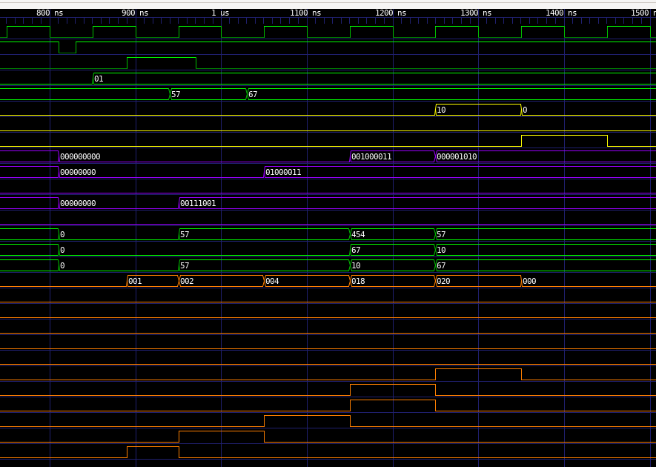
Waveform for Subtraction (Including Overflow):
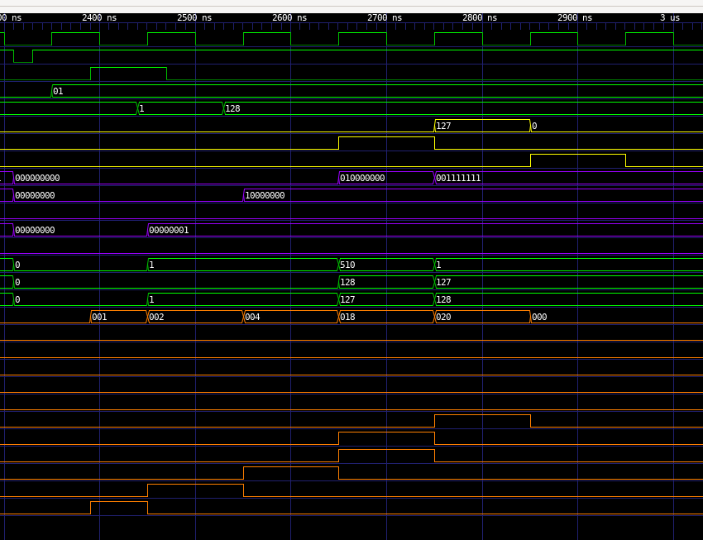
Waveform for Addition (including Overflow):
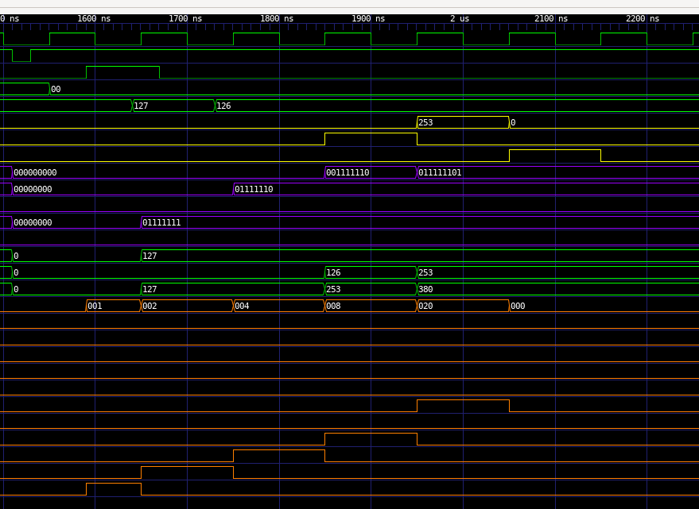
Waveform for Addition (without Overflow):
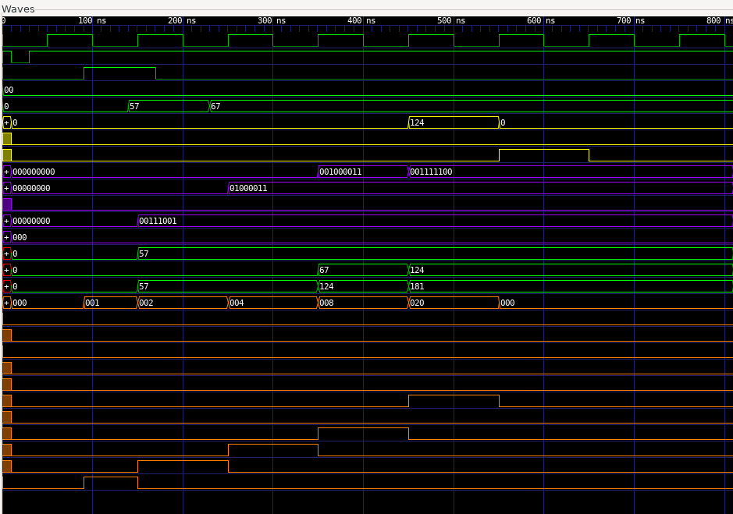

- Logisim Architecture Diagrams
Include screenshots of the Logisim circuit with labeled buses and control flow.
Full Adder Cell:
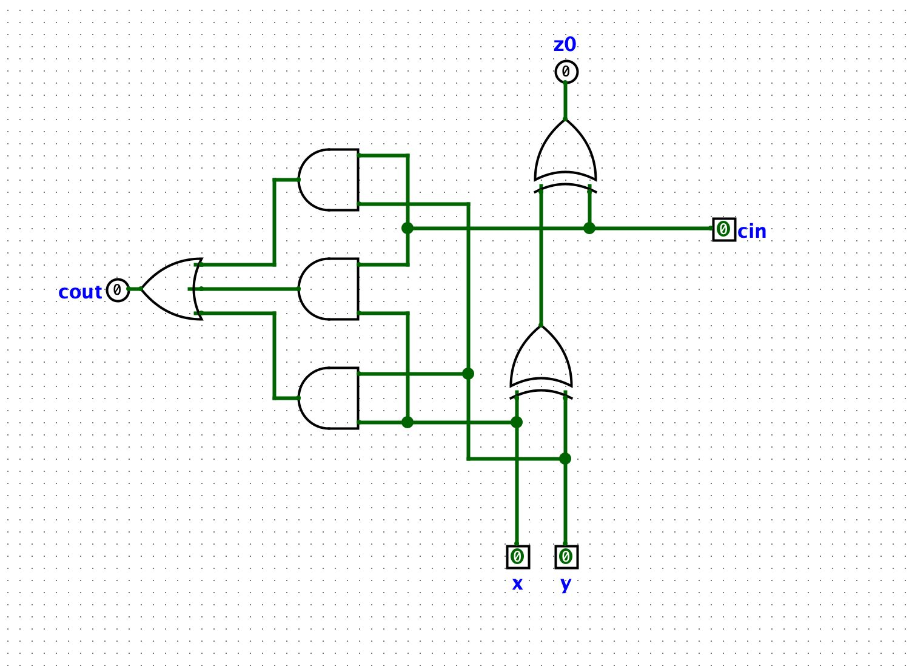
Adder/Subtracter:
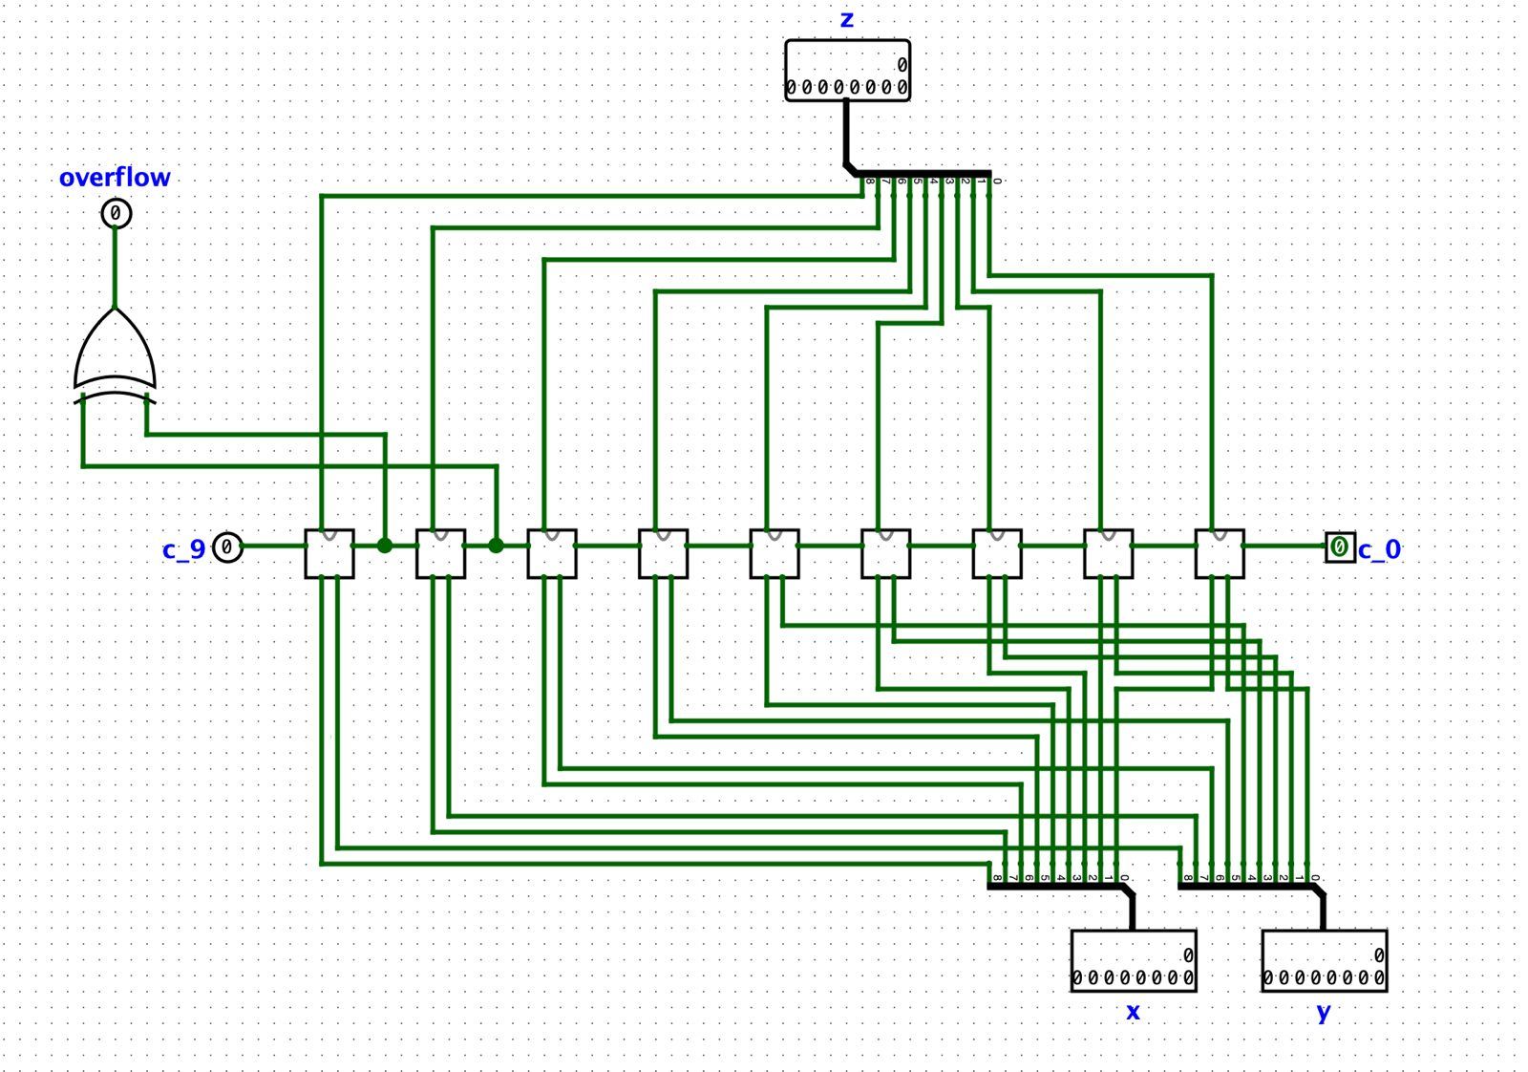
A Register:
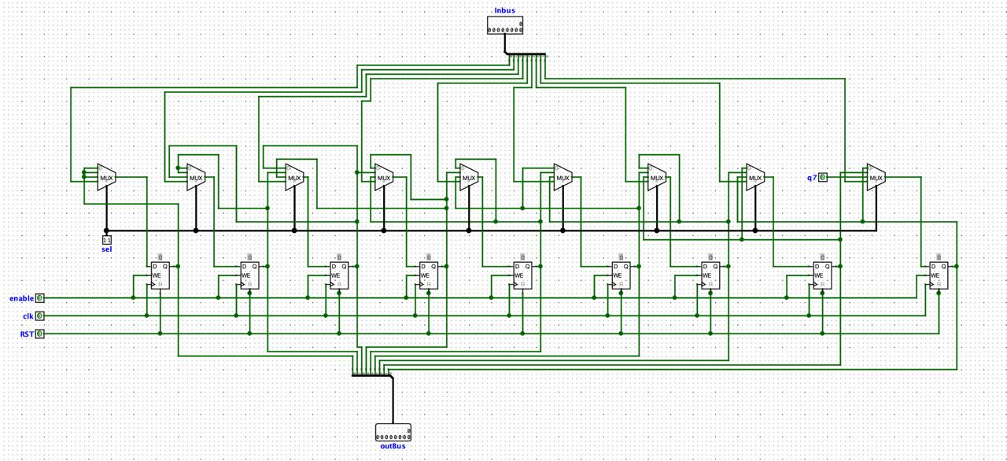

Q Register:

Q Register:
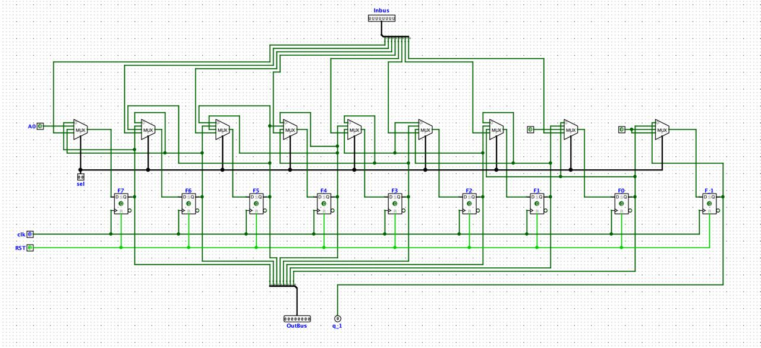

M Register:
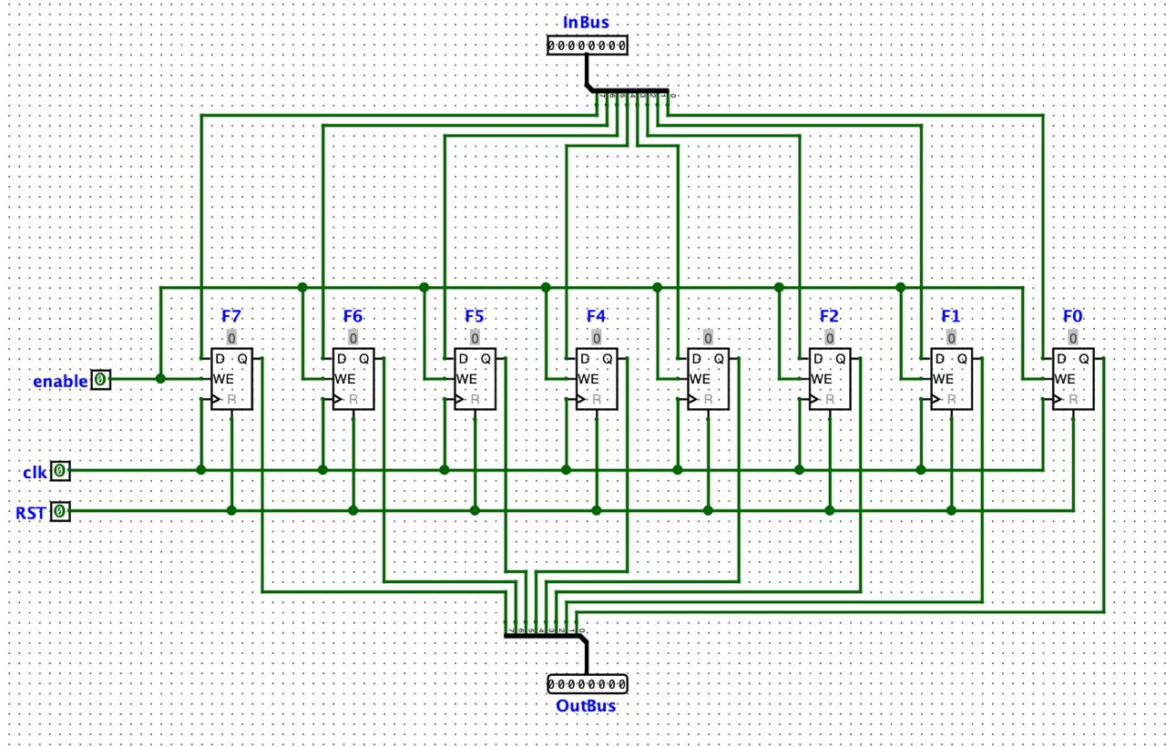

Counter:
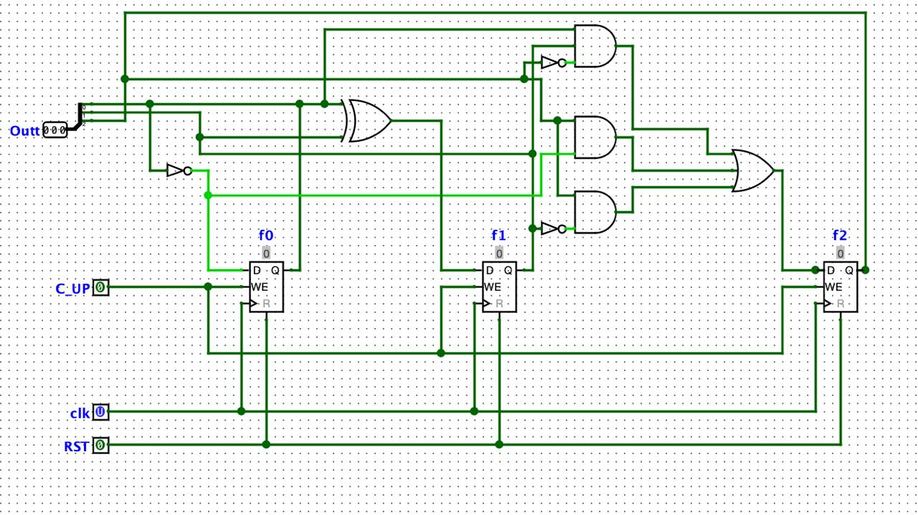

Control Unit:

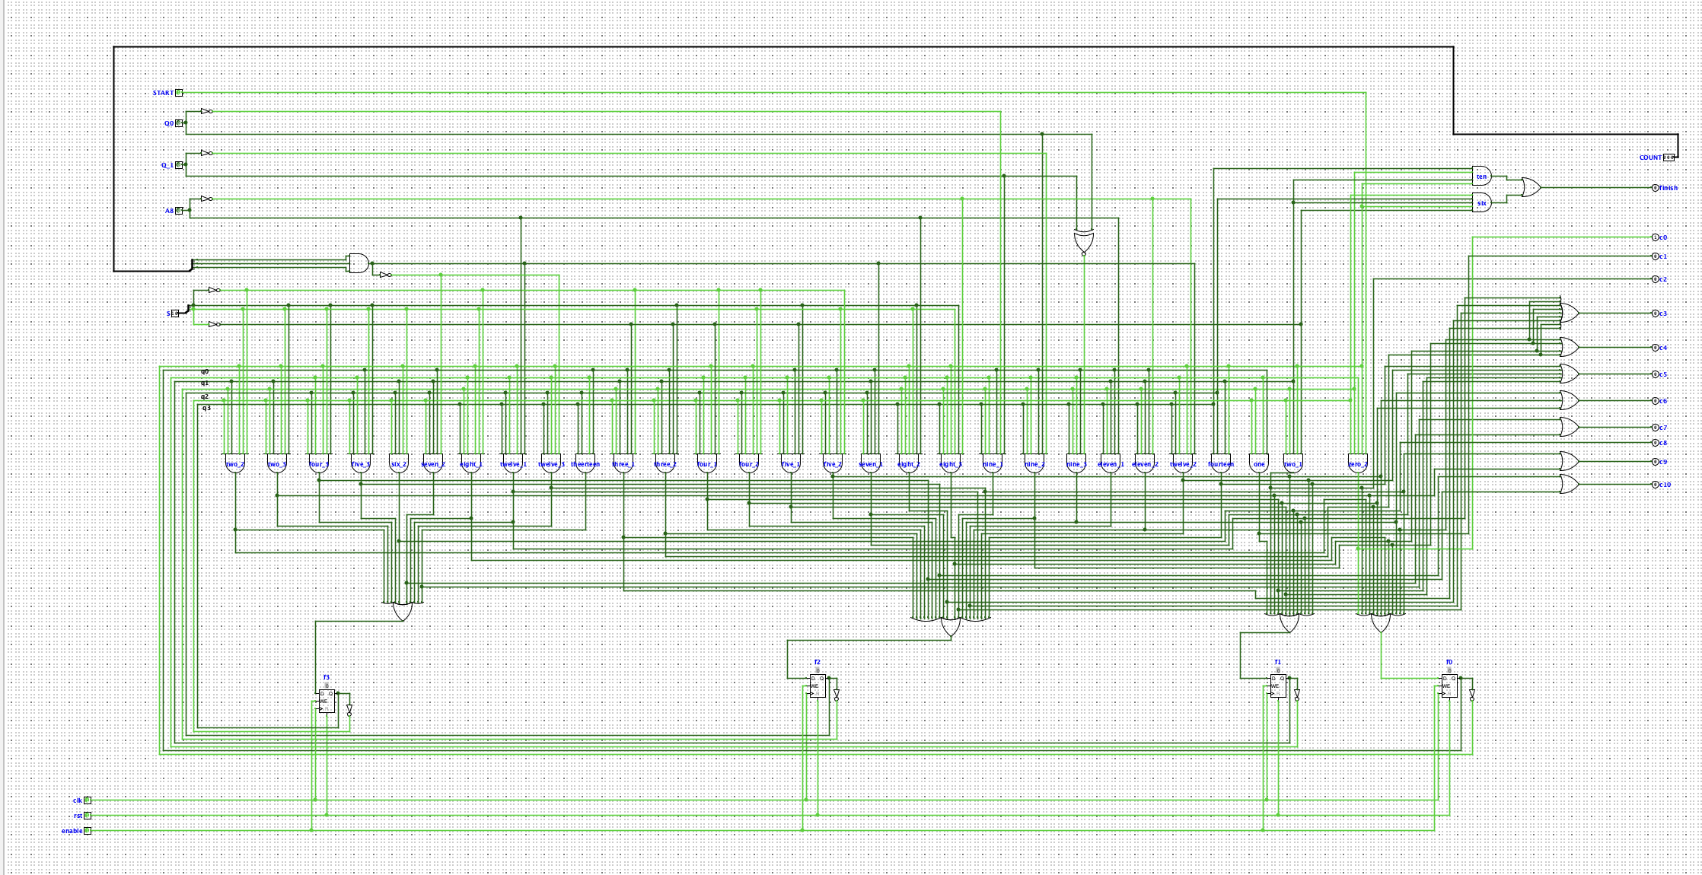

Arithmetic Logic Unit:
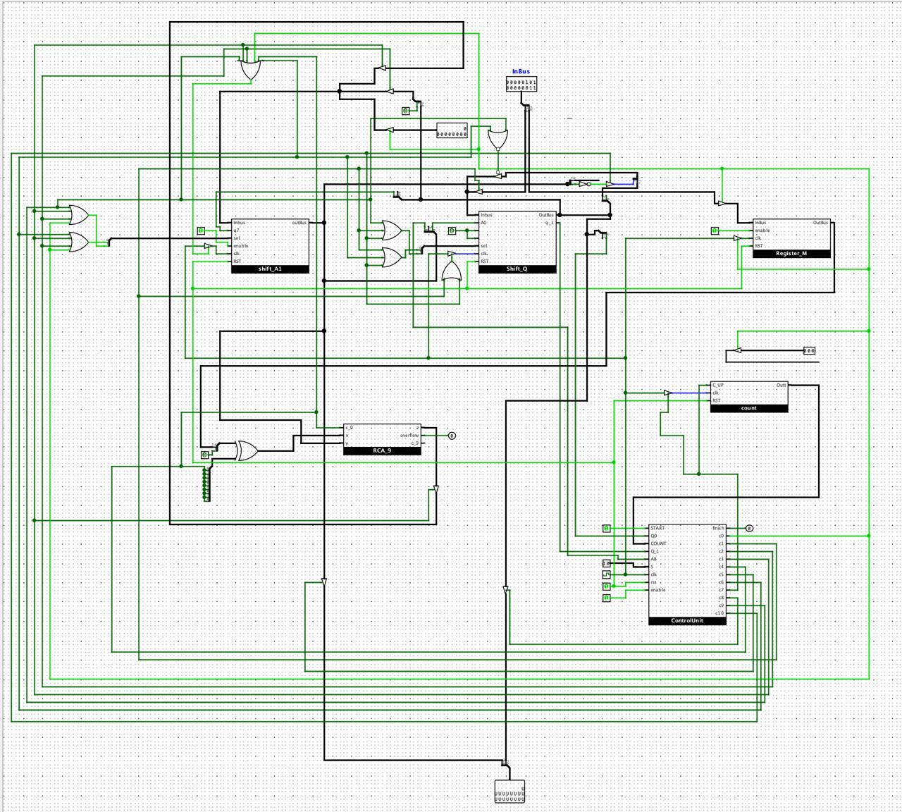

- Challenges & Resolutions
Challenge | Resolution
Sign extension in Booth logic | Add arithmetic right shift and sign bit mask
Glitches in Logisim control (signal processing errors, oscillation apparent) | Synchronize clock with the respective signal for the specific operation
Verilog module order confusion | Modular top-level ALU.v for clean instancing
Write code without if-cases and build it structurally with logic gates | Implement the truth table and write feedback equations based on it
Insufficient time for writing and reading in a single clock cycle | Add one empty state for simulating clock cycle delay

- Conclusion

This project successfully built and simulated a modular 8-bit ALU capable of performing key arithmetic operations. The use of structural Verilog and Logisim gave a dual-layered insight—both visual and code-based—into hardware design.

