### User Login:

* User should be able to login with valid credentials.
* If username or password is invalid, show an error message.

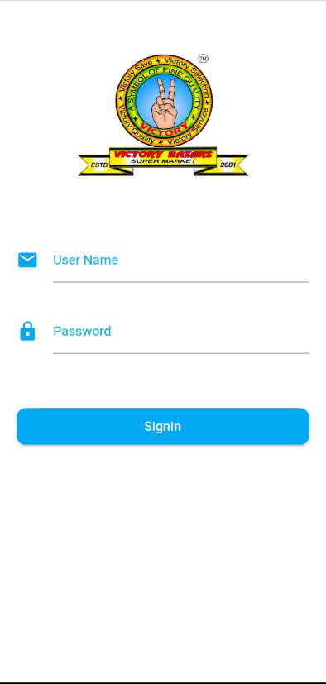

# Main Menu:

There should 3 buttons to navigate further.

* Stock Entry
* Stock Counting
* Stock Dispatch

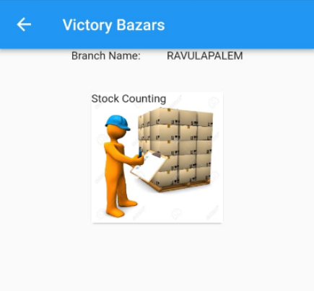

### Stock Entry

* User will select Supplier Name and Invoice Number.
* There should be a button add a new item.
* On clicking of new, it should navigate to item entry.
* On saving entry it should add to list of invoice items.
* There should an option to delete entry.
* There should be an option to edit entry.

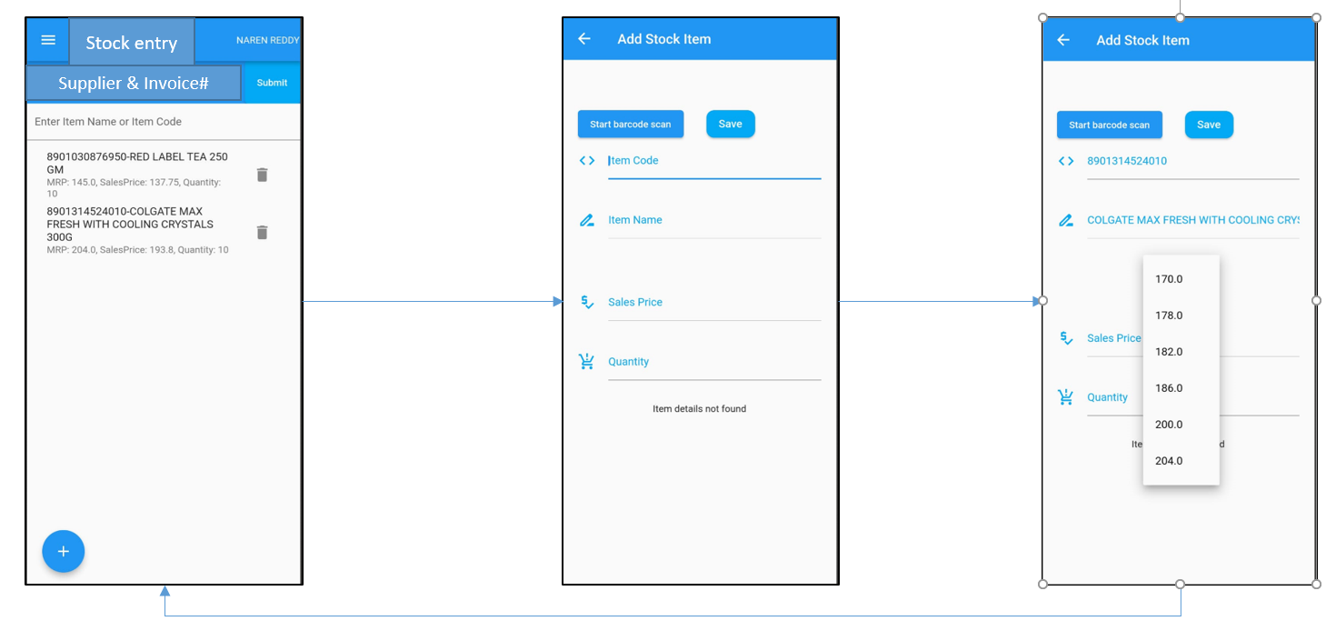

# Stock Entry, Stock Dispatch, Stock Counting

* Check the feasibility to scan 2D barcode using mobile camera.
* If Mobile camera cannot read 2D barcodes, user will connect handheld barcode scanner using OTG connector and scans the 2D barcode on the product.
* On clicking of new stock entry button on home, form should be navigated to item list as per the below mock-up screen.
* On clicking of new button, a new form should be available to enter item details.
* Scanned item details should have fetched from database and show in item name text box. App should also check the validation; weather item exists or not.

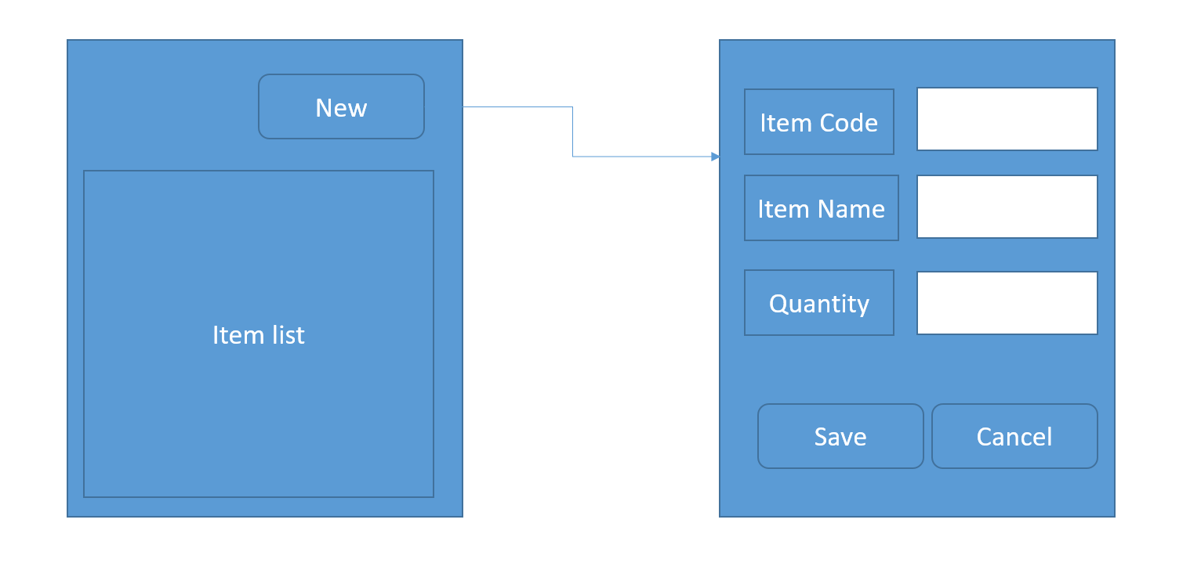

Same should be available for stock dispatch and stock audit.

Once this is completed later we can look into billing.