1. When a code is entered, There can multiple ITEM Codes under it, so first we will show item code selection and when an item code is selected there can be more than item prices, then we will show price selection

For ex: when code “1011130” is given, there will more than one item codes

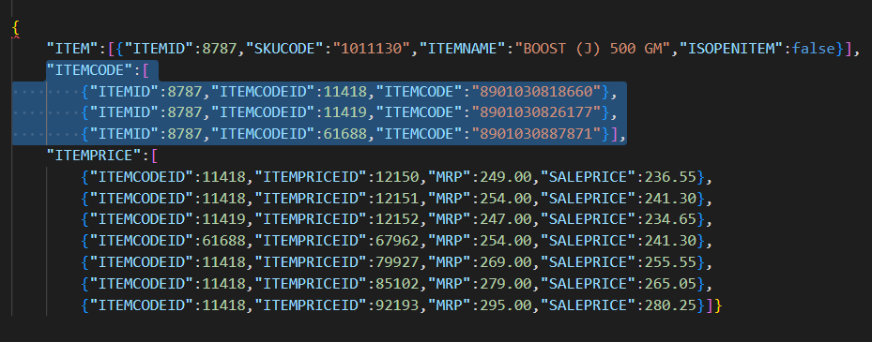

In the above example, user needs to select from the three item codes listed, and after selection we will be showing item prices selection if there are more than one prices available

1. Enable Quantity or Weight in kgs

When Item code is scanned, we will get a field ISOPENITEM which will be 1 or 0. Can be casted as Boolean. Weight in KGS should be enabled when ISOPENITEM is true, else Quantity should be enabled

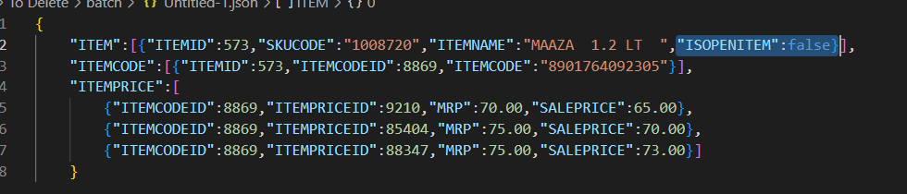

1. Fields to be filled after code & price selection: Item Code, Item Name, MRP, Sale Price, GST Code, HSN Code
2. CP with Tax & CP W/O Tax will be based on Tax Inclusive

In the first screen when enter the Supplier, Invoice # and Invoice date fields, we have a check-box Tax Inclusive. When Tax inclusive is checked, CP with Tax should be enabled and CP W/O Tax should be disabled. When Tax Inclusive is unchecked then it’s the opposite, i.e., CP W/O Tax will be enabled and CP with Tax will be disabled

1. CP with Tax & CP W/O Tax calculation

When CP with Tax is enabled and value is given, CP W/O Tax should be calculated and filled and vice versa.

CP with Tax = CP W/O Tax + (CP W/O Tax \* GST%) => Rounded to 4 digits

CP W/O Tax = CP with Tax - (CP with Tax \* GST%) => Rounded to 4 digits

1. Enable Free Quantity only if Free Item code is selected. Should this be a drop down or text box we will decide so let’s just keep it text box as of now where you can enter numbers or scan barcode. Once a code is scanned for value is entered, we call the same GetItemCode api and keep the ITEMCODEID
2. Discount %, Discount flat & Scheme %, scheme flat will always be enabled. As usual, % fields should allow number between 0.00 and 100.00.
3. GST Code should be a dropdown and will provide an API for list of values
4. Applied GST will be read only calculated field.

Formula :

Quantity = if IsOpenItem then weightInkgs else quantity;

totalPriceWT = cost price with Tax \* quantity;

totalPriceWOT = cost price W/O Tax \* quantity;

appliedDiscount = if discountFlat > 0 then discountFlat

else if discountPer > 0

then Math.Round(totalPriceWOT \* (discountPer / 100), 4)

else 0;

appliedScheme = if schemeFlat > 0 then schemeFlat

else if schemePer > 0

then Math.Round(totalPriceWOT \* (schemePer / 100), 4)

else 0;

finalPriceWOT = totalPriceWOT - appliedDiscount - appliedScheme;

finaPriceWT = totalPriceWT - appliedDiscount - appliedScheme;

finalPriceToConsider = if TAXINCLUSIVE then finaPriceWT else finalPriceWOT;

CGST = if ISIGST = 0 then Math.Round(finalPriceToConsider \* CGST% / 100, 2) else 0;

SGST = if ISIGST = 0 then Math.Round(finalPriceToConsider \* CGST% / 100, 2) else 0;

IGST = if ISIGST = 1 then Math.Round(finalPriceToConsider \* CGST% / 100, 2) else 0;

CESS= Math.Round(finalPriceToConsider \* CESS% / 100, 2);

AppliedGST = CGST + SGST + IGST + CESS

finalPrice = if TAXINCLUSIVE then finaPriceWT else finalPriceWOT + Applied GST;