|  |
| --- |
| Dualcab  Team meeting |
| Minutes: |
| January 10, 2023  Authored by: Lachlan Neilsen |

Referencing:

* Use EndNote: this is free through RMIT
* Also download RMIT Harvard file
* The addon for word is a worthwhile integration

MS-Teams:

* Most conversations should go in the DualCab Team chat. This will make our submission easier

Git:

* Regularly Fetch/Commit/Push
* Descriptive comments on all commits. This will be marked
* Always check if anyone has made commits, so that your working copy does not become superseded
* Communication in teams about what we are working on/which files we have checked out
* Meeting Recordng: 7:00 minutes : Alex shared his screen, and we discussed Git and how to track changes. This may be worth reviewing if anyone need it
* From GitHub website: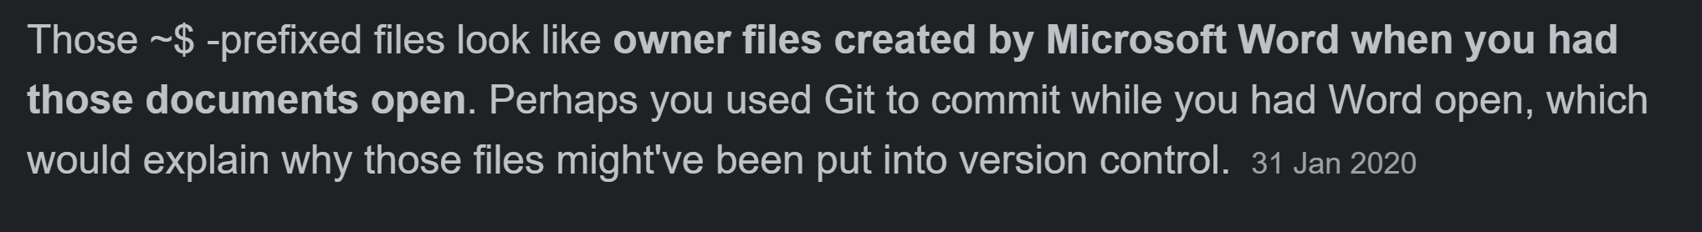
* We need everyones name to show up regularly in Git history
* If you make any errors, changes can be discarded

Web:

* We may use JSON for storing some data
* Ida will look into html modules
* If JSON doesn’t work, we will code it into .js
* Not a lot of info ready. We need to catch up on content
* Perfect “index.html” first
* Modal window can be used for some content (see “index.html”)
* Appendices on their own page

Nathan/Interview:

* We need to ask if we can use his image
* We can compliment this with stock images
* Format: *Q&A* non-verbatim report
* Christ will have this finished soon

Editing:

* Aim to edit one document per day
* Everyone should contribute to editing
* Check both content and references
* Everything should be compared to rubric