Contents

Introduction 2

Package 2

BSP application 2

View 3

Page attributes 5

Layout 5

Controller 5

Class 6

Attributes 8

Internal types 10

Methods 12

Overloaded methods 12

DO_REQUEST 12

Additionnal methods 14

ZCPWR_ANALYSE_SCI_DATA 15

SEARCH_FUNCTION 17

SEARCH_METHOD 18

SEARCH_PROG 18

SEARCH_INCLUDE 19

Summary 20

Test 21

Request 21

Response 21

# Introduction

This document describes the steps involved to implement the CAQS SAP bridge.

This bridge is used to remotely trigger SCI transaction from a client HTTP connexion and return code analysis results in a CSV (comma separated values) format.

# Package

Create a package named « ZCPWR_PACK_INSP ».

## BSP application

In this package, create a BSP application named “ZCPWR_INSPBIS”.

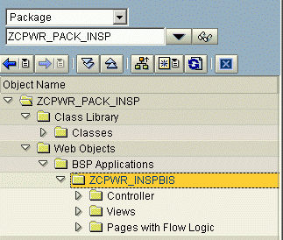

### View

In the ZCPWR_INSPBIS BSP application, create a view and name it “ZCPWR_extract_resultsbis.csv”.

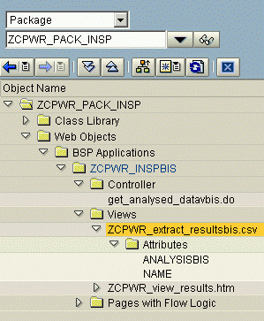

NB: Make sure it has “ZCPWR_EXTRACT_SCI_DATABIS” as its controller class.

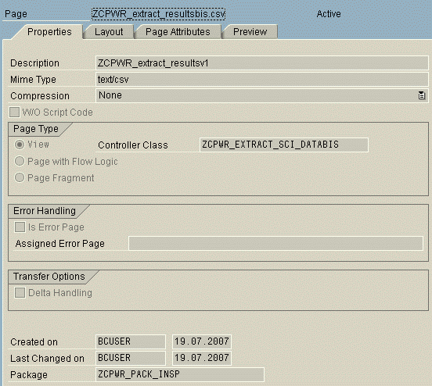

#### Page attributes

Add the following page attributes:

|  |  |  |
| --- | --- | --- |
| **Attribute** | **TypingMeth** | **Associated Type** |
| analysisbis | TYPE | SCIT_REST |
| name | TYPE | CHAR20 |

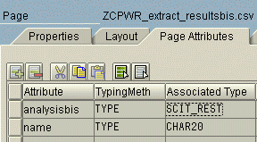

#### Layout

Insert the following layout content:

<%@page language="abap"%>

<%

data ana_line like line of analysisbis.

loop at analysisbis into ana_line.

%>

<%= ana_line-test.%>;<%= ana_line-objname.%>;<%= ana_line-objtype.%>;<%= ana_line-sobjname.%>;<%= ana_line-sobjtype.%>;<%= ana_line-PARAM1.%>;<%= ana_line-line.%>;<%= ana_line-kind.%><%endloop.%>

### Controller

In this BSP, create a controller and name it « get_analysed_datavbis.do ».

## Class

Create the associated controller class as “ZCPWR_EXTRACT_SCI_DATABIS”.

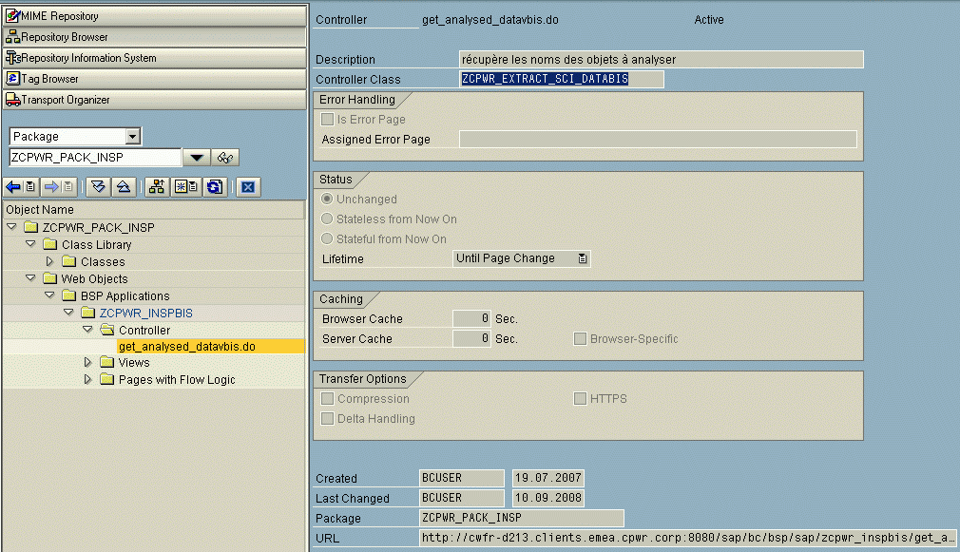

NB: this controller class must extend « CL_BSP_CONTROLLER2”.

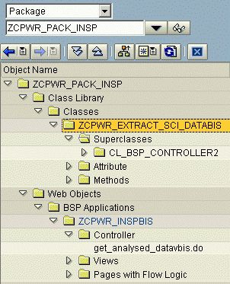

### Attributes

Add the following attributes :

|  |  |  |  |  |
| --- | --- | --- | --- | --- |
| Attribute | Level | Visibility | Typing | Associated type |
| OBJ_NAME | Static Attribute | Public | Type | CHAR40 |
| OBJ_TYPE | Static Attribute | Public | Type | CHAR20 |
| S_DATA | Instance Attribute | Private |  |  |
| P_OBJECTS | Static Attribute | Private | Type | SCIT_OBJS |
| LINE_OBJECTS | Static Attribute | Private | Type | SCIR_OBJS |
| T_DATA | Instance Attribute | Private |  |  |
| T_INCLUDE | Instance Attribute | Private | Like | T_DATA |
| P_RESULTS | Static Attribute | Private | Type | SCIT_REST |
| ANALYSIS | Static Attribute | Private | Type | SCIT_REST |
| LT_TAB | Static Attribute | Private | Type | CHAR30 |

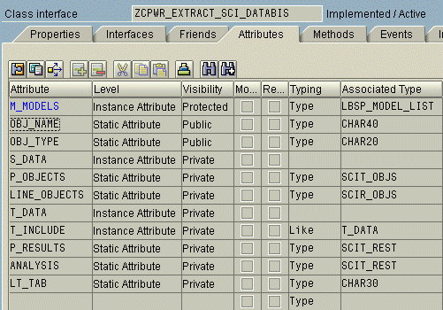

### Internal types

Add the following internal types :

|  |  |
| --- | --- |
| **Type** | **Visibility** |
| RESULTS | Protected |
| T_REP_SOURCE | Private |

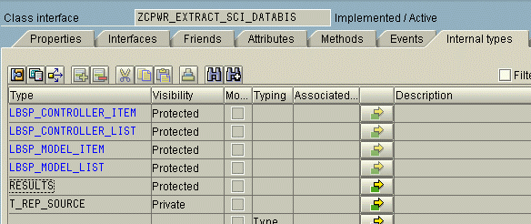

Create the following definition for type “RESULTS”:

*"* protected components of class ZCPWR_EXTRACT_SCI_DATA

*"* do not include other source files here!!!

protected section.

types:

BEGIN OF results,

object_type TYPE char04,

object_name TYPE string,

subobject_type TYPE char04,

subobject_name TYPE char40,

incl_name TYPE char40,

END OF results .

Create the following definition for type “T_REP_SOURCE”:

*"* private components of class ZCPWR_EXTRACT_SCI_DATA

*"* do not include other source files here!!!

private section.

types:

BEGIN OF t_rep_source,

line(10000),

END OF t_rep_source .

data:

BEGIN OF s_data,

object_type TYPE char04,

object_name TYPE string,

subobject_type TYPE char04,

subobject_name TYPE char40,

incl_name type char40,

END OF s_data .

class-data P_OBJECTS type SCIT_OBJS .

class-data LINE_OBJECTS type SCIR_OBJS .

data:

t_data LIKE TABLE OF s_data .

type-pools T .

data T_INCLUDE like T_DATA .

class-data P_RESULTS type SCIT_REST .

class-data ANALYSIS type SCIT_REST .

class-data LT_TAB type CHAR30 .

methods SEARCH_FUNCTION .

methods SEARCH_METHOD .

methods SEARCH_PROG .

methods SEARCH_INCLUDE

importing

!P_LINE type T_REP_SOURCE optional .

### Methods

#### Overloaded methods

Select method named “DO_REQUEST”,

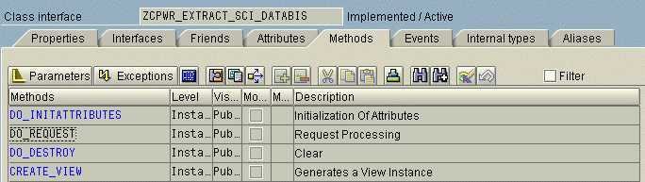

and overload it with the following code :

##### DO_REQUEST

METHOD DO_REQUEST.

obj_name = ''.

lt_tab = request->get_form_field( 'pkg' ).

TYPES: BEGIN OF t_rep_source,

line(10000),

END OF t_rep_source.

DATA: l_i_prog_source TYPE TABLE OF t_rep_source ,

l_was TYPE t_rep_source.

DATA: "p_objects TYPE scit_objs,

line_objects TYPE scir_objs,

files TYPE TABLE OF tadir,

line LIKE LINE OF files.

TYPES: BEGIN OF tmethod,

cmpname TYPE char30,

descript TYPE char30,

exposure TYPE int4,

methodkey TYPE string,

END OF tmethod.

DATA : clsn TYPE seoclsname.

TYPES : BEGIN OF seop_method_w_include,

cpdkey TYPE seocpdkey,

incname TYPE programm,

END OF seop_method_w_include.

DATA methodline TYPE seop_method_w_include.

DATA seop_methods_w_include TYPE TABLE OF seop_method_w_include .

DATA: myview TYPE REF TO if_bsp_page.

myview = create_view( view_name = 'ZCPWR_extract_resultsbis.csv' ).

SELECT * FROM tadir INTO TABLE files.

LOOP AT files INTO line.

* IF line-author EQ 'BCUSER'.

IF line-devclass EQ lt_tab.

line_objects-objtype = line-object.

line_objects-objname = line-obj_name.

line_objects-responsibl = line-author.

line_objects-devclass = 'DEVEL'.

line_objects-prgname = ''.

INSERT line_objects INTO TABLE p_objects.

ENDIF.

ENDLOOP.

CALL METHOD search_function.

CLEAR line_objects.

CALL METHOD search_method.

CLEAR line_objects.

CALL METHOD search_prog.

IF t_data IS INITIAL.

ENDIF.

DATA previous TYPE char40.

previous = ''.

LOOP AT t_data INTO s_data.

IF s_data-object_type = 'FUGR' OR s_data-object_type = 'PROG'.

IF s_data-incl_name <> previous.

previous = s_data-incl_name.

obj_name = s_data-object_name.

obj_type = s_data-object_type.

REFRESH l_i_prog_source .

READ REPORT s_data-incl_name INTO l_i_prog_source .

CHECK sy-subrc = 0.

LOOP AT l_i_prog_source INTO l_was.

CALL METHOD search_include

EXPORTING

p_line = l_was.

ENDLOOP.

ENDIF.

ENDIF.

ENDLOOP.

write( '<html><body>' ).

myview->set_attribute( name = 'name' value = sy-uname ).

CALL METHOD zcpwr_analyse_sci_data.

myview->set_attribute( name = 'analysisbis' value = analysis ).

call_view( myview ).

write( '</body></html>' ).

ENDMETHOD.

#### Additionnal methods

Create the following additionnal methods:

|  |  |  |
| --- | --- | --- |
| **Methods** | **Level** | **Visibility** |
| ZCPWR_ANALYSE_SCI_DATA | Instance Method | Public |
| SEARCH_FUNCTION | Instance Method | Private |
| SEARCH_METHOD | Instance Method | Private |
| SEARCH_PROG | Instance Method | Private |
| SEARCH_INCLUDE | Instance Method | Private |

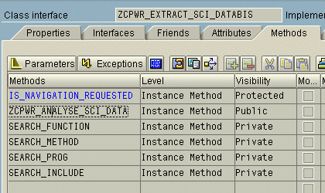

##### ZCPWR_ANALYSE_SCI_DATA

Insert the following code for method “ZCPWR_ANALYSE_SCI_DATA”:

METHOD ZCPWR_ANALYSE_SCI_DATA .

DATA: p_objects TYPE scit_objs,

line_objects TYPE scir_objs,

s_results TYPE scir_rest,

files TYPE TABLE OF tadir,

line LIKE LINE OF files,

name(40),

nommeth(40).

TYPES: BEGIN OF tmethod,

cmpname TYPE char30,

descript TYPE char30,

exposure TYPE int4,

methodkey TYPE string,

END OF tmethod.

DATA: dumimethods TYPE STANDARD TABLE OF tmethod.

DATA:ilocmethods LIKE dumimethods[].

DATA: locmethodkey TYPE program.

DATA: methodid TYPE seocpdkey.

DATA: imethods TYPE STANDARD TABLE OF tmethod.

DATA: classname TYPE char30.

DATA : amethod TYPE tmethod.

LOOP AT t_data INTO s_data.

line_objects-objtype = s_data-object_type.

line_objects-objname = s_data-object_name.

line_objects-responsibl = ''.

line_objects-devclass = ''.

line_objects-prgname = ''.

INSERT line_objects INTO TABLE p_objects.

ENDLOOP.

CALL FUNCTION 'SCI_INSPECT_LIST'

EXPORTING

p_user = sy-uname

p_objects = p_objects

p_name = 'DEFAULT'

IMPORTING

p_results = p_results

EXCEPTIONS

no_object = 1

objs_already_exists = 2

no_default_checkvariant = 3

too_many_objects = 4

could_not_read_variant = 5

OTHERS = 6.

IF p_results IS INITIAL.

ENDIF.

DATA : clsn TYPE seoclsname.

TYPES : BEGIN OF seop_method_w_include,

cpdkey TYPE seocpdkey,

incname TYPE programm,

END OF seop_method_w_include.

DATA methodline TYPE seop_method_w_include.

DATA seop_methods_w_include TYPE TABLE OF seop_method_w_include .

LOOP AT p_results INTO s_results.

DATA rulename TYPE char30.

IF s_results-objname <> s_results-sobjname.

LOOP AT t_data INTO s_data.

IF s_results-objname = s_data-object_name

AND s_results-sobjname = s_data-subobject_name.

write( 'ok : ' ).write( s_results-objname ).write( s_results-sobjname ). write( '<br>' ).

ENDIF.

ENDLOOP.

ENDIF.

IF NOT s_results-code CS 'MESSAGEG'.

CONCATENATE s_results-test '_' s_results-code INTO name.

nommeth = ''.

IF s_results-objtype EQ 'CLAS'.

clsn = s_results-objname.

nommeth = s_results-sobjname.

LOOP AT t_data INTO s_data.

IF s_data-object_name = s_results-objname AND s_data-incl_name = s_results-sobjname.

nommeth = s_data-subobject_name.

EXIT.

ENDIF.

ENDLOOP.

ENDIF.

s_results-test = name.

s_results-param1 = nommeth.

APPEND s_results TO analysis.

ENDIF.

ENDLOOP.

DATA found TYPE c.

found = ''.

LOOP AT t_data INTO s_data.

found = ''.

LOOP AT analysis INTO s_results.

IF s_data-object_name EQ s_results-objname.

found = 'X'.

ENDIF.

ENDLOOP.

IF found EQ ''.

CLEAR s_results.

s_results-objname = s_data-object_name.

s_results-objtype = s_data-object_type.

s_results-sobjname = s_data-subobject_name.

s_results-sobjtype = s_data-subobject_type.

APPEND s_results TO analysis.

ENDIF.

ENDLOOP.

ENDMETHOD.

##### SEARCH_FUNCTION

Insert the following code for method “SEARCH_FUNCTION”:

method SEARCH_FUNCTION .

*&--------------------------------------------------------------------*

*& Form search_function

*&--------------------------------------------------------------------*

data :

begin of enfline,

FUNCNAME type char30,

AREA type char26,

ACTIVE type char1,

GENERATED type char1,

FREEDATE type char8,

GLOBAL type char1,

LOC_PRIV type char1,

EXTEN1 type char1,

EXTEN2 type char1,

EXTEN3 type char1,

EXTEN4 type char1,

EXTEN5 type char1,

end of enfline.

data : begin of tfline,

FUNCNAME type char30,

PNAME type char40,

INCLUDE type char2,

FREEDATE type char8,

APPL type char1,

MAND type char3,

FMODE type char1,

HOST type char8,

UTASK type char1,

end of tfline.

TYPES: BEGIN OF t_rep_source,

line(10000),

END OF t_rep_source.

DATA: l_i_prog_source TYPE TABLE OF t_rep_source ,

l_was TYPE t_rep_source.

LOOP AT p_objects INTO line_objects.

IF line_objects-objtype = 'FUGR'.

SELECT * FROM enlfdir into enfline WHERE area = line_objects-objname.

SELECT * FROM tfdir into tfline WHERE funcname = enfline-funcname.

"pname : nom à recuperer pour les includes

s_data-object_type = 'FUGR'.

s_data-object_name = enfline-area.

s_data-subobject_type = 'FUNC'.

s_data-subobject_name = tfline-funcname.

s_data-incl_name = tfline-pname.

APPEND s_data TO t_data.

ENDSELECT.

ENDSELECT.

ENDIF.

ENDLOOP.

endmethod.

##### SEARCH_METHOD

Insert the following code for method “SEARCH_METHOD”:

method SEARCH_METHOD .

DATA : clsn TYPE seoclsname.

TYPES : BEGIN OF seop_method_w_include,

cpdkey TYPE seocpdkey,

incname TYPE programm,

END OF seop_method_w_include.

DATA methodline TYPE seop_method_w_include.

DATA seop_methods_w_include TYPE TABLE OF seop_method_w_include .

LOOP AT p_objects INTO line_objects.

IF line_objects-objtype EQ 'CLAS'.

clsn = line_objects-objname.

cl_oo_classname_service=>get_all_method_includes(

EXPORTING clsname = clsn

RECEIVING result = seop_methods_w_include

EXCEPTIONS

class_not_existing = 2 ).

LOOP AT seop_methods_w_include INTO methodline.

s_data-object_type = line_objects-objtype.

s_data-object_name = clsn.

s_data-subobject_type = 'METH'.

s_data-subobject_name = methodline-cpdkey-cpdname.

s_data-incl_name = methodline-incname.

APPEND s_data TO t_data.

ENDLOOP.

ENDIF.

ENDLOOP.

endmethod.

##### SEARCH_PROG

Insert the following code for method “SEARCH_PROG”:

METHOD SEARCH_PROG .

LOOP AT p_objects INTO line_objects.

IF line_objects-objtype = 'PROG'.

s_data-object_type = line_objects-objtype.

s_data-object_name = line_objects-objname.

s_data-subobject_type = ''.

s_data-subobject_name = ''.

s_data-incl_name = line_objects-objname.

APPEND s_data TO t_data.

ENDIF.

ENDLOOP.

ENDMETHOD.

##### SEARCH_INCLUDE

Insert the following code for method “SEARCH_INCLUDE”:

METHOD SEARCH_INCLUDE .

TYPES:

BEGIN OF t_program,

prog TYPE trdir-name,

subc TYPE trdir-subc,

text TYPE trdirt-text,

sel(1),

END OF t_program.

DATA:

l_pozicia TYPE i,

l_wa_incl_search(72),

l_include(72),

l_next_search TYPE t_rep_source.

DATA: g_i_progs TYPE STANDARD TABLE OF t_program.

DATA t_prog_line TYPE t_program.

IF p_line-line CP '*INCLUDE*'.

CLEAR: l_include, l_next_search.

MOVE sy-fdpos TO l_pozicia.

* Include found. Check if it is not a comment or something like that.

CHECK NOT p_line-line+0(1) = '*' AND

NOT p_line-line+0(1) = '"' .

SEARCH p_line-line FOR '"' STARTING AT 1 ENDING AT l_pozicia.

CHECK sy-subrc <> 0.

ADD 7 TO l_pozicia.

MOVE p_line-line+l_pozicia TO l_wa_incl_search.

SHIFT l_wa_incl_search LEFT DELETING LEADING space.

CHECK NOT l_wa_incl_search+0(1) = '"'.

CHECK l_wa_incl_search NP 'STRUCTURE*' AND

l_wa_incl_search NP 'TYPE*'.

IF l_wa_incl_search CA '.'.

l_pozicia = sy-fdpos.

CHECK l_pozicia > 0.

MOVE l_wa_incl_search+0(l_pozicia) TO l_include.

CONDENSE l_include NO-GAPS.

MOVE l_wa_incl_search+l_pozicia TO l_next_search-line.

ELSE.

CONDENSE l_wa_incl_search NO-GAPS.

MOVE l_wa_incl_search TO l_include.

ENDIF.

CHECK NOT l_include IS INITIAL.

TRANSLATE l_include TO UPPER CASE.

READ TABLE g_i_progs INTO t_prog_line WITH KEY prog = l_include sel = 'X' .

IF sy-subrc <> 0.

CLEAR g_i_progs.

SELECT SINGLE trdir~name trdir~subc trdirt~text

INTO t_prog_line

FROM trdir LEFT JOIN trdirt

ON trdir~name = trdirt~name

AND trdirt~sprsl = sy-langu

WHERE trdir~name = l_include .

data sline like line of t_include.

IF sy-subrc = 0.

sline-object_type = obj_type.

sline-object_name = obj_name.

sline-subobject_type = 'INCL'.

sline-subobject_name = l_include.

sline-incl_name = ''.

APPEND sline TO t_include.

ENDIF.

ENDIF.

IF NOT l_next_search IS INITIAL.

CALL METHOD me->search_include

EXPORTING

p_line = l_next_search.

ENDIF.

ENDIF.

ENDMETHOD.

### Summary

NB: you should end up with the following class structure:

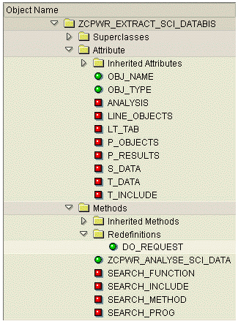

# Test

Check and activate all parts.

## Request

From a Web browser, test the URL :

http://<server>:<port>/sap/bc/bsp/sap/zcpwr_inspbis/get_analysed_datavbis.do?pkg=<packageName>

NB: replace <server> with the actual name of your SAP Web server.

NB: replace <port> with the actual port (defaults to 80).

NB: replace <packageName> with the actual name of a development package containing ABAP objects to analyse with Code Inspector.

## Response

The response should be formatted like the following example :

CL_CI_TABNAMES_PUBLIC_0001;ZCPWR_EXTRACT_SCI_DATABIS;CLAS;ZCPWR_EXTRACT_SCI_DATABIS=====CM001;PROG;SEARCH_FUNCTION;000042;N

CL_CI_TABNAMES_PUBLIC_0001;ZCPWR_EXTRACT_SCI_DATABIS;CLAS;ZCPWR_EXTRACT_SCI_DATABIS=====CM001;PROG;SEARCH_FUNCTION;000043;N

CL_CI_TABNAMES_PUBLIC_0001;ZCPWR_EXTRACT_SCI_DATABIS;CLAS;ZCPWR_EXTRACT_SCI_DATABIS=====CM002;PROG;SEARCH_INCLUDE;000050;N

CL_CI_TABNAMES_PUBLIC_0001;ZCPWR_EXTRACT_SCI_DATABIS;CLAS;ZCPWR_EXTRACT_SCI_DATABIS=====CM002;PROG;SEARCH_INCLUDE;000050;N

*[…]*