Scrum Meeting 1

Date: 11/02/2026
Time: 1hr 20min
Attendees:
Marko Turicanin
André Liu
Alex Negoescu
Luigi Del Valle.
Hollist
Oluwafemi Folarin

Tasks

So the goal of sprint 1 is to have a working web app for users to register, login, view courses and track their progress.
Deliverables:
- Working registration and login.
- Course List
- Course tracking
- Demo video

Our 6 user stories that I think are mandatory for completion by the 25th are:
ROLES
- Register and login (ISSUE 11 - L) - Marko
- View dashboard/all courses (ISSUE 13 - L) - Femi, Hollist & Alex (Collaborating)
- Searching and filtering courses (Bonus) (ISSUE 12 - M) - Luigi
- Track current status (start/pause) (ISSUE 15 - M ) - Alex
- Track course completion (ISSUE 14 - S) Marko
- Updating the user profile (ISSUE 16 - S) - any

- XS = Very simple (2-4 hours)
- S = Simple (half day)
- M = Medium (1-2 days)
- L = Large/Complex (3-4 days)
- XL = Very large (4-5+ days)

IBM Integration: Andre handles the API implementation for the IBM skills build.
Database: postgreSQL

Direct implementation from IBM skills website

Issue Board (Updated) :
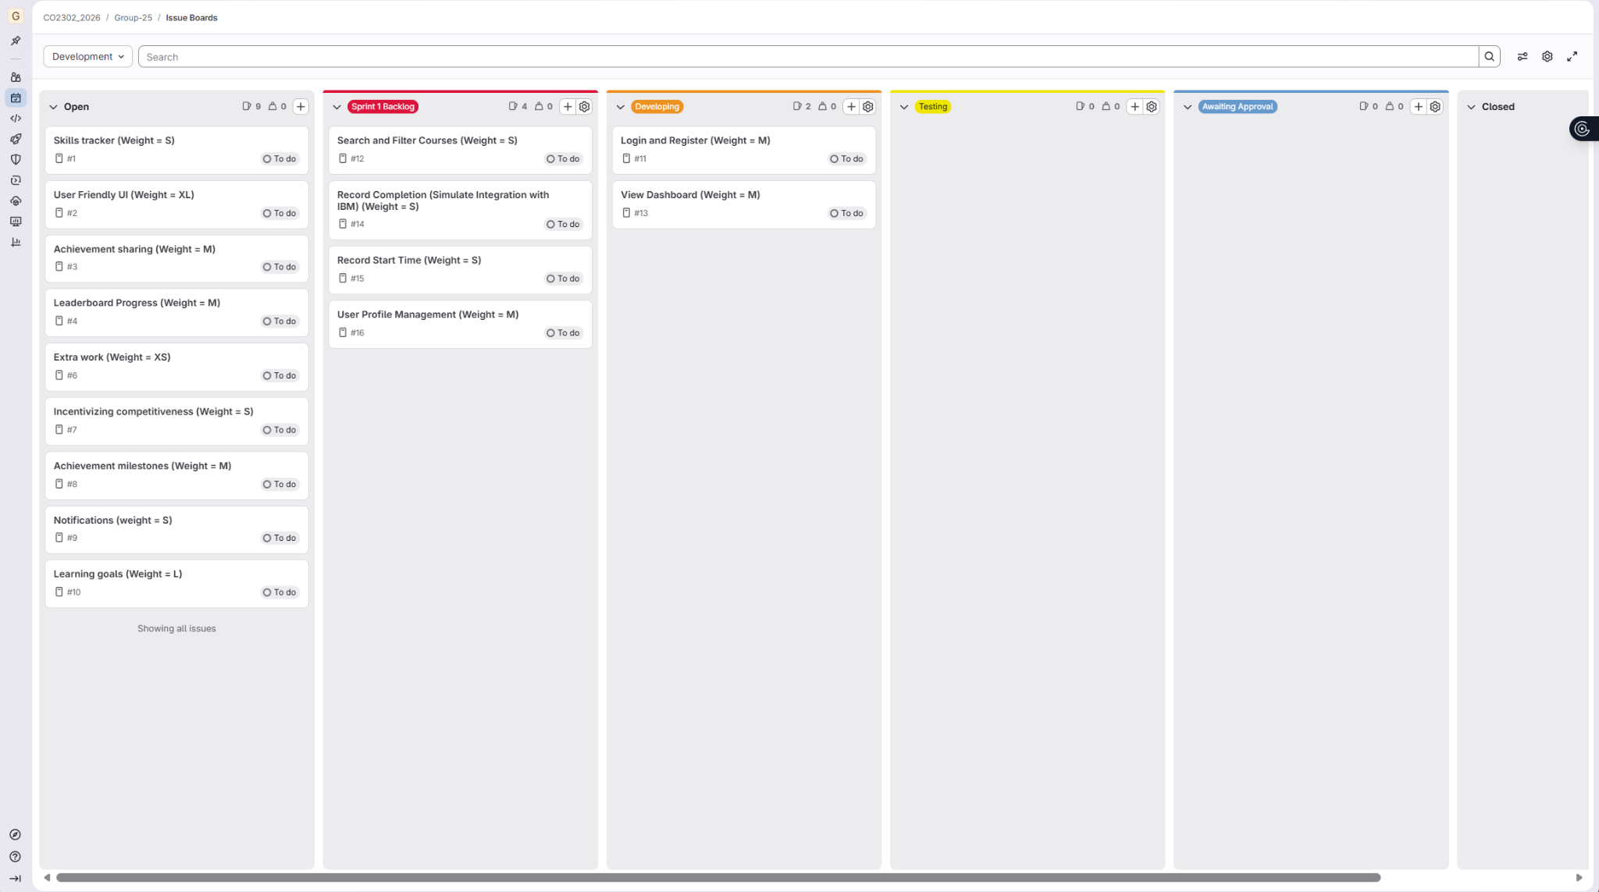
Everyone should know what user stories they will be completing due for the 25th Feb.

Meeting Summary :

All group members attended the session and should be informed as to what user stories they should start coding. Some user stories will be worked on in collaboration as developing specific user stories with higher weightings will require more effort and time like the dashboard or extra user stories. We aim to commit code by this Friday and will continue to review and communicate with each other during this week. For next week we have set up a scrum meeting that will take place on Tuesday, followed up with a shorter meeting on Wednesday for any coding related issues.
Communication plan:
Daily standups - Whatsapp
Scrum meeting (week beginning 16th) - Tuesday
Scrum (Check-in) (week beginning 16th) - Wednesday

