Scrum Meeting 3
Date: 23/02/2026
Time: 1 hour

Previous SL - Alex Negoescu
Current SL - Andre Liu
Next SL – Luigi Del Valle

Attendees:
Marko Turicanin
Andre Liu
Alex Negoescu
Luigi Del Valle
Femi Folarin
Hollist Rukundo

What was done?
- Marko is about to push his login and home page onto gitlab
- Andre created backend folder to store the files onto + started with user managment
- Luigi is about to push search and filter courses
- Femi, Hollist, Alex pushing code

The goal of sprint 2 is to see what we have done so far.
Deliverables:
• Working registration and login.
• Course List
• Course tracking
• Demo video

Our 6 user stories that I think are mandatory for completion by the 25th are:
- Login and register
- Search and filter courses
- Record start time
- View dashboard
- User profile management
- Record completion

Database: postgreSQL

Direct implementation from IBM skills website

Issue Board (Updated):
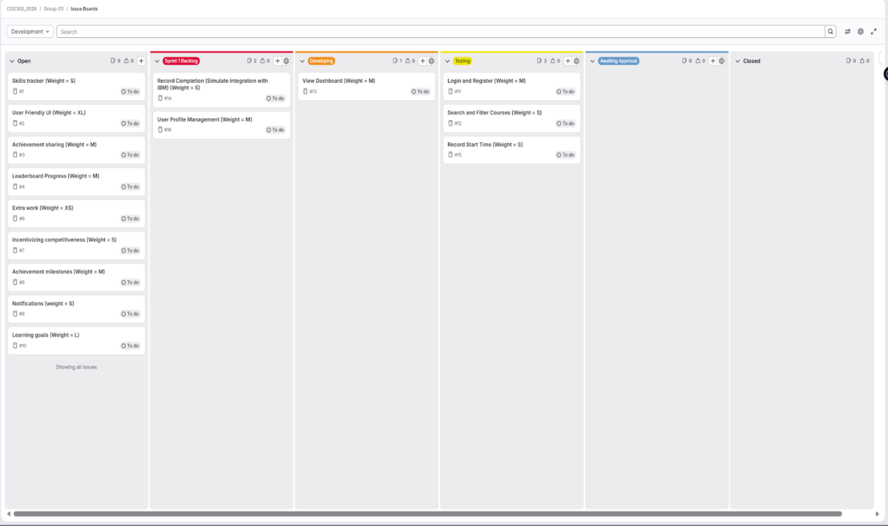
Register and login user story (Marko):
Login and register user story has been moved to testing. Currently the login and register user story is working as intended however I am still configuring the edge cases as well as adding a password check and making sure it is encrypted.

This Scrum meeting was used to review our current development progress and ensure that all implemented features are on track for completion. We also discussed and evaluated which additional user stories the team will focus on next. By the next meeting, we aim to complete at one user story per person + extra ones before the scrum

