Scrum meeting 6:
Scrum Leader: Andre Liu - AL548
Date: 15/03/26
Duration: 1hr
Attendees:

Marko Turicanin
Andre Liu
Luigi Del Valle
Alex Negoescu

Overview:
Complete six mandatory user stories + 2-4 bonus stories by March 27th.
Duration: March 8 - 27th

Postgres database:

Andre has setup the firebase database and the other members have to adjust controllers to match that.

Luigi is refining his user stories to increase the quality of his work, but it is done.

Marko is finishing up user story (24).

Alex is finishing user story (10) for learning goals.

Femi Folarin & Hollist Rukundo:
- Still have yet to respond and select user stories.

Sprint 2 priorities:

Scrum board cleanup:
We now have 14 user stories in the sprint 2 backlog.
6 mandatory user stories have been identified and are listed below.
Additional user stories will be reduced in the coming weeks.
User stories aligned with DoD:

Recap:
- Code has been tested and reviewed by peers for no outstanding bugs.
- Relevant Documentation and comments have been added/updated.
- Code has been merged into the main branch.

User stories we should look to complete for sprint 2:

User story 18 - Progress bar (Luigi)

User story 20 - Comments (Any)

User story 24 - Global leaderboard (Marko)

User story 23 - Adding friends (Andre)

User story 7 – Incentivising competitiveness (Any)

User story 10 - Learning goals (Alex)

Additional user stories that we should think about:

User story 9 - Notifications
User story 8 - Achievement milestone
User story 4 - Friends Leaderboard
User story 22 - Analytics page

Updated Scrum board:

User stories we should look to complete for Sunday 22nd:
- Global leaderboard *24
- Learning goals * 10
- Record start time * 15

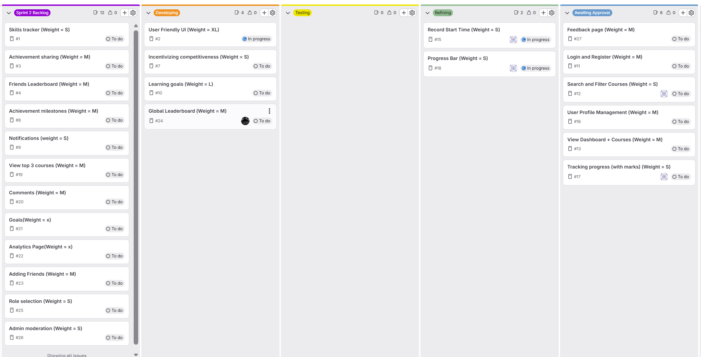

NOTES:
Sprint 1 Retrospective lessons applied: mid-sprint checkpoints, stricter accountability, Most of the team is up-to-date with the work that should be completed.
Team size: Working as 4 active members until we get confirmation and committed code from the rest of the team. Femi and Holist have yet to respond to groupchat messages and have not committed any work

