Scrum meeting 5:
Scrum Leader: Marko Turicanin - Mt492
Date: 08/03/26
Duration: 1hr 30mins
Attendees:

Marko Turicanin
Andre Liu
Luigi Del Valle
Alex Negoescu
Femi Folarin

Overview:
Complete six mandatory user stories + 2-4 bonus stories by March 27th.
Duration: March 8 - 27th

Postgres database:

Andre is looking at options for a cloud shared database for easier access. This decision will be finalised by this week.
However, All group members who have not set up the Postgres database should do so ASAP.

Andre is currently working on our database so we are able to integrate the new user stories effectively for example our leaderboard would need a full integration with our postgres database and will be starting to work on his mandatory user story (23).

Luigi is currently working on finishing user story 15, as well as starting his new mandatory user story (18) for a progress bar with completion tracking.

Marko is currently working on improving user story 13, as well as starting his new mandatory user story (24) for a global leaderboard page.

Alex is currently working on his new user story (10) for learning goals.

Femi Folarin & Hollist Rukundo:
- Need to select and commit to user stories by the next sprint.

Sprint 2 priorities:

Scrum board cleanup:
We now have 14 user stories in the sprint 2 backlog.
6 mandatory user stories have been identified and are listed below.
Additional user stories will be reduced in the coming weeks.
User stories aligned with DoD:

Recap:
- Acceptance criteria for the user story is well-defined and understood by the team.
- Team members have developed code which follows the criteria.
- Code has been tested and reviewed by peers for no outstanding bugs.
- Relevant Documentation and comments have been added/updated.
- Code has been merged into the main branch.

User stories we should look to complete for sprint 2:

User story 18 - Progress bar (Luigi)

User story 20 - Comments(Any)

User story 24 - Global leaderboard (Marko)

User story 23 - Adding friends (Andre)

User story 7 – Incentivising competitiveness (Any)

User story 10 - Learning goals (Alex)

Additional user stories that we should think about:

User story 9 - Notifications
User story 8 - Achievement milestone
User story 4 - Friends Leaderboard
User story 22 - Analytics page

Updated Scrum board:
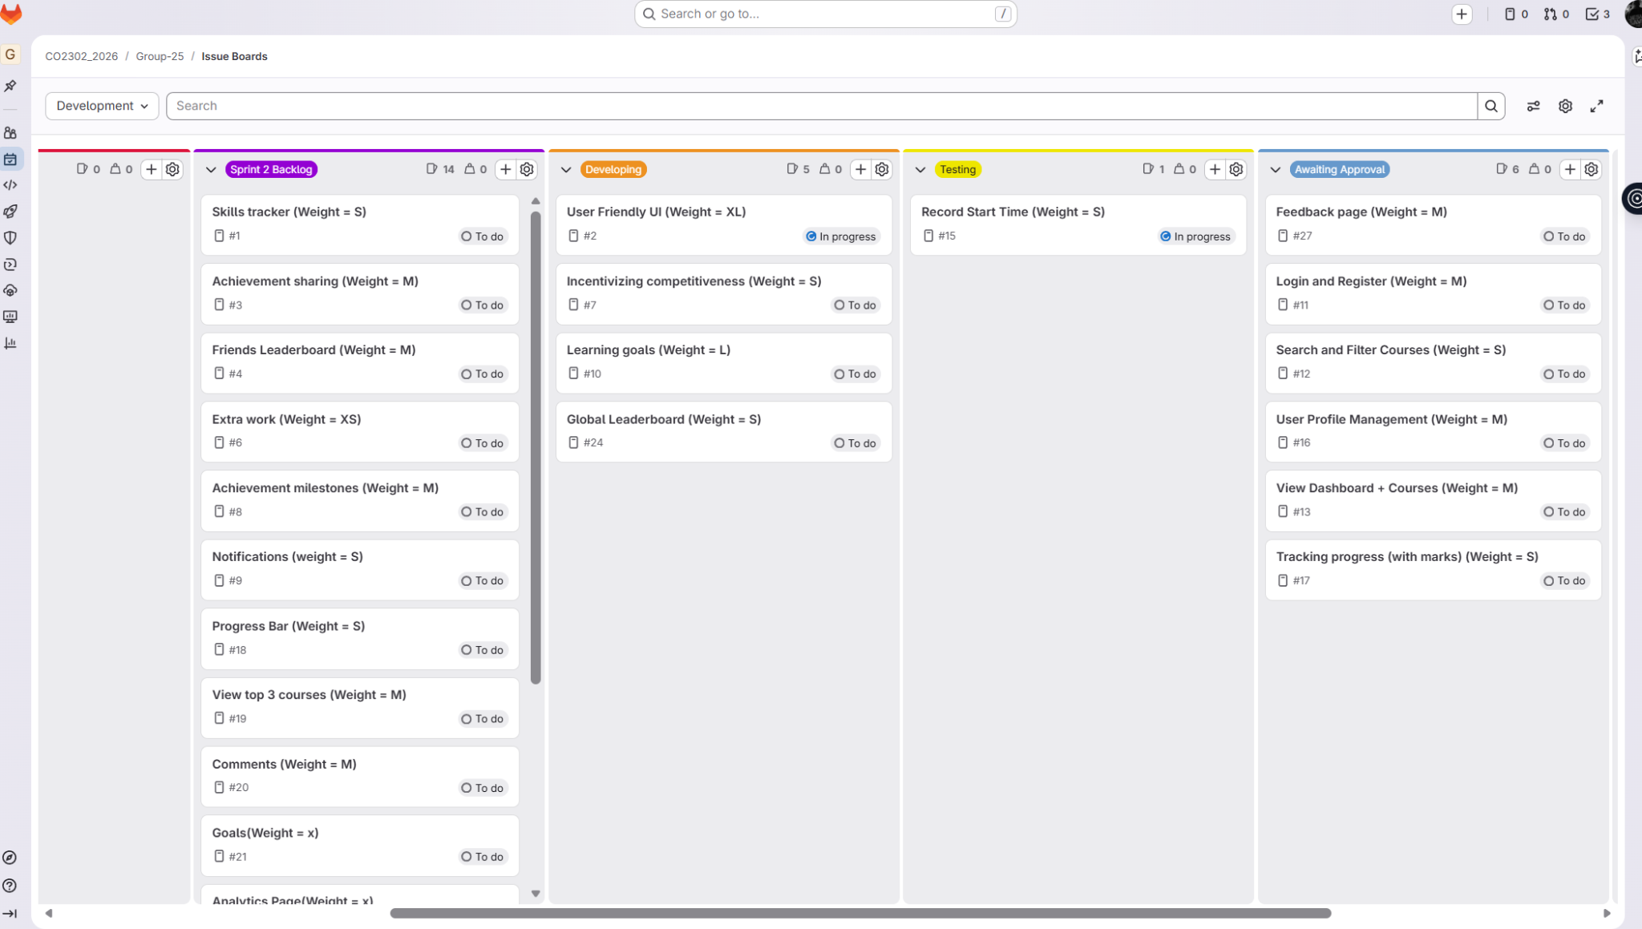

User stories we should look to complete for Sunday 15th:
- Global leaderboard *24
- Learning goals * 10
- Progress bar * 18
- Record start time * 15

NOTES:
Sprint 1 Retrospective lessons applied: mid-sprint checkpoints, stricter accountability, Most of the team is up-to-date with the work that should be completed.
Team size: Working as 4 active members until we get confirmation and committed code from the rest of the team.

Goal: Try and achieve 76-85% grade range through quality mandatory user stories and additional user stories from good communication, scheduling and commits on git.

Next scrum leader: Andre
Mid-week call to check for any user story issues.

