PRACTICAL 1. MongoDB Basics
(a)Write a MongoDB query to create and drop database
> use school
>db.students.insertMany([{name:"Aarchie",age:20,rollno:22},{name:"Tanvi",age:21,rollno:07},{name:"Ravi",age:18,rollno:33},{name:"Vikrant",age:22,rollno:06}])

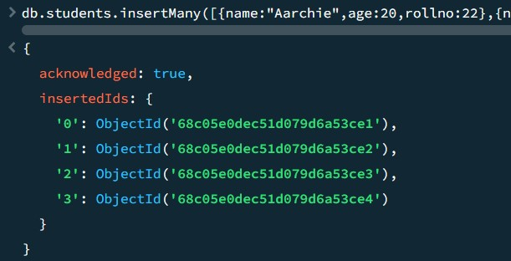
- db.dropDatabase()
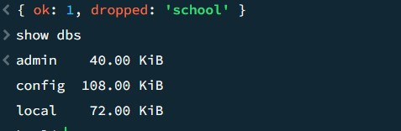

(b) Write a MongoDB query to create, display and drop collection
>use school
>db.students.insertMany([{name:"Aarchie",age:20,rollno:22},{name:"Tanvi",age:21,rollno:07},{name:"Ravi",age:18,rollno:33},{name:"Vikrant",age:22,rollno:06}])


- db.students.find()
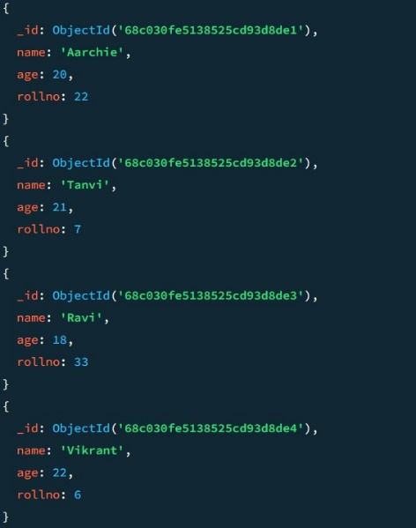
- db.students.drop()
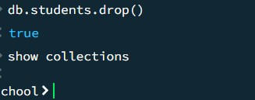

PRACTICAL 2. Simple queries with MongoDB
>use school

- create:-
db.students.insertMany([{name:"Aarchie",age:20,rollno:22},{name:"Tanvi",age:21,rollno:07},
{name:"Ravi",age:18,rollno:33},{name:"Vikrant",age:22,rollno:06}])

- update age of someone:-
db.students.updateOne({name:"Aarchie"},{$set:{age:21}})
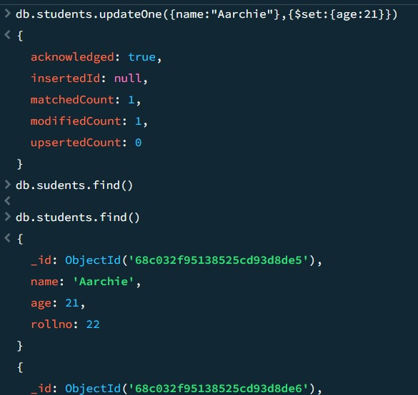

- update the one’s having age 21 to 25
db.students.updateMany({age:21},{$set:{age:25}})
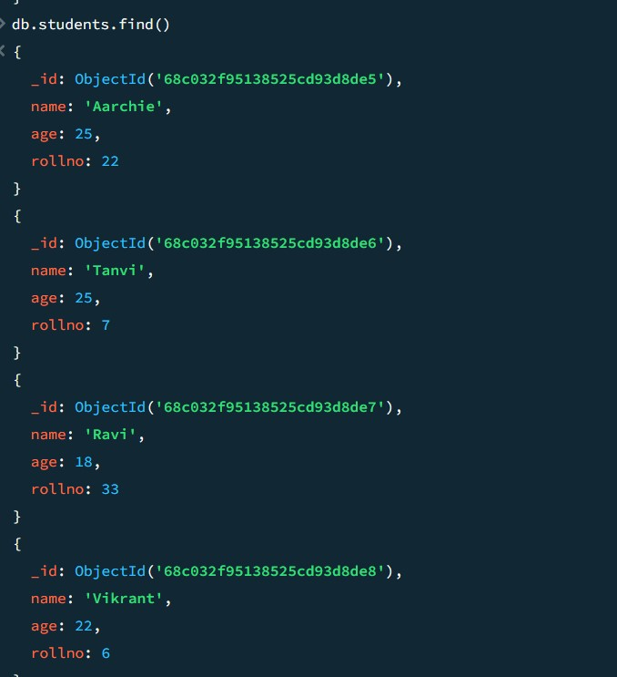

- show that the one’s having age 18 is not eligible
db.students.updateMany({age:18},{$set:{age:"Not Eligible"}})
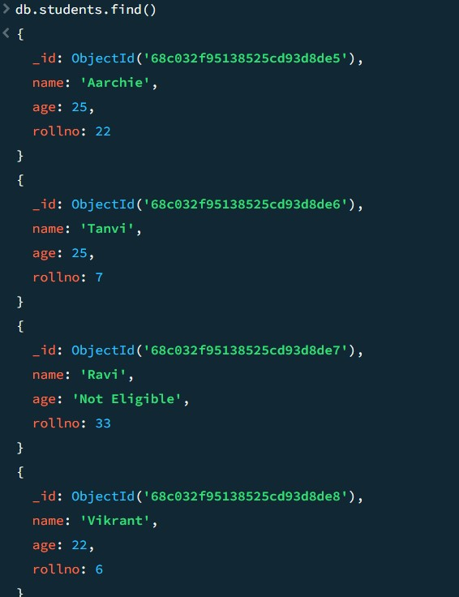

- age>=21 are eligible
db.students.updateMany({age:{$gte:21}},{$set:{"is eligible:":true}})
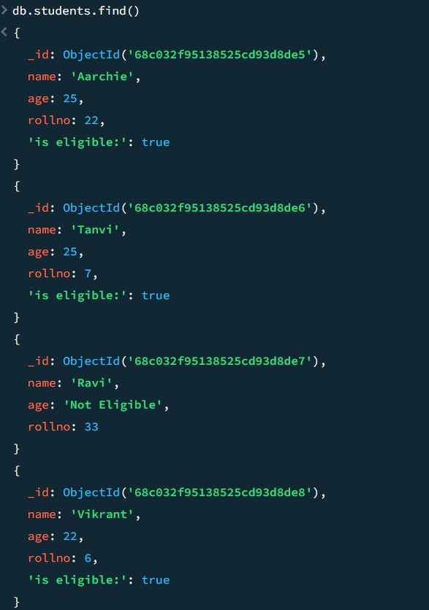
- delete someone’s name
db.students.deleteOne({name:”Tanvi”})

PRACTICAL 3. Implementing Aggregation
- Write a MongoDB query to use sum, avg, min and max expression.
>use shop

>db.orders.insertMany([{item:"pen",qty:10,price:5},{item:"book",qty:2,price:100},{item:"pencil",qty:2,price:200},{item:"bag",qty:1,price:500}])
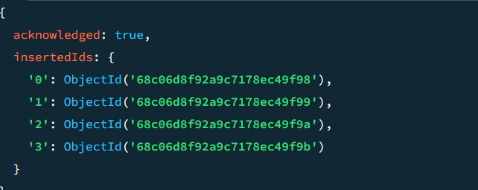

>db.orders.aggregate([{$group:{_id:null,totalQuantity:{$sum:"$Quantity"},averagePrice:{$avg:"$price"},minPrice:{$min:"$price"},maxPrice:{$max:"$price"}}}])
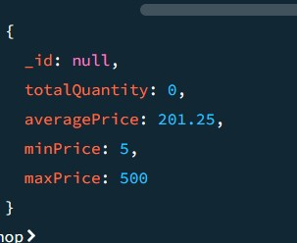

>db.orders.aggregate([{$addFields:{amount:{$multiply:["$qty","$price"]}}}])
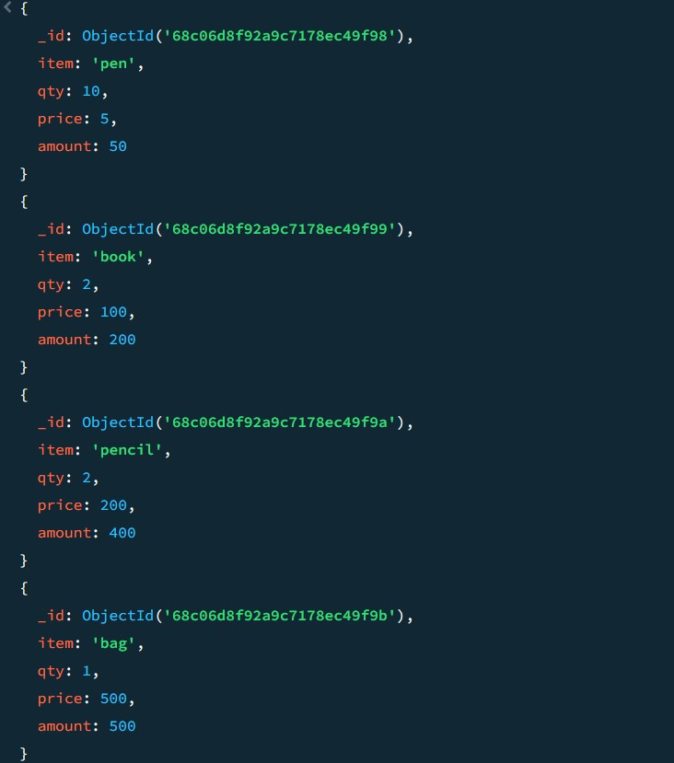

- Write a MongoDB query to push and addToSet expression
>use company

>db.sales.insertMany([{id:1,cust:"Aarchie",item:"apple"},{id:2,cust:"Tanvi",item:"apple"},{id:3,cust:"Vikrant",item:"strawberry"},{id:4,cust:"Ravi",item:"strawberry"},{id:5,cust:"Aarchie",item:"pear"},{id:6,cust:"Tanvi",item:"banana"},{id:7,cust:"Vikrant",item:"apple"},{id:8,cust:"Ravi",item:"apple"},{id:9,cust:"Aarchie",item:"pear"},{id:10,cust:"Vikrant",item:"apple"}])
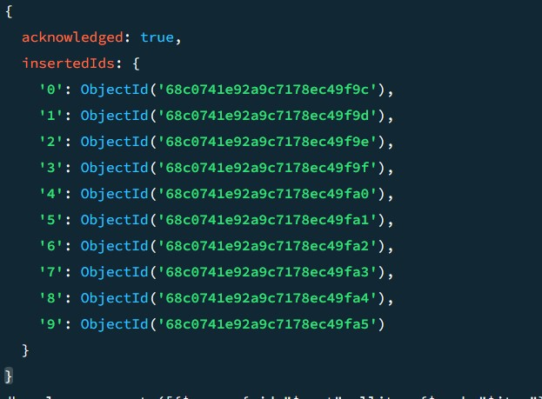

>db.sales.aggregate([{$group:{_id:"$cust",allitem:{$push:"$item"}}}])
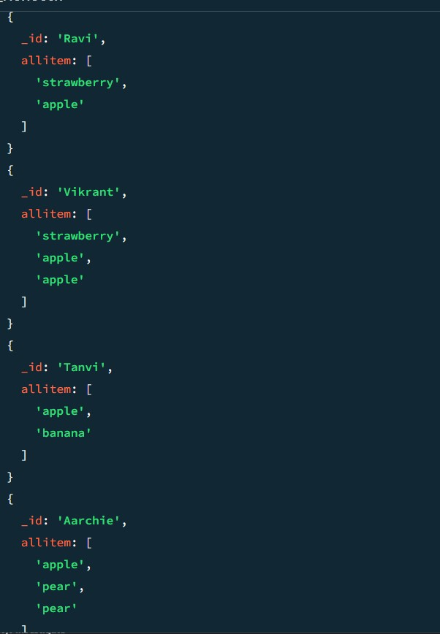

>db.sales.aggregate([{$group:{_id:"$cust",uniqueitem:{$addToSet:"$item"}}}])

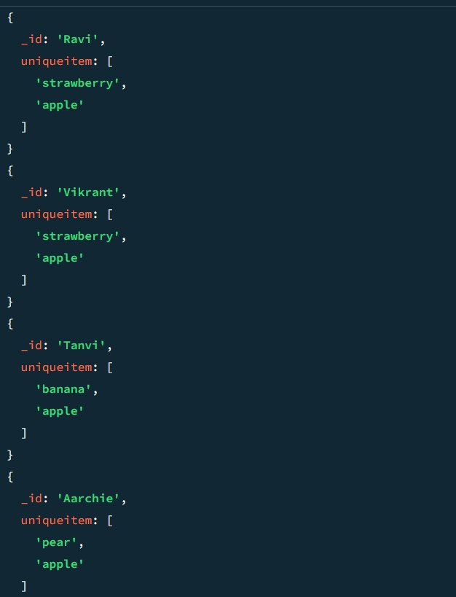

PRACTICAL 4. Replication
- Write a MongoDB query to create Replica of existing database
>use school
>db.students.insertMany([{name:"Rahul",age:21,course:"B.Sc.IT",subjects:["AI","AWP"]},{name:"Aarchie",age:22,course:"B.Sc.IT",subjects:["AI","SPM"]},{name:"Tanvi",
age:23,course:"B.Sc.IT",subjects:["SPM","NGT"]}])
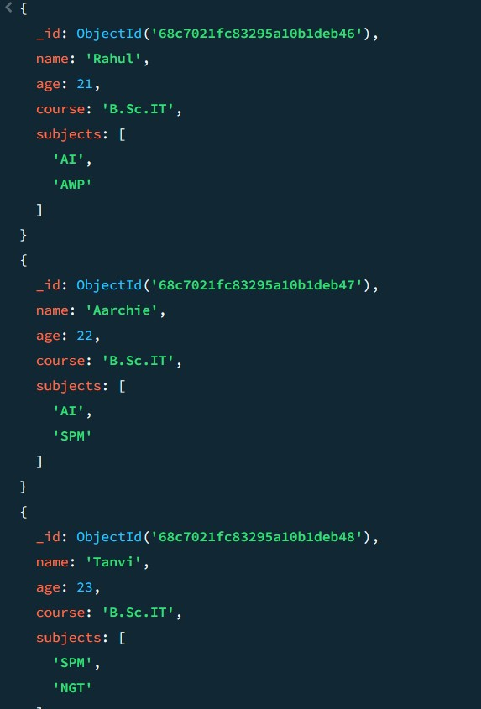

>db.students.find({age:{$gt:21}})
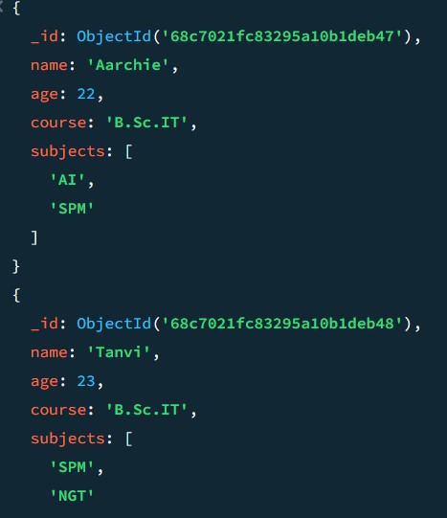

>db.students.aggregate([{$match:{}},{$out:{db:"NEWDB",coll:"New_coll"}}])
>show dbs
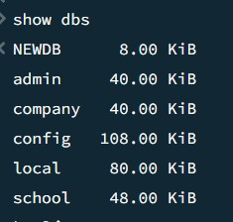

>use NEWDB
>show collections
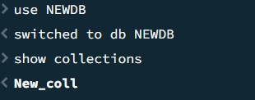

>db.New_coll.find()
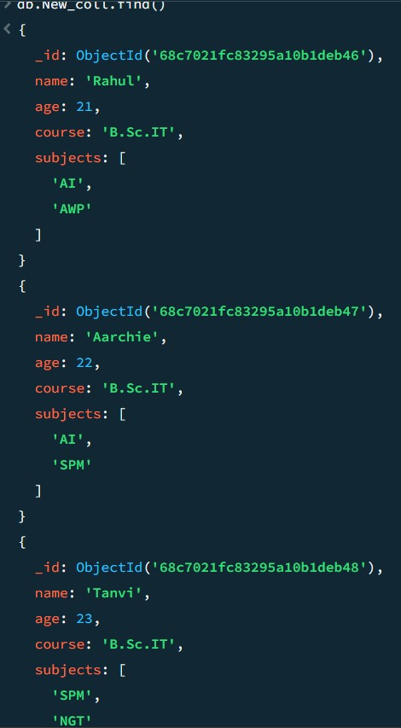

PRACTICAL 5. Programs on basic jQuery
- jQuery basic, jQuery events
jQuery basic
<!DOCTYPE html>
<html>
<head>
<title>Basic jQuery Example</title>
<script src="https://code.jquery.com/jquery-3.6.0.min.js"></script>
</head>
<body>
<h2>Hello, jQuery!</h2>
<button id="btn">Click Me</button>

<script>
$(document).ready(function() {
$("#btn").click(function() {
$("h2").text("Welcome to jQuery!");
});
});
</script>
</body>
</html>

OUTPUT:-
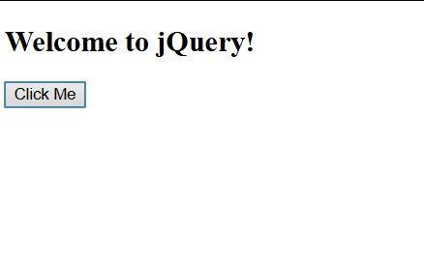

jQuery Events
<!DOCTYPE html>
<html>
<head>
<title>jQuery Events</title>
<script src="https://code.jquery.com/jquery-3.6.0.min.js"></script>
</head>
<body>
<p id="para">Hover or Click Me!</p>

<script>
$(document).ready(function(){
$("#para").click(function(){
$(this).css("color","red");
});
$("#para").mouseenter(function(){
$(this).css("background","yellow");
});
$("#para").mouseleave(function(){
$(this).css("background","white");
});
});
</script>
OUTPUT:-
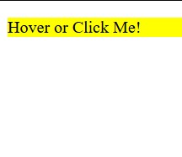

- jQuery Selectors, jQuery Hide and Show effects
jQuery Selectors
<!DOCTYPE html>
<html>
<head>
<title>jQuery Selectors</title>
<script src="https://code.jquery.com/jquery-3.6.0.min.js"></script>
</head>
<body>
<p class="cls">This is Class Selectors</p>
<p id="id1">This is Id Selector</p>
<p>This is Tag Selector</p>
<script>
$(document).ready(function(){
$(".cls").css("color","blue");
$("#id1").css("font-size","20px");
$("p").css("font-weight","bold");
});
</script>
</body>
</html>

OUTPUT:-
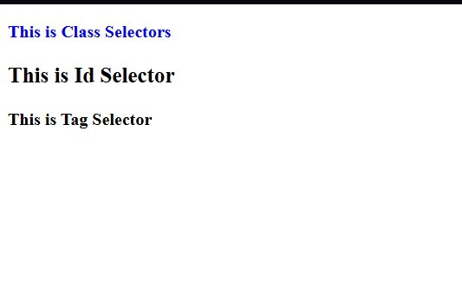

jQuery hide and show effects
<!DOCTYPE html>
<html>
<head>
<title>Hide Show Example</title>
<script src="https://code.jquery.com/jquery-3.6.0.min.js"></script>
</head>
<body>
<p id="text">This is a paragraph.</p>
<button id="hide">Hide</button>
<button id="show">Show</button>

<script>
$(document).ready(function(){
$("#hide").click(function(){
$("#text").hide();
});
$("#show").click(function(){
$("#text").show();
});
});
</script>
</body>

OUTPUT:-
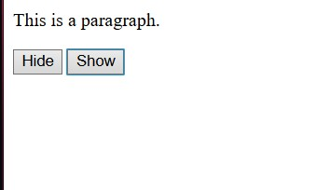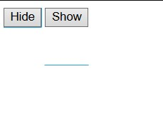

PRACTICAL 6. jQuery Advanced
(a)Animation effects, Chaining
Animation effects
<!DOCTYPE html>
<html>
<head>
<title>jQuery Animation</title>
<script src="https://code.jquery.com/jquery-3.6.0.min.js"></script>
<style>
#box {width:100px; height:100px; background:blue; position:relative; }
</style>
</head>
<body>
<button id="animate">Animate Box</button>
<div id="box"</div>

<script>
$(document).ready(function(){
$("#animate").click(function(){
$("#box").animate({
left:'250px',
height:'150px',
width:'150px',
opacity:0.5
}, 2000);
});
});
</script>

OUTPUT:-
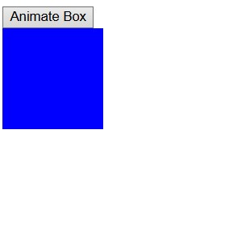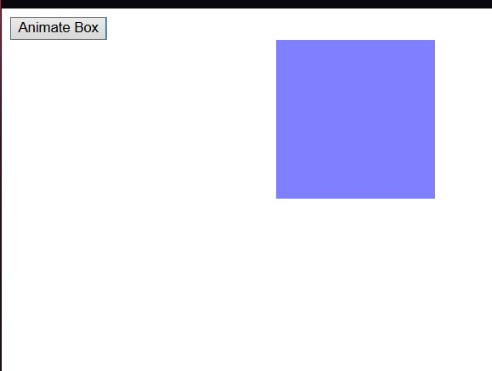

Chaining
<!DOCTYPE html>
<html>
<head>
<title>jQuery Chaining</title>
<script src="https://code.jquery.com/jquery-3.6.0.min.js"></script>
</head>
<body>
<p id="text">Watch me change!</p>
<button id="chain">Click Me</button>

<script>
$(document).ready(function(){
$("#chain").click(function(){
$("#text").css("color","red")
.slideUp(1000)
.slideDown(1000)
.fadeOut(1000)
.fadeIn(1000);
});
});
</script>
</body>
OUTPUT:-
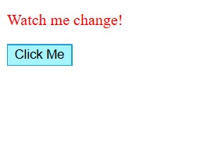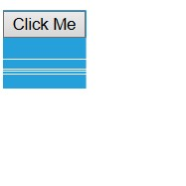
(b)Callback, Get and Set contents
Callback
<!DOCTYPE html>
<html>
<head>
<title>jQuery CallBack</title>
<script src="https://code.jquery.com/jquery-3.6.0.min.js"></script>
</head>
<body>
<button id="fade">Fade Out with Callback</button>
<p id="msg">I will fade out first, then show an alert.</p>

<script>
$(document).ready(function(){
$("#fade").click(function(){
$("#msg").fadeOut(2000, function(){
alert("Paragraph is now hidden!");
});
});
});
</script>
</body>
</html>
OUTPUT:-
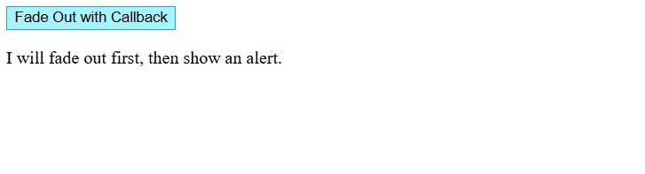
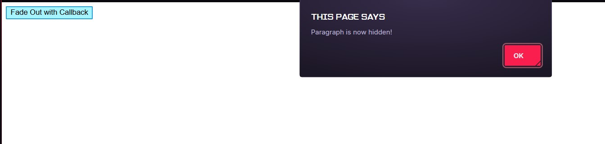

Get and Set contents
<!DOCTYPE html>
<html>
<head>
<title>jQuery Get and Set</title>
<script src="https://code.jquery.com/jquery-3.6.0.min.js"></script>
</head>
<body>
<p id="para">This is original text.</p>
<button id="get">Get Text</button>
<button id="set">Set Text</button>

<script>
$(document).ready(function(){
$("#get").click(function(){
alert($("#para").text());
});
$("#set").click(function(){
$("#para").text("This is new text set by jQuery!");
});
});
</script>
</body>
OUTPUT:-
