PRACT 4 - AIM: To perform classification algorithm on a given data set in R
data(iris)
head(iris)
str(iris)
# install.packages("rpart")
library(rpart)
set.seed(1)
index <- sample(1:nrow(iris), 0.7 * nrow(iris))
train <- iris[index, ]
test <- iris[-index, ]
model <- rpart(Species ~ Sepal.Length + Sepal.Width + Petal.Width,data = train,method = "class")
result <- predict(model, test, type = "class")
table(result, test$Species)
accuracy <- sum(result == test$Species) / nrow(test)
accuracy

PRACT 5 - AIM: To perform clustering algo on given dataset using R.
data(iris)
data <- iris[, 1:4]
head(data)
summary(data)
data_scaled <- scale(data)
set.seed(123)
kmeans_result <- kmeans(data_scaled, centers = 3, nstart = 25)
kmeans_result$cluster
kmeans_result$centers
kmeans_result$withinss
final_data <- data
final_data$cluster <- as.factor(kmeans_result$cluster)
head(final_data)
plot(data_scaled[,1], data_scaled[,2],col = kmeans_result$cluster, pch = 19,xlab = "Sepal length",ylab = "Sepal width",main = "k-means Clustering")
points(kmeans_result$centers[,1], kmeans_result$centers[,2], col = 1:3, pch = 8, cex = 2)

PRACT 6 - AIM: To perform logistic regression on given data set using R.
data <- data.frame(Hours = c(1,2,3,4,5,6,7,8),Result = c(0,0,0,0,1,1,1,1))
print(data)
model <- glm(Result ~ Hours, data = data, family = binomial)
summary(model)
probabilites <- predict(model, type = "response")
print(probabilites)
predicted_class <- ifelse(probabilites > 0.5, 1, 0)
print(predicted_class)
data$predicted_Prob <- probabilites
data$predicted_Class <- predicted_class
print(data)
plot(data$Hours, data$Result,xlab = "Hours studied",ylab = "Result",main = "logistic Regression",pch = 16,col = "blue")
curve(predict(model, data.frame(Hours = x), type = "response"),add = TRUE,col = "red",lwd = 2)

PRACT 7 -AIM: To perform linear regression on given data set using R.
data <- data.frame(Hours = c(1, 2, 3, 4, 5, 6, 7, 8),Marks = c(35, 40, 50, 55, 65, 70, 75, 85))
print(data)
# Build Linear Regression model
model <- lm(Marks ~ Hours, data = data)
# View model summary
summary(model)
# Predict values
predicted_values <- predict(model)
print(predicted_values)
# Add predicted values to dataset
data$Predicted_Marks <- predicted_values
print(data)
# Plot original data
plot(data$Hours, data$Marks,xlab = "Hours Studied",ylab = "Marks",main = "Linear Regression",col = "blue",pch = 16)
# Add regression line
abline(model, col = "red", lwd = 2)

PRACT 3- AIM: Apply what-If analysis for data visualization design and generate necessary report-based data warehouse.
- GOAL SEEK.
- STEP 1: Go to Data → What-If Analysis → Goal Seek.
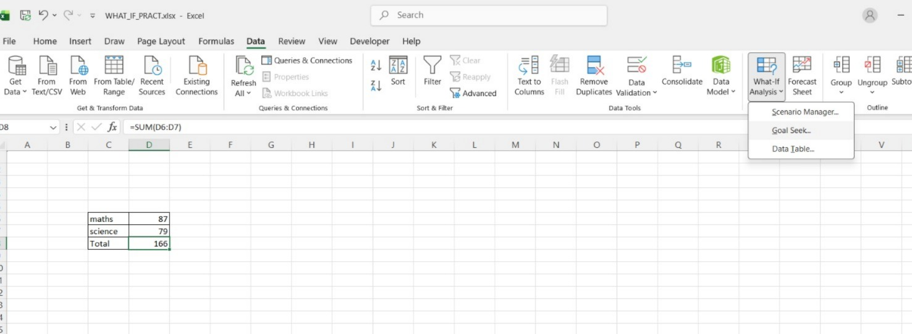
- STEP 2: Set D8 as Set cell, enter 200 as To value, and select D7 as By changing cell. Click OK.
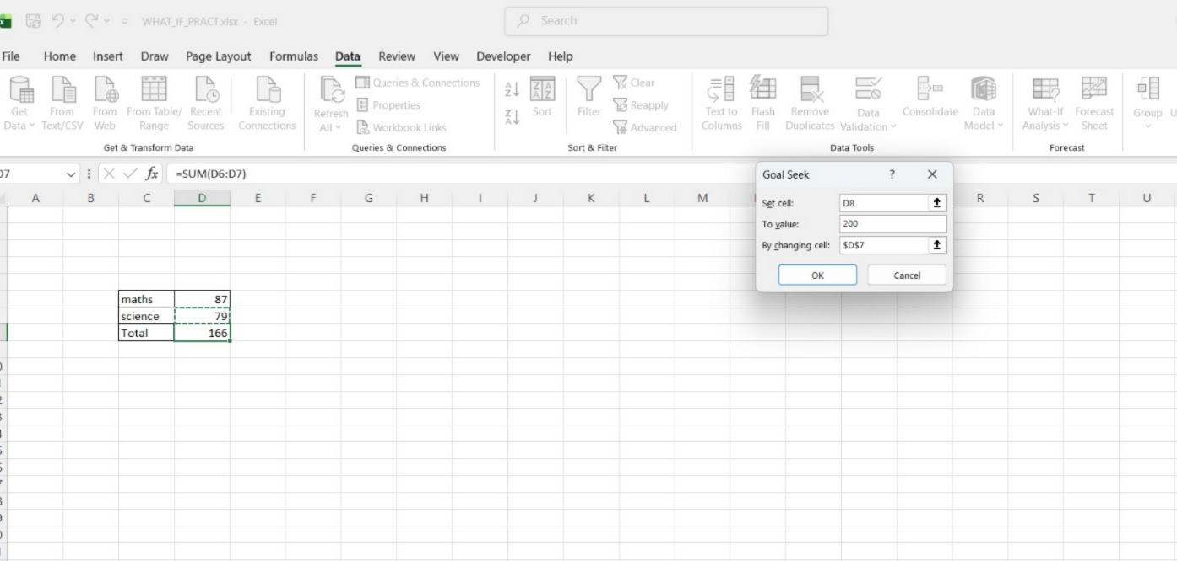
- STEP 3: Excel shows solution message and automatically changes Science marks (D7) to make total 200.
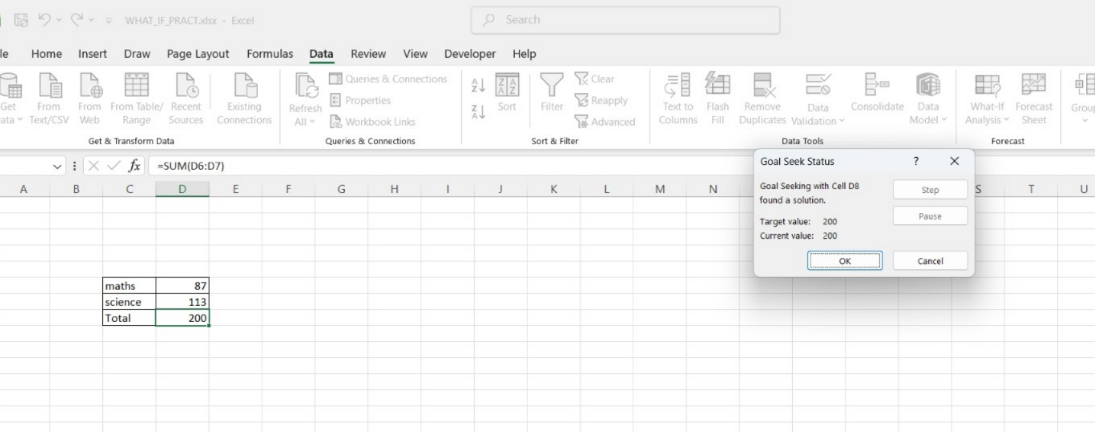
- SCENARIO MANAGER.
- STEP 1: Enter data and apply formula =E8*F8+E9*F9 to calculate total.
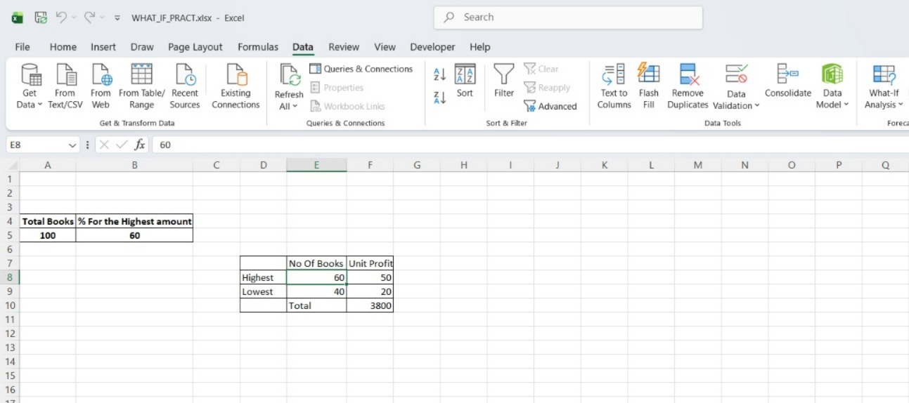
- STEP 2: Go to Data → What-If Analysis → Scenario Manager → Add.
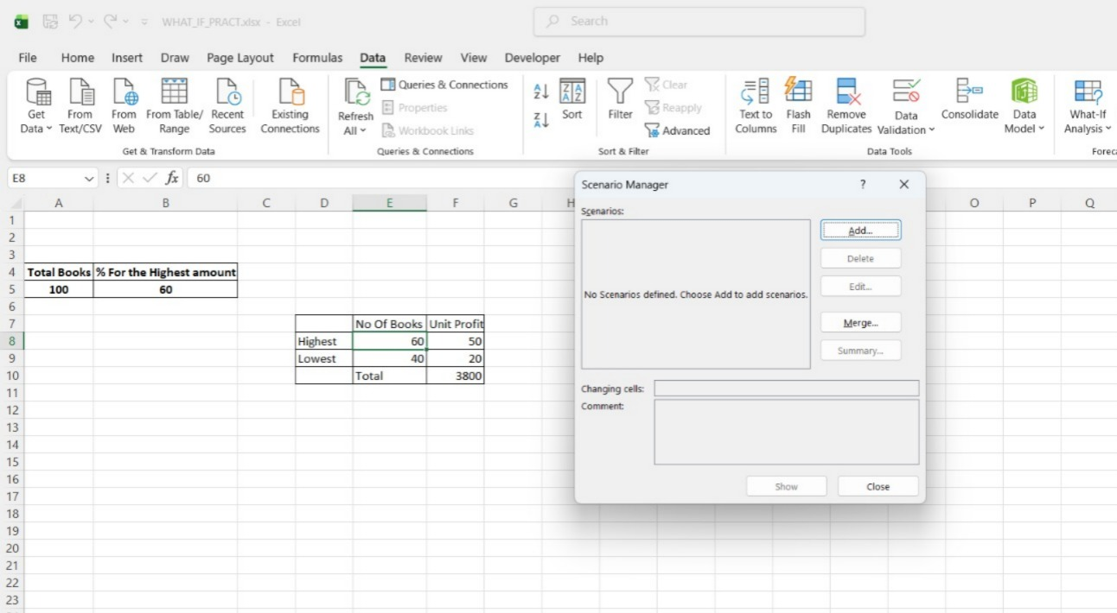
- STEP 3: Enter Scenario Name “60 percent”, select changing cells E8:F9, click OK.
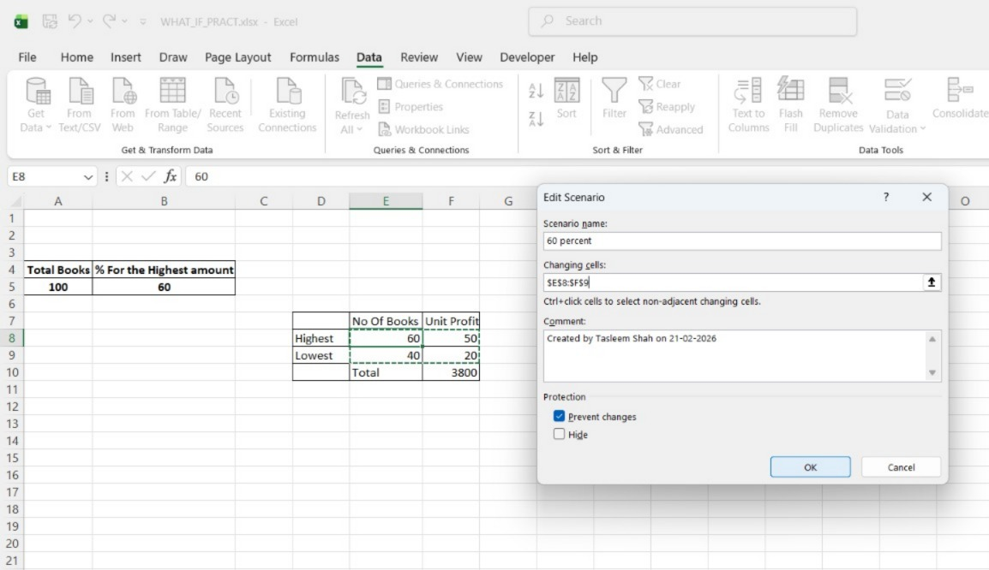
- STEP 4: Enter values 60, 50, 40, 20 and click OK.
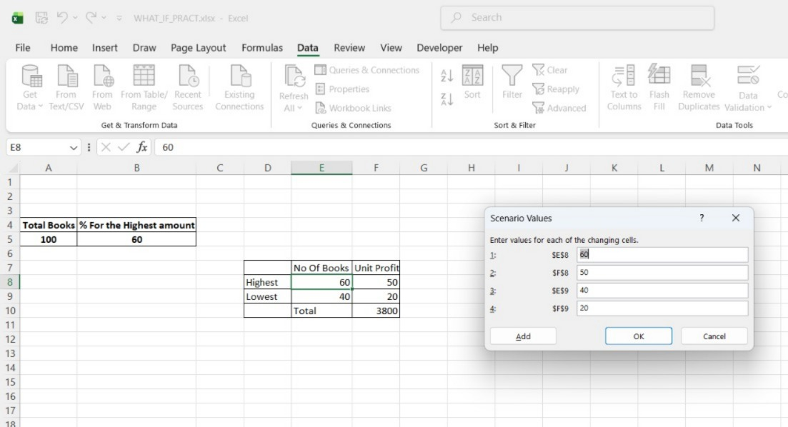
- STEP 5: Select scenario “60 percent” and click Show.
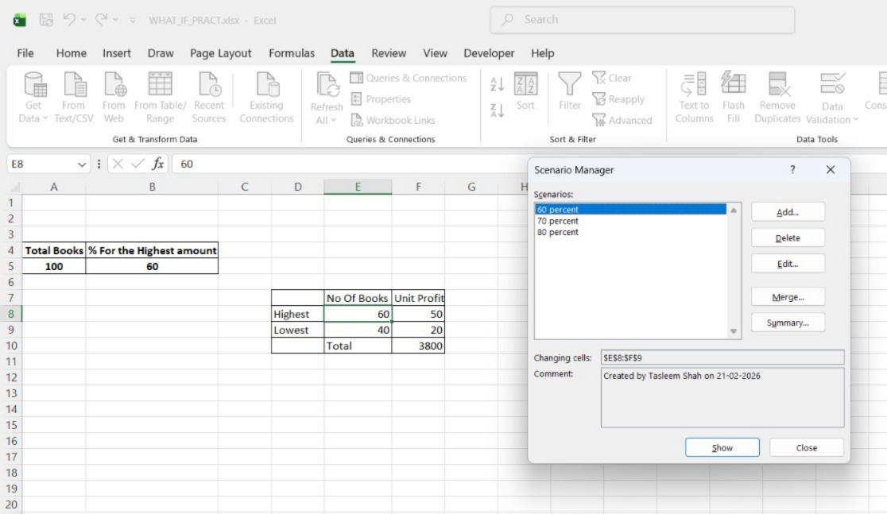
- STEP 6: Add new scenario “70 percent”, change values (70 & 30), click Show.
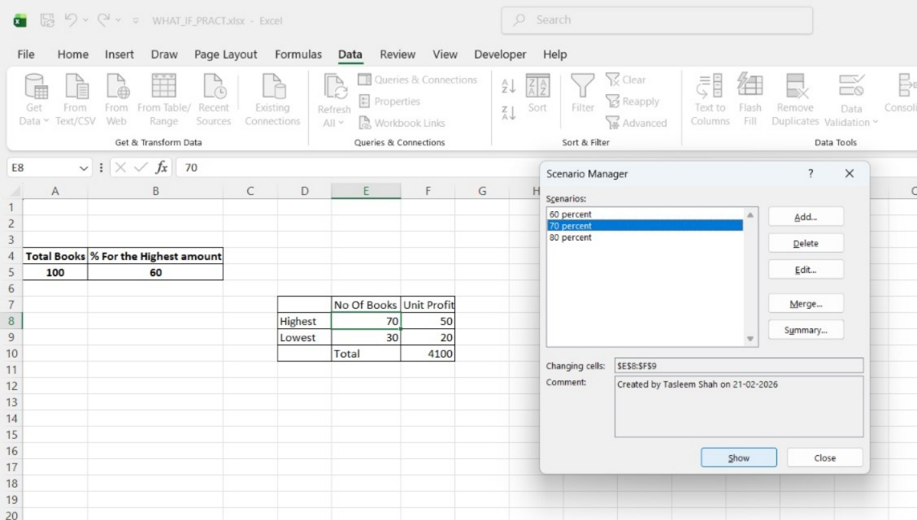
- STEP 7: Add “80 percent” scenario and click Show.
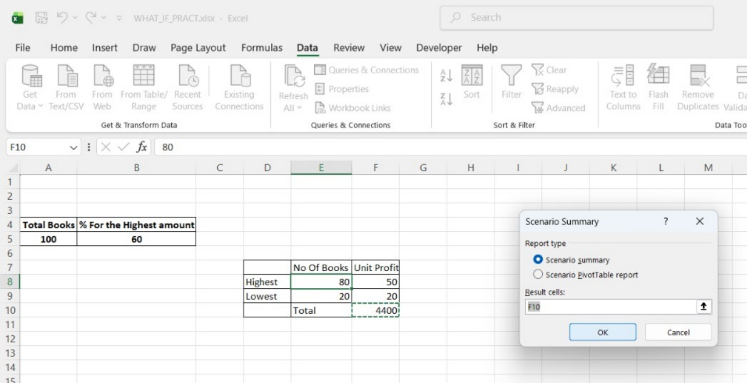
- STEP 8: Click Summary → Scenario Summary, select result cell F10, and click OK to generate report.
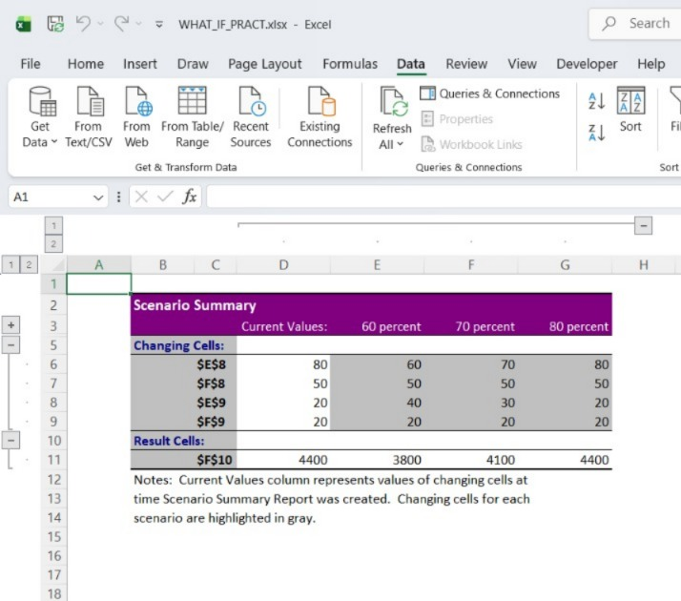
PRACT 1- AIM: Import legacy data from different sources and load in the target system
- STEP 1: Open Power BI.
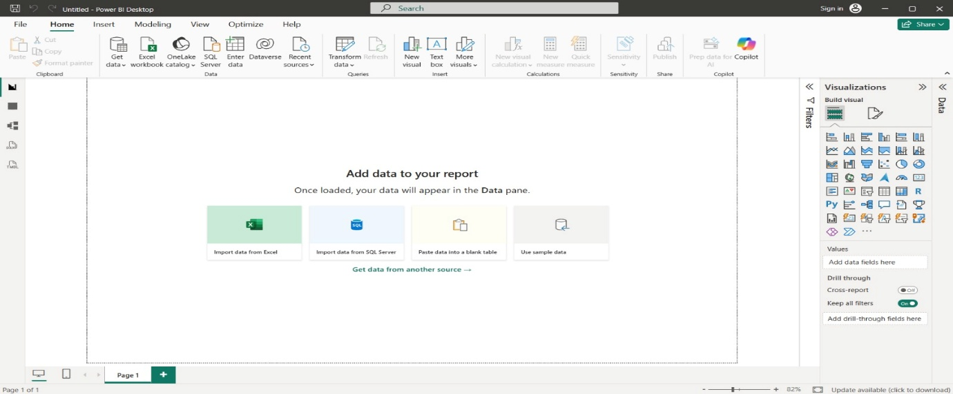
- STEP 2: Click on Get data following list will be displayed → select Excel.
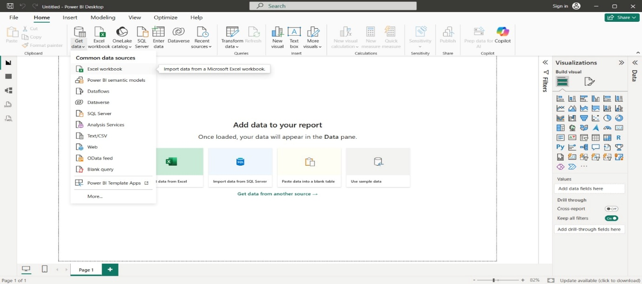
- STEP 3: Select required file and click on Open, Navigator screen appears.
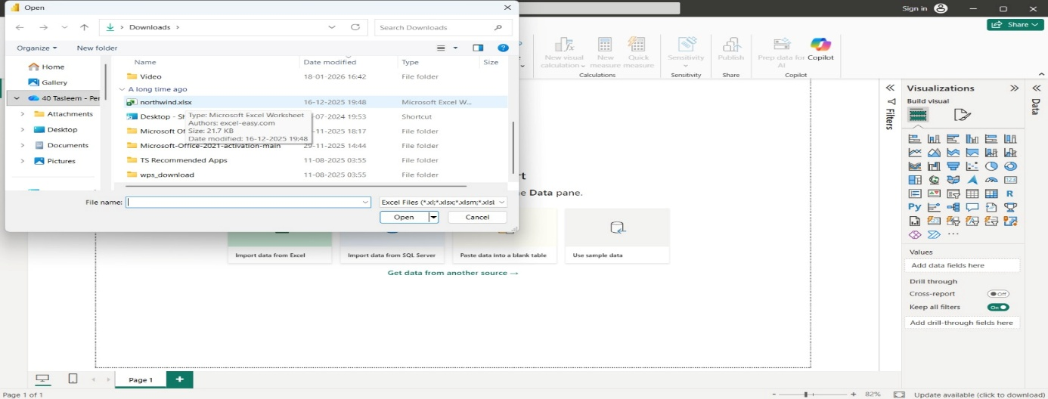
- STEP 4: Select file and click on edit.
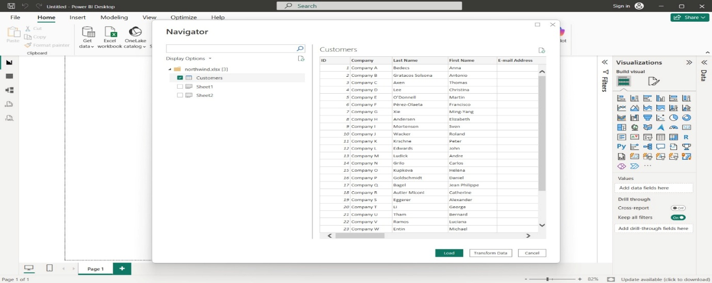
- STEP 5: Power query editor appears.
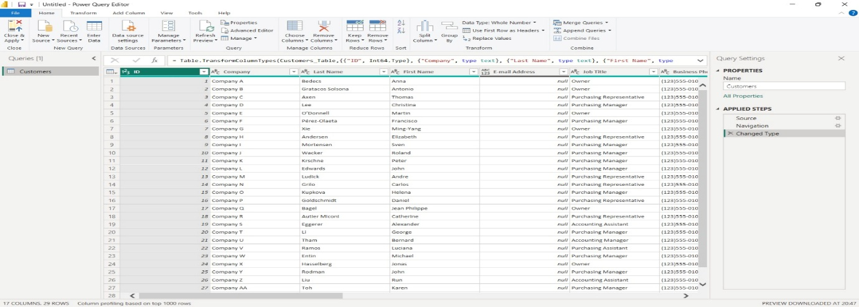
- STEP 6: Again, go to Get Data and select OData feed.
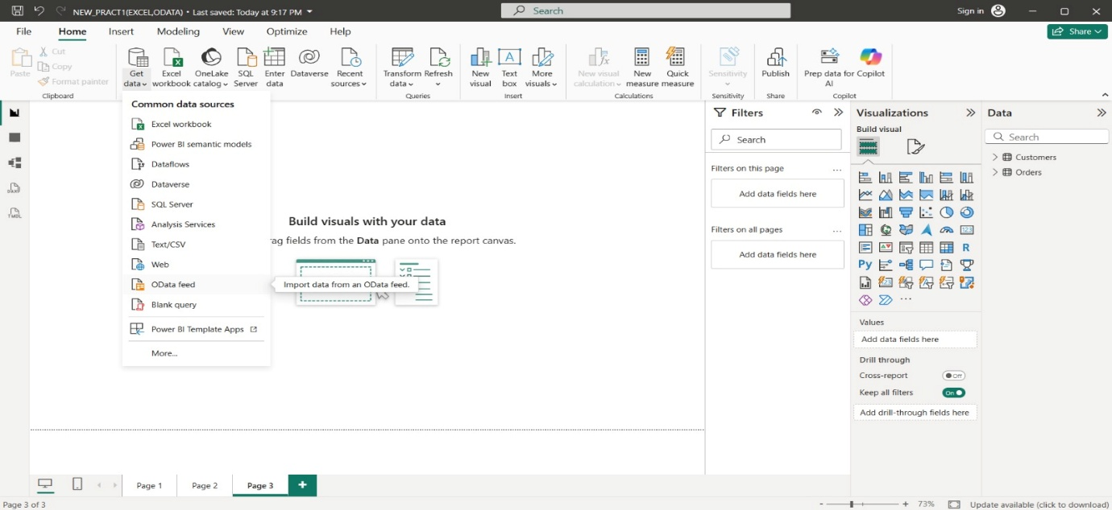

- STEP 7: Paste url as-
http://services.odata.org/V3/Northwind/Northwind.svc/
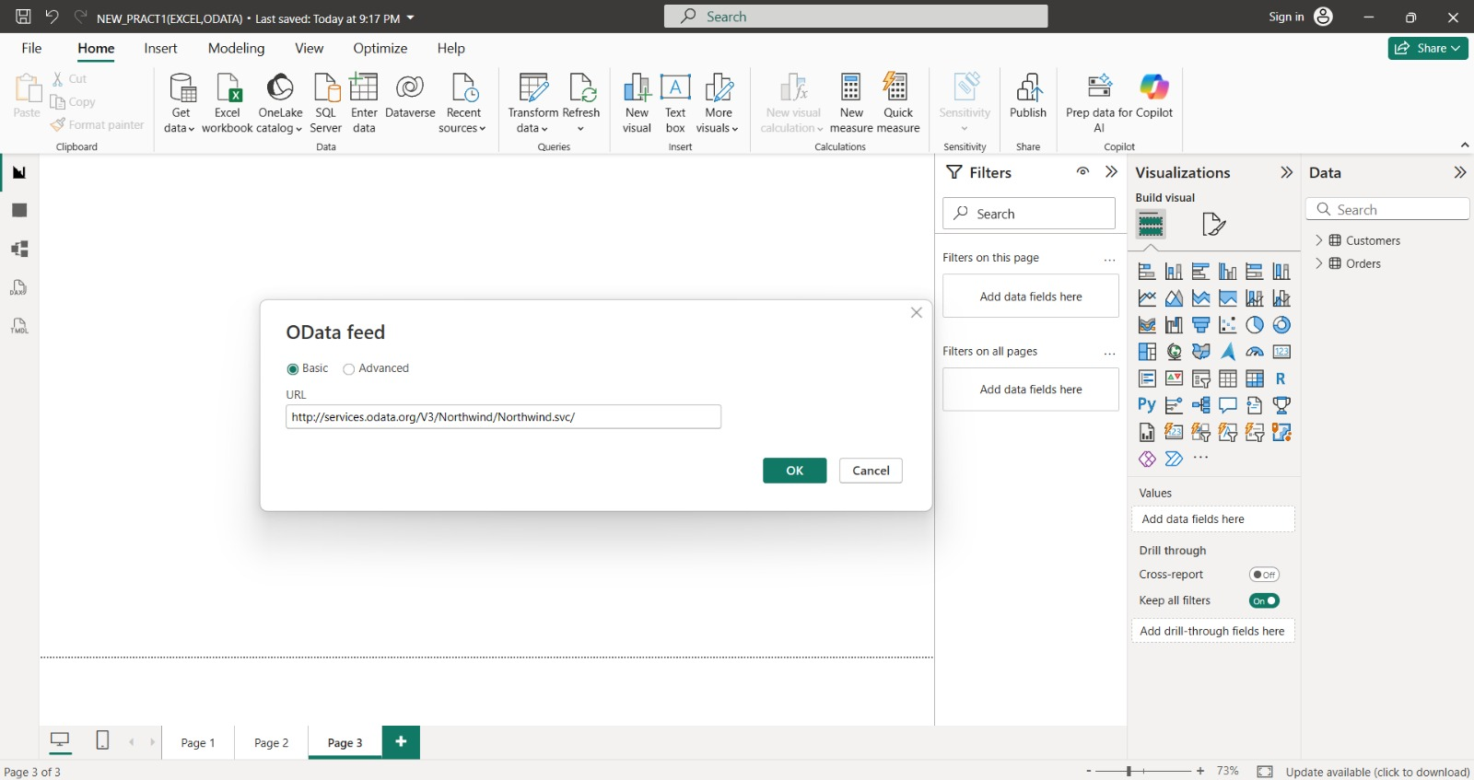

- STEP 8: Select orders table and click on edit Note: If you just want to see preview you can just click on table name without clicking on checkbox Click on edit to view table.
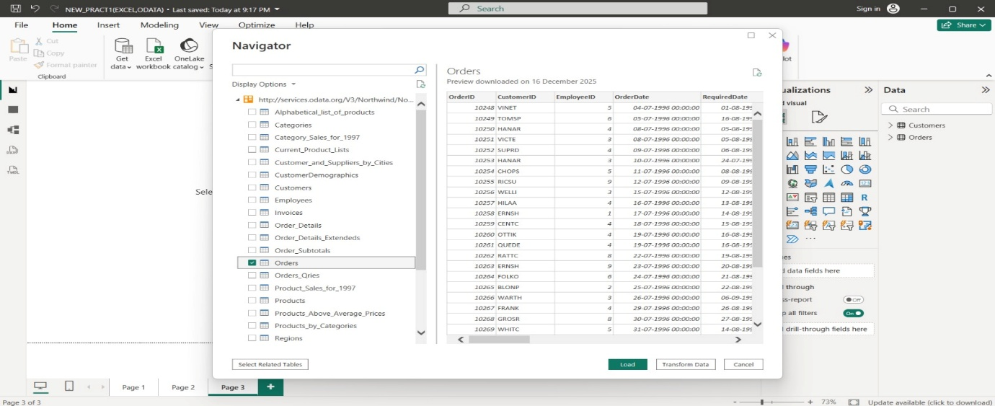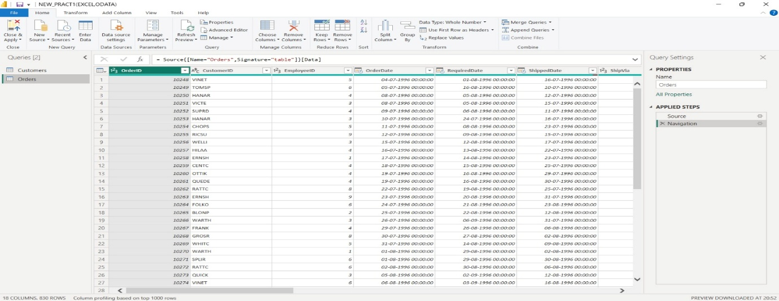
- STEP 9: Under the close section, click on close and apply.
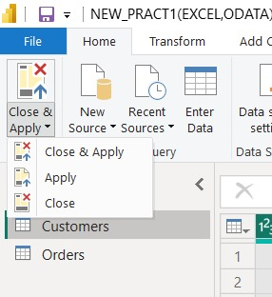
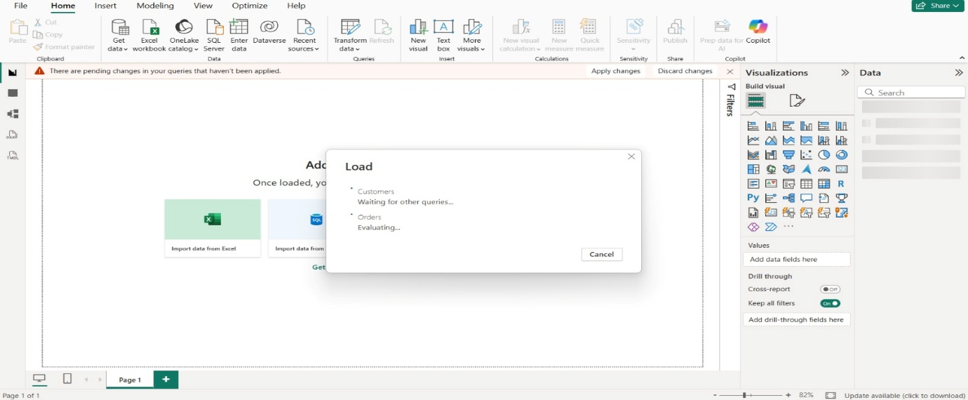
- STEP 10: Data Load.
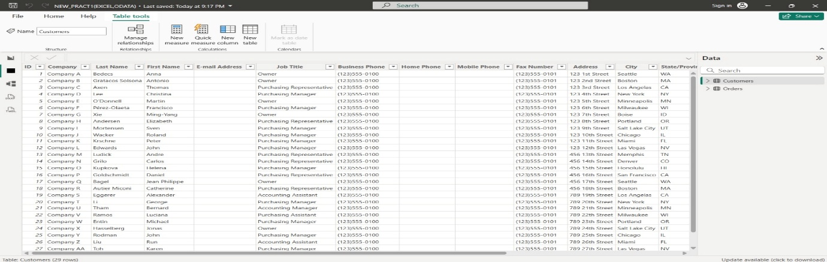
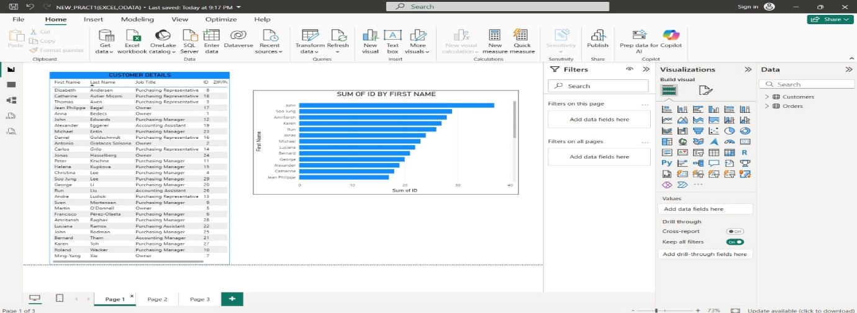
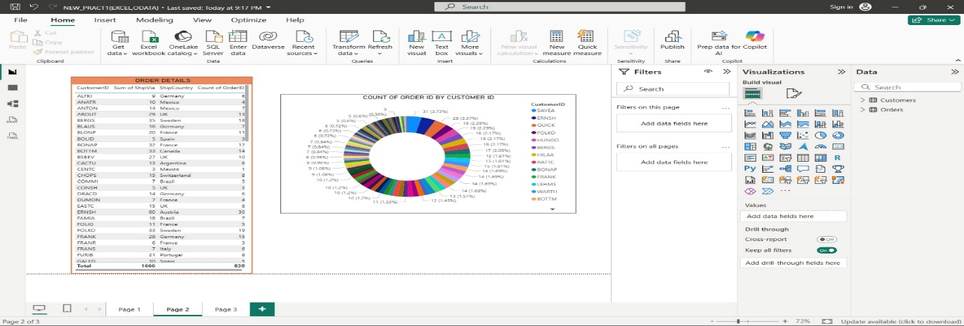
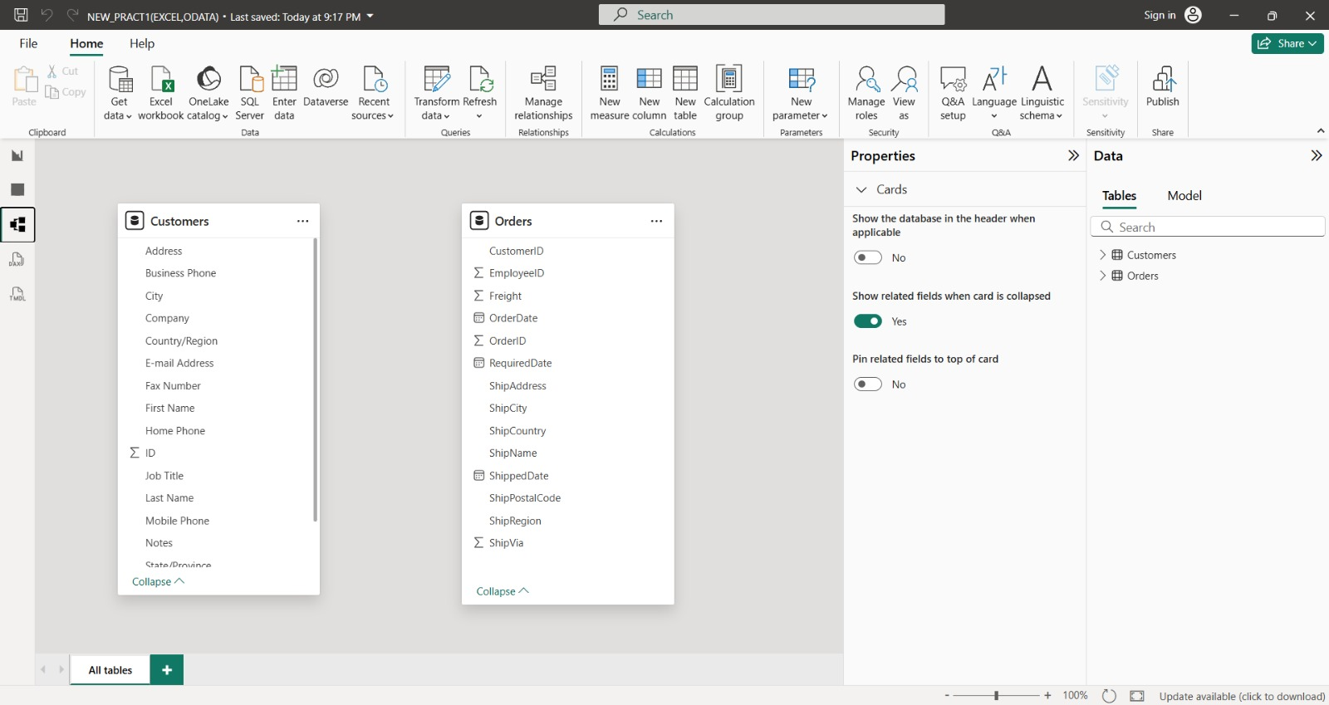
PRACT 2- AIM: Perform the extraction transform and loading (ETL) process to construct database in Power BI.
- STEP 1: Open Power BI, Click on Get Data → OData Feed.
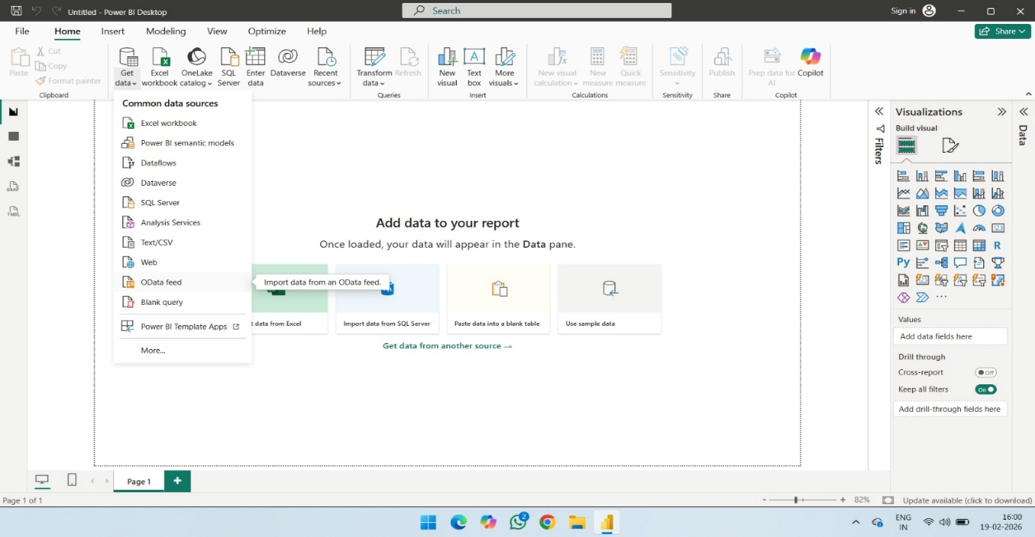
- Paste Url: http://services.odata.org/V3/Northwind/Northwind.svc/
And Click OK.
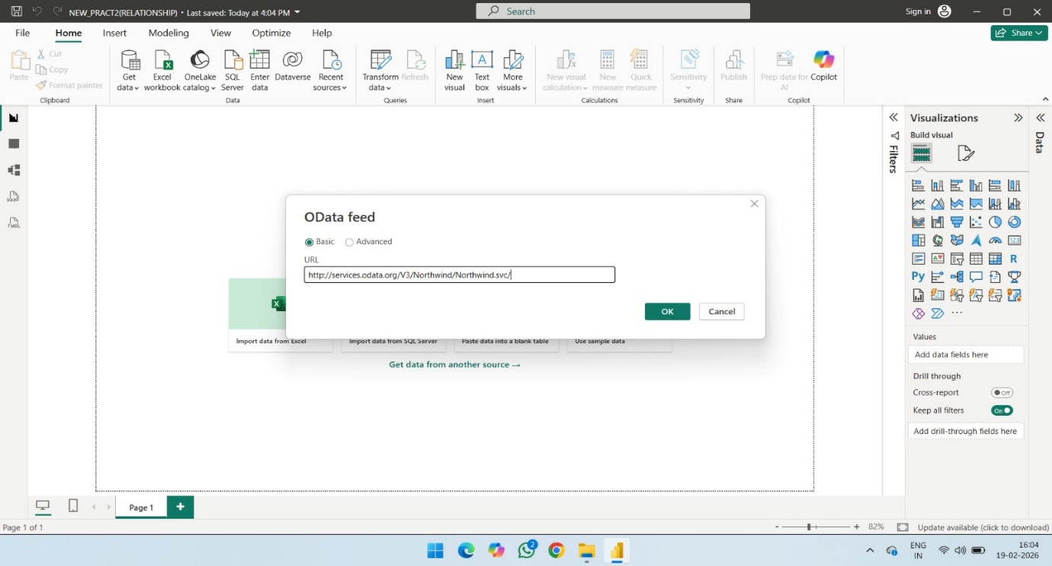

- STEP 2: Click on Check Box of Products table and then click on Edit.
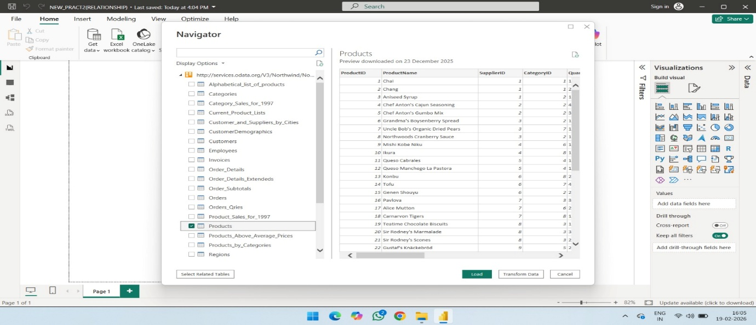
1) Remove other columns to only display columns of interest In Query Editor, select the ProductID, ProductName, QuantityPerUnit, and UnitsInStock columns (use Ctrl+Click to select more than one column, or Shift+Click to select columns that are beside each other).
2) Select Remove Columns > Remove Other Columns from the ribbon, or rightclick on a column header and click Remove Other Columns.
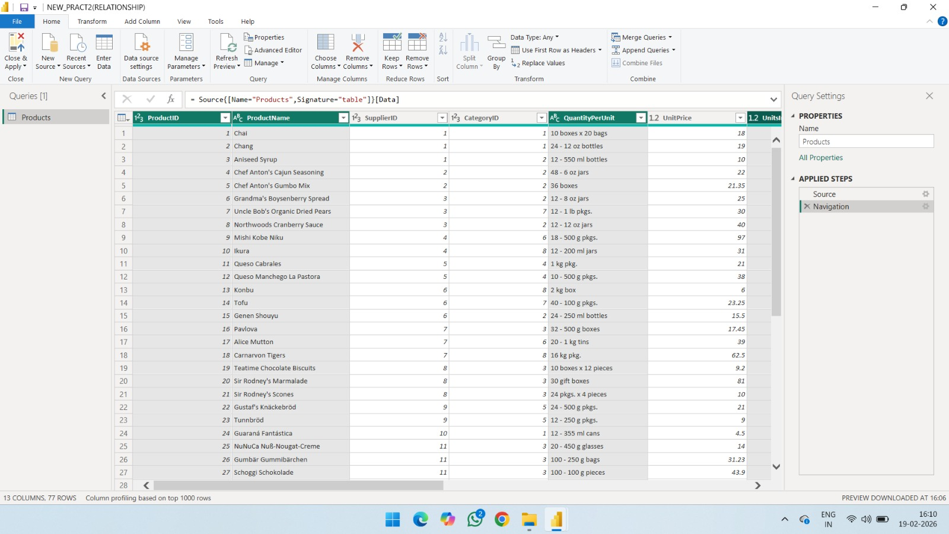

3) After selecting Remove Other Columns only selected four columns are displayed other columns are discarded.
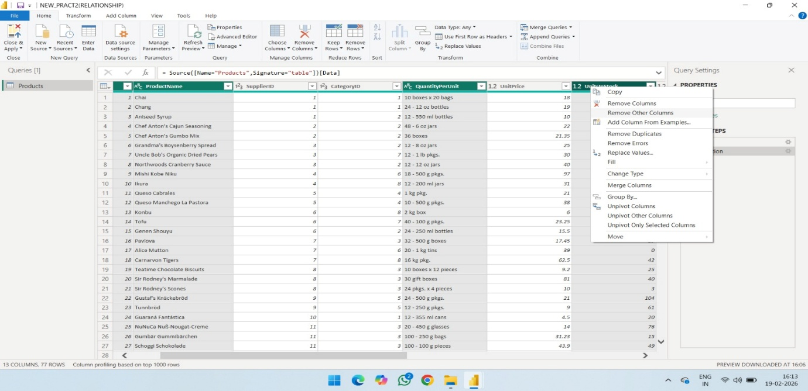
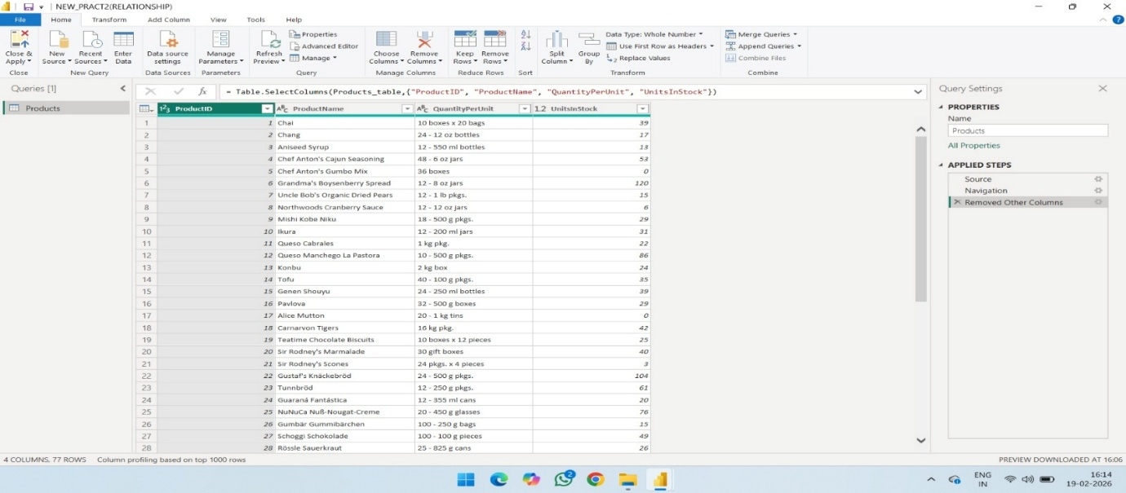
- STEP 3: Change the data type of the UnitsinStock column.
- Select the UnitsinStock column.
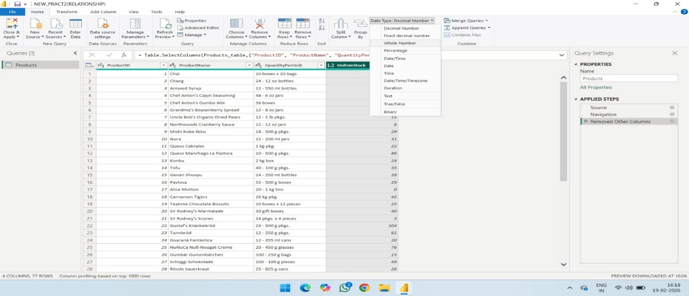
- Select the Data Type drop-down button in the Home ribbon.
- If not already a Whole Number, select Whole Number for data type from the drop down (the Data Type: button also displays the data type for the current selection).
- After clicking on Whole number, you can see the changed Datatype in column header of UnitsInStock.
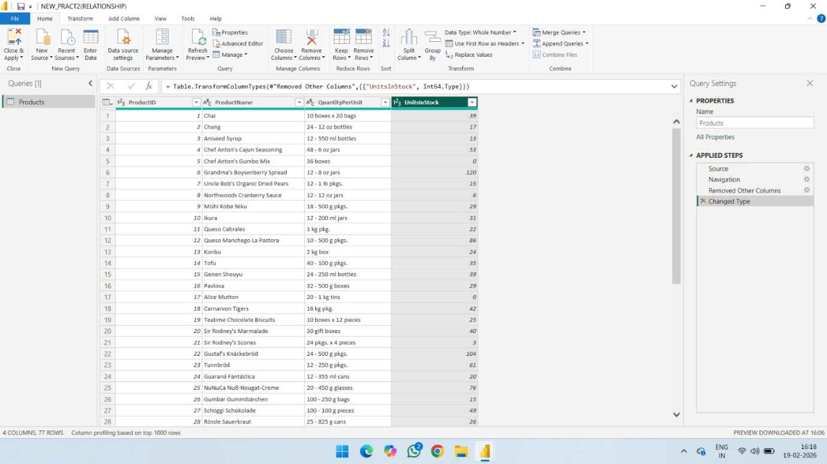
- After above step, close query editor and click on Yes to save changes.
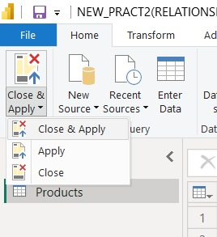
- Now you can view fields of Products table on right side, check all the fields of table to get representation in charts form.
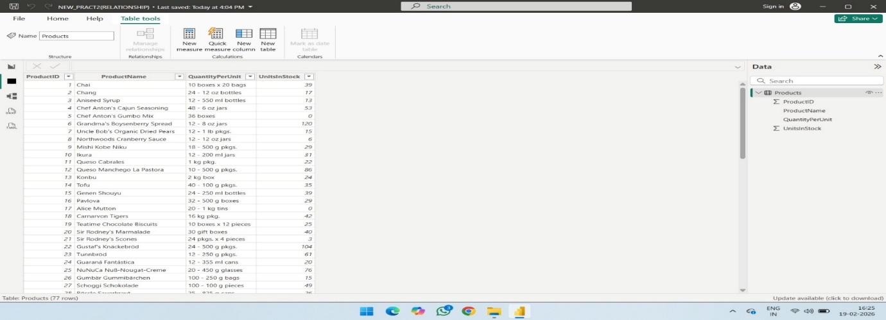
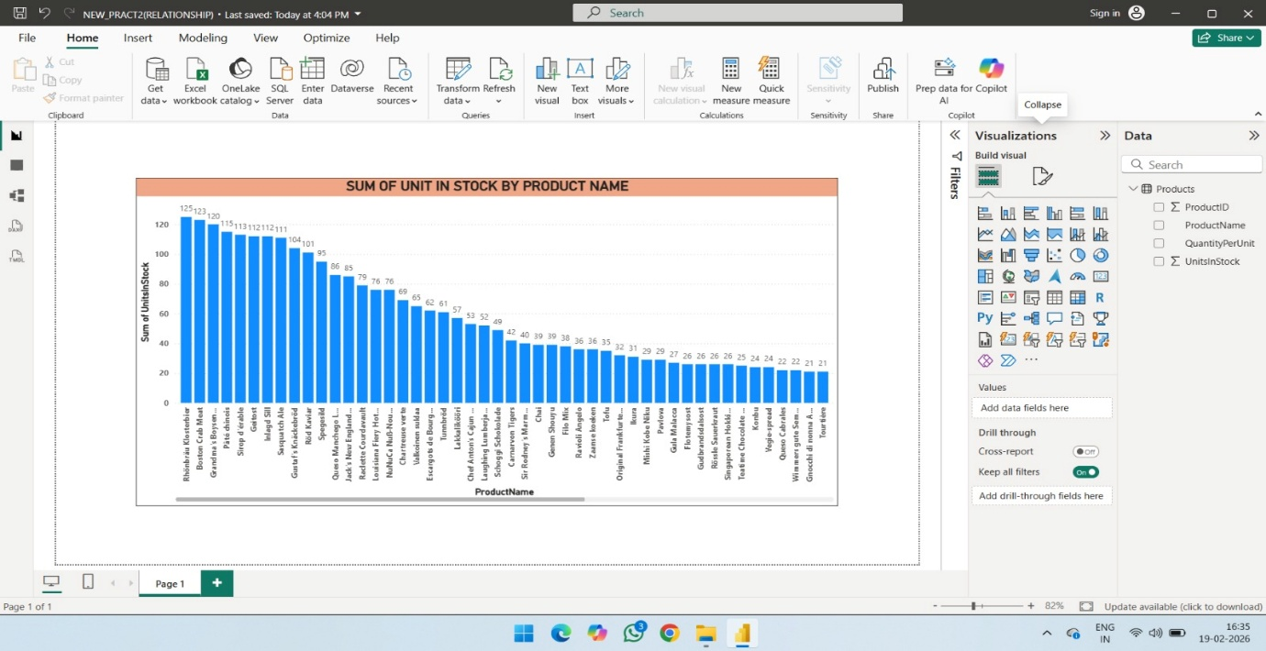
- STEP 4: Expand the Orders table.
- Once You have loaded a data source, you can click on Recent Sources to select desired table (Orders).
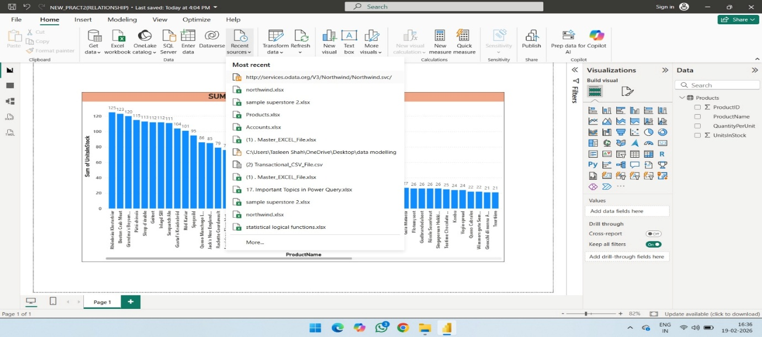
- After selecting the URL, Navigator window will appear from which you can select Orders table Click on Edit.
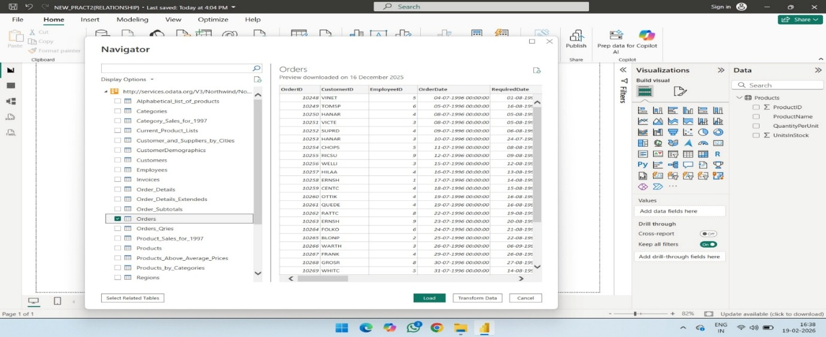
- Query Editor Window will appear
1. In the Query View, scroll to the Order_Details column.
2. In the Order_Details column, select the expand icon.
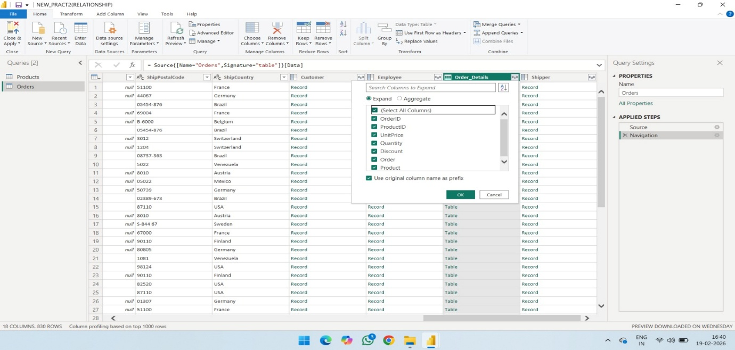
3. In the Expand drop-down:
a. Select (Select All Columns) to clear all columns.
b. Select ProductID, UnitPrice, and Quantity.
c. Click OK.
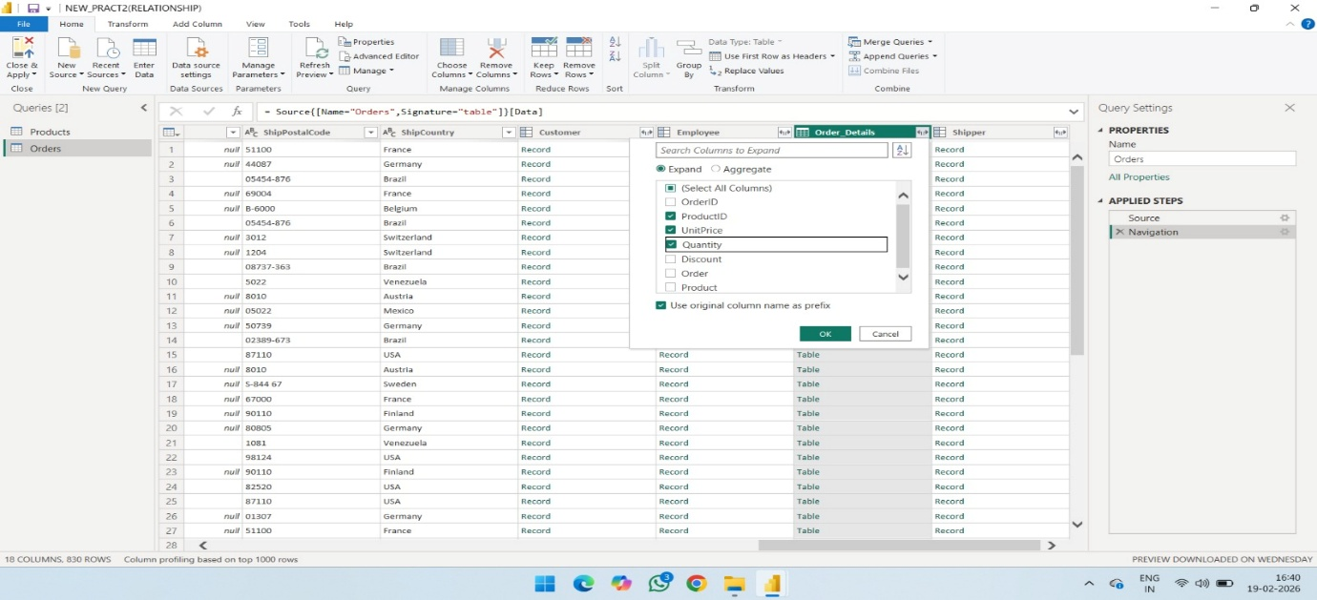

- After clicking on OK following screen appears with combined columns.

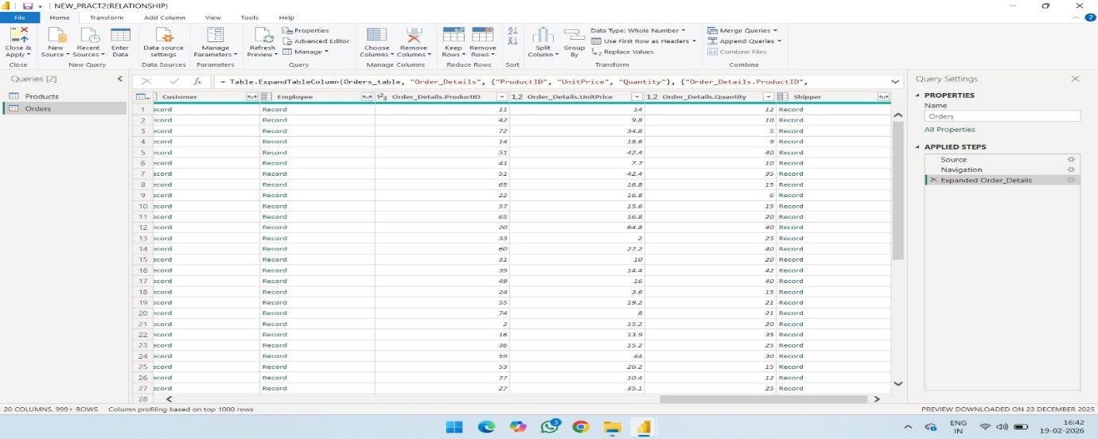
- STEP 5: Calculate the line total for each Order_Details row.
- Power BI Desktop lets you to create calculations based on the columns you are importing, so you can enrich the data that you connect to. In this step, you create a Custom Column to calculate the line total for each Order_Details row.

- Calculate the line total for each Order_Details row:
- In the Add Column ribbon tab, click Add Custom Column.
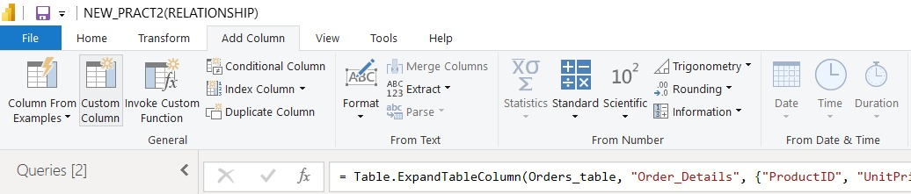
b) In the Custom Column dialog box, in the Custom Column Formula textbox, enter
[Order_Details. UnitPrice] * [Order_Details.Quantity] by selecting from available columns and click on insert for each column.
c) In the New column name textbox, enter LineTotal.
d) Click OK.
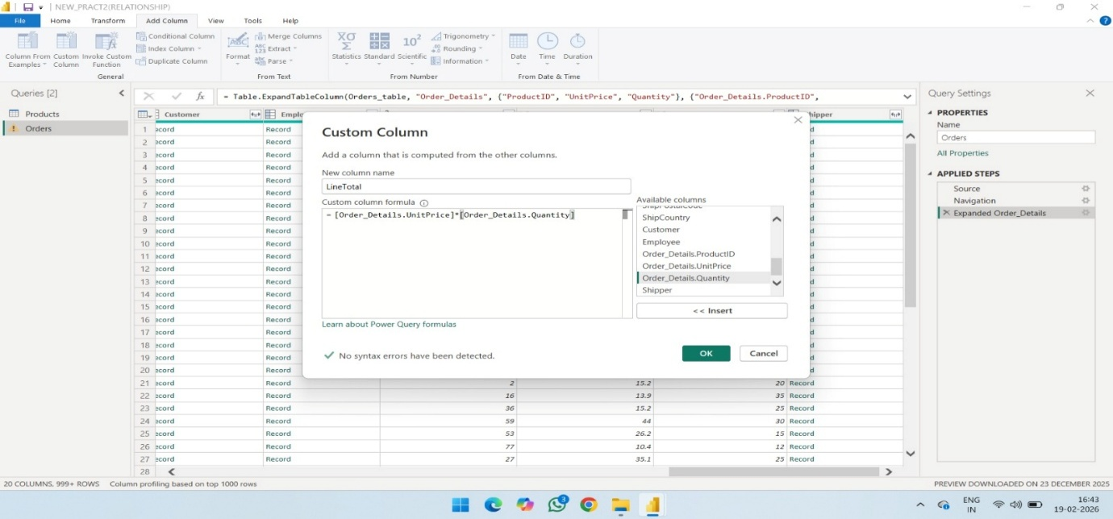

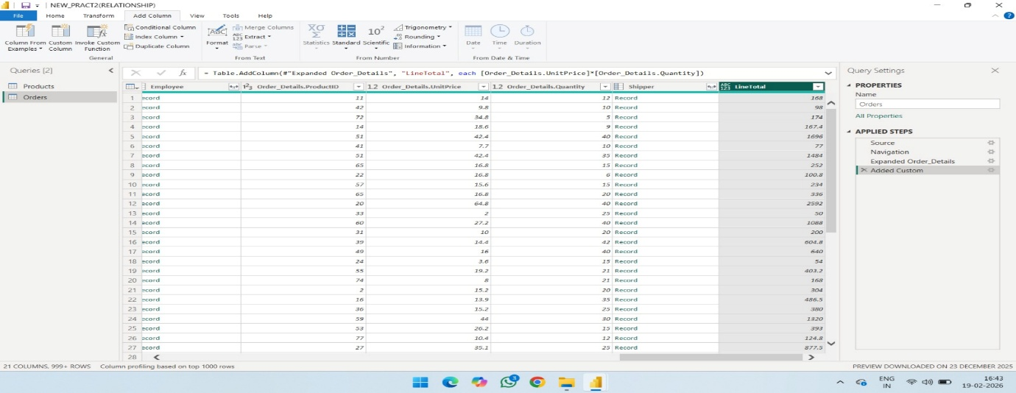
- STEP 6: Rename and reorder columns in the query In this step you finish making the model easy to work with when creating reports, by renaming the final columns and changing their order.
- In Query Editor, drag the LineTotal column to the left, after ShipCountry.
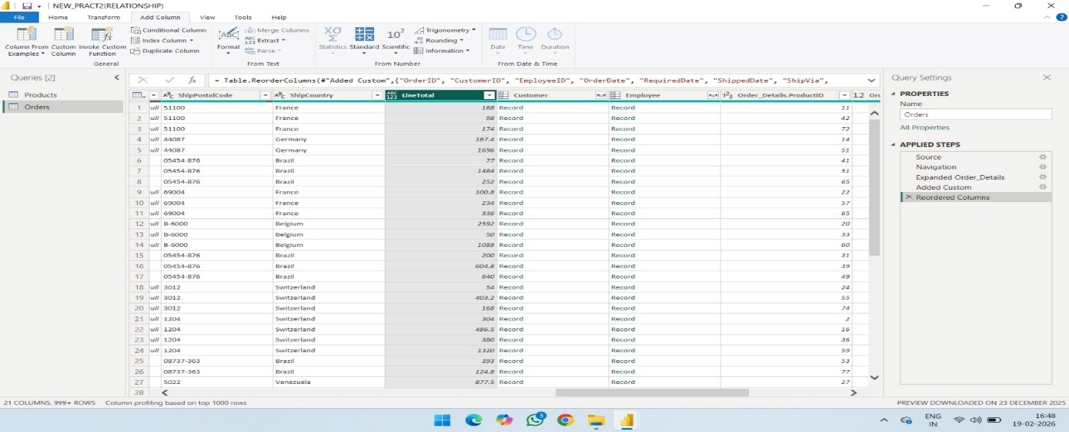
- Remove the Order_Details. prefix from the Order_Details. ProductID, Order_Details.UnitPrice and Order_Details. Quantity columns, by double-clicking on each column header, and then deleting that text from the column name.
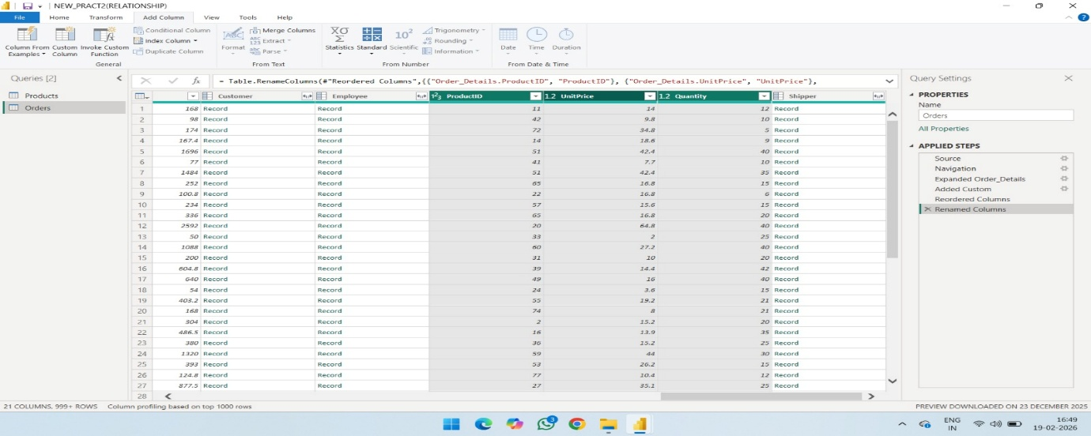
- STEP 7: Combine the Products and Total Sales queries.
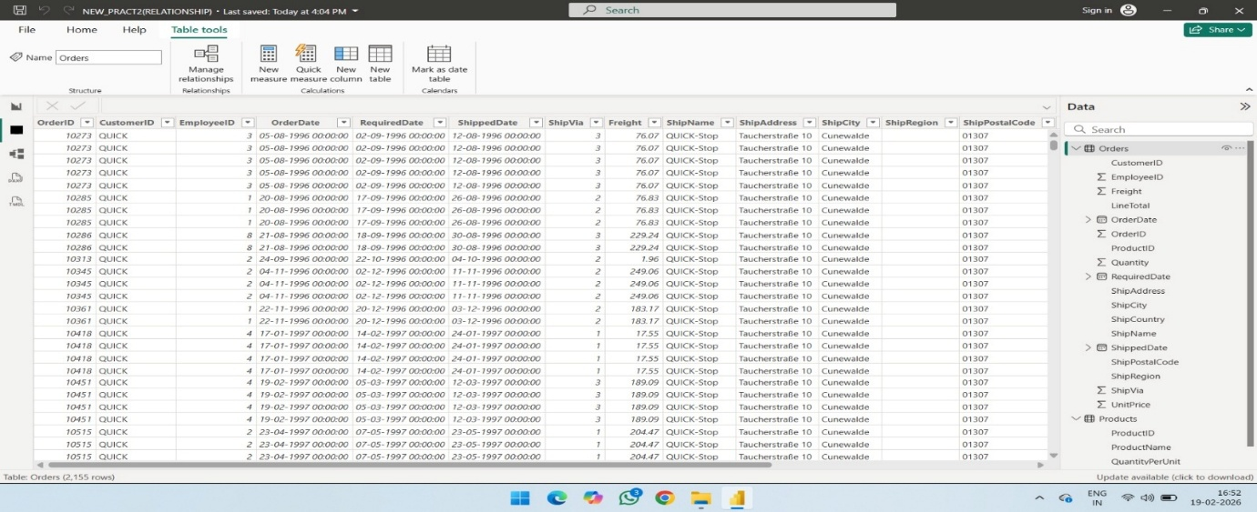
- Select Relationship view in Power BI Desktop.
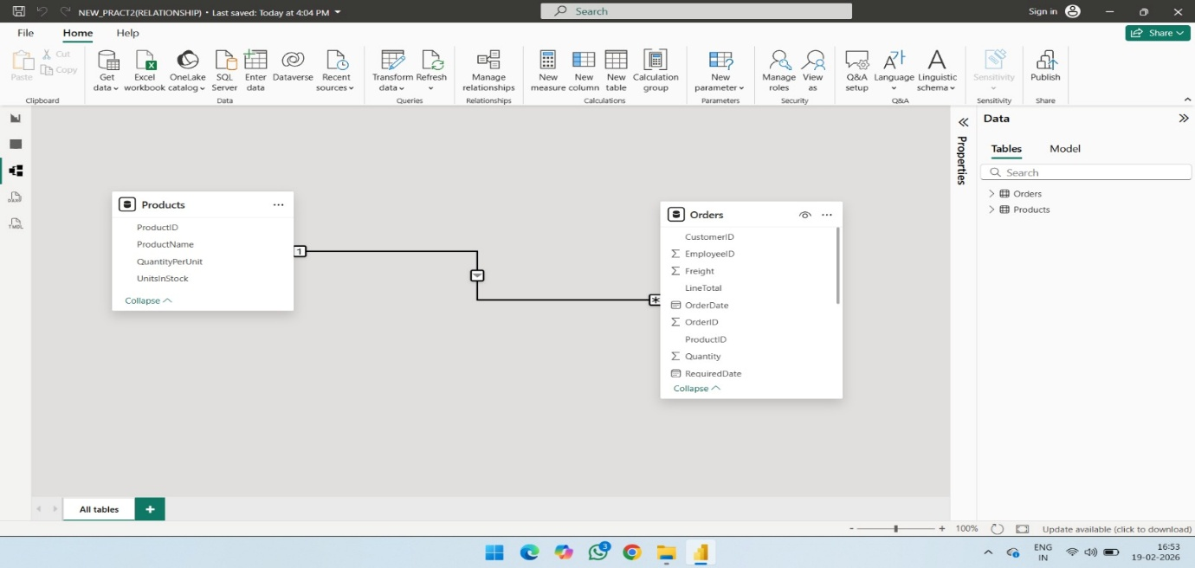
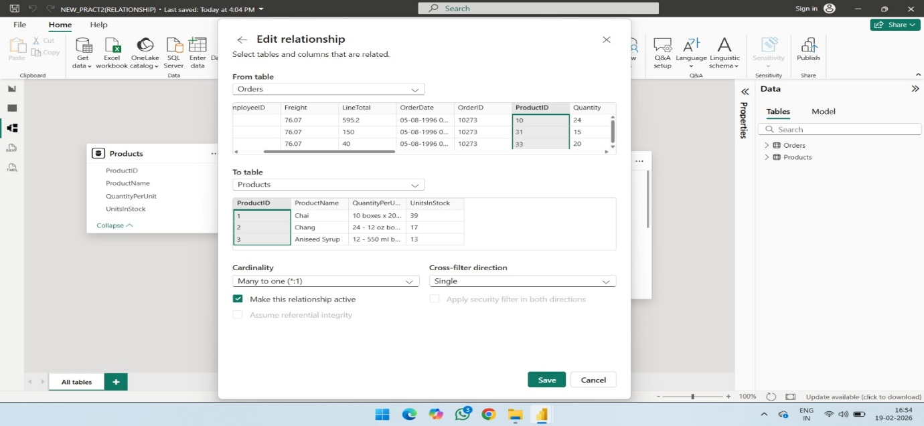
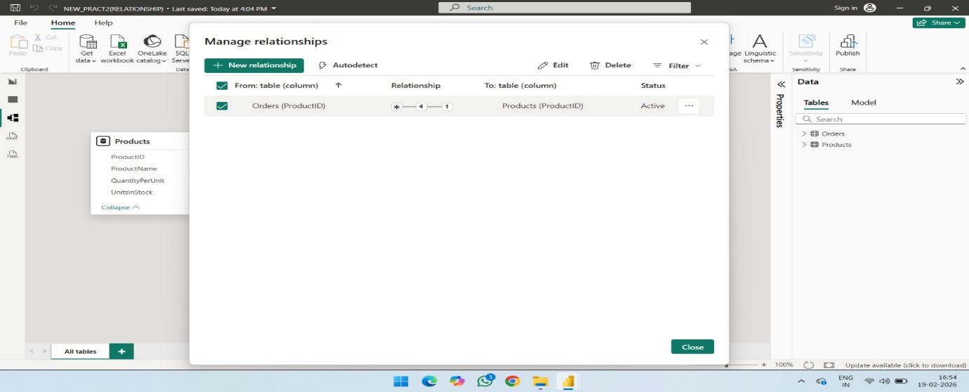
PRACT 8- AIM: Import the data warehouse data in MS excel and create the pivot table and chart.
SQL SERVER: -
STEP 1: -
- SETTINGS
- SEARCH
- DEVICE SPECIFICATION
- DEVICE NAME
- COPY
- \SQLEXPRESS
- CLICK TRUST CERTIFICATION
- CONNECT
STEP 2: -
- DATABASES
- RIGHT CLICK
- RESTORE DATABASES
- ENABLE DEVICE (3 DOTS)-------ADD
- SEARCH FOR FILE(ADVENTURE-WORKS)
- SELECT – OK
- SELECT BACKUP MEDIA CONTENT
- OK --- OK
- MESSAGE(RESTORE SUCCESS)-----OK

- STEP 3: Import Data from SQL Server to Excel.
- Open Excel → Go to Data tab.
- Click Get Data → From Database → From SQL Server Database.
- Enter Server Name → Click OK.
- Select required Database & Table → Click Load.
- Data appears in a new worksheet.
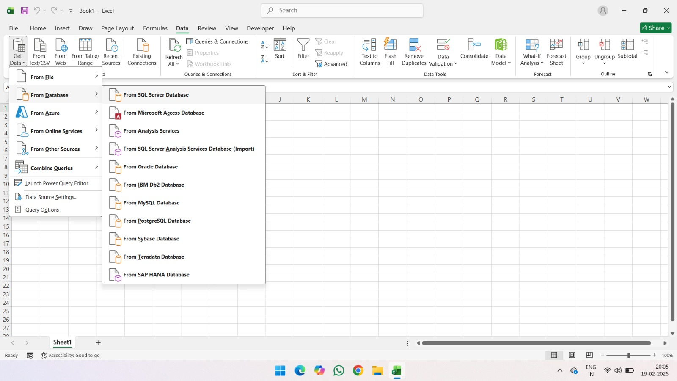
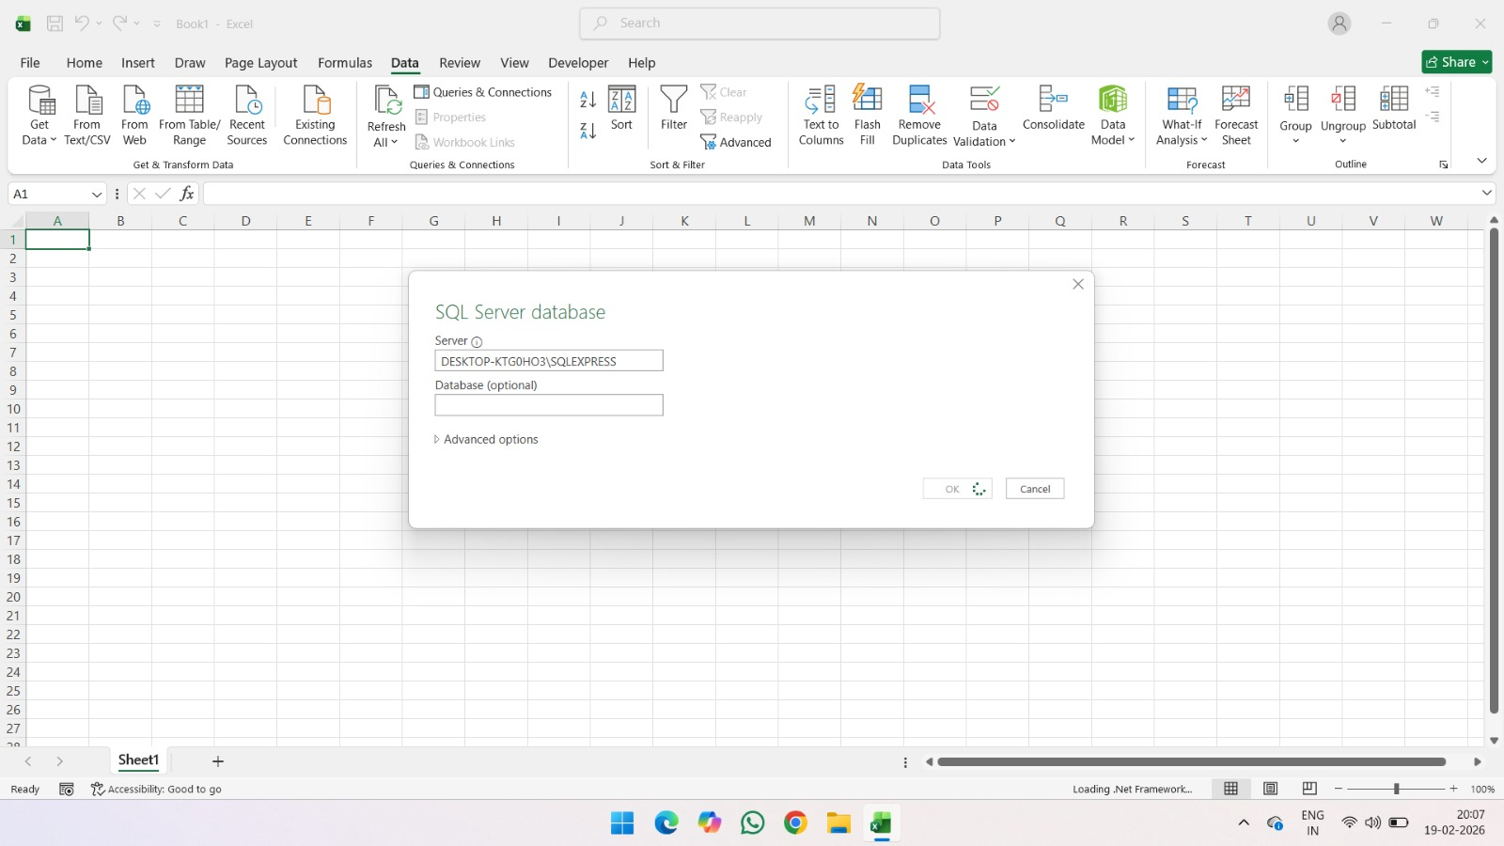
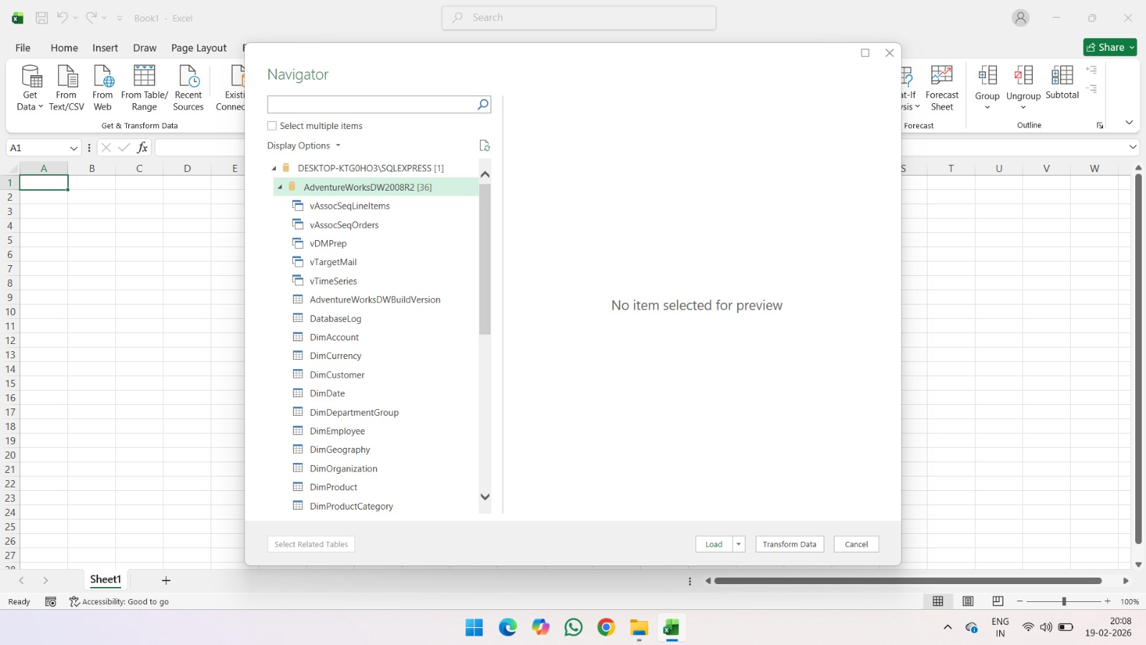
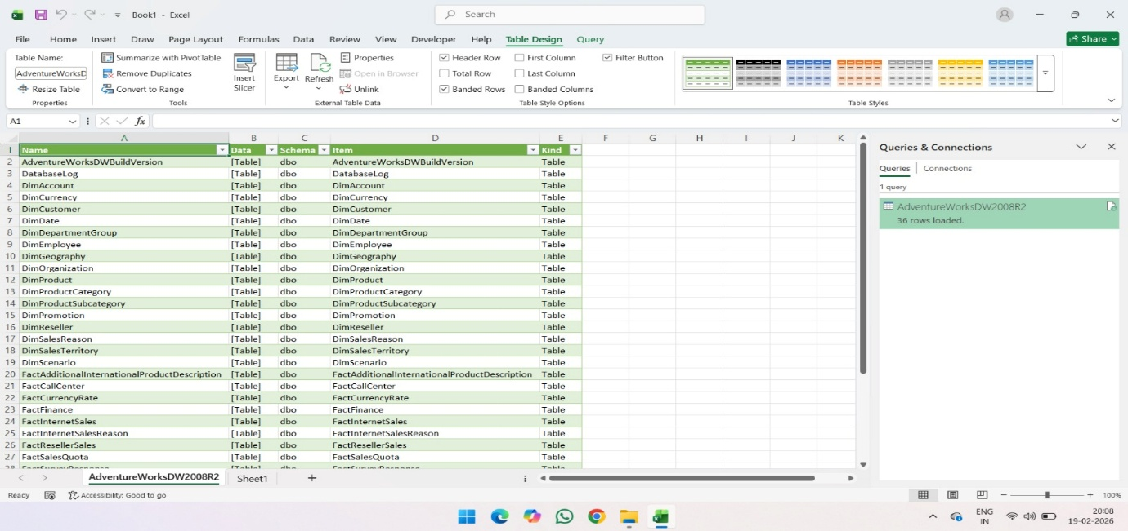
- STEP 4: Create Pivot Table.
- Select the imported data.
- Go to Insert → PivotTable.
- Choose From Table/Range → Click OK.
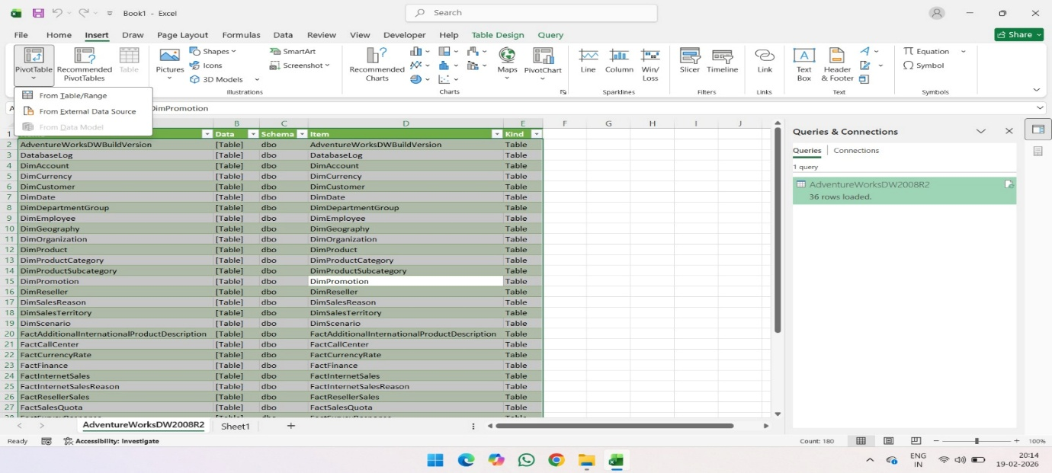
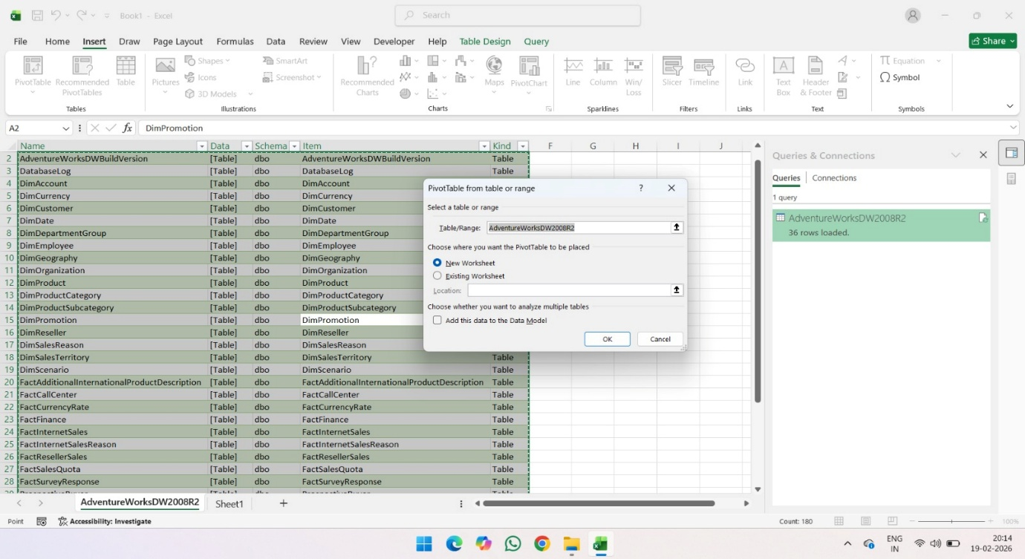
- STEP 5: Arrange PivotTable Fields.
- Drag Name → Rows.
- Drag Item → Columns.
- Drag Count of Kind → Values.
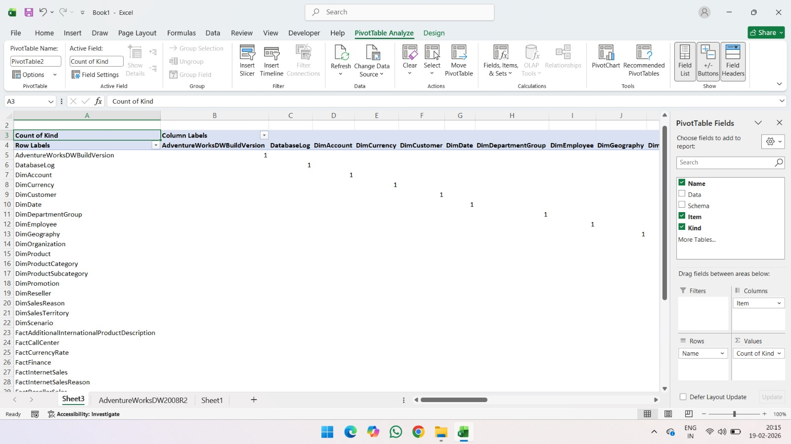
- STEP 4: Create Pivot Chart.
- Click inside the PivotTable.
- Go to Insert → PivotChart.
- Select Pie Chart → Click OK.
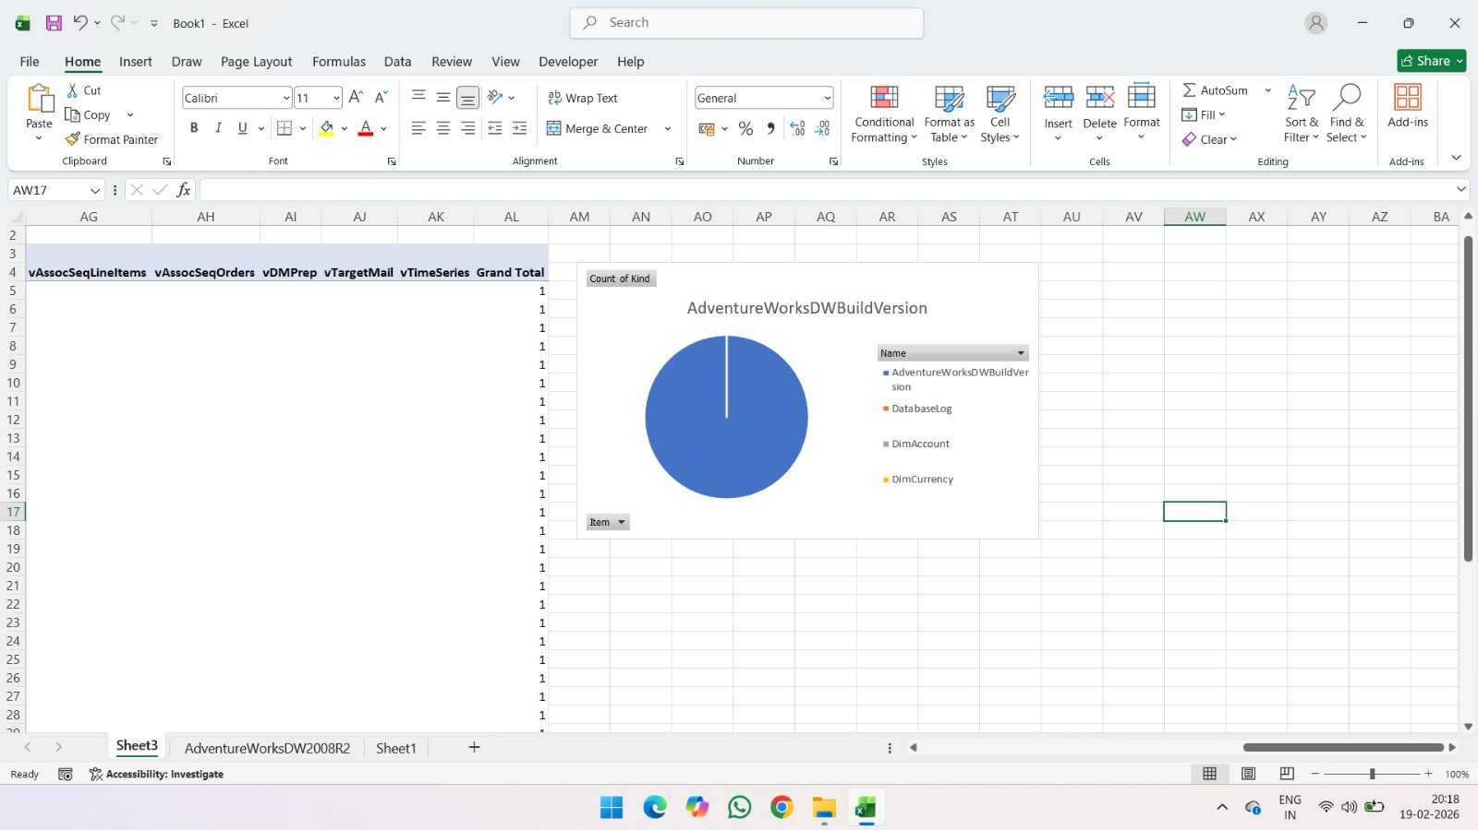
- STEP 6: Import Data from Excel Workbook to Excel.
- Open Excel → Go to Data tab.
- Click Get Data → From File → From Excel Workbook.
- Select online-store-orders.xlsx → Click Open → Load.
- Data appears in a new worksheet.
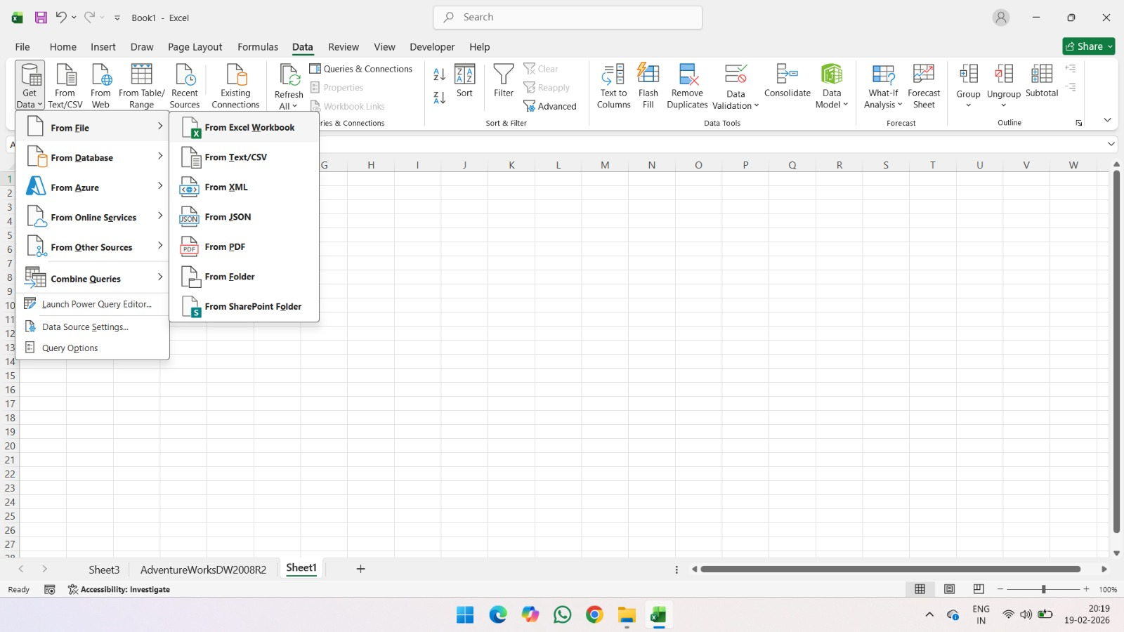
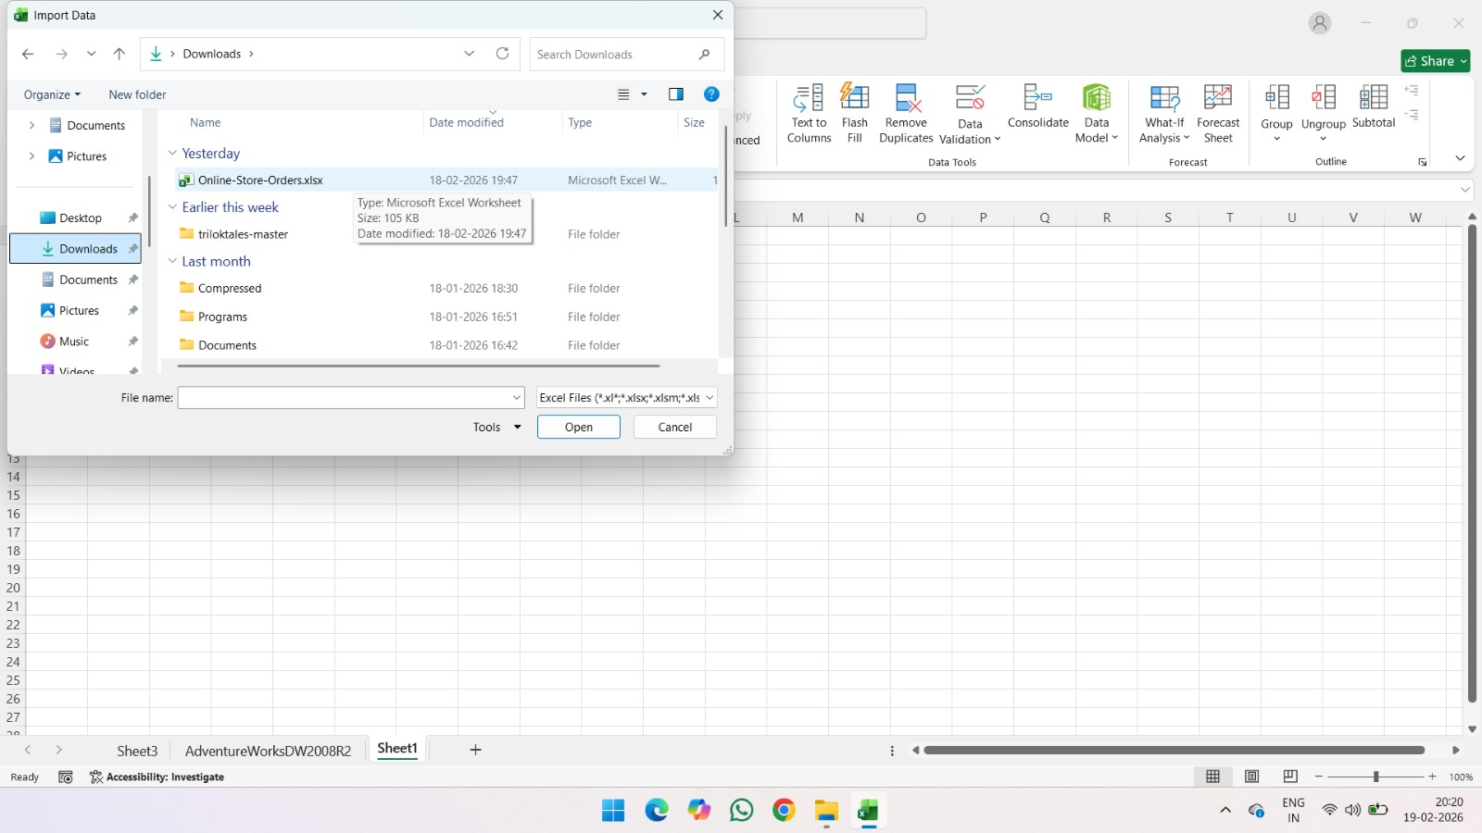
- STEP 7: Create Pivot Table.
- Select the loaded data.
- Go to Insert → PivotTable.
- Choose From Table/Range → Click OK.
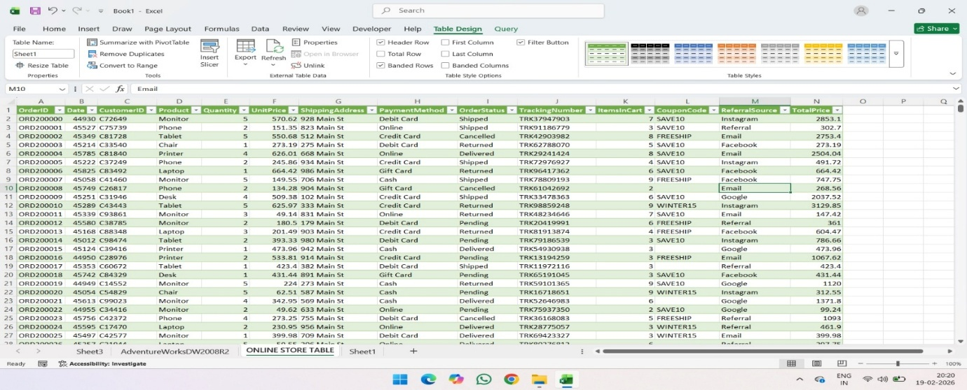
- STEP 8: Arrange PivotTable Fields.
- Drag Product → Rows.
- Drag Quantity → Columns.
- Drag Sum of UnitPrice → Values.
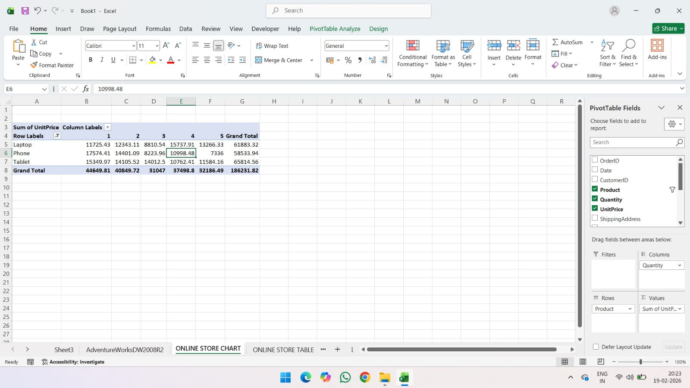
- STEP 9: Create Pivot Chart.
- Click inside the PivotTable.
- Go to Insert → PivotChart.
- Select Clustered Column Chart → Click OK.
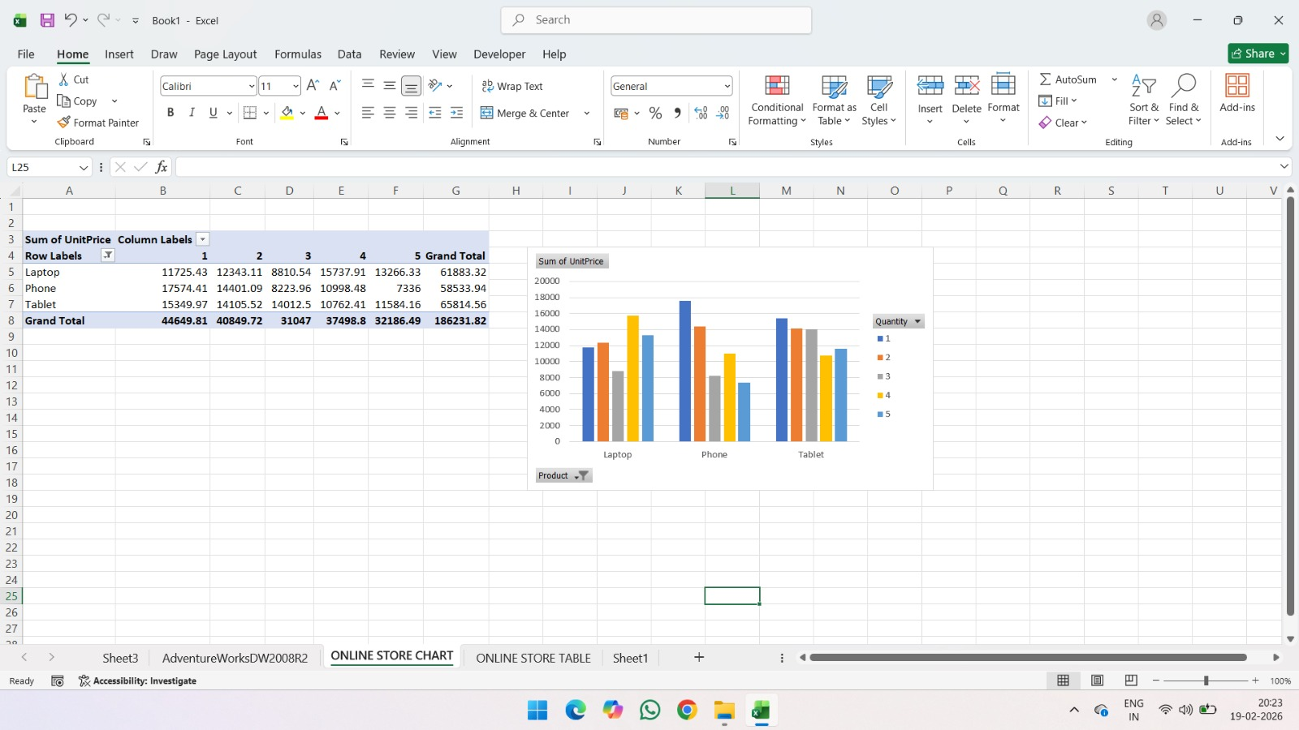

PRACT 9-
- PART A
AIM: To restore a database using SQL server management studio.
- STEP 1:
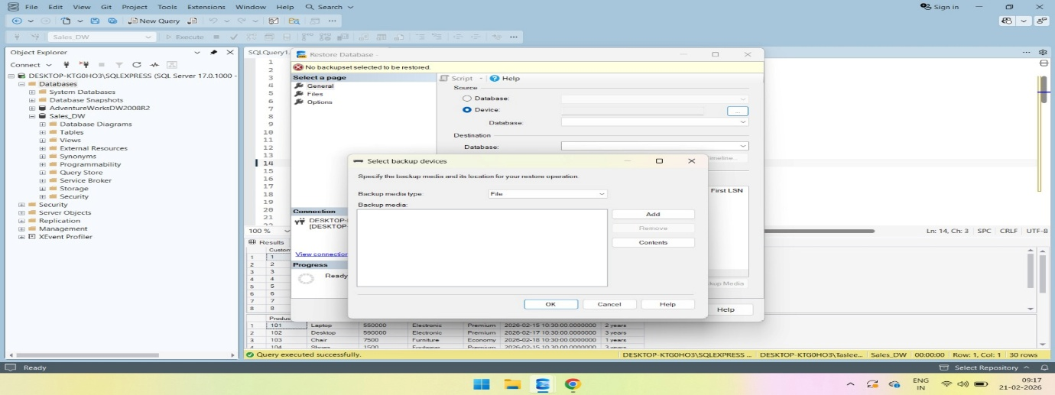
- STEP 2:
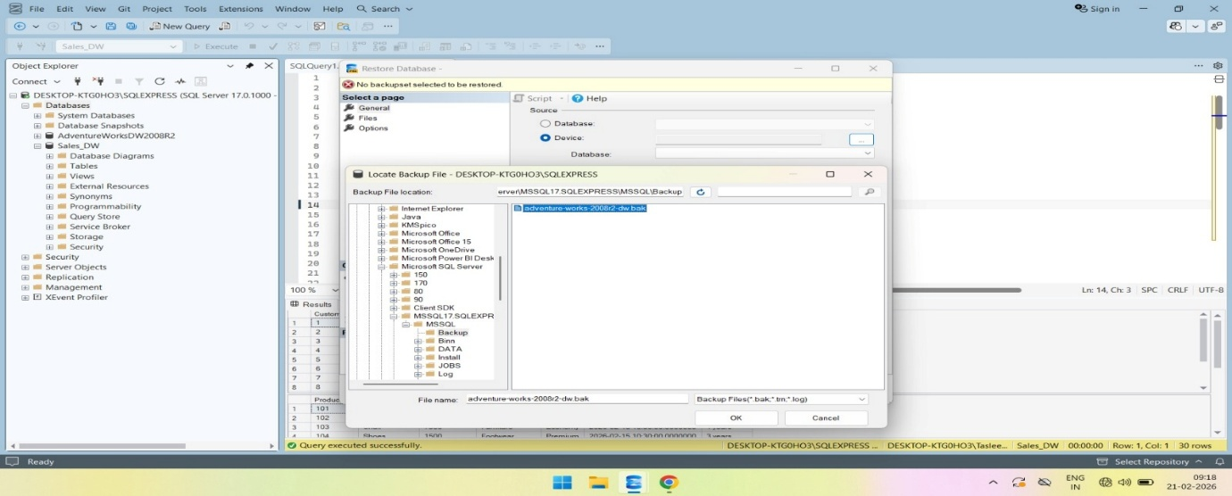
- STEP 3:
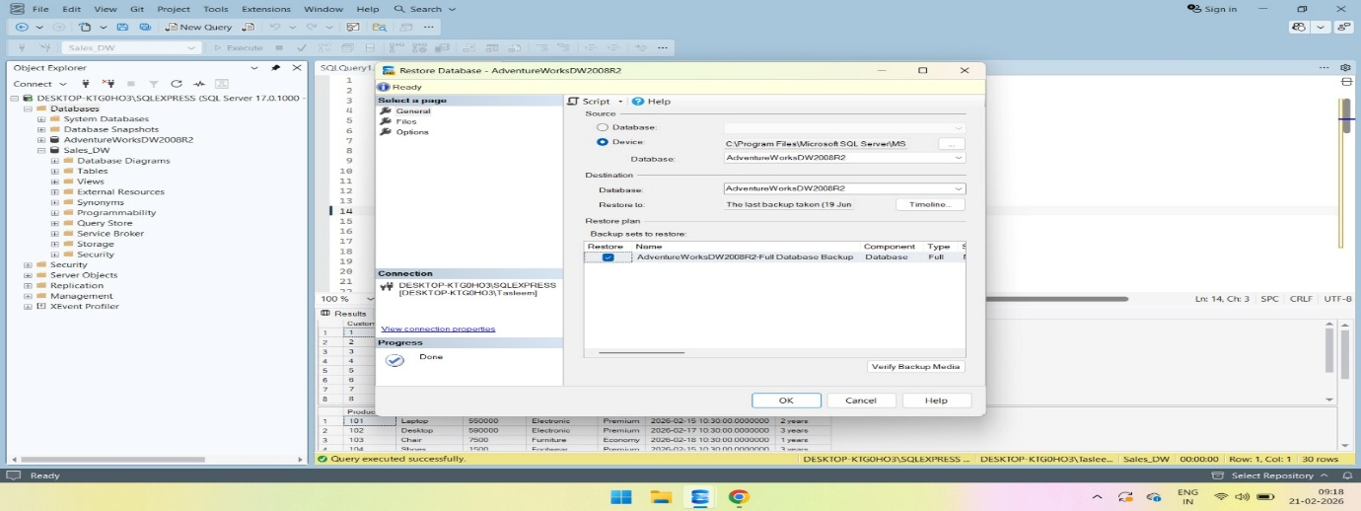
- STEP 4:
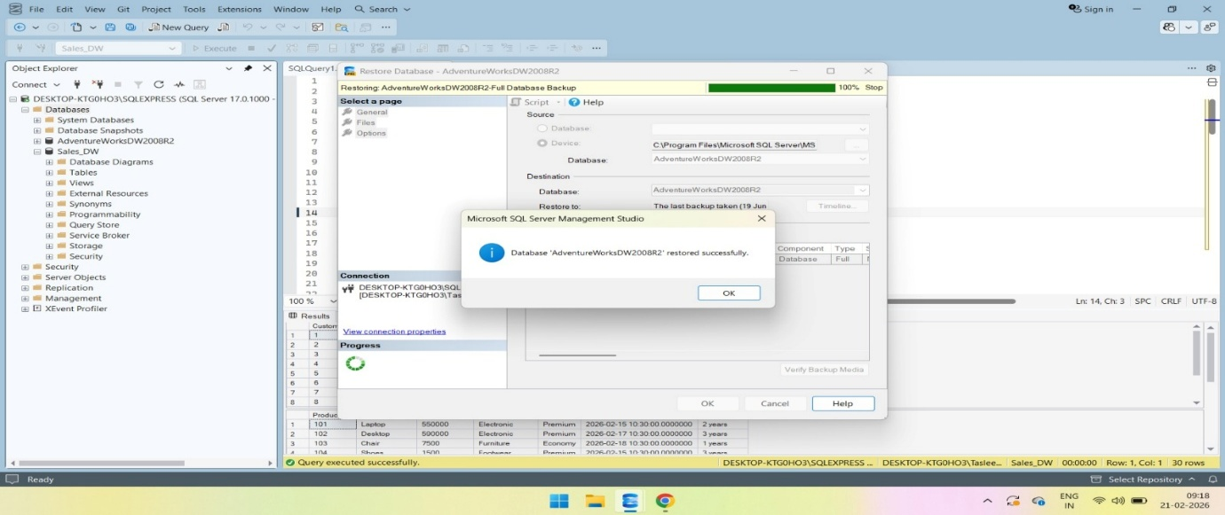
- PART B
AIM: To create data warehouse using SQL server management studio.
- CODING:
GO
Create database Sales_DW
Go

Use Sales_DW
Go

Create table DimCustomer
( CustomerID int primary key identity,
CustomerAltID varchar(10) not null,
CustomerName varchar(50),
Gender varchar(20)
)
Go

Insert into DimCustomer
(CustomerAltID,CustomerName,Gender)values
('IMI-001','Henry Ford','M'),
('IMI-002','Sasha Skye','F'),
('IMI-003','Tia Matthews','F'),
('IMI-004','Bill Gates','M'),
('IMI-005','Eric Dane','M'),
('IMI-006','Tom Ford','M')

CREATE TABLE Product(
[Product ID] INT NOT NULL,
[Product Name] NVARCHAR(50) NOT NULL,
[Product Price] float NOT NULL,
[Category Name] NVARCHAR(50) NOT NULL,
Class NVARCHAR(50) NOT NULL,
[Modify Date] datetime2(7) NOT NULL,
[Vitality Date] NVARCHAR(50) NOT NULL
);

Insert into Product([Product ID],[Product Name],[Product Price],[Category Name],Class,[Modify Date],[Vitality Date])values
(101,'Laptop',550000.00,'Electronic','Premium','2026-02-15 10:30:00.00000000','2 years'),
(102,'Desktop',590000.00,'Electronic','Premium','2026-02-17 10:30:00.00000000','3 years'),
(103,'Chair',7500.00,'Furniture','Economy','2026-02-18 10:30:00.00000000','1 years'),
(104,'Shoes',1500.00,'Footwear','Premium','2026-02-15 10:30:00.00000000','3 years'),
(105,'Backpack',1800.00,'Accessories','Economy','2026-02-19 10:30:00.00000000','3 years'),
(106,'Laptop',580000.00,'Electronic','Premium','2026-02-15 10:30:00.00000000','2 years')

CREATE TABLE [Transaction Date]
(
[Transaction Date] DATETIME2(7) PRIMARY KEY,
[Transaction Day] INT NOT NULL,
[Transaction Month] INT NOT NULL,
[Transaction Year] INT NOT NULL
);
GO

INSERT INTO [Transaction Date]
VALUES
('2026-02-01', 1, 2, 2026),
('2026-02-02', 2, 2, 2026),
('2026-02-03', 3, 2, 2026),
('2026-02-04', 4, 2, 2026),
('2026-02-05', 5, 2, 2026),
('2026-02-06', 6, 2, 2026);
GO

CREATE TABLE [Transaction Fact]
(
[Transaction Number] NVARCHAR(50) PRIMARY KEY,
[Employee ID] INT NOT NULL,
[Product ID] INT NOT NULL,
[Customer ID] INT NOT NULL,
[Transaction Date] DATETIME2(7) NOT NULL,
[Quantity Sold] INT NOT NULL,
[Total Price] FLOAT NOT NULL,
Discount FLOAT NOT NULL
);
GO

INSERT INTO [Transaction Fact]
VALUES
('T001', 201, 101, 1, '2026-02-01', 1, 55000, 500),
('T002', 202, 102, 2, '2026-02-02', 2, 50000, 1000),
('T003', 203, 103, 3, '2026-02-03', 1, 5000, 200),
('T004', 204, 104, 4, '2026-02-04', 1, 8000, 300),
('T005', 205, 105, 5, '2026-02-05', 2, 6000, 500),
('T006', 206, 106, 6, '2026-02-06', 3, 4500, 250);
GO

SELECT * FROM DimCustomer;
SELECT * FROM Product;
SELECT * FROM [Transaction Date];
SELECT * FROM [Transaction Fact];

- OUTPUT:
