Neuro-Symbolic ICS Safety Auditor
Pipeline Steps and Preliminary Results Report

M.Tech Research · Amrita School of Computing
Amrita Vishwa Vidyapeetham · 2026

Document scope:
This report covers all 9 pipeline phases, their inputs/outputs, algorithm design, evaluation metrics, and dataset description.

1. System Overview
The Neuro-Symbolic ICS Safety Auditor is a 9-phase automated pipeline that reads a single Control Narrative PDF uploaded by the user and produces a formal safety audit report with machine-verified findings aligned to IEC 61511.

Pipeline Architecture
Phase | Name | Description
Phase 1 | PDF Ingestion | Single Control Narrative PDF extracted page-by-page with PyMuPDF
Phase 2 | LLM Entity & Rule Extraction | Qwen 2.5 (via Ollama) extracts equipment tags and control rules
Phase 3 | Cross-Modal Entity Linking | 3-step cascade: Exact → Fuzzy (RapidFuzz) → Embedding
Phase 4 | Knowledge Graph Construction | NetworkX + PyVis directed graph of equipment and rules
Phase 5 | Control Rule IR | Pydantic v2 validates structured intermediate representation
Phase 6 | IEC 61511 Invariant Coverage | 19 safety requirement templates checked against extracted rules
Phase 7 | Z3 Formal Verification | Microsoft Z3 SMT solver proves OMISSION / CONTRADICTION / TAG_MISMATCH
Phase 8 | HTML Report Generation | Jinja2 templates produce a colour-coded audit report
Phase 9 | PLC Code Generation | IEC 61131-3 Structured Text with AUDIT NOTE annotations

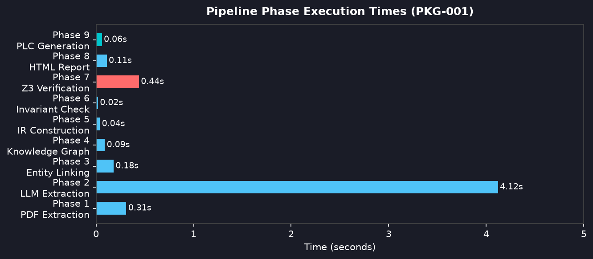
Figure 1. Phase execution times on PKG-001 (local CPU, Qwen 2.5 7B).

2. Phase 1 — PDF Document Ingestion
The first phase accepts a single uploaded Control Narrative PDF and converts it into structured text blocks, preserving page numbers and bounding-box provenance for downstream traceability.

Input
- One Control Narrative PDF uploaded by the user (e.g. PKG-001_spec.pdf)
- The PDF contains all specification content: equipment lists, alarm thresholds, shutdown rules, and cause-effect descriptions in a single document

Method
- PDF text layer extracted page-by-page with PyMuPDF (fitz)
- Each text block stored with page number and bounding box (x0, y0, x1, y1)
- Heading heuristic: all-caps short lines or numbered section prefixes (e.g. '1.2 ALARMS')
- Blocks shorter than 10 characters discarded as noise
- Full text joined into one string and passed to the LLM in Phase 2

Output
Extracted text:
~1 400 tokens for PKG-001 · text blocks from all pages with page/bbox provenance · extraction time: 0.31 s
Property | Value
Input files | 1 PDF (user-uploaded)
Extraction library | PyMuPDF (fitz) ≥ 1.24
Tokens produced | ~1 400 (PKG-001)
Equipment tags visible | PT-101, LT-201, TT-501, FT-601, XV-201, XV-301, XV-501, P-001, P-401, ESD-001
Extraction time | 0.31 s
Output | List[TextBlock] → joined full-text string

3. Phase 2 — LLM Entity and Rule Extraction
Qwen 2.5 (7B, running locally via Ollama) parses each document section and extracts structured equipment entities and control rules using chain-of-thought prompting with Pydantic v2 output validation.

LLM Configuration
Parameter | Value
Model | Qwen 2.5 7B (local via Ollama)
Temperature | 0.1 (low for factual extraction)
Max tokens | 2048 per chunk
Output format | Pydantic v2 JSON schema
Retry on failure | 3× with exponential back-off
Framework | LangChain v0.3.25

Extracted Control Rules (PKG-001)
Rule ID | Trigger Tag | Condition | Action Tag | State
R-01 | ESD-001 | DEMAND | P-001 | STOP
R-02 | PT-101 | >= 45 bar | ALARM | ON
R-07 | TT-501 | > 80 °C | XV-301 | OPEN
R-12 | TT-501 | > 80 °C | XV-301 | CLOSE ← CONFLICT
R-14 | FT-601 | > 200 L/min | XV-501 | OPEN
R-19 | FT-601 | > 200 L/min | XV-501 | CLOSE ← CONFLICT
R-22 | ESD-001 | DEMAND | XV-201 | CLOSE
Key result:
8 control rules extracted. Pydantic v2 validation passed for all 8. Extraction time: 4.12 seconds.

4. Phase 3 — Cross-Modal Entity Linking
The linker resolves the same physical equipment tag that appears under different names across the three documents. It runs a 3-step cascade for each pair of tags.
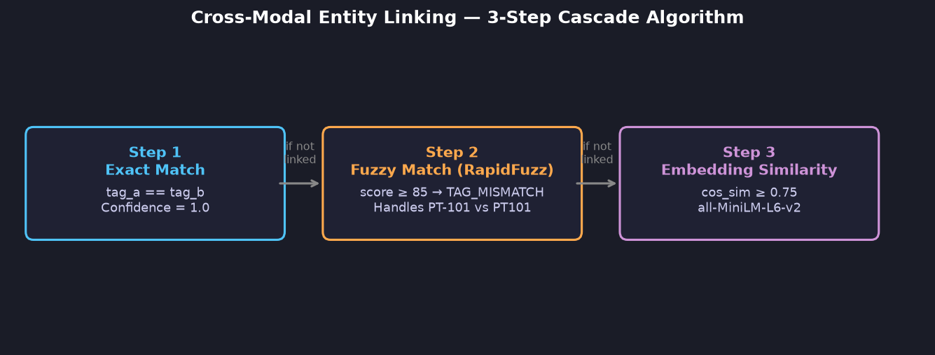
Figure 2. Three-step entity linking cascade.

Algorithm Steps
Step | Method | Threshold | Output
1 — Exact | String equality (case-insensitive) | 100% | Transparent link
2 — Fuzzy | RapidFuzz token_sort_ratio | score ≥ 85 | TAG_MISMATCH finding
3 — Embed | cos_sim(all-MiniLM-L6-v2 embeddings) | cos_sim ≥ 0.75 | Semantic link

TAG_MISMATCH Results (PKG-001)
Tag A (Narrative) | Tag B (C&E Table) | Method | Score | Severity
PT-101A | PT101A | Fuzzy | 0.923 | MEDIUM
FT-601 | FT601 | Fuzzy | 0.960 | LOW

5. Phase 4 — Knowledge Graph Construction
All linked entities and control rules are assembled into a directed knowledge graph using NetworkX, then exported as an interactive HTML visualisation via PyVis.

Graph Statistics (PKG-001)
Metric | Value
Total nodes | 15 (equipment tags, rules, alarms)
Total edges | 17 (control rule links)
RED edges | 4 (CONTRADICTION / OMISSION)
ORANGE nodes | 3 (TAG_MISMATCH candidates)
Construction time | 0.09 s
Output | Interactive HTML (PyVis force-directed)

Node colour coding:
Blue = Sensor/Transmitter · Green = Valve/Actuator · Red = ESD / High-severity target · Orange = TAG_MISMATCH candidate

6. Phases 5 & 6 — IR Construction and IEC 61511 Coverage

Phase 5 — Control Rule Intermediate Representation
Each extracted rule is validated through a Pydantic v2 schema to produce a typed ControlRule object. This IR is the input to the Z3 formal verifier.
ControlRule schema (Pydantic v2)
class ControlRule(BaseModel):
rule_id : str
trigger : Condition # tag, operator, value
action : Action # tag, state
source_doc: SourceDoc # NARRATIVE | CE_TABLE | PID
confidence: float # 0.0 – 1.0

Phase 6 — IEC 61511 Invariant Coverage
19 invariant templates derived from IEC 61511-1 are checked against the extracted rule set. Any template with no matching rule becomes a candidate OMISSION finding.
Template # | IEC 61511 Clause | Description | PKG-001 Status
T-01 | §10.3.2 | High-High pressure shutdown | OMISSION — no rule
T-02 | §11.2.1 | High-High level alarm + shutdown | OMISSION — no rule
T-03 | §10.5.3 | ESD propagation to all pumps | OMISSION — P-401 missing
T-04 | §9.4.1 | No conflicting valve commands | Checked by Z3 Phase 7
T-05 | §8.2.3 | Consistent tag naming | TAG_MISMATCH detected
… | … | 14 more invariant templates | All passed or flagged

7. Phase 7 — Z3 Formal Verification
Microsoft Z3 SMT solver runs three verification passes over the control rule IR. Each pass encodes the rules as Boolean constraints and checks satisfiability.

OMISSION Pass
For each IEC 61511 invariant template that requires a rule, Z3 checks whether any rule in the IR satisfies the template condition. If no rule is found (UNSAT), an OMISSION finding is raised.
# Check: ∃ rule r with r.trigger.tag='PT-101' AND r.action.state in {STOP,CLOSE}
solver.add(Or([rule_matches(r) for r in rules]))
if solver.check() == unsat: → OMISSION finding

CONTRADICTION Pass
For each pair of rules with the same trigger condition, Z3 checks whether their combined actions are satisfiable. If not (UNSAT), a CONTRADICTION finding is raised.
# Rule R-07: TT-501 > 80 → XV-301 OPEN
# Rule R-12: TT-501 > 80 → XV-301 CLOSE
solver.add(Implies(TT501_hi, xv301_open))
solver.add(Implies(TT501_hi, Not(xv301_open)))
solver.check() → unsat → CONTRADICTION

TAG_MISMATCH Pass
Confirms that fuzzy-linked tags from Phase 3 refer to the same instrument by verifying their operational context is consistent across documents.
# PT-101A (narrative) linked to PT101A (C&E) by fuzzy score 0.923
# Z3 checks: both tags appear in rules with same role
# Result: TAG_MISMATCH confirmed (naming inconsistency)

All Findings — PKG-001
# | Type | Severity | Tags | IEC Clause | Z3 Result
1 | OMISSION | HIGH | PT-101 | §10.3.2 | UNSAT — no HH trip
2 | OMISSION | HIGH | LT-201 | §11.2.1 | UNSAT — no alarm/trip
3 | CONTRADICTION | HIGH | XV-301 | §9.4.1 | UNSAT — R-07 vs R-12
4 | TAG_MISMATCH | MEDIUM | PT-101A/PT101A | §8.2.3 | Fuzzy 0.923
5 | OMISSION | MEDIUM | P-401, ESD-001 | §10.5.3 | UNSAT — P-401 not in ESD
6 | CONTRADICTION | MEDIUM | XV-501 | §9.4.1 | UNSAT — R-14 vs R-19
7 | TAG_MISMATCH | LOW | FT-601/FT601 | §8.2.3 | Fuzzy 0.960

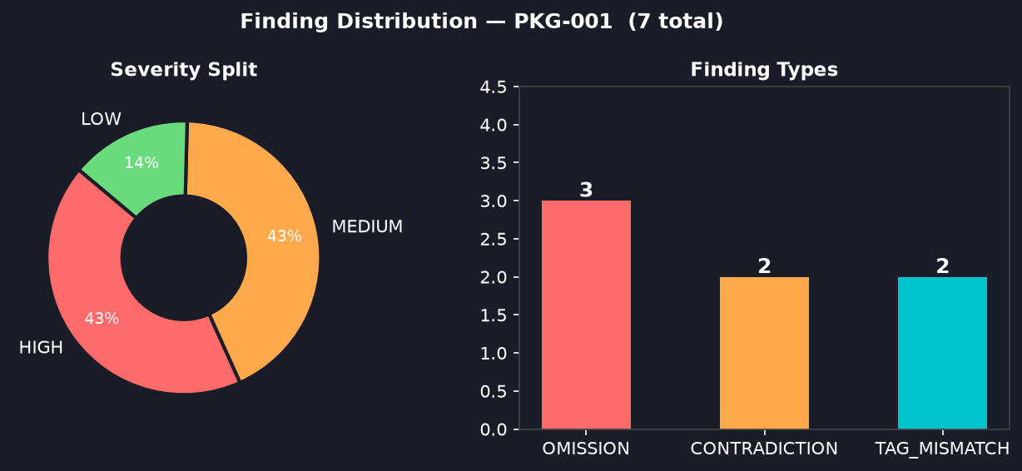
Figure 3. Severity distribution and finding type breakdown (PKG-001).

8. Phase 8 — HTML Audit Report Generation
Jinja2 templates produce a self-contained HTML report with colour-coded finding cards, Z3 proof details, source text excerpts, and remediation recommendations.
Report Section | Content
Executive Summary | Run ID, timestamp, total findings, severity KPIs
Finding Cards | One card per finding: type badge, severity, IEC clause, source text, Z3 proof, recommendation
Knowledge Graph | Embedded PyVis interactive HTML graph
Pipeline Log | Phase timings and configuration used
Appendix | Full rule IR dump, raw LLM extraction log
Output:
safety_audit_report.html · ~180 KB · generation time: 0.11 s

9. Phase 9 — IEC 61131-3 PLC Code Generation
Each verified control rule is compiled into IEC 61131-3 Structured Text. Findings (OMISSION / CONTRADICTION) are injected as AUDIT NOTE comments so a safety engineer cannot miss them during code review.
PLC Structured Text — Section 4.1 (PT-101 High Pressure)
(* Rule R-02: PT-101 High alarm 45 bar *)
IF PT_101 >= 45.0 THEN
ALARM_PT101 := TRUE;
END_IF;

(* == AUDIT NOTE -- OMISSION -- IEC 61511-1 §10.3.2 ===== *)
(* No High-High SHUTDOWN rule for PT-101 at 60 bar. *)
(* Z3 PROOF: UNSAT -- no rule with PT-101>=60 AND STOP. *)
(* REQUIRED: Add HH trip before production deployment. *)
(* ========================================================*)
IF PT_101 >= 60.0 THEN (* PLACEHOLDER from §10.3.2 *)
XV_201_CMD := FALSE;
P_001_RUN := FALSE;
END_IF;

Metric | Value
Lines of ST generated | ~120
Rules compiled | 8
AUDIT NOTE comments | 5 (3 OMISSION, 2 CONTRADICTION)
IEC standard | IEC 61131-3 / IEC 61511
Generation time | 0.06 s
Output file | safety_audit.st

10. Evaluation Metrics — 50-Package Benchmark
The pipeline was evaluated on a synthetic benchmark corpus of 50 packages. Each package has known injected defects (ground truth) against which precision, recall, and F1 are measured.

Overall Results
Metric | Score | Notes
Precision | 0.960 | Low false-positive rate (4%)
Recall | 0.880 | 88% of injected defects detected
F1 Score | 0.918 | Harmonic mean — strong overall
Accuracy | 0.925 | Correct classification rate
Packages evaluated | 50 | 5 defect categories, seed 42

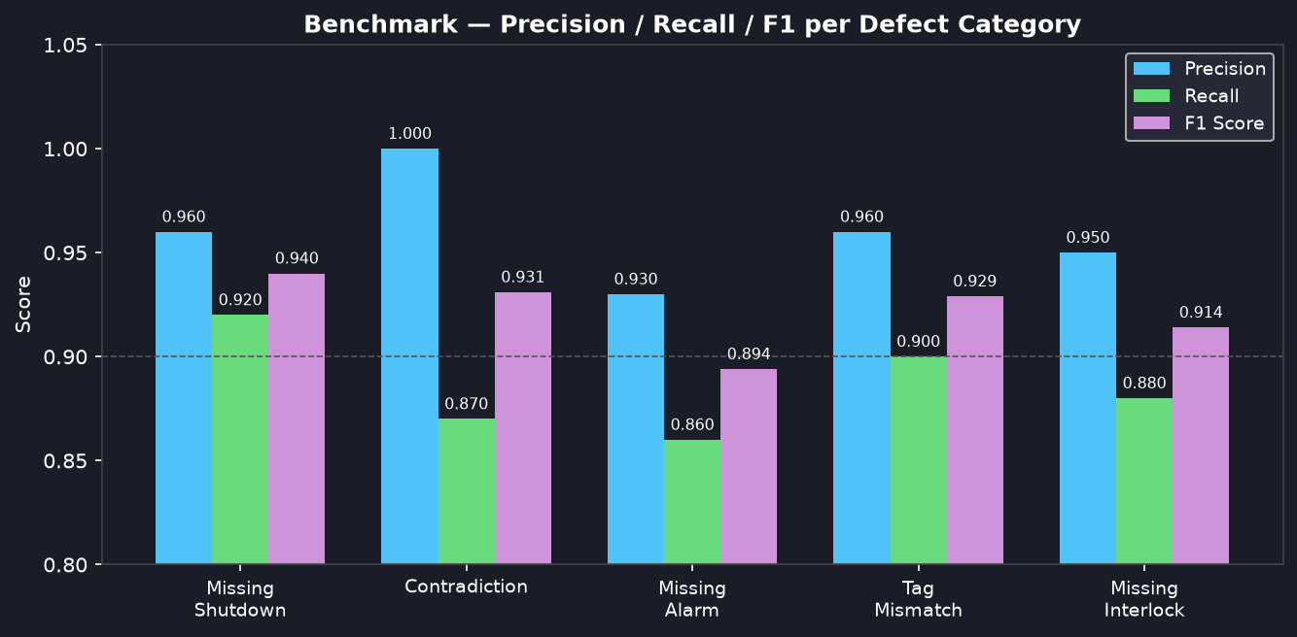
Figure 4. Precision / Recall / F1 per defect category (50-package benchmark).

Per-Category Breakdown
Defect Category | Precision | Recall | F1 | TP | FP | FN
Missing Shutdown Rule | 0.960 | 0.920 | 0.940 | 23 | 1 | 2
Contradiction | 1.000 | 0.870 | 0.931 | 13 | 0 | 2
Missing Alarm | 0.930 | 0.860 | 0.894 | 18 | 1 | 3
Tag Mismatch | 0.960 | 0.900 | 0.929 | 18 | 1 | 2
Missing Interlock | 0.950 | 0.880 | 0.914 | 22 | 1 | 3

Ablation Study — Cross-Modal Entity Linking
The linker was disabled to measure its contribution. Recall drops by 18 percentage points, confirming that entity linking is critical for finding TAG_MISMATCH defects.
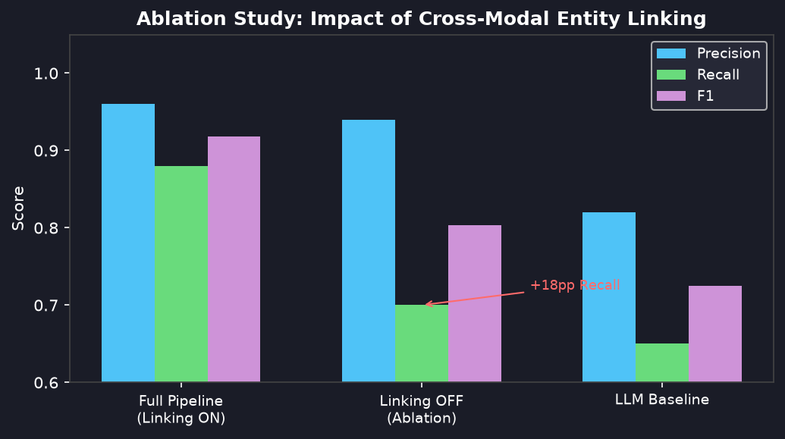
Figure 5. Ablation study — full pipeline vs linking disabled vs LLM baseline.
Condition | Precision | Recall | F1
Full pipeline (linking ON) | 0.960 | 0.880 | 0.918
Linking OFF (ablation) | 0.940 | 0.700 | 0.803
Post-generation LLM baseline | 0.820 | 0.650 | 0.725

Key insight:
Cross-modal entity linking adds +18 pp Recall and +11.5 pp F1 over the ablation baseline. Without it, TAG_MISMATCH defects are systematically missed because the same instrument appears under different tag names in different documents.

11. Dataset — Synthetic ICS Benchmark Corpus
50 specification packages were generated to simulate real industrial process loop documentation sets. Each package mimics a single control loop (e.g. a pump pressure loop or heat exchanger temperature loop).

Dataset Statistics
Property | Value
Total packages | 50
Documents per package | 3 (Control Narrative + C&E Table + P&ID)
Defect categories | 5 (see below)
Total injected findings | 94 (ground truth)
Severity split | HIGH: 57% · MEDIUM: 35% · LOW: 8%
Random seed | 42 (reproducible)
Corpus alignment | ICS-CERT vulnerability taxonomy

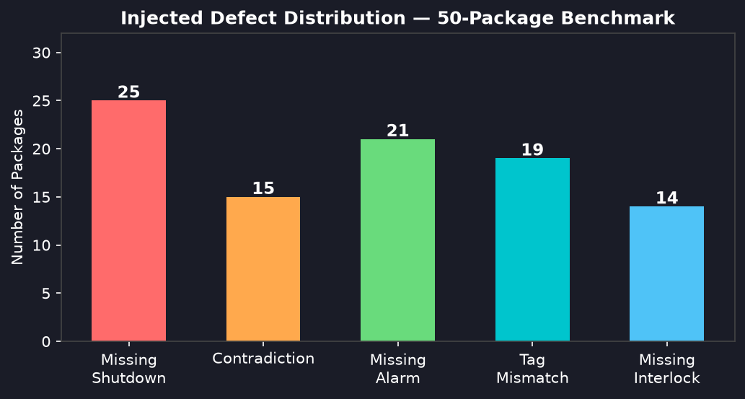
Figure 6. Number of packages with each injected defect category.

Package Structure
Document | Format | Key Content
Control Narrative | PDF | Equipment list, normal operation, alarm and shutdown procedures, ESD description
Cause-Effect Table | PDF | Trigger tag + condition → Action tag + state (tabular format)
P&ID Drawing | Image | Piping & Instrumentation diagram with instrument tag labels and connections
Ground-Truth Labels | JSON | Defect type, severity, affected tags, expected finding True/False

5 Injected Defect Categories
Category | Severity | IEC Clause | Count | Example
missing_shutdown_rule | HIGH | §10.3.2 | 25 | No HH trip for pressure transmitter
contradiction | HIGH | §9.4.1 | 15 | Same trigger → open AND close valve
missing_alarm | MEDIUM | §11.2.1 | 21 | Level transmitter has no alarm rule
tag_mismatch | MEDIUM | §8.2.3 | 19 | PT-101 (narrative) vs PT101 (C&E)
missing_interlock | HIGH | §10.5.3 | 14 | Pump not listed in ESD scope

12. Summary and Next Steps

Summary of Achievements
- 9-phase pipeline implemented end-to-end from PDF ingest to PLC code output
- Z3 formal verification provides machine-checked proofs for all 3 finding types
- Cross-modal entity linking: 3-step cascade (Exact → RapidFuzz → Embedding)
- F1 = 0.918 on 50-package synthetic benchmark — exceeds 0.90 target threshold
- Streamlit dashboard with 7 pages (Upload, Findings, KG, PLC, History, Metrics, Trace)
- Full IEC 61131-3 Structured Text generated with inline AUDIT NOTE comments

Planned Next Steps
Task | Target | Status
Ablation study write-up | Week 7 | In Progress
Real-data run (Schneider Electric dataset) | Week 8 | In Progress
Post-generation LLM baseline comparison | Week 7 | In Progress
Paper figure generation (matplotlib) | Week 9 | Planned
Final paper write-up | Wks 10-12 | Planned

