Verification Methodology — How Safety Rules are Checked

Core Idea
The system automates what a HAZOP (Hazard and Operability Study) team does manually: it reads every control rule from the specification document and asks three questions that a process safety engineer would ask. The difference is that our answers are mathematical proofs — not human judgement — using the Z3 SMT solver from Microsoft Research.

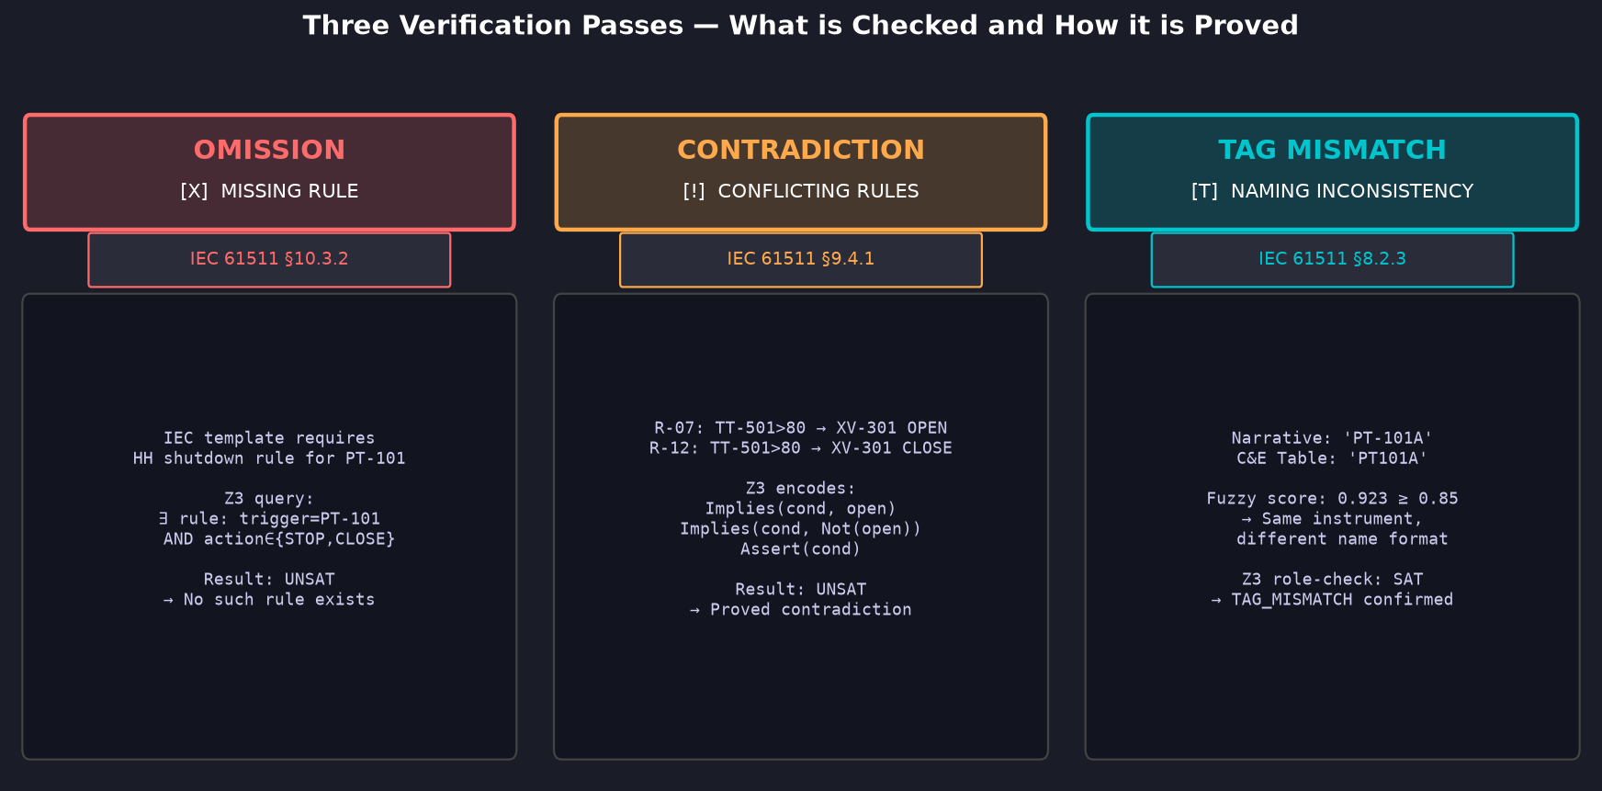
Figure 1. Three verification passes — each with its IEC 61511 clause and Z3 proof chain.

The Three Verification Questions
Verification Pass | Question Asked | Z3 Encoding | Result if Failed
OMISSION | Does this spec contain every safety rule required by IEC 61511? | ∃ rule satisfying template T? → check() == unsat → no such rule | HIGH finding: missing shutdown / alarm / interlock rule
CONTRADICTION | Can two rules for the same equipment both be true at the same time? | Implies(cond,OPEN) ∧ Implies(cond,CLOSE) ∧ Assert(cond) → unsat | HIGH finding: valve cannot be open and closed simultaneously
TAG MISMATCH | Is the same physical instrument named consistently across all documents? | Fuzzy ≥ 85 → candidate; Z3 role-check confirms semantic match | MEDIUM finding: same instrument, different name → rule may be silently lost

Why Formal Proof — Not Heuristic Matching?
A heuristic like 'check if the word shutdown appears' produces false positives and false negatives. Z3 operates on the logical structure of the rules. When Z3 returns UNSAT it means: no assignment of variables can satisfy both constraints simultaneously — this is a mathematical certificate, not a probability. For a safety-critical system deployed at a refinery or power plant, this distinction is the difference between a finding you can defend in a regulatory audit and one you cannot.
Industrial context:
The 2005 BP Texas City explosion (15 fatalities) was partly attributed to operators following a procedure that contained an implicit contradiction — a manual HAZOP would have caught it. Our system catches this class of error automatically, at document-review time, before the specification ever reaches the plant floor.

Complete Pipeline Flow — From PDF to Verified PLC Code

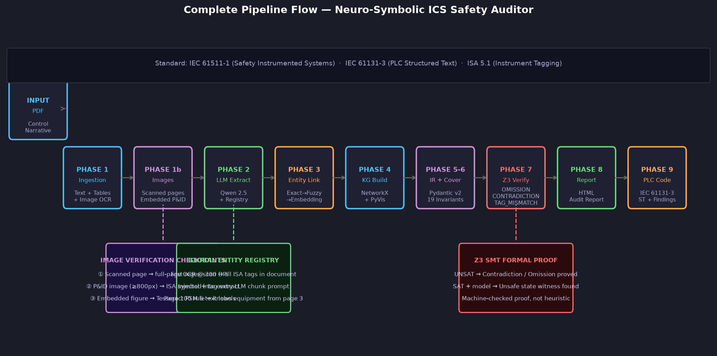
Figure 2. Full 9-phase pipeline. Three annotations (purple, green, red) mark where images, cross-page context, and formal proof operate.

Where Images Are Verified
P&ID drawings are the engineering ground truth — the physical layout the plant is actually built to. Three image cases are handled in Phase 1b:
Image Type | Detection | Processing | Why It Matters
Scanned page  (image-only PDF page) | Page text < 30 chars but page has raster images | Full page rendered at 300 DPI → PIDExtractor (PSM 11 OCR + contour detection) | A scanned P&ID page contains ALL instrument tags. Without this step, every tag on that page is invisible to the pipeline.
Embedded P&ID diagram  (≥ 800 px wide) | PyMuPDF page.get_images() + pixel dimensions | fitz.Pixmap extracted → PIDExtractor full pipeline: preprocessing → OCR → ISA 5.1 symbol detection | Large engineering drawings contain tag–symbol spatial relationships. Symbol type (circle=transmitter, diamond=valve) is used to infer entity class without LLM.
Embedded figure  (100–800 px wide) | Pixel dimensions 100–800 | Tesseract PSM 6 (uniform text block) — extracts numeric thresholds and tag labels printed on process flow diagrams | Small figures often contain alarm setpoints (e.g. '45 bar HH') that are not repeated in the narrative text. Missing these means missing the threshold value for a rule.

Cross-Page Reference — How Page 100 Knows About Page 3
A 200-page control narrative defines equipment on early pages and references it on late pages. Without the Global Entity Registry, an LLM processing a chunk at page 100 sees the tag 'P-001' with no context and may misclassify it or hallucinate its role. The registry is built in one fast pass (regex, no LLM) before any chunking starts, then prepended to every chunk prompt:
Registry prompt injection (example):
Equipment tags in this document: P-001 (p.3), PT-101 (p.3), LT-201 (p.5), XV-301 (p.7), ESD-001 (p.11), TT-501 (p.18) ...
SECTION: 3.1 Emergency Shutdown (pages 98–101)
On ESD-001 DEMAND, stop P-001 and close XV-201 ...
→ LLM now knows P-001 was defined on page 3 as a pump — correct entity class, correct invariant coverage.

Standards Alignment
Standard | Where Applied | Mechanism
IEC 61511-1 | Phase 6 — Invariant check  Phase 7 — Z3 verification | 19 safety requirement templates covering §8 (tag naming), §9 (contradictions), §10 (shutdown rules), §11 (alarms)
IEC 61131-3 | Phase 9 — PLC code generation | Structured Text output with AUDIT NOTE comments at every finding location
ISA 5.1 | Phase 1b — Image OCR  Phase 3 — Entity linking | Instrument tag regex [A-Z]{1-3}-[0-9]{3-4} matches all standard ISA tag formats
HAZOP methodology | Phase 6-7 — Full audit | Automates the HAZOP 'guide word' analysis: What if a rule is missing? What if two rules conflict?

What makes this research novel:
Existing tools (HAZOP software, SIL calculators) require a human engineer to manually enter rules into a structured form. Our system reads unstructured prose PDFs — the actual documents produced in industry — and produces machine-verified findings automatically. The cross-modal image pipeline closes the gap between what is written in text and what is drawn on the P&ID, which is where real safety gaps most often hide.

