Lab 1: Define polymorphism. Write a program to achieve the run time polymorphism.

Polymorphism is fundamental OOP. The word polymorphism is derived from Greek words: poly and morphs. “Poly” means many, and “morphs” means forms. Polymorphism allows one interface to be used for different data types or single method name to behave differently based on the object that calls it.
In C#, polymorphism can be achieved in two ways:
- Compile-time (Static) polymorphism – through method overloading and operator overloading.
- Run-time (Dynamic) polymorphism – through method overriding using the virtual and override keywords.

Program:

namespace Run_time_Polymorphism
{
class Class1
{
public virtual void Show()
{
Console.WriteLine("Parent Class Show Method");
}
}
class Class2 : Class1
{
public override void Show()
{
Console.WriteLine("Child Class Show Method");
}
}
class Program
{
static void Main(string[] args)
{
Console.WriteLine("Prepared by: Lokesh Nath Yogi\n");
Class1 obj = new Class2();
obj.Show();

}
}
}

Output:

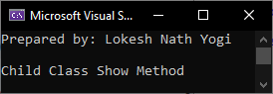

Lab 2: What is inheritance? Write a program to implement multiple inheritance.

Inheritance is fundamental concept of OOP. It allows one class to acquire (inherit) the properties and methods of another class. Inheritance promotes code reusability and establishes a parent-child (base-derived) relationship between classes. Types of Inheritance: Single Inheritance, Multilevel Inheritance, Hierarchical Inheritance, Multiple Inheritance (via interfaces).

Program:
namespace Multiple_Inheritance
{
public class Program
{
static void Main()
{
Console.WriteLine("Prepared by: Lokesh Nath Yogi\n");
SmartPhone obj = new SmartPhone();
obj.GetPhoneModel();
obj.GetCameraDetails();
obj.GetDetails();
}
}
class Phone
{
public void GetPhoneModel()
{
Console.WriteLine("IPhone 17 Pro Max");
}
}
interface ICamera
{
void GetCameraDetails();
}
class SmartPhone : Phone, ICamera
{
public void GetCameraDetails()
{
Console.WriteLine("48 Mega Pixel Camera");
}
public void GetDetails()
{
Console.WriteLine("It's a Iphone Smart Phone");
}
}
}

Output:

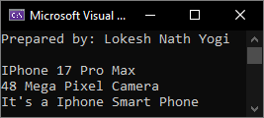
Lab 3: Define Lambda. Write a program to display student list filter by department Id using Lambda expression. Student has attributes (Id, DepartmentId, Name and Address) and take any number of students.

Lambda Expression is an anonymous function (a function without a name) that can contain expressions and statements, and can be used to create delegates or expression tree types. It provides a short and concise way to write inline functions.
Syntax: (parameters) => expression
Example: (x, y) => x + y;

Program:
using System.Collections.Generic;
using System.Linq;
namespace Lambda_Expression
{
class Student
{
public int Id { get; set; }
public int DepartmentId { get; set; }
public string? Name { get; set; }
public string? Address { get; set; }
}
class Program
{
static void Main(string[] args)
{
Console.WriteLine("Prepared by: Lokesh Nath Yogi\n");
List<Student> students = new List<Student>()
{
new Student {Id = 1, DepartmentId = 101, Name = "Apple", Address = "Kirtipur"},
new Student {Id = 2, DepartmentId = 102, Name = "Banana", Address = "Lalitpur"},
new Student {Id = 3, DepartmentId = 101, Name = "Cherry", Address = "Lainchaur"},
new Student {Id = 4, DepartmentId = 103, Name = "Mango", Address = "Balaju"},
new Student {Id = 5, DepartmentId = 102, Name = "Grapes", Address = "Kalimati"}
};
Console.Write("Enter Department ID to search students:");
int depId = Convert.ToInt32(Console.ReadLine());
var filteredStudents = students.Where(s => s.DepartmentId == depId).ToList();
Console.WriteLine($"\nStudents in Department {depId}:");
if (filteredStudents.Count > 0)
{
foreach (var student in filteredStudents)
{
Console.WriteLine($"Id: {student.Id}, Name: {student.Name}, Address: {student.Address}");
}
}
else
{
Console.WriteLine("No students found in this department.");
}
}
}
}

Output:

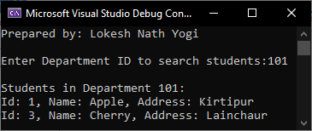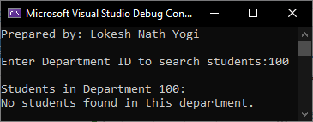

Lab 4: Define LINQ. Write a program to display voter name whose age is greater than 18 and lives in “Patan”.

LINQ stands for Language Integrated Query, a Microsoft .NET Framework that provides a standardized way to query data from various data sources using a common syntax within programming languages like C# or VB. LINQ allows developers to write queries to retrieve, manipulate, and transform data from different data sources, such as databases, collections, XML, and In-Memory objects.

Program:
using System.Collections.Generic;
using System.Linq;
namespace LINQ
{
class Voter
{
public int Id { get; set; }
public string? Name { get; set; }
public int Age { get; set; }
public string? City { get; set; }
}
class Program
{
static void Main(string[] args)
{
Console.WriteLine("Prepared by: Lokesh Nath Yogi\n");
List<Voter> voters = new List<Voter>()
{
new Voter {Id = 1, Name = "Apple", Age = 20, City = "Patan"},
new Voter {Id = 2, Name = "Banana", Age = 17, City = "Kathmandu"},
new Voter {Id = 3, Name = "Cherry", Age = 25, City = "Patan"},
new Voter {Id = 4, Name = "Mango", Age = 19, City = "Pokhara"},
new Voter {Id = 5, Name = "Berry", Age = 16, City = "Patan"}
};
var eligibleVoters = from v in voters
where v.Age > 18 && v.City == "Patan"
select v;
Console.WriteLine("Voters from Patan whose age is greater than 18:");
foreach (var voter in eligibleVoters)
{
Console.WriteLine($"Name: {voter.Name}, Age: {voter.Age}, City: {voter.City}");
}
}
}
}

Output:
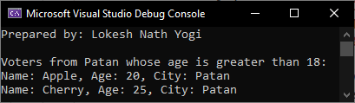
Lab 5: What is exception handling? Write a program to handle exception when User put character in price field.

The process of catching the exception for converting the CLR-given exception message to an understandable end-user message and stopping the abnormal termination of the program whenever runtime errors occur is called Exception Handling.
Reason for need of Exception Handling:
- To stop the Abnormal Termination of the program.
- To provide users with understandable messages when an exception is raised.

Program
namespace Exception_Handling
{
class Program
{
static void Main(string[] args)
{
Console.WriteLine("Prepared by: Lokesh Nath Yogi\n");
try
{
Console.Write("Enter price of product:");
double price = Convert.ToDouble(Console.ReadLine());
Console.WriteLine($"Price you entered: {price}");
}
catch (FormatException)
{
Console.WriteLine("Please enter a valid numeric price value.");
}
catch (Exception Ex)
{
Console.WriteLine("An unexpected error occurred: " + Ex.Message);
}
finally
{
Console.WriteLine("Program execution completed.");
}
}
}
}
Output:
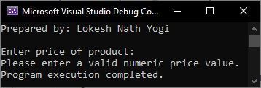
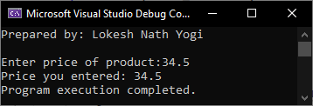
Lab 6: Define MVC. Write a CRUD operation to display, insert, update and delete Student information using ASP.NET Core MVC.

MVC (Model–View–Controller) is a software design pattern that separates an application into three parts:
- Model: Manages data, business logic, and rules.
- View: Displays the data (UI) to the user.
- Controller: Handles user input and updates the Model and View accordingly.
The MVC separation improves code organization, maintainability, and scalability.

Source Code:

Program.cs

using Microsoft.EntityFrameworkCore;
using Microsoft.AspNetCore;
using MVC_CRUD.Data;
using Microsoft.EntityFrameworkCore.SqlServer;
namespace MVC_CRUD
{
public class Program
{
public static void Main(string[] args)
{
var builder = WebApplication.CreateBuilder(args);
// Add MVC services
builder.Services.AddControllersWithViews();
// Add DbContext
builder.Services.AddDbContext<ApplicationDbContext>(options =>
options.UseSqlServer(
builder.Configuration.GetConnectionString("DefaultConnection"))
);
var app = builder.Build();
// Middleware
if (!app.Environment.IsDevelopment())
{
app.UseExceptionHandler("/Home/Error");
}
app.UseStaticFiles();
app.UseRouting();
app.UseAuthorization();
// Default route
app.MapControllerRoute(
name: "default",
pattern: "{controller=Students}/{action=Index}/{id?}");
app.Run();
}
}
}

Data/ApplicationDbContext.cs

using Microsoft.EntityFrameworkCore;
using MVC_CRUD.Models;
namespace MVC_CRUD.Data
{
public class ApplicationDbContext : DbContext
{
public ApplicationDbContext(DbContextOptions<ApplicationDbContext> options)
: base(options)
{
}
public DbSet<Student> Students { get; set; }
}
}

appsetting.json

{
"ConnectionStrings": {
"DefaultConnection": "Server=.\\SQLEXPRESS;Database=StudentDB;Trusted_Connection=True;TrustServerCertificate=True"
},
"Logging": {
"LogLevel": {
"Default": "Information",
"Microsoft.AspNetCore": "Warning"
}
},
"AllowedHosts": "*"
}

Controller/StudentsController.cs

using Microsoft.AspNetCore.Mvc;
using Microsoft.EntityFrameworkCore;
using MVC_CRUD.Data;
using MVC_CRUD.Models;
using System.Threading.Tasks;
using static MVC_CRUD.Models.Student;
namespace MVC_CRUD.Controllers
{
public class StudentsController : Controller
{
private readonly ApplicationDbContext _context;

public StudentsController(ApplicationDbContext context)
{
_context = context;
}
// READ
public async Task<IActionResult> Index()
{
return View(await _context.Students.ToListAsync());
}

// CREATE - GET
public IActionResult Create()
{
return View();
}
// CREATE - POST
[HttpPost]
public async Task<IActionResult> Create(Student student)
{
if (ModelState.IsValid)
{
_context.Students.Add(student);
await _context.SaveChangesAsync();
return RedirectToAction("Index");
}
return View(student);
}
// UPDATE - GET
public async Task<IActionResult> Edit(int id)
{
var student = await _context.Students.FindAsync(id);
return View(student);
}
// UPDATE - POST
[HttpPost]
public async Task<IActionResult> Edit(Student student)
{
if (ModelState.IsValid)
{
_context.Students.Update(student);
await _context.SaveChangesAsync();
return RedirectToAction("Index");
}
return View(student);
}
// DELETE - GET
public async Task<IActionResult> Delete(int id)
{
var student = await _context.Students.FindAsync(id);
return View(student);
}
// DELETE - POST
[HttpPost, ActionName("Delete")]
public async Task<IActionResult> DeleteConfirmed(int id)
{
var student = await _context.Students.FindAsync(id);
_context.Students.Remove(student);
await _context.SaveChangesAsync();
return RedirectToAction("Index");
}
}
}

Models/Student.cs
using System.ComponentModel.DataAnnotations;
namespace MVC_CRUD.Models
{
public class Student
{
public int Id { get; set; }
[Required]
public string Name { get; set; }
public int Age { get; set; }
[EmailAddress]
public string Email { get; set; }
}
}

Views/Students/Index.cshtml
@model IEnumerable<Student>
<a asp-action="Create">Add Student</a>
<table border="1">
<tr>
<th>Name</th>
<th>Age</th>
<th>Email</th>
<th>Actions</th>
</tr>
@foreach (var s in Model)
{
<tr>
<td>@s.Name</td>
<td>@s.Age</td>
<td>@s.Email</td>
<td>
<a asp-action="Edit" asp-route-id="@s.Id">Edit</a> |
<a asp-action="Delete" asp-route-id="@s.Id">Delete</a>
</td>
</tr>
}
</table>

Views/Students/Create.cshtml

@model Student
<form asp-action="Create" method="post">
Name: <input asp-for="Name" /><br />
Age: <input asp-for="Age" /><br />
Email: <input asp-for="Email" /><br />
<button type="submit">Save</button>
</form>

Views/Students/Edit.cshtml

@model Student
<form asp-action="Edit" method="post">
<input type="hidden" asp-for="Id" />
Name: <input asp-for="Name" /><br />
Age: <input asp-for="Age" /><br />
Email: <input asp-for="Email" /><br />
<button type="submit">Update</button>
</form>

Views/Students/Delete.cshtml

@model Student
<h3>Are you sure?</h3>
<form asp-action="Delete" method="post">
<input type="hidden" asp-for="Id" />
<button type="submit">Delete</button>
</form>

Views/Shared/_Layout.cshtml

<!DOCTYPE html>
<html lang="en">
<head>
<meta charset="utf-8" />
<meta name="viewport" content="width=device-width, initial-scale=1.0" />
<title>@ViewData["Title"] - MVC_CRUD</title>
<script type="importmap"></script>
</head>
<body>
<p>Prepared by: Lokesh Nath Yogi (79011351)</p>
<div class="container">
<main role="main" class="pb-3">
@RenderBody()
</main>
</div>
</body>
</html>

Output:

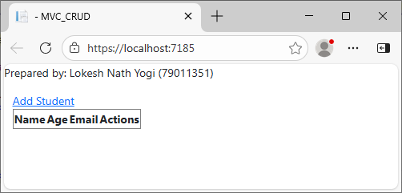
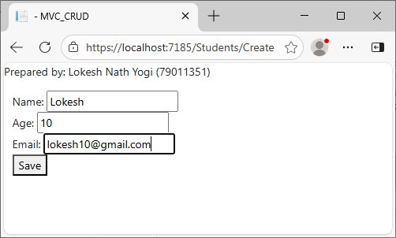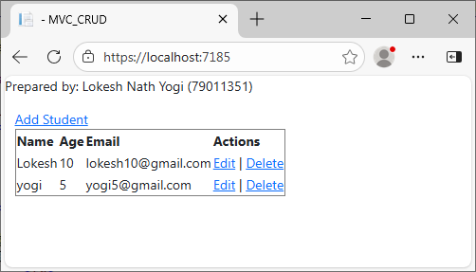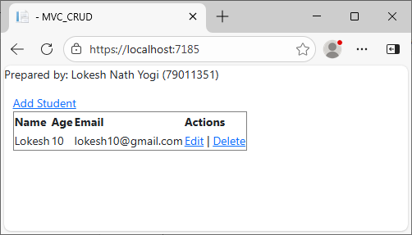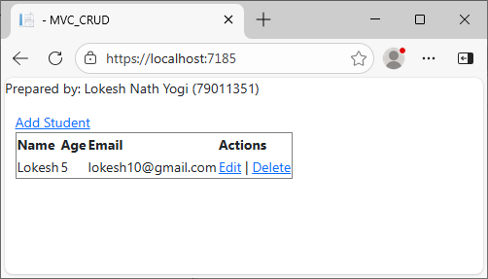

Lab 7: What is Data Annotation? Write a program to validate Player information when click on save button using MVC pattern.

Data Annotation in C# is a feature that uses attributes to add metadata to classes and properties for validation, formatting, and database mapping, commonly used in ASP.NET and Entity Framework.

Source Code:
Models/Player.cs
using System;
using System.ComponentModel.DataAnnotations;
namespace MyApp.Models
{
public class Player
{
public int Id { get; set; }
[Required(ErrorMessage = "Player name is required.")]
[StringLength(50, ErrorMessage = "Name can't be longer than 50 characters.")]
public string Name { get; set; }
[Required(ErrorMessage = "Email is required.")]
[EmailAddress(ErrorMessage = "Enter a valid email address.")]
public string Email { get; set; }
[Required(ErrorMessage = "Jersey number is required.")]
[Range(1, 99, ErrorMessage = "Jersey number must be between 1 and 99.")]
public int JerseyNumber { get; set; }
[Required(ErrorMessage = "Position is required.")]
[StringLength(30)]
public string Position { get; set; }
[Required(ErrorMessage = "Date of birth is required.")]
[DataType(DataType.Date)]
[MinimumAge(18, ErrorMessage = "Player must be at least 18 years old.")]
public DateTime DateOfBirth { get; set; }

[Range(0, double.MaxValue, ErrorMessage = "Salary must be non-negative.")]
public decimal Salary { get; set; }
}
// Custom validation attribute (server-side)
public class MinimumAgeAttribute : ValidationAttribute
{
private readonly int _minAge;

public MinimumAgeAttribute(int minAge)
{
_minAge = minAge;
}
protected override ValidationResult IsValid(object value, ValidationContext validationContext)
{
if (value == null)
return new ValidationResult(ErrorMessage ?? $"Minimum age is {_minAge}.");
if (value is DateTime dob)
{
var today = DateTime.Today;
int age = today.Year - dob.Year;
if (dob > today.AddYears(-age)) age--;
return (age >= _minAge)
? ValidationResult.Success
: new ValidationResult(ErrorMessage ?? $"Minimum age is {_minAge}.");
}
return new ValidationResult("Invalid date");
}
}
}

Controllers/PlayersController.cs
using Microsoft.AspNetCore.Mvc;
using MyApp.Models;
using System.Collections.Generic;
namespace MyApp.Controllers
{
public class PlayersController : Controller
{
// Temp in-memory store for example; in production use DB
private static readonly List<Player> _players = new List<Player>();
// GET: /Players/Create
public IActionResult Create()
{
return View();
}
// POST: /Players/Create
[HttpPost]
[ValidateAntiForgeryToken]
public IActionResult Create(Player player)
{
// Model binding happens before this and DataAnnotations are evaluated.
if (!ModelState.IsValid)
{
// If validation failed, return the same view with the model so validation messages are displayed.
return View(player);
}
// Simulate saving to DB
player.Id = _players.Count + 1;
_players.Add(player);
// Redirect after POST to avoid resubmission; could go to Details/Index.
return RedirectToAction(nameof(Index));
}
// GET: /Players
public IActionResult Index()
{
return View(_players);
}
}
}

Views/Player/Create.cshtml
@model MyApp.Models.Player
@{
ViewData["Title"] = "Create Player";
}

<h2>Add Player</h2>
<form asp-action="Create" method="post" class="needs-validation" novalidate>
<div asp-validation-summary="ModelOnly" class="text-danger"></div>
<div class="form-group">
<label asp-for="Name"></label>
<input asp-for="Name" class="form-control" />
<span asp-validation-for="Name" class="text-danger"></span>
</div>
<div class="form-group">
<label asp-for="Email"></label>
<input asp-for="Email" class="form-control" />
<span asp-validation-for="Email" class="text-danger"></span>
</div>
<div class="form-group">
<label asp-for="JerseyNumber"></label>
<input asp-for="JerseyNumber" class="form-control" type="number" />
<span asp-validation-for="JerseyNumber" class="text-danger"></span>
</div>
<div class="form-group">
<label asp-for="Position"></label>
<input asp-for="Position" class="form-control" />
<span asp-validation-for="Position" class="text-danger"></span>
</div>
<div class="form-group">
<label asp-for="DateOfBirth"></label>
<input asp-for="DateOfBirth" class="form-control" type="date" />
<span asp-validation-for="DateOfBirth" class="text-danger"></span>
</div>
<div class="form-group">
<label asp-for="Salary"></label>
<input asp-for="Salary" class="form-control" type="number" step="0.01" />
<span asp-validation-for="Salary" class="text-danger"></span>
</div>
<button type="submit" class="btn btn-primary">Save</button>
</form>
@section Scripts {
@{await Html.RenderPartialAsync("_ValidationScriptsPartial");}
}

Views/Players/Index.cshtml
@model IEnumerable<MyApp.Models.Player>
@{
ViewData["Title"] = "Players List";
}
<h2>Players List</h2>
<p>
<a asp-action="Create">Add New Player</a>
</p>
@if (!Model.Any())
{
<p>No players have been added yet.</p>
}
else
{
<table>
<thead>
<tr>
<th>Name</th>
<th>Email</th>
<th>Jersey Number</th>
<th>Position</th>
<th>Date of Birth</th>
<th>Salary</th>
</tr>
</thead>
<tbody>
@foreach (var player in Model)
{
<tr>
<td>@player.Name</td>
<td>@player.Email</td>
<td>@player.JerseyNumber</td>
<td>@player.Position</td>
<td>@player.DateOfBirth.ToString("yyyy-MM-dd")</td>
<td>@player.Salary.ToString("C")</td>
</tr>
}
</tbody>
</table>
}

Program.cs
namespace Data_Annotation
{
public class Program
{
public static void Main(string[] args)
{
var builder = WebApplication.CreateBuilder(args);
// Add services to the container.
builder.Services.AddControllersWithViews();
var app = builder.Build();
// Configure the HTTP request pipeline.
if (!app.Environment.IsDevelopment())
{
app.UseExceptionHandler("/Home/Error");
app.UseHsts();
}
app.UseHttpsRedirection();
app.UseStaticFiles();
app.UseRouting();
app.UseAuthorization();
app.MapControllerRoute(
name: "default",
pattern: "{controller=Players}/{action=Index}/{id?}");
app.Run();
}
}
}

Views/Shared/_Layout.cshtml
<!DOCTYPE html>
<html lang="en">
<head>
<meta charset="utf-8" />
<meta name="viewport" content="width=device-width, initial-scale=1.0" />
<title>@ViewData["Title"] - Data_Annotation</title>
</head>
<body>
<p>Prepared by: Lokesh Nath Yogi (79011351)</p>
<div class="container">
<main role="main" class="pb-3">
@RenderBody()
</main>
</div>
<script src="~/lib/jquery/dist/jquery.min.js"></script>
<script src="~/lib/bootstrap/dist/js/bootstrap.bundle.min.js"></script>
<script src="~/js/site.js" asp-append-version="true"></script>
@await RenderSectionAsync("Scripts", required: false)
</body>
</html>

wwwroot/css/site.cs
table, th, td {
border: 1px solid #000;
}
Output:
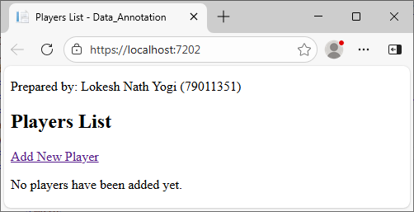

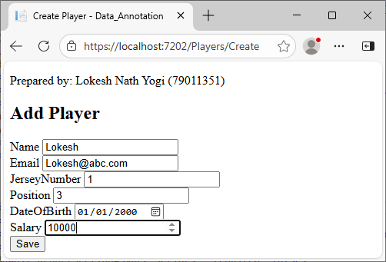
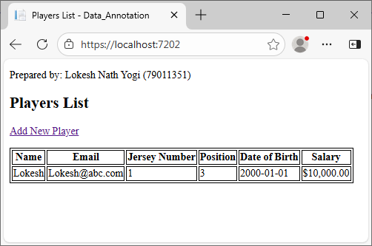

Lab 8: Define Authentication. Write a program to implement Authentication and Authorization using User Roles.

Authentication is the process of verifying the identity of a user or system, ensuring they are who they claim to be before granting access.

Source Code:

Controller/AccountController.cs

using Microsoft.AspNetCore.Identity;
using Microsoft.AspNetCore.Mvc;
using Authentication_Authorization.Models;
using Microsoft.EntityFrameworkCore.Metadata.Internal;
using Authentication_Authorization.ViewModels;
namespace Authentication_Authorization.Controllers
{
public class AccountController : Controller
{
private readonly UserManager<ApplicationUser> _userManager;
private readonly SignInManager<ApplicationUser> _signInManager;
public AccountController(UserManager<ApplicationUser> userManager, SignInManager<ApplicationUser> signInManager)
{
_userManager = userManager;
_signInManager = signInManager;
}
[HttpGet]
public IActionResult Register() => View();
[HttpPost]
public async Task<IActionResult> Register(RegisterViewModel model)
{
if (ModelState.IsValid)
{
var user = new ApplicationUser { UserName = model.Email, Email = model.Email };
var result = await _userManager.CreateAsync(user, model.Password);
if (result.Succeeded)
{
await _userManager.AddToRoleAsync(user, "User");
await _signInManager.SignInAsync(user, false);
return RedirectToAction("Index", "Home");
}
foreach (var error in result.Errors)
ModelState.AddModelError("", error.Description);
}
return View(model);
}
[HttpGet]
public IActionResult Login() => View();
[HttpPost]
[ValidateAntiForgeryToken]
public async Task<IActionResult> Login(LoginViewModel model)
{
if (ModelState.IsValid)
{
var user = await _userManager.FindByEmailAsync(model.Email);
if(user !=null & !await _userManager.IsEmailConfirmedAsync(user))
{
ModelState.AddModelError("", "You need to confirm your email before logging in.");
return View(model);
}
var result = await _signInManager.PasswordSignInAsync(model.Email, model.Password, false, false);
if (result.Succeeded)
{
if (await _userManager.IsInRoleAsync(user, "Admin"))
{
return RedirectToAction("Admin", "Dashboard");
}
else if (await _userManager.IsInRoleAsync(user, "User"))
{
return RedirectToAction("User", "Dashboard");
}
else
{
return RedirectToAction("Index", "Home");
}
}
ModelState.AddModelError("", "Invalid Login Attempt");
}
return View(model);
}
public async Task<IActionResult> Logout()
{
await _signInManager.SignOutAsync();
return RedirectToAction("Index", "Home");
}
}
}

Controller/DashboardController.cs

using Microsoft.AspNetCore.Authorization;
using Microsoft.AspNetCore.Mvc;
namespace Authentication_Authorization.Controllers
{
public class DashboardController : Controller
{
// Accessible only by Admin role
[Authorize(Roles = "Admin")]
public IActionResult Admin()
{
return View();
}
// Accessible only by Users role
[Authorize(Roles = "User")]
public IActionResult User()
{
return View();
}
// Accessible by Admin and User role
[Authorize(Roles = "Admin, User")]
public IActionResult Common()
{
return View();
}
}
}

Data/ApplicationDbContext.cs

using Microsoft.AspNetCore.Identity.EntityFrameworkCore;
using Microsoft.EntityFrameworkCore;
using Authentication_Authorization.Models;

namespace Authentication_Authorization.Data
{
public class ApplicationDbContext : IdentityDbContext<ApplicationUser>
{
public ApplicationDbContext(DbContextOptions<ApplicationDbContext> options)
: base(options)
{
}
}
}

Models/ApplicationUser.cs

using Microsoft.AspNetCore.Identity;
namespace Authentication_Authorization.Models
{
public class ApplicationUser : IdentityUser
{
}
}

ViewModels/LoginViewModel.cs

using System.ComponentModel.DataAnnotations;
namespace Authentication_Authorization.ViewModels
{
public class LoginViewModel
{
[Required]
[EmailAddress]
public required string Email { get; set; }
[Required]
[DataType(DataType.Password)]
public required string Password { get; set; }
}
}

ViewModels/RegisterViewModel.cs

using System.ComponentModel.DataAnnotations;
namespace Authentication_Authorization.ViewModels
{
public class RegisterViewModel
{
[Required]
[EmailAddress]
public required string Email { get; set; }
[Required]
[DataType(DataType.Password)]
public required string Password { get; set; }
[DataType(DataType.Password)]
[Compare("Password", ErrorMessage = "Passwords do not match")]
public required string ConfirmPassword { get; set; }
}
}

Views/Account/Login.cshtml

@model Authentication_Authorization.ViewModels.LoginViewModel
@{
ViewData["Title"] = "Login";
}
<h2>Login</h2>
<form asp-action="Login" method="post">
<div class="form-group">
<label asp-for="Email"></label>
<input asp-for="Email" class="form-control" />
<span asp-validation-for="Email" class="text-danger"></span>
</div>
<div class="form-group">
<label asp-for="Password"></label>
<input asp-for="Password" type="password" class="form-control" />
<span asp-validation-for="Password" class="text-danger"></span>
</div>
<button type="submit" class="btn btn-primary">Login</button>
</form>
@section Scripts {
<partial name="_ValidationScriptsPartial"></partial>
}

Views/Account/Register.cshtml

@model Authentication_Authorization.ViewModels.RegisterViewModel
@{
ViewData["Title"] = "Register";
}
<h2 class="text-center mb-4">Register</h2>

<div class="row justify-content-center">
<div class="col-md-6">
<div class="card shadow-lg p-4 rounded-3">
<form asp-action="Register" method="post">
<div asp-validation-summary="ModelOnly" class="text-danger"></div>
<!-- Email -->
<div class="form-group mb-3">
<label asp-for="Email" class="form-label"></label>
<input asp-for="Email" class="form-control" placeholder="Enter your email" />
<span asp-validation-for="Email" class="text-danger"></span>
</div>
<!-- Password -->
<div class="form-group mb-3">
<label asp-for="Password" class="form-label"></label>
<input asp-for="Password" type="password" class="form-control" placeholder="Enter password" />
<span asp-validation-for="Password" class="text-danger"></span>
</div>
<!-- Confirm Password -->
<div class="form-group mb-4">
<label asp-for="ConfirmPassword" class="form-label"></label>
<input asp-for="ConfirmPassword" type="password" class="form-control" placeholder="Confirm password" />
<span asp-validation-for="ConfirmPassword" class="text-danger"></span>
</div>
<div class="text-center">
<button type="submit" class="btn btn-primary px-4">Register</button>
</div>
</form>
<div class="text-center mt-3">
<p>Already have an account? <a asp-controller="Account" asp-action="Login">Login here</a></p>
</div>
</div>
</div>
</div>

@section Scripts {
<partial name="_ValidationScriptsPartial" />
}

Views/Dashboard/Admin.cshtml

@{
ViewData["Title"] = "Admin Dashboard";
}
<h2>Admin Dashboard</h2>
<p>Welcome, Admin!, You can manage the system from here.</p>

Views/Dashboard/User.cshtml

@{
ViewData["Title"] = "User Dashboard";
}
<h2>User Dashboard</h2>
<p>Welcome, User!, You can view your personal data here.</p>

Views/Dashboard/Common.cshtml

@{
ViewData["Title"] = "Common Dashboard";
}
<h2>Common Dashboard</h2>
<p>Both Admin and User roles can see this page.</p>

Views/Shared/_Layout.cshtml

<!DOCTYPE html>
<html lang="en">
<head>
<meta charset="utf-8" />
<meta name="viewport" content="width=device-width, initial-scale=1.0" />
<title>@ViewData["Title"] - Authentication_Authorization</title>
<link rel="stylesheet" href="~/lib/bootstrap/dist/css/bootstrap.min.css" />
<link rel="stylesheet" href="~/css/site.css" asp-append-version="true" />
<link rel="stylesheet" href="~/Authentication_Authorization.styles.css" asp-append-version="true" />
</head>
<body>
<header>
<nav class="navbar navbar-expand-sm navbar-toggleable-sm navbar-light bg-white border-bottom box-shadow mb-3">
<div class="container-fluid">
<a class="navbar-brand" asp-area="" asp-controller="Home" asp-action="Index">Authentication_Authorization</a>
<button class="navbar-toggler" type="button" data-bs-toggle="collapse" data-bs-target=".navbar-collapse" aria-controls="navbarSupportedContent"
aria-expanded="false" aria-label="Toggle navigation">
<span class="navbar-toggler-icon"></span>
</button>
<div class="collapse navbar-collapse" id="navbarNav">
<ul class="navbar-nav me-auto">
<li class="nav-item">
<a class="nav-link" asp-controller="Home" asp-action="Index">Home</a>
</li>
@* Role-based links *@
@if (User.IsInRole("Admin"))
{
<li class="nav-item">
<a class="nav-link" asp-controller="Dashboard" asp-action="Admin">Admin Dashboard</a>
</li>
}
@if (User.IsInRole("User"))
{
<li class="nav-item">
<a class="nav-link" asp-controller="Dashboard" asp-action="User">User Dashboard</a>
</li>
}
@if (User.IsInRole("Admin") || User.IsInRole("User"))
{
<li class="nav-item">
<a class="nav-link" asp-controller="Dashboard" asp-action="Common">Common Dashboard</a>
</li>
}
</ul>
<ul class="navbar-nav ms-auto">
@if (User.Identity != null && User.Identity.IsAuthenticated)
{
<li class="nav-item">
<span class="nav-link">Hello, @User.Identity.Name!</span>
</li>
<li class="nav-item">
<form class="d-inline" asp-controller="Account" asp-action="Logout" method="post">
<button type="submit" class="btn btn-link nav-link" style="display:inline; padding:0;">Logout</button>
</form>
</li>
}
else
{
<li class="nav-item">
<a class="nav-link" asp-controller="Account" asp-action="Login">Login</a>
</li>
<li class="nav-item">
<a class="nav-link" asp-controller="Account" asp-action="Register">Register</a>
</li>
}
</ul>
</div>
</div>
</nav>
</header>
<div class="container">
<main role="main" class="pb-3">
@RenderBody()
</main>
</div>
<script src="~/lib/jquery/dist/jquery.min.js"></script>
<script src="~/lib/bootstrap/dist/js/bootstrap.bundle.min.js"></script>
<script src="~/js/site.js" asp-append-version="true"></script>
@await RenderSectionAsync("Scripts", required: false)
</body>
</html>

Views/Home/Index.cshtml

@{
ViewData["Title"] = "Home Page";
}
<div class="text-center">
<h1 class="display-4">Welcome</h1>
<p>Prepared by: Lokesh Nath Yogi</p>
</div>

Output:

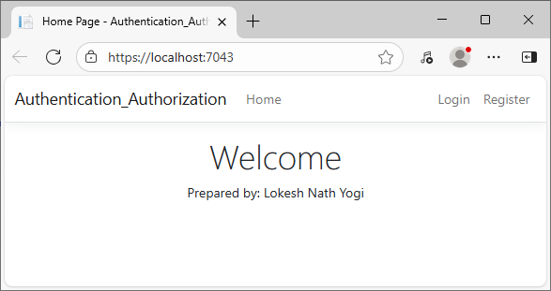
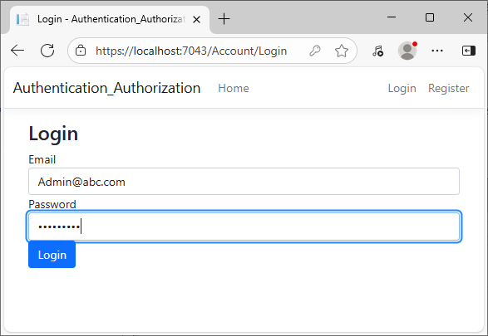
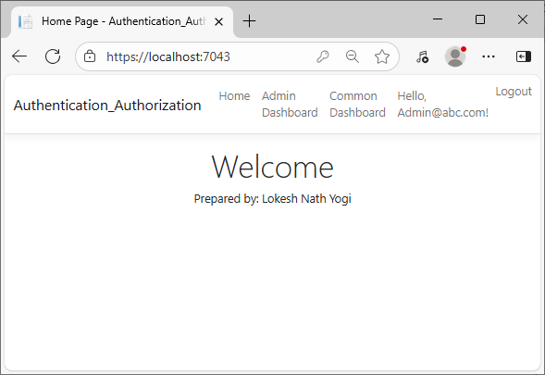
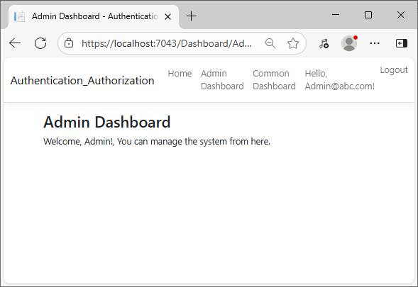
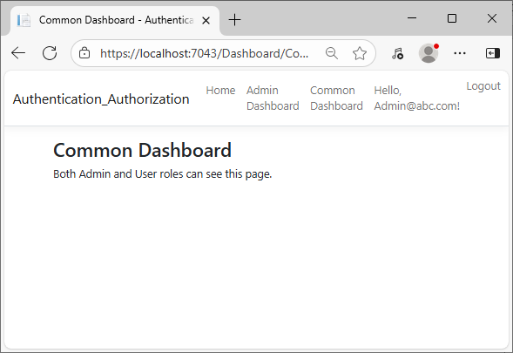

User

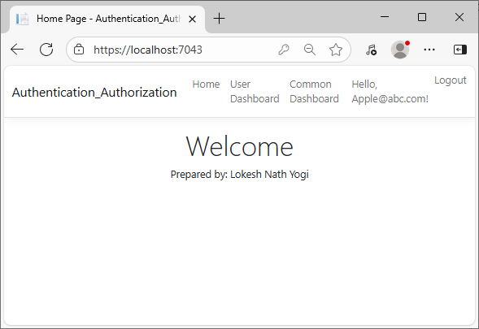
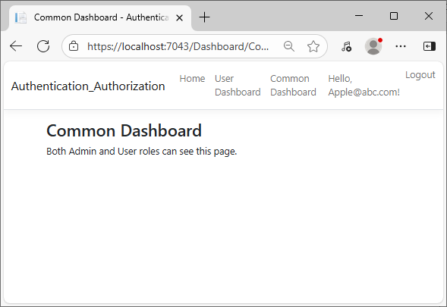

Lab 9: Define cookie. Write a program to store User login information for 5 days using Cookie.

A cookie is a small piece of data stored on the client’s browser by a web server.
It is used to remember information between HTTP requests – such as user login details, preferences, or session identifiers.
In ASP.NET Core, cookies are often used for:
- Authentication and Authorization
- User preferences or settings
- Remembering logged-in users

Source Code:

Controllers/AccountController.cs

using Microsoft.AspNetCore.Mvc;
using Microsoft.AspNetCore.Http;
using System;
namespace MVC_Cookies.Controllers
{
public class AccountController : Controller
{
// GET: Account/Login
[HttpGet]
public IActionResult Login()
{
return View();
}
// POST: Account/Login
[HttpPost]
public IActionResult Login(string username, string password)
{
// Dummy validation (for example only)
if (username == "admin" && password == "1234")
{
// Create cookie options
CookieOptions options = new CookieOptions
{
Expires = DateTime.Now.AddDays(5), // Cookie valid for 5 days
HttpOnly = true, // Prevents client-side script access
Secure = true // Use HTTPS
};
// Store user login info in cookie
Response.Cookies.Append("UserName", username, options);

ViewBag.Message = "Login successful! Cookie stored for 5 days.";
return View("Welcome");
}
else
{
ViewBag.Message = "Invalid username or password.";
return View();
}
}
// GET: Account/Welcome
public IActionResult Welcome()
{
string username = Request.Cookies["UserName"];
if (username != null)
{
ViewBag.User = username;
return View();
}
return RedirectToAction("Login");
}
// Logout Action
public IActionResult Logout()
{
Response.Cookies.Delete("UserName");
return RedirectToAction("Login");
}
}
}

Views/Account/Login.cshtml

@{
ViewData["Title"] = "Login";
}
<h2>Login Page</h2>
<form method="post" asp-controller="Account" asp-action="Login">
<label>Username:</label>
<input type="text" name="username" required /><br /><br />
<label>Password:</label>
<input type="password" name="password" required /><br /><br />
<button type="submit">Login</button>
</form>
<p style="color:red">@ViewBag.Message</p>

Views/Account/Welcome.cshtml

@{
ViewData["Title"] = "Welcome";
}
<h2>Welcome, @ViewBag.User!</h2>
<p>Your login information is stored in a cookie for 5 days.</p>
<a asp-controller="Account" asp-action="Logout">Logout</a>

Views/Shared/_Layout.cshtml

<!DOCTYPE html>
<html lang="en">
<head>
<meta charset="utf-8" />
<meta name="viewport" content="width=device-width, initial-scale=1.0" />
<title>@ViewData["Title"] - MVC_Cookies</title>
</head>
<body>
<header>
<p>Prepared by: Lokesh Nath Yogi (79011351)</p>
</header>
<div class="container">
<main role="main" class="pb-3">
@RenderBody()
</main>
</div>
<script src="~/lib/jquery/dist/jquery.min.js"></script>
<script src="~/lib/bootstrap/dist/js/bootstrap.bundle.min.js"></script>
<script src="~/js/site.js" asp-append-version="true"></script>
@await RenderSectionAsync("Scripts", required: false)
</body>
</html>

Program.cs

namespace MVC_Cookies
{
public class Program
{
public static void Main(string[] args)
{
var builder = WebApplication.CreateBuilder(args);
// Add services to the container.
builder.Services.AddControllersWithViews();
var app = builder.Build();
// Configure the HTTP request pipeline.
if (!app.Environment.IsDevelopment())
{
app.UseExceptionHandler("/Home/Error");
app.UseHsts();
}
app.UseHttpsRedirection();
app.UseStaticFiles();
app.UseRouting();
app.UseAuthorization();
app.MapControllerRoute(
name: "default",
pattern: "{controller=Account}/{action=Login}/{id?}");
app.Run();
}
}
}

Output:

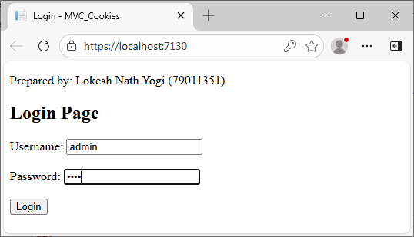
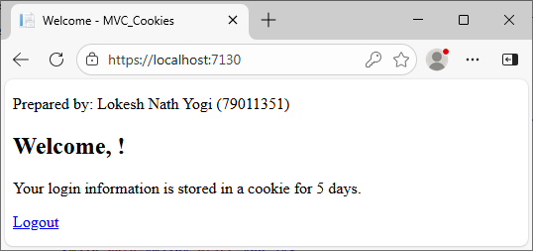

Lab 10: Define single page application. Write a program to validation the login form when user submit empty value using jQuery.

A Single Page Application (SPA) is a type of web application that loads a single HTML page and dynamically updates content as the user interacts with the app – without reloading the entire page from the server.
It uses AJAX and JavaScript frameworks (like Angular, React, or Vue.js) to fetch and render data dynamically.
Only required data is exchanged with the server, improving speed and user experience.
The browser updates content via client-side routing.
Example: Gmail, Google Maps, Facebook.

Source Code:

Controller/AccountController.cs

using Microsoft.AspNetCore.Mvc;
using MVC_jQuery.Models;
namespace MVC_jQuery.Controllers
{
public class AccountController : Controller
{
[HttpGet]
public IActionResult Login()
{
return View();
}
[HttpPost]
public IActionResult Login(LoginViewModel model)
{
if (!ModelState.IsValid)
{
return View(model);
}
// Add authentication logic here...
return RedirectToAction("Index", "Home");
}
}
}

Models/LoginViewModel.cs

using System.ComponentModel.DataAnnotations;
namespace MVC_jQuery.Models
{
public class LoginViewModel
{
[Required(ErrorMessage = "Username is required")]
public string Username { get; set; }
[Required(ErrorMessage = "Password is required")]
public string Password { get; set; }
}
}

Views/Account/Login.cshtml

@model MVC_jQuery.Models.LoginViewModel
@{
ViewData["Title"] = "Login";
}
<h2>Login</h2>
<form id="loginForm" asp-action="Login" asp-controller="Account" method="post">
<div>
<label>Username:</label>
<input type="text" id="Username" name="Username" />
</div>
<div>
<label>Password:</label>
<input type="password" id="Password" name="Password" />
</div>
<div>
<input type="submit" value="Login" />
</div>
</form>
<!-- Validation Message Display -->
<div id="errorMessages" style="color:red; margin-top:10px;"></div>
@section Scripts {
<script src="https://code.jquery.com/jquery-3.6.0.min.js"></script>
<script>
$(document).ready(function () {
$("#loginForm").submit(function (e) {
var username = $("#Username").val().trim();
var password = $("#Password").val().trim();
var errorMsg = "";
if (username === "" || password === "") {
e.preventDefault(); // Stop form submission

if (username === "") {
errorMsg += "Username is required.<br/>";
}
if (password === "") {
errorMsg += "Password is required.<br/>";
}
$("#errorMessages").html(errorMsg);
}
});
});
</script>
}

Program.cs

namespace MVC_jQuery
{
public class Program
{
public static void Main(string[] args)
{
var builder = WebApplication.CreateBuilder(args);
// Add services to the container.
builder.Services.AddControllersWithViews();
var app = builder.Build();
// Configure the HTTP request pipeline.
if (!app.Environment.IsDevelopment())
{
app.UseExceptionHandler("/Home/Error");
app.UseHsts();
}
app.UseHttpsRedirection();
app.UseStaticFiles();
app.UseRouting();
app.UseAuthorization();
app.MapControllerRoute(
name: "default",
pattern: "{controller=Account}/{action=Login}/{id?}");
app.Run();
}
}
}

Output:

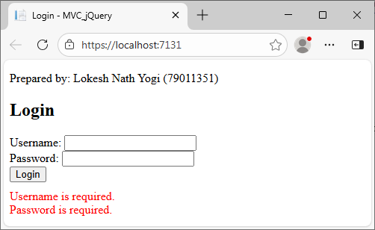

Lab 11: Define Web API. Write a program to get the list of products in json format using ASP.NET Web API.

A Web API (Application Programming Interface) is a framework that allows applications to communicate with each other over the web using HTTP.
In ASP.NET, a web API is used to build RESTful services that can be consumed by wide range of clients – such as browsers, mobile apps, or another web application.

Source Code:

Models/Product.cs

using System;
using System.Collections.Generic;
using System.Linq;
using System.Web;
namespace WebAPI_Example.Models
{
public class Product
{
public int Id { get; set; }
public string Name { get; set; }
public double Price { get; set; }
}
}

Controller/ProductsController.cs

using System;
using System.Collections.Generic;
using System.Web.Http;
using WebAPI_Example.Models;
namespace WebAPI_Example.Controllers
{
public class ProductsController : ApiController
{
public IEnumerable<Product> Get()
{
var products = new List<Product>
{
new Product { Id = 1, Name = "Laptop", Price = 55000 },
new Product { Id = 2, Name = "Smartphone", Price = 25000 },
new Product { Id = 3, Name = "Headphones", Price = 3000 }
};
return products;
}
}
}

App_Start/WebApiConfig.cs

using System;
using System.Collections.Generic;
using System.Linq;
using System.Web.Http;
namespace WebAPI_Example
{
public static class WebApiConfig
{
public static void Register(HttpConfiguration config)
{
// Web API configuration and services
// Web API routes
config.MapHttpAttributeRoutes();
config.Routes.MapHttpRoute(
name: "DefaultApi",
routeTemplate: "api/{controller}/{id}",
defaults: new { id = RouteParameter.Optional }
);
// Removing XML Formatter to force JSON
config.Formatters.Remove(config.Formatters.XmlFormatter);
// Returning JSON Formatter
config.Formatters.JsonFormatter.SerializerSettings.Formatting = Newtonsoft.Json.Formatting.Indented;
}
}
}

Output:

