Patients are the primary users of the system, allowing them to search for doctors based on their medical specializations. Each doctor is registered by an operator and has a dedicated account to manage their professional information. Patients can browse through the available doctors, each specializing in a specific area of medicine.They can view important details about each doctor, including their name, email, specialty, consultation fees, experience, and a brief overview of their medical philosophy.
Once a patient selects a doctor, they can book an appointment by choosing from the available time slots. The system enables patients to select the date and time that works best for them, streamlining the appointment scheduling process. Upon confirming the appointment, the system stores all relevant details, including the patient’s information, the selected doctor’s information (name, specialty, fees,payment method), the scheduled date and time of the appointment, and the appointment’s status (scheduled or canceled). patients can also manage their scheduled appointments through the system. If they need to cancel an appointment, they can easily do so, and the system updates the appointment status accordingly. They can select payment method as cash or card or insurance as well.
Doctors play a vital role in this system. Once registered by an operator, they can log into their accounts to view the appointments scheduled with them. They can check which patients have booked appointments, along with the corresponding date and time. Doctors are responsible for maintaining their profiles, including updating their consultation fees and availability status. They can also cancel appointments if necessary, ensuring that their schedules remain accurate.Doctors can also add presctiption, based on the patient's condition. If the doctor isn't available on a particular day, all the appointments for the doctor on that particular day will be cancelled.

Operators act as intermediaries between patients and doctors, managing the administrative aspects of the system. They are responsible for creating and updating doctor accounts, ensuring that each doctor’s information is accurate and current. This includes maintaining records of the doctors' specializations, consultation fees, and availability. Operators also have access to view and manage patient information and appointments, allowing them to provide support as needed.
The admin holds the highest level of control within the system, possessing the authority to create operator accounts and oversee the entire operation.

Prescription

_id
appointmentId
medicines

Admin

_id
name
email
password

Prescription

_id
medicines
pharmacyStore
startDate
endDate

Operator

_id
name
email
Password
createdBy
role

Document Data Model(2) for DVDs rental

Doctor

_id
name
email
password
image
speciality
degree
experience
about
available
fees
address
slotsBooked
role
createdById
timeSlotId

Patient

_id
name
email
image
phone
address
gender
dob
password
role
paymentId

Appointment

_id
docId
patientId
slotDate
slotTime
patientData
Reason
prescriptionId
docData
amount
date
cancelled
payment
isCompleted

Store

Payment

_id
cardDetails
insuranceId

TimeSlot

_id
availableDays
startTime
endTime

NoSQL Database Model

Document Database Model

Document-Based Store(JSON File): All data is stored in a document, so there’s no need for cross-referencing and instead of storing information in a table, it’s stored in a document.
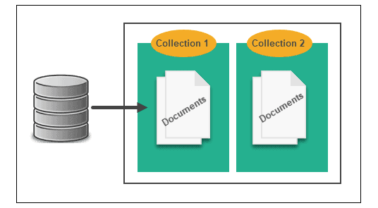

Collection 1- Doctor contains:

Id
Name
Email
Password
Image
Speciality
Degree
Experience
About
Available
Fees
Address
Slots_booked
Role
createdById(Operator ID)
timeSlotId

Collection 2- Operator contains:

Id
Name
Email
Password
createdBy(AdminID)
Role

Collection 3- Patient contains:

Id
Name
Email
Image
Phone
Address
Gender
Dob
Password
Role
paymentId(PaymentID)

Collection 4- Appointment contains:

Id
docId(Doctor ID)
patientId(patientID)
slotDate
slotTime
patientData
docData
Amount
Reason
prescriptionID(PrescriptionID)
Date
Cancelled
Payment
Iscompleted

Collection 5-Prescription contains:

Id
Medicines
pharmacyStore
startDate
endDate

Collection 6-TimeSlot contains:

Id
availableDays
startTime
endTime

Collection 7-Admin contains:

_id
name
email
password

Collection 8- Payment contains:

_id
cardDetails
insuranceId

Sample data: Qapp database

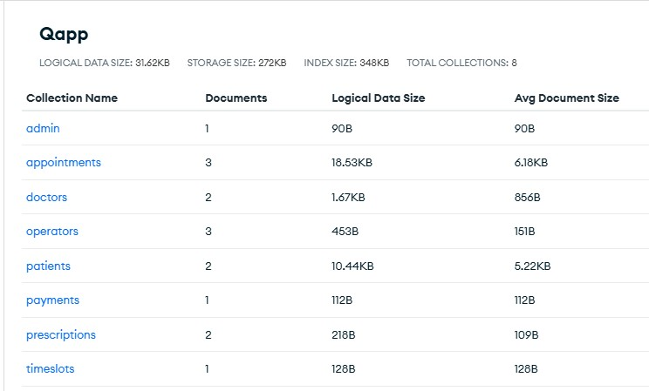

Admin:
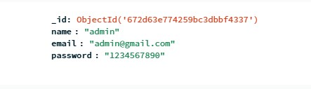

Patient:
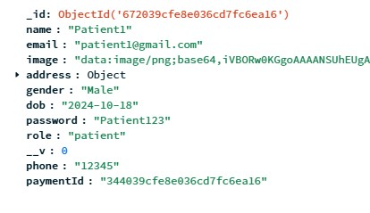

Doctor:
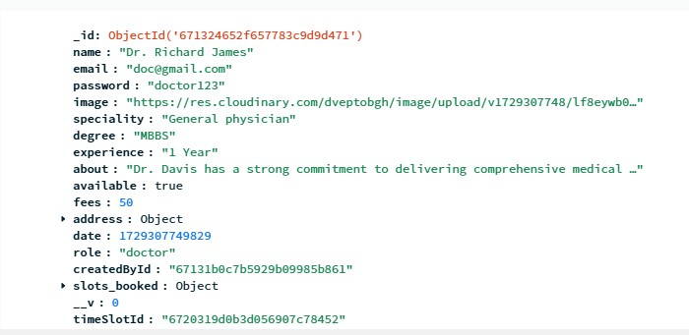

Operator:

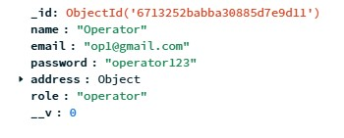

Appointment:

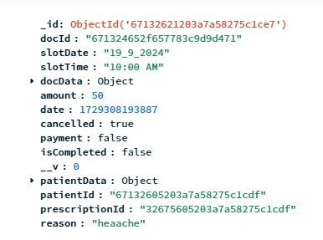

Prescription:

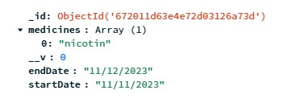

Payment:
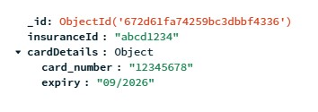

TimeSlot:

