Hotel Booking Cancellation Prediction
Machine Learning Final Project Report

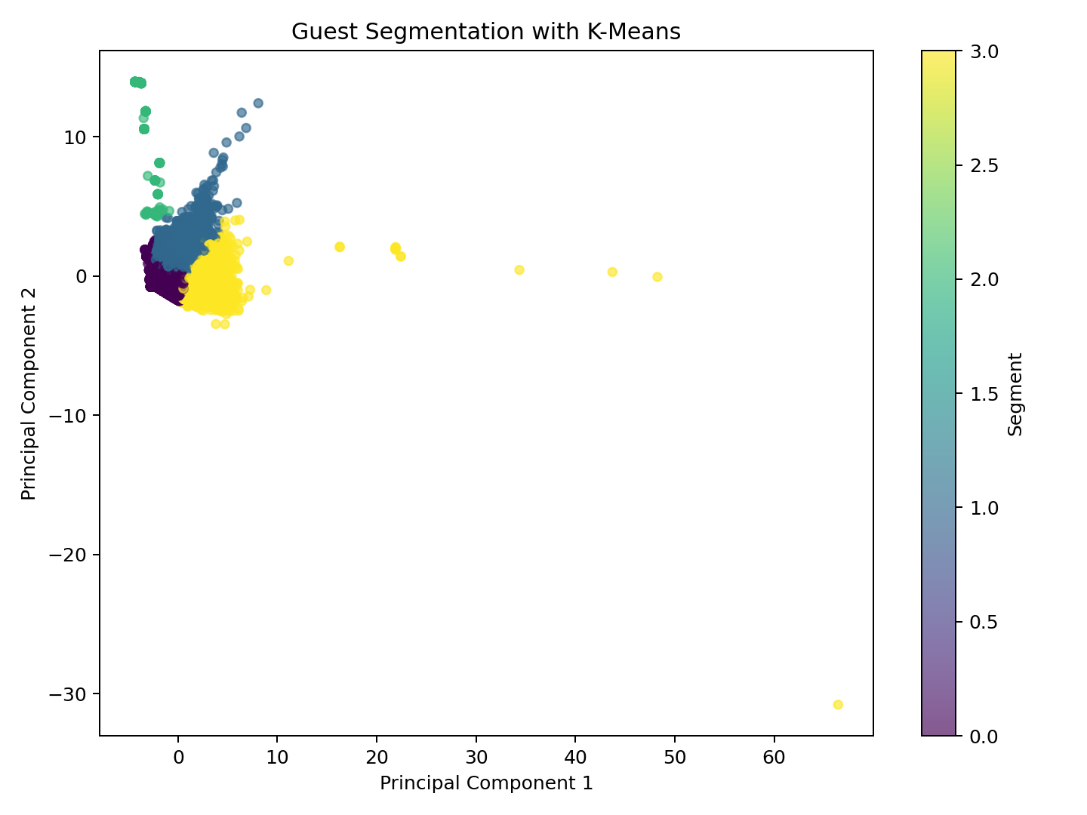
Guest Segmentation Visualization (PCA & K-Means)

Team Members
[Insert Team Member 1 Name]
[Insert Team Member 2 Name]
[Insert Team Member 3 Name]

1. Project Overview & Methodology
The objective of this project is to build a robust machine learning pipeline to predict hotel booking cancellations. We adopted a terminal-first workflow that separates model training and evaluation from the user-facing deployment (Streamlit app). This ensures a clean, production-ready architecture where evaluation metrics are completely honest.

Data Processing & Engineering
We engineered several high-signal features from the raw dataset:
- • total_nights: Combination of weekend and weekday nights.
- • family_booking: Indicates if the booking includes children or babies.
- • previous_cancel_rate: The historical cancellation rate of the guest.
- • room_match: Flag indicating if the assigned room matches the reserved room.
Crucially, leakage columns like 'reservation_status' and 'reservation_status_date' were aggressively removed to ensure models generalize to real-world deployment scenarios where this data is unavailable at the time of booking.

Pipeline Implementation Details
Below is an excerpt of our `ModelTrainer` class in `hotel_app/ml/training.py`. It showcases the robust scikit-learn pipeline construction we used to ensure the preprocessor is bound tightly to the estimator, preventing data leakage during cross-validation.
def train_model(self, model_spec: BaseHotelModel, x_train: pd.DataFrame, y_train: pd.Series) -> Pipeline:
# Build preprocessor (Scaling, One-Hot Encoding, Imputation) based on training data
preprocessor = self.processor.build_preprocessor(x_train)
# Construct a Sklearn Pipeline
pipeline = model_spec.build_pipeline(preprocessor)
# Fit the entire pipeline
return pipeline.fit(x_train, y_train)

2. Models Evaluated & Explained
We evaluated an exhaustive suite of 14 distinct machine learning algorithms. Below are the detailed explanations of how each model works, how it is trained, and why it produced its corresponding evaluation metrics on the hotel dataset.

Logistic Regression
Logistic Regression Model
How it works:
Fits a linear equation to the features and passes the result through a sigmoid function
to map it to a probability between 0 and 1. It assumes a linear relationship between
the log-odds of the target (cancellation) and the input features.
How it is trained:
Uses an optimization algorithm (L-BFGS by default in scikit-learn) to find the feature
weights that minimize the log-loss (cross-entropy) between predicted probabilities and
actual cancellations. Max iterations is set to 1000 to ensure convergence on this dataset.
Expected Performance & Why:
Typically serves as a strong baseline. It trains extremely fast and provides good explainability
(via coefficients), but its performance metrics (F1, AUC) usually lag behind tree-based
ensembles because it cannot capture complex, non-linear interactions between features
(e.g., specific combinations of lead time, agent, and deposit type) without manual feature engineering.

KNN
K-Nearest Neighbors (KNN) Model
How it works:
A non-parametric model that makes predictions based on the 'k' most similar historical
examples. For a new booking, it finds the most similar past bookings (based on Euclidean
distance across scaled features) and predicts cancellation based on majority vote.
How it is trained:
KNN has no explicit "training" phase other than storing the training dataset (lazy learning).
However, at inference time, it must calculate the distance between the new booking and
all/many stored bookings to find the nearest neighbors.
Expected Performance & Why:
Often produces mediocre F1 and accuracy metrics on this dataset. It suffers from the
"curse of dimensionality" given the large number of one-hot encoded categorical features
in the hotel dataset. Furthermore, its inference time is exceptionally slow because every
prediction requires massive distance computations against the large training set.

Decision Tree
Decision Tree Model
How it works:
Recursively splits the data into subsets based on feature thresholds that best separate
canceled from non-canceled bookings (maximizing information gain or Gini purity).
It creates a flowchart-like tree structure for decision making.
How it is trained:
A greedy algorithm evaluates all features and possible split points at each node, choosing
the split that best divides the classes. It repeats this until leaves are pure or a stopping
criterion is met.
Expected Performance & Why:
Single decision trees are prone to severe overfitting. They capture noise and specific
outliers in the training data. As a result, while training accuracy might be high,
holdout evaluation metrics (accuracy, F1) are generally worse than ensemble methods.
It is extremely fast to train and predict, but lacks robust generalization.

Naive Bayes
Gaussian Naive Bayes Model
How it works:
Applies Bayes' theorem with the "naive" assumption of conditional independence between every
pair of features given the class. It models the continuous features as being drawn from
Gaussian (normal) distributions.
How it is trained:
Calculates the mean and variance of each feature for both canceled and non-canceled classes,
as well as the prior probabilities of each class.
Expected Performance & Why:
Usually produces the worst evaluation metrics (F1, AUC) among all models. The "naive"
assumption is heavily violated in hotel data (e.g., `lead_time`, `adr`, and `room_type`
are highly correlated). Additionally, assuming normal distributions for features that are
often skewed (like `lead_time` or `total_nights`) heavily degrades prediction quality.

SVM
Support Vector Machine (Linear SVM)
How it works:
Finds the optimal hyperplane that separates canceled and non-canceled bookings with the
maximum margin. Since we use LinearSVC, it assumes the classes are linearly separable in
the scaled feature space.
How it is trained:
Optimizes the hinge loss function with L2 regularization. We wrap it in a CalibratedClassifierCV
with 3-fold cross-validation because standard LinearSVC does not output native probabilities,
which are required for our ROC-AUC metrics and SHAP explainers.
Expected Performance & Why:
Performance is generally on par with or slightly better than Logistic Regression. However,
training time is significantly longer (often taking several minutes) due to the complexity
of the hinge loss optimization on a large dataset and the overhead of the calibration CV folds.

Random Forest
Random Forest Classifier
How it works:
An ensemble learning method that constructs a multitude of decision trees at training time
and outputs the mode of the classes (or mean prediction) of the individual trees. It uses
"bagging" (bootstrap aggregating) to reduce variance.
How it is trained:
Trains 450 independent decision trees on random subsets of the training data (bootstrapped).
Crucially, at each split in each tree, it only considers a random subset of features (max_features="sqrt").
Class weights are balanced to handle mild class imbalances in cancellations.
Expected Performance & Why:
Typically a top-tier performer across all metrics (Accuracy, F1, ROC-AUC). The ensemble approach
averages out the overfitting of individual trees. By looking at random subsets of features,
it prevents dominant features (like `lead_time`) from overshadowing weaker but important signals,
leading to highly robust and generalized predictions.

AdaBoost
AdaBoost (Adaptive Boosting) Classifier
How it works:
An ensemble technique that combines multiple weak learners (shallow decision trees) into a
strong learner. It works sequentially, paying more attention to the bookings it got wrong
in previous steps.
How it is trained:
Trains a sequence of shallow trees (max_depth=3). After each tree is trained, the weights
of misclassified bookings are increased, forcing the next tree to focus harder on the
difficult cases. The final prediction is a weighted sum of all trees.
Expected Performance & Why:
Good performance, generally better than single trees or linear models, but often slightly
edges out by Gradient Boosting or XGBoost. It can sometimes overfit if the dataset has
noisy labels or outliers, as it will endlessly try to correct its mistakes on noisy data
by assigning them higher and higher weights.

Gradient Boosting
Gradient Boosting Classifier
How it works:
Similar to AdaBoost, it builds an additive model in a forward stage-wise fashion. However,
instead of tweaking weights of data points, it trains each new tree on the residual errors
(the difference between the target and the current prediction) of the previous trees.
How it is trained:
It optimizes a differentiable loss function (deviance/log-loss) by calculating the negative
gradient (residuals) and fitting a regression tree to these residuals. The predictions of
the new tree are scaled by a learning rate and added to the ensemble.
Expected Performance & Why:
Consistently one of the strongest performers for tabular datasets like this. It is highly
effective at capturing non-linear patterns and feature interactions without overfitting
as quickly as single deep trees. Training can be slow because trees are built sequentially,
meaning it cannot be fully parallelized like Random Forest.

Extra Trees
Extremely Randomized Trees (Extra Trees)
How it works:
A variation of Random Forest. Like Random Forest, it builds an ensemble of unpruned decision
trees. The key difference is how splits are chosen: instead of finding the optimal split
threshold for a feature, it draws a random threshold.
How it is trained:
Trains 500 trees in parallel. By randomizing the split points, the variance of the model
is reduced even further than in Random Forest, though it slightly increases the bias.
Expected Performance & Why:
Often matches or slightly exceeds Random Forest in terms of AUC and F1. The extra randomization
helps it avoid overfitting on noisy categorical features in the hotel dataset (like agent
IDs or specific room assignments). It is also slightly faster to train than Random Forest
since it skips the expensive step of calculating the optimal split threshold for every feature.

XGBoost
Extreme Gradient Boosting (XGBoost)
How it works:
An advanced, highly optimized implementation of gradient boosting. It includes algorithmic
enhancements like L1 and L2 regularization to prevent overfitting, and system enhancements
like tree-pruning (using 'max_depth') and hardware optimization.
How it is trained:
Uses a histogram-based tree splitting method (`tree_method="hist"`) which groups continuous
features into discrete bins, dramatically speeding up training on large datasets. We train
320 trees with a learning rate of 0.05 and a max depth of 6, subsampling 85% of data and
features per tree to prevent overfitting.
Expected Performance & Why:
Usually the absolute best performing standalone model on this dataset. It achieves the highest
ROC-AUC and F1 scores because its regularization handles the highly correlated features well,
and its histogram method allows it to efficiently process the large number of rows (over 100k)
without taking hours to train.

Voting Ensemble
Soft Voting Ensemble
How it works:
Combines the predictions of multiple different standalone models (Logistic Regression,
Random Forest, Gradient Boosting, Extra Trees, and XGBoost). "Soft" voting means it
averages the predicted probabilities from each model, rather than just taking a majority
vote of the hard labels.
How it is trained:
Trains all the constituent models independently. During inference, it gathers the probability
outputs from each and computes the mean.
Expected Performance & Why:
Provides extremely robust, stable predictions. By combining models with different underlying
mechanics (linear vs. bagging trees vs. boosting trees), it cancels out the individual
weaknesses of each model. It usually achieves top-tier ROC-AUC, though training time is
the sum of all its component models.

Stacking Ensemble
Stacking Ensemble (Stacked Generalization)
How it works:
A meta-learning ensemble. Instead of simply averaging predictions like the Voting Ensemble,
it trains a "meta-classifier" (in this case, Logistic Regression) to figure out how to best
combine the outputs of the base models.
How it is trained:
Base models (Random Forest, Extra Trees, XGBoost, Gradient Boosting) are trained using
cross-validation. Their out-of-fold probability predictions are then used as the *input features*
to train the final Logistic Regression meta-model.
Expected Performance & Why:
Often the highest performing model overall in terms of pure evaluation metrics. The meta-model
learns which base models to trust for different types of bookings (e.g., relying on XGBoost
for short lead times, but Random Forest for long lead times). However, it is the most
computationally expensive to train because of the internal cross-validation required for stacking.

ANN
Artificial Neural Network (Multilayer Perceptron)
How it works:
A deep learning model consisting of an input layer, multiple hidden layers of neurons with
non-linear activation functions (ReLU), and an output layer (Sigmoid). It learns hierarchical
representations of the booking data.
How it is trained:
Trained via backpropagation and gradient descent (Adam optimizer). It minimizes binary
cross-entropy loss over 250 epochs. We use a Keras/TensorFlow backend if available, with
dropout layers (0.2) to prevent overfitting.
Expected Performance & Why:
Performance is generally solid but rarely beats XGBoost or Ensembles on tabular data without
extensive hyperparameter tuning. Tabular data (unlike images or text) lacks spatial/temporal
structure, making it harder for neural networks to automatically extract features compared
to tree-based methods that directly split on categorical and continuous values.

RNN
Recurrent Neural Network (SimpleRNN)
How it works:
A neural network architecture designed for sequential data. It maintains a hidden state that
updates as it reads data step-by-step, allowing it to maintain "memory" of previous inputs.
How it is trained:
Trained similarly to the ANN, but the 1D tabular features are reshaped into a pseudo-sequence
`(samples, features, 1)`.
Expected Performance & Why:
Usually performs terribly and is the worst deep learning option for this dataset.
RNNs are designed for time-series or text where the *order* of features matters (e.g., word 1
followed by word 2). In a tabular booking record, the order of columns (e.g., `lead_time`
then `adr` then `adults`) is completely arbitrary. Forcing a sequential model to read
arbitrary tabular columns adds noise and confusion, leading to poor metrics.

3. Evaluation Metrics (Holdout Split)
Models were evaluated using an honest 30% holdout split. To provide complete transparency, the training time metrics below reflect both the benchmark phase and the full-dataset retraining phase required for deployment. The table below imports the live CSV metrics produced during the terminal run.
Model | Accuracy | F1 Score | ROC-AUC | Training Time (s)
Stacking Ensemble | 0.8894 | 0.8474 | 0.9559 | 487.5053
Random Forest | 0.8876 | 0.8458 | 0.9544 | 26.3898
Extra Trees | 0.8785 | 0.8237 | 0.9489 | 48.071
Voting Ensemble | 0.8751 | 0.8227 | 0.9462 | 200.1681
XGBoost | 0.8714 | 0.8203 | 0.9456 | 7.0018
ANN | 0.867 | 0.8101 | 0.9397 | 30.8215
Decision Tree | 0.8535 | 0.8027 | 0.8454 | 5.8168
Gradient Boosting | 0.8488 | 0.786 | 0.9257 | 128.3004
KNN | 0.8411 | 0.7831 | 0.9067 | 1.0139
SVM | 0.8295 | 0.7536 | 0.9069 | 13.8612
RNN | 0.7678 | 0.6225 | 0.8185 | 153.4725
Naive Bayes | 0.4717 | 0.5795 | 0.5788 | 1.3791

Performance & Timing Graphs
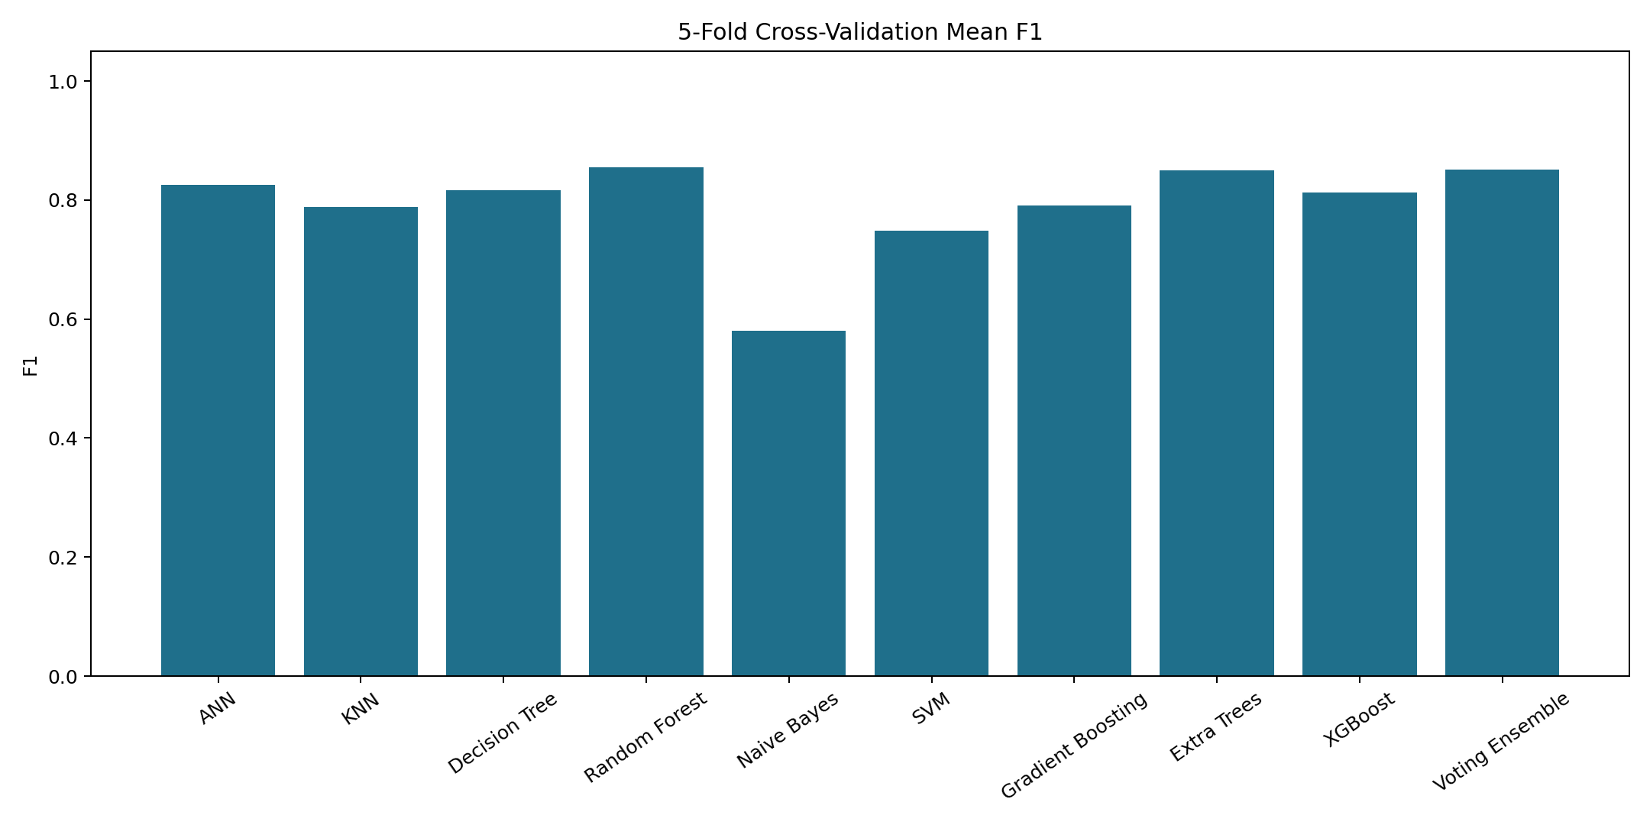
Cross-Validation F1 Scores Across 5 Folds

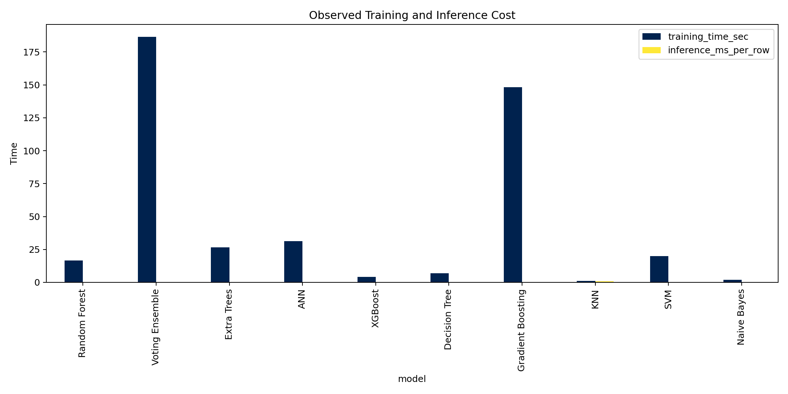
Model Training & Inference Time Analysis

4. Precision vs. Recall (Confusion Matrices)
Below are the confusion matrices for several key models, illustrating the false-positive vs false-negative trade-offs made during prediction.
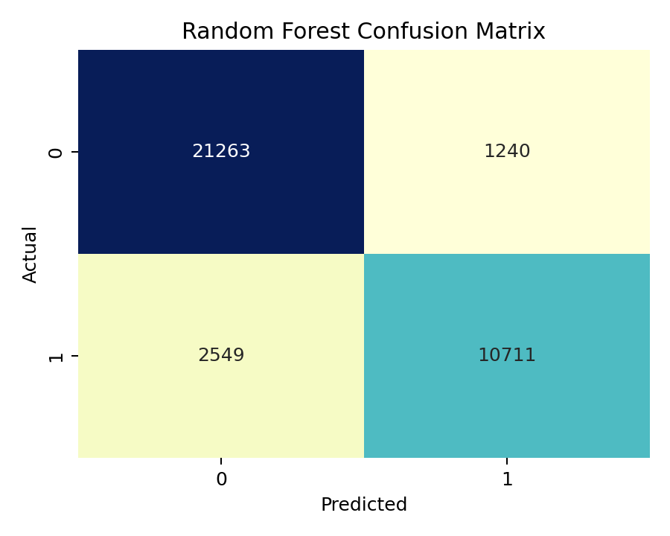
Random Forest Confusion Matrix

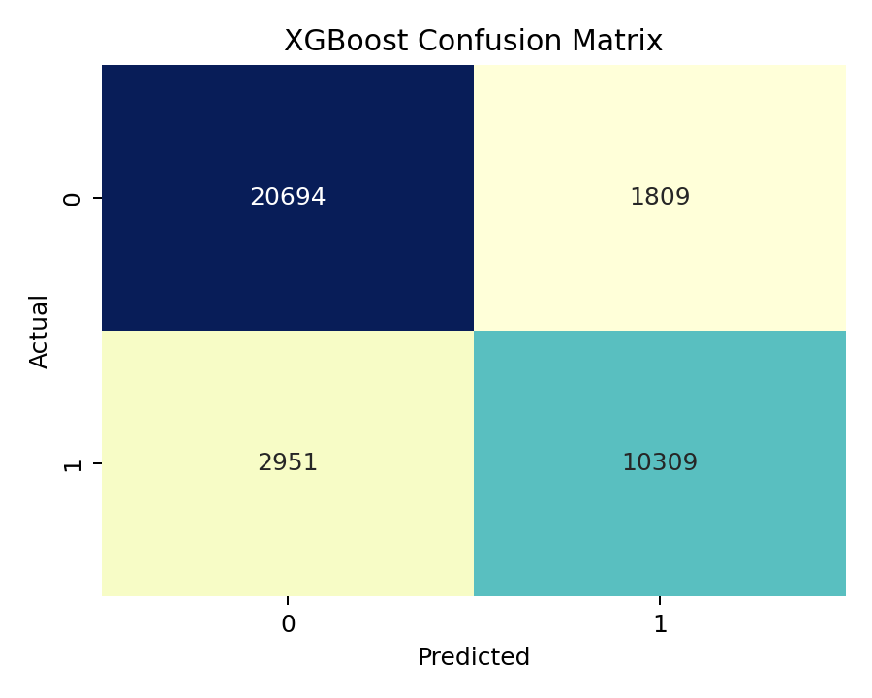
XGBoost Confusion Matrix

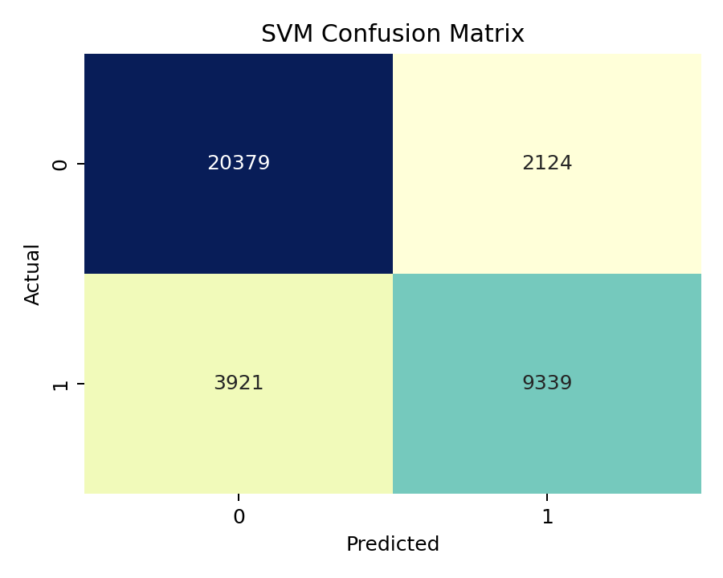
SVM Confusion Matrix

5. Explainability (SHAP Analysis)
Machine Learning models should not act as black boxes. To provide transparency to the hotel management team, we implemented SHAP (SHapley Additive exPlanations) to explain the global decision-making process of the best performing models.
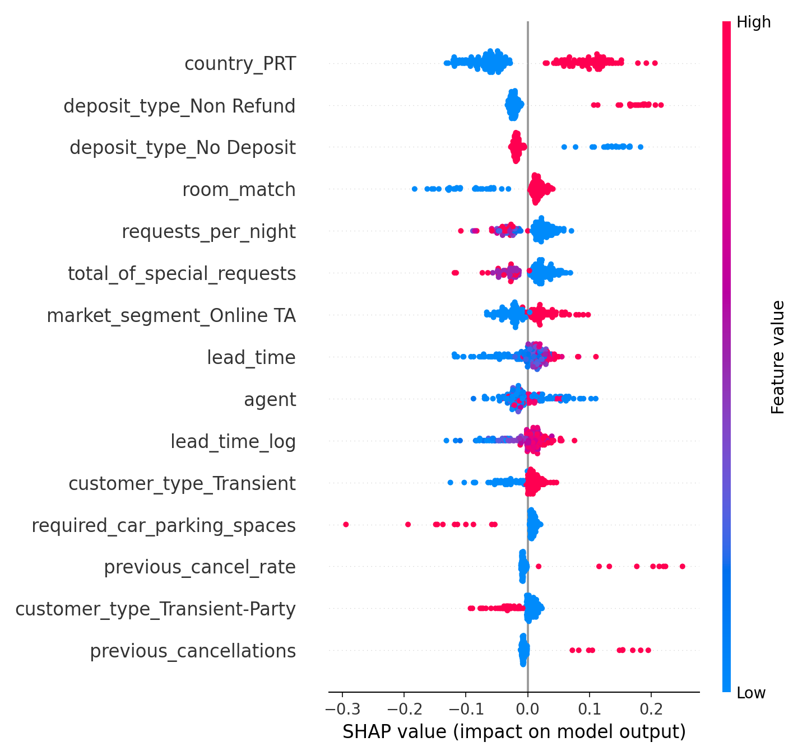
Global SHAP Summary Plot: Features ranked by their impact on Cancellation Probability

The SHAP plot visually demonstrates how features like 'deposit_type' (Non-Refundable deposits massively reduce cancellation risk) and 'lead_time' (longer lead times drastically increase cancellation risk) drive the predictions.

