Hotel Booking Cancellation Prediction
Machine Learning Final Project Report

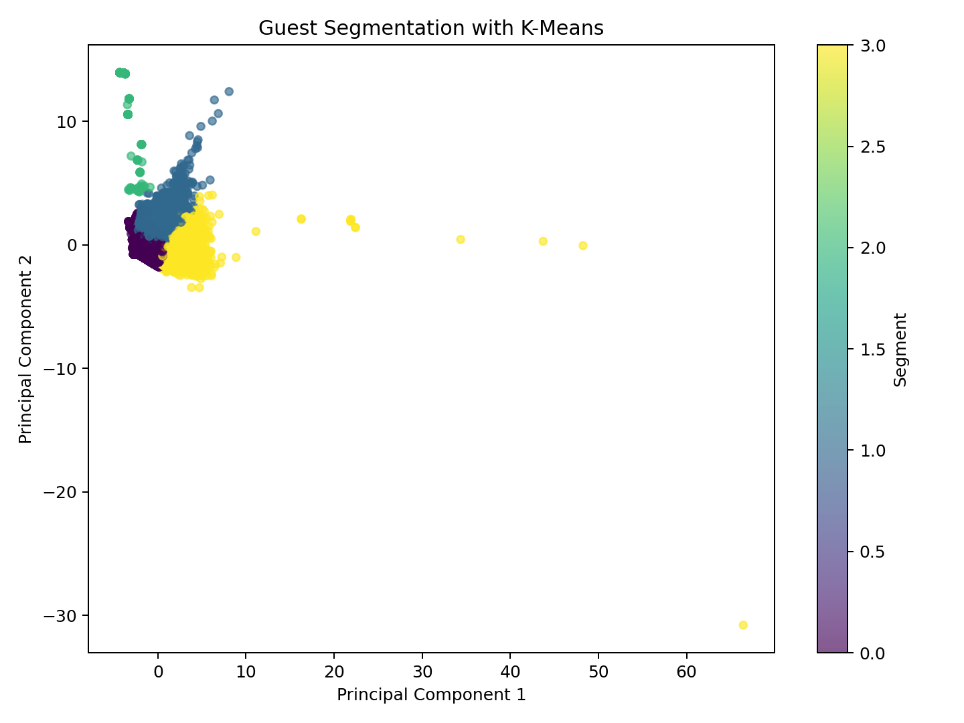
Guest Segmentation Visualization (PCA & K-Means)

Team Members
[Insert Team Member 1 Name]
[Insert Team Member 2 Name]
[Insert Team Member 3 Name]

1. Project Overview & Methodology
The objective of this project is to build a robust machine learning pipeline to predict hotel booking cancellations. We adopted a terminal-first workflow that separates model training and evaluation from the user-facing deployment (Streamlit app). This ensures a clean, production-ready architecture where evaluation metrics are completely honest.

Data Processing & Engineering
We engineered several high-signal features from the raw dataset:
- • total_nights: Combination of weekend and weekday nights.
- • family_booking: Indicates if the booking includes children or babies.
- • previous_cancel_rate: The historical cancellation rate of the guest.
- • room_match: Flag indicating if the assigned room matches the reserved room.
Crucially, leakage columns like 'reservation_status' and 'reservation_status_date' were aggressively removed to ensure models generalize to real-world deployment scenarios where this data is unavailable at the time of booking.

Pipeline Implementation Details
Below is an excerpt of our `ModelTrainer` class in `hotel_app/ml/training.py`. It showcases the robust scikit-learn pipeline construction we used to ensure the preprocessor is bound tightly to the estimator, preventing data leakage during cross-validation.
def train_model(self, model_spec: BaseHotelModel, x_train: pd.DataFrame, y_train: pd.Series) -> Pipeline:
# Build preprocessor (Scaling, One-Hot Encoding, Imputation) based on training data
preprocessor = self.processor.build_preprocessor(x_train)
# Construct a Sklearn Pipeline
pipeline = model_spec.build_pipeline(preprocessor)
# Fit the entire pipeline
return pipeline.fit(x_train, y_train)

2. Models Evaluated & Source Code
We evaluated an exhaustive suite of 14 distinct machine learning algorithms. Each model is encapsulated in its own class, inheriting from `BaseHotelModel`. Below is the exact implementation code and functions used for each model in our pipeline.

Logistic Regression
class LogisticRegressionModel(BaseHotelModel):
name = "Logistic Regression"
def get_estimator(self) -> LogisticRegression:
return LogisticRegression(max_iter=1000, random_state=42)

KNN
class KNNModel(BaseHotelModel):
name = "KNN"
def get_estimator(self) -> KNeighborsClassifier:
return KNeighborsClassifier()

Decision Tree
class DecisionTreeModel(BaseHotelModel):
name = "Decision Tree"
def get_estimator(self) -> DecisionTreeClassifier:
return DecisionTreeClassifier(random_state=42)

Naive Bayes
class NaiveBayesModel(BaseHotelModel):
name = "Naive Bayes"
def get_estimator(self) -> GaussianNB:
return GaussianNB()

SVM
class SVMModel(BaseHotelModel):
name = "SVM"
def get_estimator(self) -> CalibratedClassifierCV:
return CalibratedClassifierCV(estimator=LinearSVC(C=1.0, random_state=42, dual="auto"), cv=3)

Random Forest
class RandomForestModel(BaseHotelModel):
name = "Random Forest"
def get_estimator(self) -> RandomForestClassifier:
return RandomForestClassifier(
n_estimators=450,
max_features="sqrt",
min_samples_leaf=2,
class_weight="balanced_subsample",
random_state=42,
n_jobs=-1,
)

AdaBoost
class AdaBoostModel(BaseHotelModel):
name = "AdaBoost"
def get_estimator(self) -> AdaBoostClassifier:
tree = DecisionTreeClassifier(max_depth=3, random_state=42)
try:
return AdaBoostClassifier(estimator=tree, random_state=42)
except TypeError:
return AdaBoostClassifier(base_estimator=tree, random_state=42)

Gradient Boosting
class GradientBoostingModel(BaseHotelModel):
name = "Gradient Boosting"
def get_estimator(self) -> GradientBoostingClassifier:
return GradientBoostingClassifier(random_state=42)

Extra Trees
class ExtraTreesModel(BaseHotelModel):
name = "Extra Trees"
def get_estimator(self) -> ExtraTreesClassifier:
return ExtraTreesClassifier(
n_estimators=500,
max_features="sqrt",
min_samples_leaf=2,
random_state=42,
n_jobs=-1,
)

XGBoost
class XGBoostModel(BaseHotelModel):
name = "XGBoost"
def get_estimator(self) -> Any:
try:
xgboost = importlib.import_module("xgboost")
except ImportError as exc:
raise ImportError(
"XGBoost is required for XGBoostModel. Install it with `pip install xgboost` "
"or remove XGBoost from the selected models."
) from exc
return xgboost.XGBClassifier(
booster="gbtree",
learning_rate=0.05,
max_depth=6,
n_estimators=320,
min_child_weight=2,
subsample=0.85,
colsample_bytree=0.85,
reg_lambda=1.5,
eval_metric="logloss",
tree_method="hist",
n_jobs=-1,
random_state=42,
)

Voting Ensemble
class VotingEnsembleModel(BaseHotelModel):
name = "Voting Ensemble"
def get_estimator(self) -> VotingClassifier:
estimators = [
("logistic", LogisticRegression(max_iter=1000, random_state=42)),
(
"random_forest",
RandomForestClassifier(
n_estimators=300,
max_features="sqrt",
min_samples_leaf=2,
class_weight="balanced_subsample",
random_state=42,
n_jobs=-1,
),
),
("gradient_boosting", GradientBoostingClassifier(random_state=42)),
(
"extra_trees",
ExtraTreesClassifier(
n_estimators=350,
max_features="sqrt",
min_samples_leaf=2,
random_state=42,
n_jobs=-1,
),
),
("xgboost", XGBoostModel().get_estimator()),
]
return VotingClassifier(estimators=estimators, voting="soft", n_jobs=-1)

Stacking Ensemble
class StackingEnsembleModel(BaseHotelModel):
name = "Stacking Ensemble"
def get_estimator(self) -> StackingClassifier:
estimators = [
(
"random_forest",
RandomForestClassifier(
n_estimators=250,
max_features="sqrt",
min_samples_leaf=2,
class_weight="balanced_subsample",
random_state=42,
n_jobs=-1,
),
),
(
"extra_trees",
ExtraTreesClassifier(
n_estimators=250,
max_features="sqrt",
min_samples_leaf=2,
random_state=42,
n_jobs=-1,
),
),
("xgboost", XGBoostModel().get_estimator()),
("gradient_boosting", GradientBoostingClassifier(random_state=42)),
]
return StackingClassifier(
estimators=estimators,
final_estimator=LogisticRegression(max_iter=1000, random_state=42),
stack_method="predict_proba",
n_jobs=-1,
passthrough=False,
)

ANN
class ANNModel(BaseHotelModel):
name = "ANN"
def __init__(self, epochs: int = 250, batch_size: int = 256) -> None:
self.epochs = epochs
self.batch_size = batch_size
def get_estimator(self) -> Any:
try:
importlib.import_module("tensorflow")
return KerasTabularClassifier(model_type="ann", epochs=self.epochs, batch_size=self.batch_size)
except ImportError:
return MLPClassifier(
hidden_layer_sizes=(128, 64, 32),
activation="relu",
learning_rate_init=0.001,
batch_size=min(self.batch_size, 256),
max_iter=self.epochs,
early_stopping=True,
validation_fraction=0.1,
random_state=42,
)

RNN
class RNNModel(BaseHotelModel):
name = "RNN"
def __init__(self, epochs: int = 20, batch_size: int = 256) -> None:
self.epochs = epochs
self.batch_size = batch_size
def get_estimator(self) -> KerasTabularClassifier:
return KerasTabularClassifier(model_type="rnn", epochs=self.epochs, batch_size=self.batch_size)

3. Evaluation Metrics (Holdout Split)
Models were evaluated using an honest 30% holdout split. To provide complete transparency, the training time metrics below reflect both the benchmark phase and the full-dataset retraining phase required for deployment. The table below imports the live CSV metrics produced during the terminal run.
Model | Accuracy | F1 Score | ROC-AUC | Training Time (s)
Stacking Ensemble | 0.8894 | 0.8474 | 0.9559 | 487.5053
Random Forest | 0.8876 | 0.8458 | 0.9544 | 26.3898
Extra Trees | 0.8785 | 0.8237 | 0.9489 | 48.071
Voting Ensemble | 0.8751 | 0.8227 | 0.9462 | 200.1681
XGBoost | 0.8714 | 0.8203 | 0.9456 | 7.0018
ANN | 0.867 | 0.8101 | 0.9397 | 30.8215
Decision Tree | 0.8535 | 0.8027 | 0.8454 | 5.8168
Gradient Boosting | 0.8488 | 0.786 | 0.9257 | 128.3004
KNN | 0.8411 | 0.7831 | 0.9067 | 1.0139
SVM | 0.8295 | 0.7536 | 0.9069 | 13.8612
RNN | 0.7678 | 0.6225 | 0.8185 | 153.4725
Naive Bayes | 0.4717 | 0.5795 | 0.5788 | 1.3791

Performance & Timing Graphs
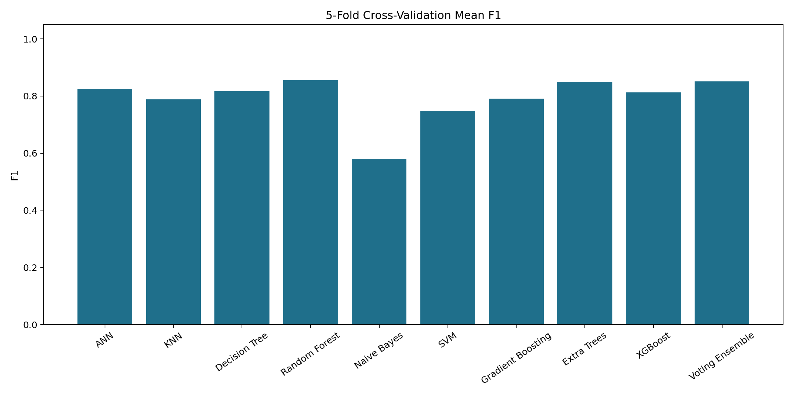
Cross-Validation F1 Scores Across 5 Folds

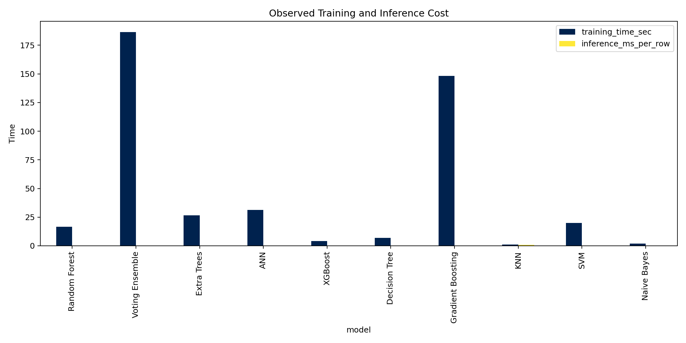
Model Training & Inference Time Analysis

4. Precision vs. Recall (Confusion Matrices)
Below are the confusion matrices for several key models, illustrating the false-positive vs false-negative trade-offs made during prediction.
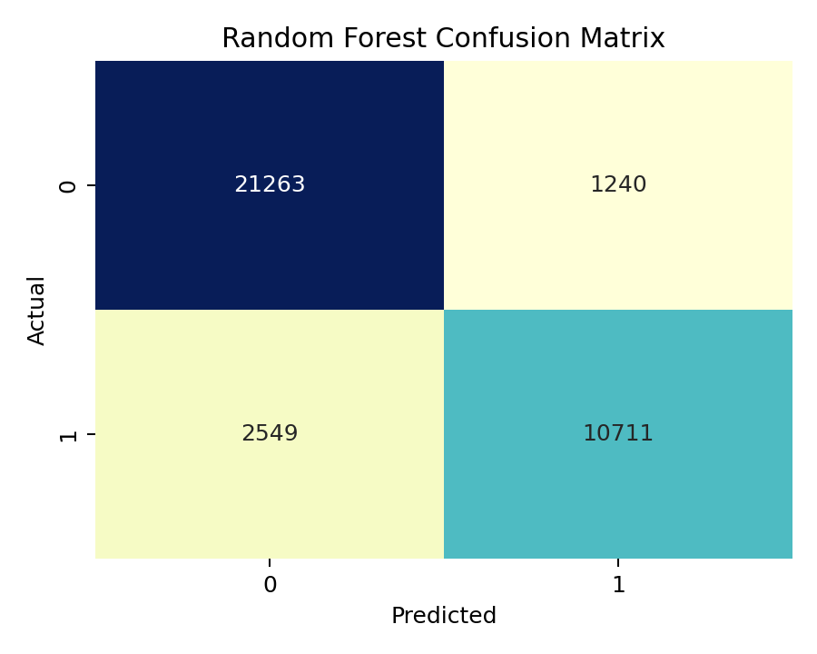
Random Forest Confusion Matrix

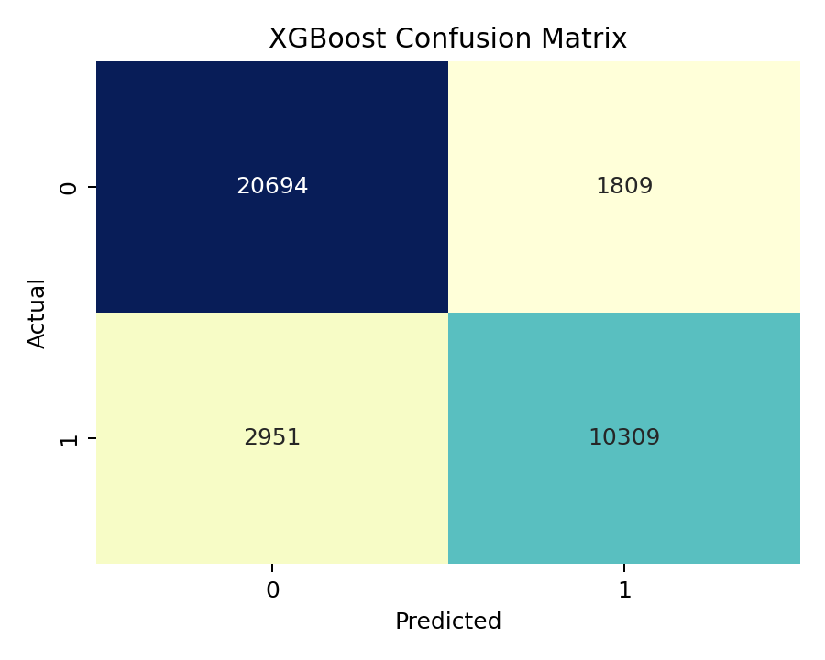
XGBoost Confusion Matrix

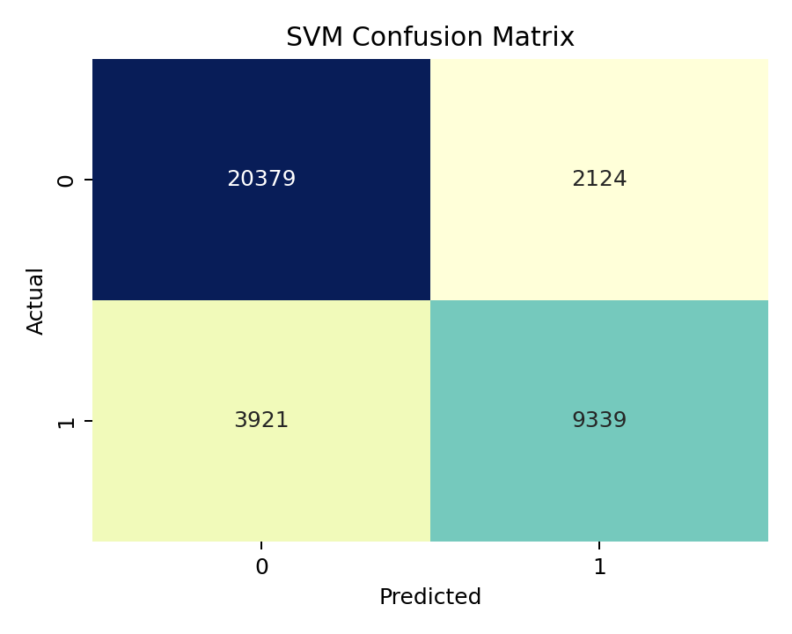
SVM Confusion Matrix

5. Explainability (SHAP Analysis)
Machine Learning models should not act as black boxes. To provide transparency to the hotel management team, we implemented SHAP (SHapley Additive exPlanations) to explain the global decision-making process of the best performing models.
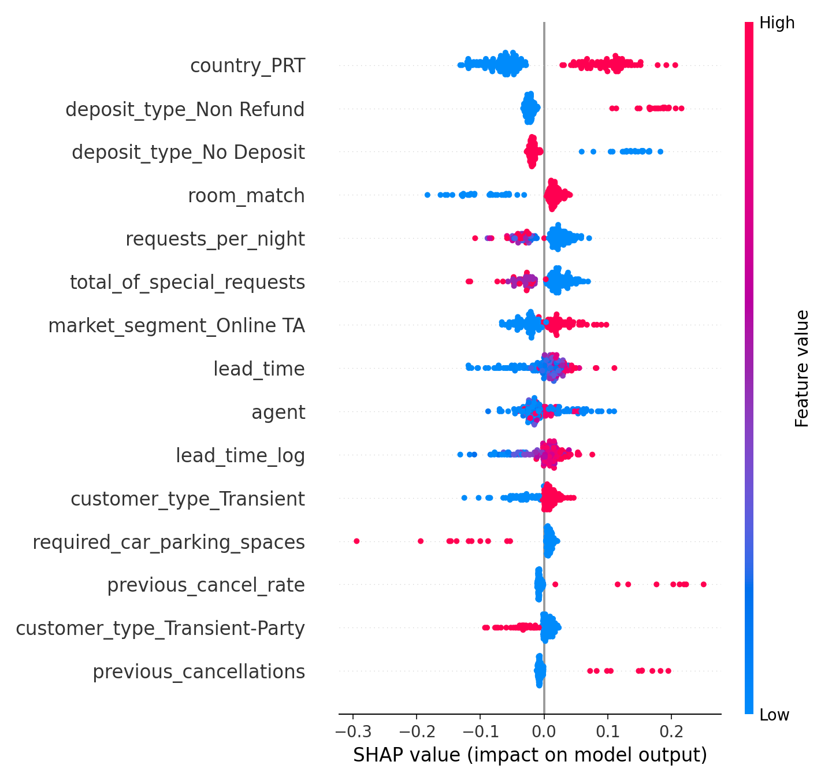
Global SHAP Summary Plot: Features ranked by their impact on Cancellation Probability

The SHAP plot visually demonstrates how features like 'deposit_type' (Non-Refundable deposits massively reduce cancellation risk) and 'lead_time' (longer lead times drastically increase cancellation risk) drive the predictions.

