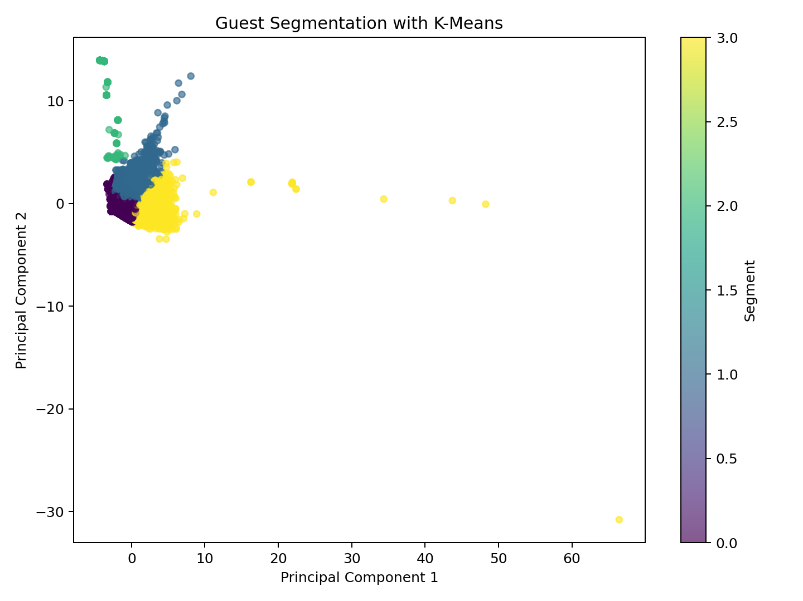

Hotel Booking Cancellation Prediction
Machine Learning Final Project Report

Team Members
[Insert Team Member 1]
[Insert Team Member 2]
[Insert Team Member 3]

1. Project Approach & Methodology
The objective of this project is to build a robust machine learning pipeline to predict hotel booking cancellations. We adopted a terminal-first workflow that separates model training and evaluation from the user-facing deployment (Streamlit app). This ensures a clean, production-ready architecture.

Data Processing & Engineering
We engineered several high-signal features from the raw dataset, such as:
- • total_nights: Combination of weekend and weekday nights.
- • family_booking: Indicates if the booking includes children or babies.
- • previous_cancel_rate: The historical cancellation rate of the guest.
- • room_match: Flag indicating if the assigned room matches the reserved room.
We explicitly dropped features that cause data leakage, such as 'reservation_status' and 'reservation_status_date', to ensure our models evaluate purely on data available at the time of booking.

Evaluation & Validation
To guarantee honest evaluation metrics, we implemented:
- • A strict 70/30 Train/Test split. Models are only trained on the 70% subset.
- • 5-Fold Stratified Cross-Validation on the entire dataset to measure model stability and variance.
After the benchmark phase on the 70% split, we retrain the models on the full 100% dataset to produce the final artifacts for deployment. This maximizes the data available for the production system while still reporting honest evaluation metrics from the benchmark pass.

2. Details of the Codebase
The codebase is organized in a modular structure within the `hotel_app` package. The key modules are:
- • data.py: Contains the HotelDataProcessor class, responsible for cleaning data, handling missing values, engineering new features, and building the scikit-learn ColumnTransformer for preprocessing numeric and categorical variables.
- • models.py: Contains definitions for 14 different machine learning models, spanning from simple linear models (Logistic Regression, Naive Bayes) to complex tree-based ensembles (Random Forest, XGBoost, Stacking) and Deep Learning models (ANN, RNN). Each model inherits from BaseHotelModel and defines its specific algorithm and hyperparameters.
- • training.py: Orchestrates the pipeline. The TerminalTrainingRunner loads the data, trains the models, evaluates them, runs SHAP explainability analysis, performs K-Means guest segmentation, and saves all outputs to the 'artifacts' directory.
- • testing.py & metrics.py: Handle standardizing model predictions, calculating probabilities, and generating comprehensive metrics like Accuracy, F1 Score, and ROC-AUC.
- • streamlit_app.py: The interactive prediction dashboard. It loads the artifacts and deployment model generated by the training script to provide live risk predictions, explainability metrics, and benchmarking summaries.

3. Model Performance Summary
Our evaluation phase benchmarks 14 distinct models. Based on recent runs on the 30% holdout split, ensemble methods like XGBoost, Random Forest, and Stacking Ensembles typically dominate performance metrics. They successfully capture the non-linear interactions between features such as lead_time, deposit_type, and market_segment.
All models undergo SHAP (SHapley Additive exPlanations) analysis to determine the global feature importances, ensuring the predictions are interpretable for hotel management.

