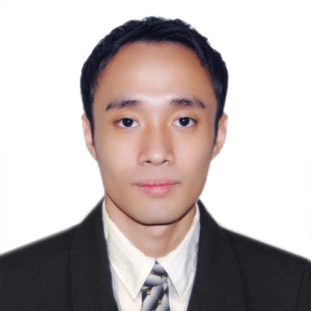**ARVIN T. VAJE**

#72-A Central Kalayaan Balagbag

Pasay City

Mobile No. +639459854111

Email Address: [arvinvaje26@yahoo.com](mailto:arvinvaje26@yahoo.com)

**OBJECTIVES:**

To obtain a challenging position that utilizes my knowledge and skills in the field of hospitality industry. To be able to contribute to the company’s growth and development in fulfilling duties and responsibilities efficiently and effectively as an employee. To work towards the advancement of my career and to explore my knowledge and skills in a related field.

**WORK EXPERIENCE:**

Microsoft 365 Support Ambassador (Concierge)

Company: Rhipe May 24, 2021 – Till Present

* + Provides support for business organization related to Microsoft 365.
  + Knowledgeable with Exchange Online, SharePoint Online, OneDrive for Business, including DNS requirements and user mastery scenarios.
  + Help business administrators with office 365 email migrations.
  + Basic knowledge with windows server 2016 – 2019 and exchange server 2016-2019.

IT Helpdesk

Conduent

Company: Atos Mall of Asia March 11, 2018 – May 24, 2021

* Can speak and communicate well in English.
* Assisting users/clients in their password related issues.
* Troubleshoot desktop/laptop basic issues.
* Creating tickets to the correct resolving groups that have admin access to user’s PC.
* Assisting outlook and skype for business related issues.
* Can also give passive support regarding internet related problems.
* Provide resolution to customers satisfaction.

Technical Support Representative

HP Desktop and Laptop Computers

Company: Convergys Philippines Moa July 31, 2017 – Dec. 22, 2017

* Can speak and communicate well in English.
* Assisting customers in their desktop and laptop issue.
* Can also give passive support regarding internet related problems.
* Provide resolution to customers satisfaction.

Technical Support Representative/Customer Service Representative

Comcast Video Repair / Comcast Billing

Company: Sitel Philippines August 22, 2014-August 3, 2017

* Can speak and communicate well in English.
* Assisting customers in their cable box issue.
* Can also give passive support regarding computer problems.
* Provide resolution to a billing related concern to customers satisfaction.

**TERTIARY:**

AMA Computer University Las Piñas

B.S. Information Technology

2001-2003

**SECONDARY:**

Bernardo College Las Piñas

Date Graduated: March 31, 2001

**SKILLS AND CERTIFICATIONS:**

* Basic skill in computer applications such as ms word, excel, powerpoint and computer formatting.
* Basic knowledge to OS such as windows 7/8/10.
* Basic knowledge to use and set up account Microsoft live/outlook/macmail.
* Basic knowledge with Frontend web design such as HTML, CSS, JAVASCRIPT, REACT.
* Got certification with Windows Server 2016 Basic Administration and Microsoft Office 365 Administration
* Natural ability to work on own initiative or as part of a team.
* Driving

**PERSONAL DATA:**

Nickname : Arvin

Date of birth : August 26, 1984

Place of birth : Parañaque Community Hospital

Civil Status : Single

Nationality : Filipino

Height : 5’9

Language Spoken : English and Tagalog

**Character References:**

Rona Delos Santos Raymundo Apostol

Coach/Supervisor Comcast Co - employee

09165529220 09357534042

Robert Sequitin Marvin Berdos

Co - employee Co - employee

09150425956 09179576555