**Data Science AI/ML**

plt.figure(figsize = (12,6))

plt.plot(category_df['Category'], category_df['Quantity'] , label = 'Quantity' , marker = 'o')

plt.plot(category_df['Category'], category_df['count'] , label = 'Count' , marker = 'o')

plt.xlabel('Category')

plt.ylabel('Quantity')

plt.xticks(rotation = 60)

plt.title('Total Quantity Ordered from Each Category')

plt.legend()

plt.show()

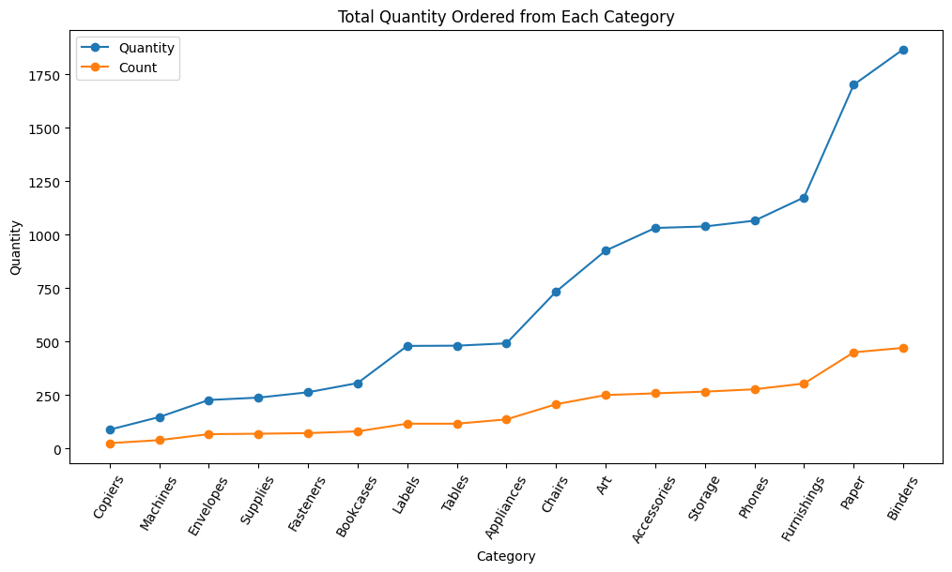

plt.figure(figsize = (12,6))

plt.scatter(category_df['Category'], category_df['Quantity'] , label = 'Quantity' , marker = 'o')

plt.scatter(category_df['Category'], category_df['count'] , label = 'Count' , marker = 'o')

plt.xlabel('Category')

plt.ylabel('Quantity')

plt.xticks(rotation = 90)

plt.title('Total Quantity Ordered from Each Category')

plt.legend()

plt.show()

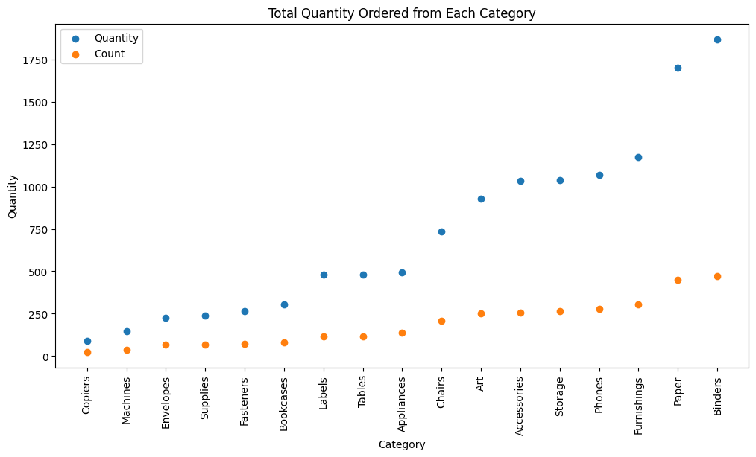

profit_status = []

for profit in df['Profit']:

if (profit <= 0):

profit_status.append('red')

else:

profit_status.append('green')

print(profit_status)

_____________________________________

plt.figure(figsize = (12,6))

plt.scatter(df['Sales'] , df['Profit'] , color = profit_status)

plt.axhline(y = 0 , color = 'violet' , linestyle = '--' )

plt.axvline(x = 2000 , color = 'blue' , linestyle = '--')

plt.xlabel('Sales')

plt.ylabel('Profit')

plt.title('Sales vs Profit')

plt.show()

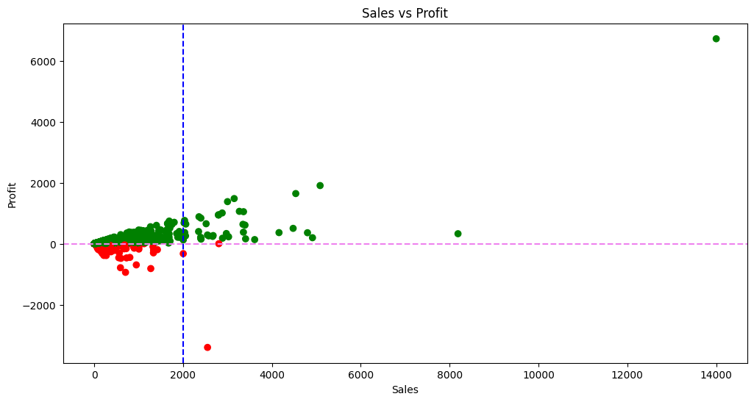

av_sales = round(df['Sales'].mean(),2)

av_profit = round(df['Profit'].mean(),2)

plt.figure(figsize = (12,6))

plt.scatter(df['Sales'] , df['Profit'] , color = profit_status)

plt.axhline(y = df['Profit'].mean() , color = 'violet' , linestyle = '--' ,

label = f"AverageProfit - {av_profit}")

plt.axvline(x = df['Sales'].mean() , color = 'blue' , linestyle = '--' ,

label = f"AverageSales - {av_sales}")

plt.xlabel('Sales')

plt.ylabel('Profit')

plt.title('Sales vs Profit')

plt.legend()

plt.show()

