UN Report on the relationship between GDP and Life Expectancy

Dongyuan Zhou

2023-10-13

# Summary

This report was prepared to the attention of the UN. It analyzes the relationship between a country’s GDP, its life expectancy, and CO2 emissions. Our goal is to determine to what degree a country’s economic strength or weakness is related to its public health status and impact on climate pollution. We hypothesize that both life expectancy and CO2 emissions increase with the country’s GDP.

## Important figure

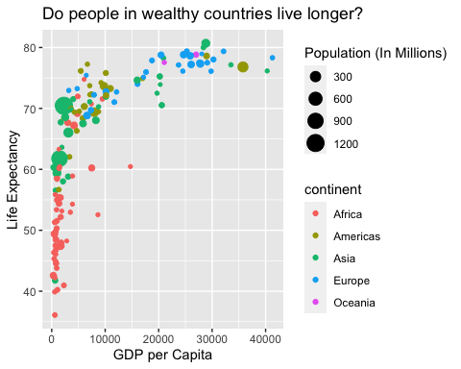

The above plot shows the relationship between GDP per capita and life expectancy for a total of 142 countries. For this set of countries, economic wealth ranged from a minimum of $312.2 to a maximum of $41283.2 per capita.

## Related tables

| Summary of data |  |
| --- | --- |
| Number of countries | 142 |
| Minimum GDP per capita | 312.2 |
| Maximum GDP per capita | 41283.2 |

| country | pop | continent | lifeExp | gdpPercap |
| --- | --- | --- | --- | --- |
| Australia | 18565243 | Oceania | 78.83 | 26997.94 |
| New Zealand | 3676187 | Oceania | 77.55 | 21050.41 |

## My number list

1. action 1 **R**
2. action 2 *gourp_by*
3. action 3 ***still R***
4. Markdown [cheatsheet](https://www.markdownguide.org/cheat-sheet/)