5.10 For the Hamming code shown in Figure 5.10, show what happens when a check bit

rather than a data bit is in error?

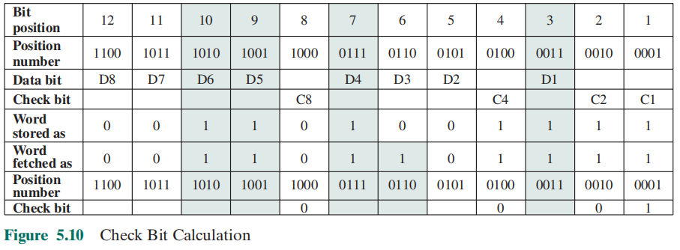

假设校验位C8传输错误，Word fetch as 由0变成1，然后讲新的校验位与传输过来的校验位进行XOR运算。

C8 C4 C2 C1

1 1 1 1

XOR 0 1 1 1

1 0 0 0

根据计算的结果，C8位置出错，将数据位C8由0改为1，检验为出错。

5.11 Suppose an 8-bit data word stored in memory is 11000010. Using the Hamming algorithm,

determine what check bits would be stored in memory with the data word.

Show how you got your answer.

C1=0⊕1⊕0⊕0⊕1=0 （数据位倒数第1位是1的数据异或）

C2=0⊕0⊕0⊕0⊕1=1 （数据位倒数第2位是1的数据异或）

C4=1⊕0⊕0⊕1=0 （数据位倒数第3位是1的数据异或）

C8=0⊕0⊕1⊕1=0 （数据位倒数第4位是1的数据异或）

Check bits 是：0010

5.12 For the 8-bit word 00111001, the check bits stored with it would be 0111. Suppose

when the word is read from memory, the check bits are calculated to be 1101. What is

the data word that was read from memory?

校验位与原来的检验为进行XOR运算：

C8 C4 C2 C1

0 1 1 1

XOR 1 1 0 1

1 0 1 0

Bit第十位，数据D6出错，所以读出的数据为：00011001

5.13 How many check bits are needed if the Hamming error correction code is used to

detect single bit errors in a 1024-bit data word?

根据公式： $2^{K}−1≥1024+K$，求得 $K=11$，即校验位为11位