**Final year project – 7CSPR-B**

**TEAM NAME – CODE WITH US**

**Scrum Master: Palvi Devi Guided By: Chandan Kumar Dubey**

**Scrum Member 1: Lalita Sharma**

**Scrum Member 2: Lovedeep Kaur**

**Data Flow Diagram**

Data Flow Diagrams (DFDs) describe the processes of how the transfer of data takes place from the input till prediction of the corresponding output.

**1.Data Flow Diagram – Level 0**

The DFD Level 0 depicts the users to input the image of the plant leaves. The system in turn detects and recognizes the plant leaf disease.



**Figure 1: Level 0 Data Flow Diagram**

**2. Data Flow Diagram – Level 1:**

The Figure 2 displays the DFD Level 1, where the CNN model takes the image from the training dataset and then CNN model predicts the type of disease of the leaf.



**Figure 2: Level 1 Data Flow Diagram**

**3. Data Flow Diagram – Level 2:**

DFD Level 2 goes one step deeper into parts of 1-level DFD. It can be used to plan or record the specific/necessary detail about the system’s functioning.

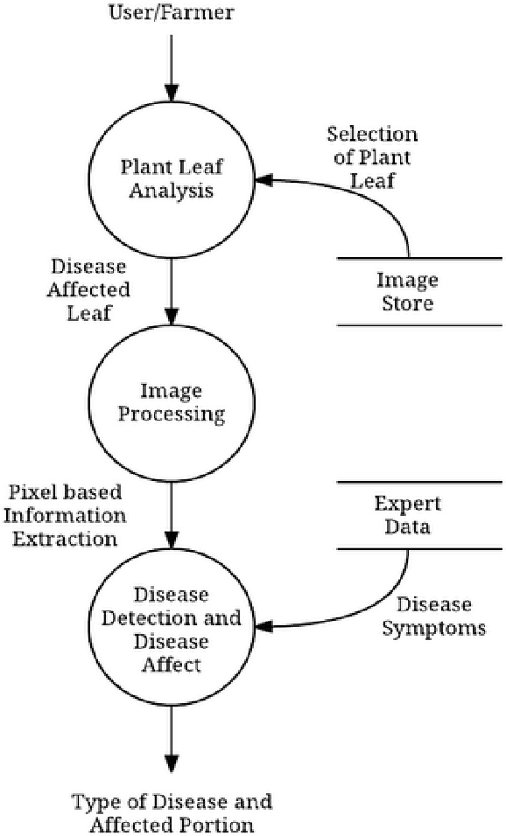

**Figure 3: Level 2 Data Flow Diagram**