Ch 1 : Modules System, FS, REPL, NPM, Package.json = 31st-July 2023 = ✅

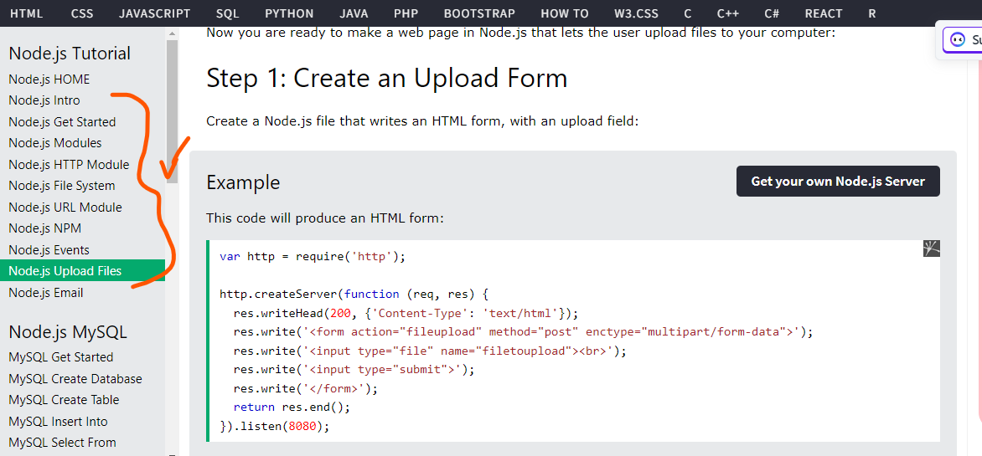

Ch 2 : Web Server using Node JS = 31st-July 2023 = ✅

Ch 3 : Express JS =1st-Aug 2023 = ✅ + Middleware - ✅

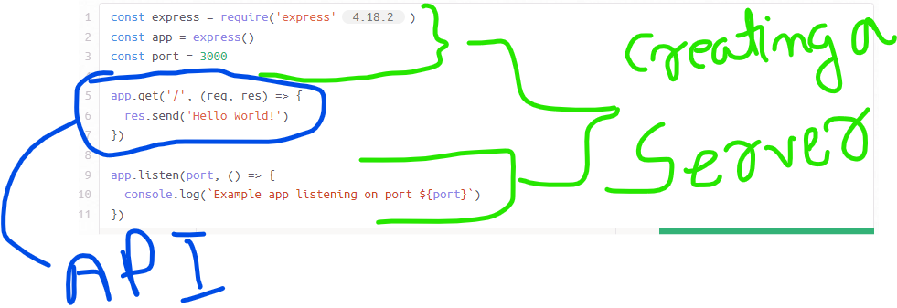

Ch 4 : REST APIs and CRUD = 1st-Aug 2023 = Started ✌️