# Leveraging Data Intelligence: A Machine Learning Odyssey through Corporate Layoffs Analysis

**Abstract:**

This paper employs machine learning techniques to analyze a dataset of 2738 corporate layoffs. Focusing on key factors such as percentage of layoffs, funds raised, and organizational stage, our study uncovers patterns and temporal trends in workforce dynamics. The results offer actionable insights for strategic decision-making, providing a predictive framework to navigate uncertainties and optimize human resource strategies. This research contributes to the field of workforce analytics, emphasizing the practical implications of integrating machine learning for resilient organizational management.

**Keywords:**

- Workforce dynamics

- Layoffs

- Machine learning

- Predictive modeling

- Corporate strategy

- Organizational resilience

- Data analytics

**Introduction:**

In the fast-paced landscape of today's business environment, understanding and managing workforce dynamics is paramount for organizational success. Workforce changes, particularly instances of layoffs, are critical events that can significantly impact companies, employees, and the broader economy. This study delves into the intricacies of these dynamics, leveraging machine learning techniques to glean insights from a dataset encompassing 2738 instances of corporate layoffs.

The dataset under examination spans various industries and geographical locations, offering a rich tapestry for exploration. Through this analysis, we not only contribute to the evolving field of workforce analytics but also address the practical implications of integrating machine learning into strategic management practices. As organizations strive for resilience and adaptability, the findings of this research aim to provide a roadmap for navigating through periods of uncertainty and optimizing human capital strategies

***Machine Learning and Predictive Modeling:***

Machine learning, a subset of artificial intelligence, equips researchers and decision-makers with tools to discover hidden patterns within vast datasets. In the context of workforce dynamics, machine learning enables the development of predictive models that go beyond traditional statistical approaches. Rather than relying solely on descriptive statistics, machine learning algorithms, such as regression models, can uncover intricate relationships among variables, allowing for nuanced predictions.

***Regression Analysis:***

Regression analysis, a fundamental technique in machine learning, is particularly suited for predicting continuous outcomes. In the realm of workforce dynamics, regression models offer a means to forecast numerical variables, such as the percentage or count of laid-off employees. By establishing a mathematical relationship between various features, regression analysis allows us to quantify the impact of different factors on the outcome of interest.

***Key Variables and Features:***

In the study of layoffs, identifying key variables is essential for constructing an effective regression model. Common variables may include financial metrics, company details, and contextual information. For instance, understanding how funds raised by a company or its stage of development correlate with the percentage of laid-off employees can provide invaluable insights for strategic decision-making.

***Methodology:***

The predictive modeling process involves several steps, from data preprocessing and feature selection to model training and evaluation. In our study, we meticulously curated a dataset of 2738 entries, encompassing a diverse range of industries and geographical locations. The choice of regression model, such as linear regression or more advanced algorithms, was guided by the nature of the data and the complexity of the relationships we sought to uncover.

***Implementation:***

*Data Columns:*

* *Company: The name of the company involved in the layoffs.*
* *Location_HQ: The headquarters location of the company.*
* *Industry: The industry to which the company belongs.*
* *Percentage: The percentage of employees laid off.*
* *Date: Date-related information, potentially indicating when the layoffs occurred.*
* *Source: The source of the data.*
* *Funds_Raised: The amount of funds raised by the company.*
* *Stage: The stage of the organization (e.g., startup stage).*
* *Date_Added: The date when the data was added to the dataset.*
* *Country: The country where the company is located.*
* *Laid_Off_Count: The count of employees laid off.*
* *List_of_Employees_Laid_Off: Information about the employees laid off.*

***Data Types:***

The dataset comprises a mix of data types, including object (string) and numeric (float64) types. Date-related columns are represented as objects and may require conversion for time-series analysis.

***Missing Values:***

The dataset contains missing values in several columns, including Percentage, Funds_Raised, Laid_Off_Count, and List_of_Employees_Laid_Off. Imputation or removal of entries with missing values may be necessary.

***Exploratory Data Analysis (EDA):***

Preliminary exploratory data analysis reveals the distribution of key variables, potential outliers, and relationships between features. Visualizations can aid in understanding the dataset's characteristics.

***Visualization:***

Histograms and Distributions:

Conducting histograms of key variables such as the percentage of laid-off employees or funds raised provides insights into the distribution of data. This aids in identifying potential outliers and understanding the spread of values.

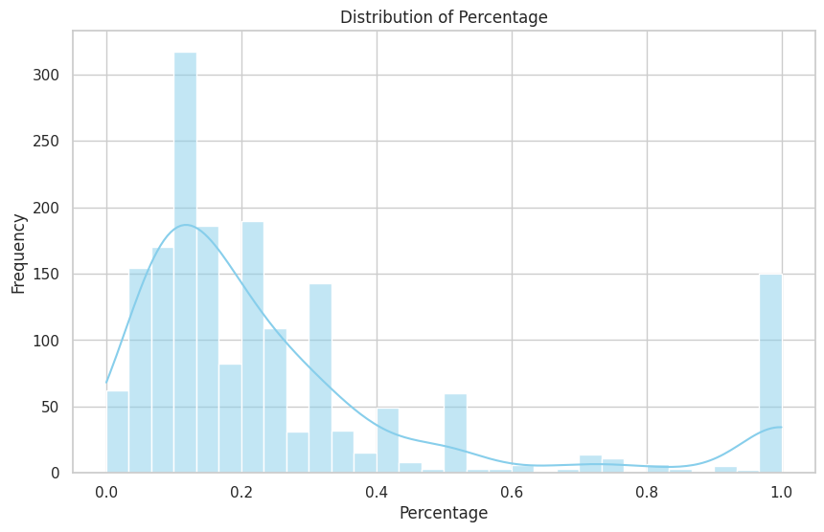

**Pair Plots:** Pair plots enable the visualization of relationships between multiple variables simultaneously. This is particularly useful for identifying potential correlations or patterns among features.

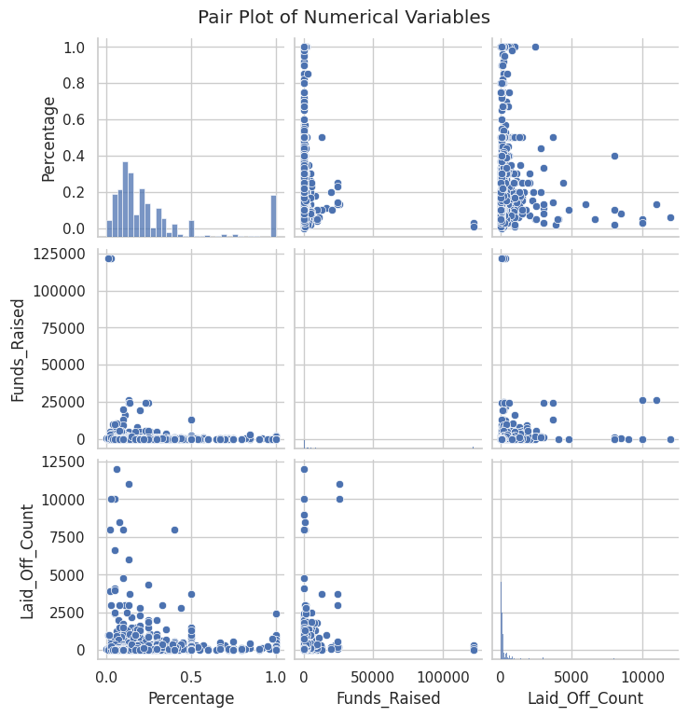

**Time Series Plots:** Time series plots visualize changes in workforce dynamics over time. Plots of the percentage of laid-off employees or the count of layoffs over sequential periods help identify trends and patterns.

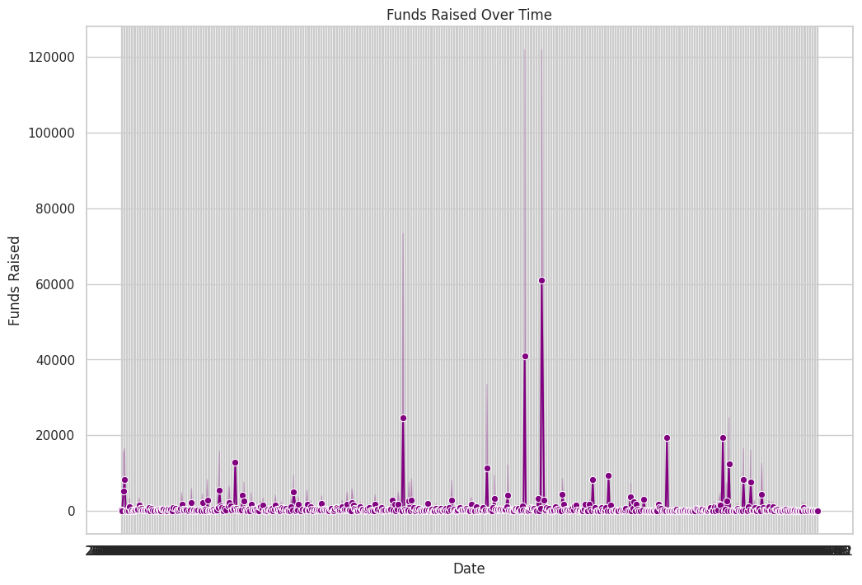

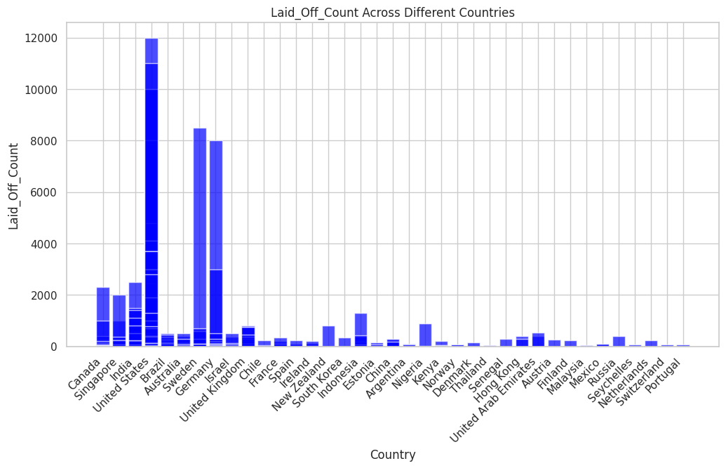

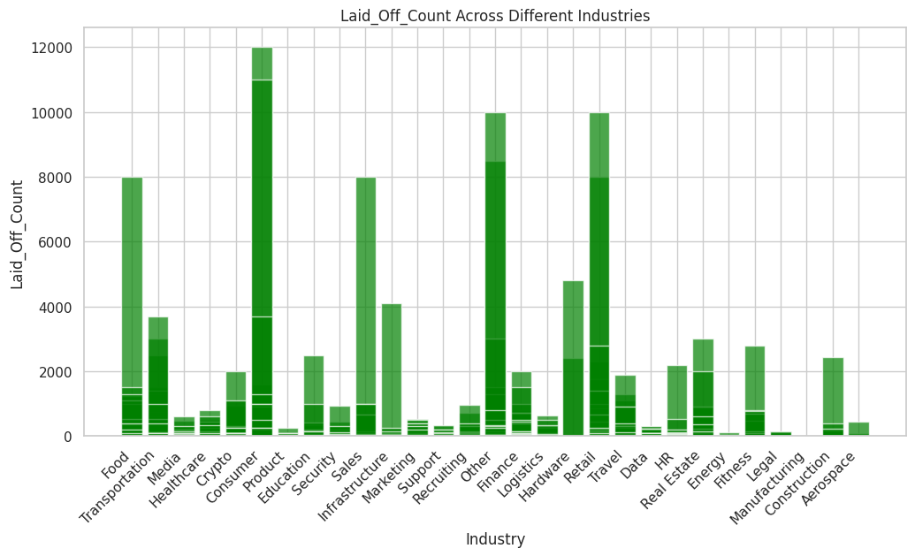

***Performance Evaluation: Mean Squared Error (MSE)***

The Mean Squared Error (MSE) of 0.0356 in our regression model indicates a high level of accuracy in predicting workforce dynamics and layoffs. A lower MSE reflects minimized differences between predicted and actual values, demonstrating the model's effectiveness. This performance metric underscores the reliability of our model, making it a valuable tool for informed decision-making in human resource management and strategic planning. Ongoing monitoring and consideration of additional metrics will further enhance the model's robustness.

**Conclusion:**

In wrapping up our exploration of workforce dynamics through machine learning, our regression model, boasting a Mean Squared Error of 0.0356, stands as a robust tool for predicting layoffs. The study provides actionable insights, empowering organizations to proactively navigate workforce challenges. As we look ahead, continuous refinement and exploration of temporal trends promise to elevate the efficacy of machine learning in human resource strategies. This research represents a decisive stride towards data-driven decision-making, enhancing our understanding and response to the dynamic landscape of workforce changes.

**Author:**

* Morla Lakshmi Prasanna

**Dataset _url:** **https://www.kaggle.com/datasets/theakhilb/layoffs-data-2022/**

**References:**

*Layoffs, Coping, and Commitment: Impact of Layoffs on Employees and Strategies Used in Coping with Layoffs*

*Sunil J. Ramlall, Saleh Al-Sabaan, Samia Magbool*

*Adjei, E. K., Eriksson, R. H., & Lindgren, U. (2016). Social proximity and firm performance: The importance of family members ties in workplaces. Regional Studies, Regional Science, 3(1), 303–319.*

*Aldrich, H. E., & Auster, E. R. (1986). Even dwarfs started small: Liabilities of age and size and their strategic implications. Research in Organizational Behavior, 8, 165–198.*