**BME2104 -《生物医学影像技术》Home Work #2**

Due Date: April 17, 2024

***Note:*** *Please prepare your answers to the problems in a single PDF, and upload your PDF to Blackboard.*

* 1. Iodine-based agent is commonly used in X-ray and CT imaging to enhance contrast. Applying the physics principle of X-ray and matter interactions, and if the X-rays are of monochromatic energy at 60 keV, please find the answers to the following:
     1. What is the wavelength and frequency of 60 keV x-ray photon?
     2. What is the relative x-ray absorption ratio of iodine to calcium which is the main element in bone?
     3. What is the K-edge absorption energy of iodine and calcium, respectively?
     4. At 60 keV, which one is the dominant interaction mechanism for total x-ray attenuation, absorption or scattering? Is there any chance of pair production at 60 keV?
     5. When incident X-ray is at 60 keV, how does the energy of Compton scattered x-ray depend on the scattering angle? Write down your equation, and then plot the scattering photon energy versus scattering angle.

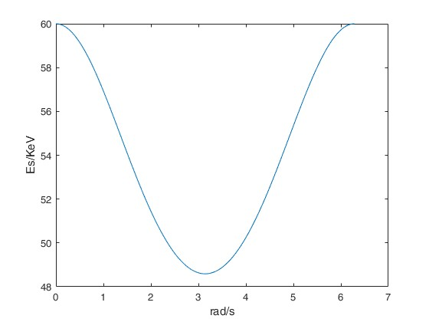

* 1. The spectrum from an x-ray tube is shown in the following figure. After the x-rays from this tube passed through a water cylinder (see right figure below), please sketch out the two expected x-ray spectra at the two positions (1 & 2). Please label those two spectra on the figure. You can superimpose your sketches onto the existing spectrum figure.

|  |  |
| --- | --- |
|  |  |

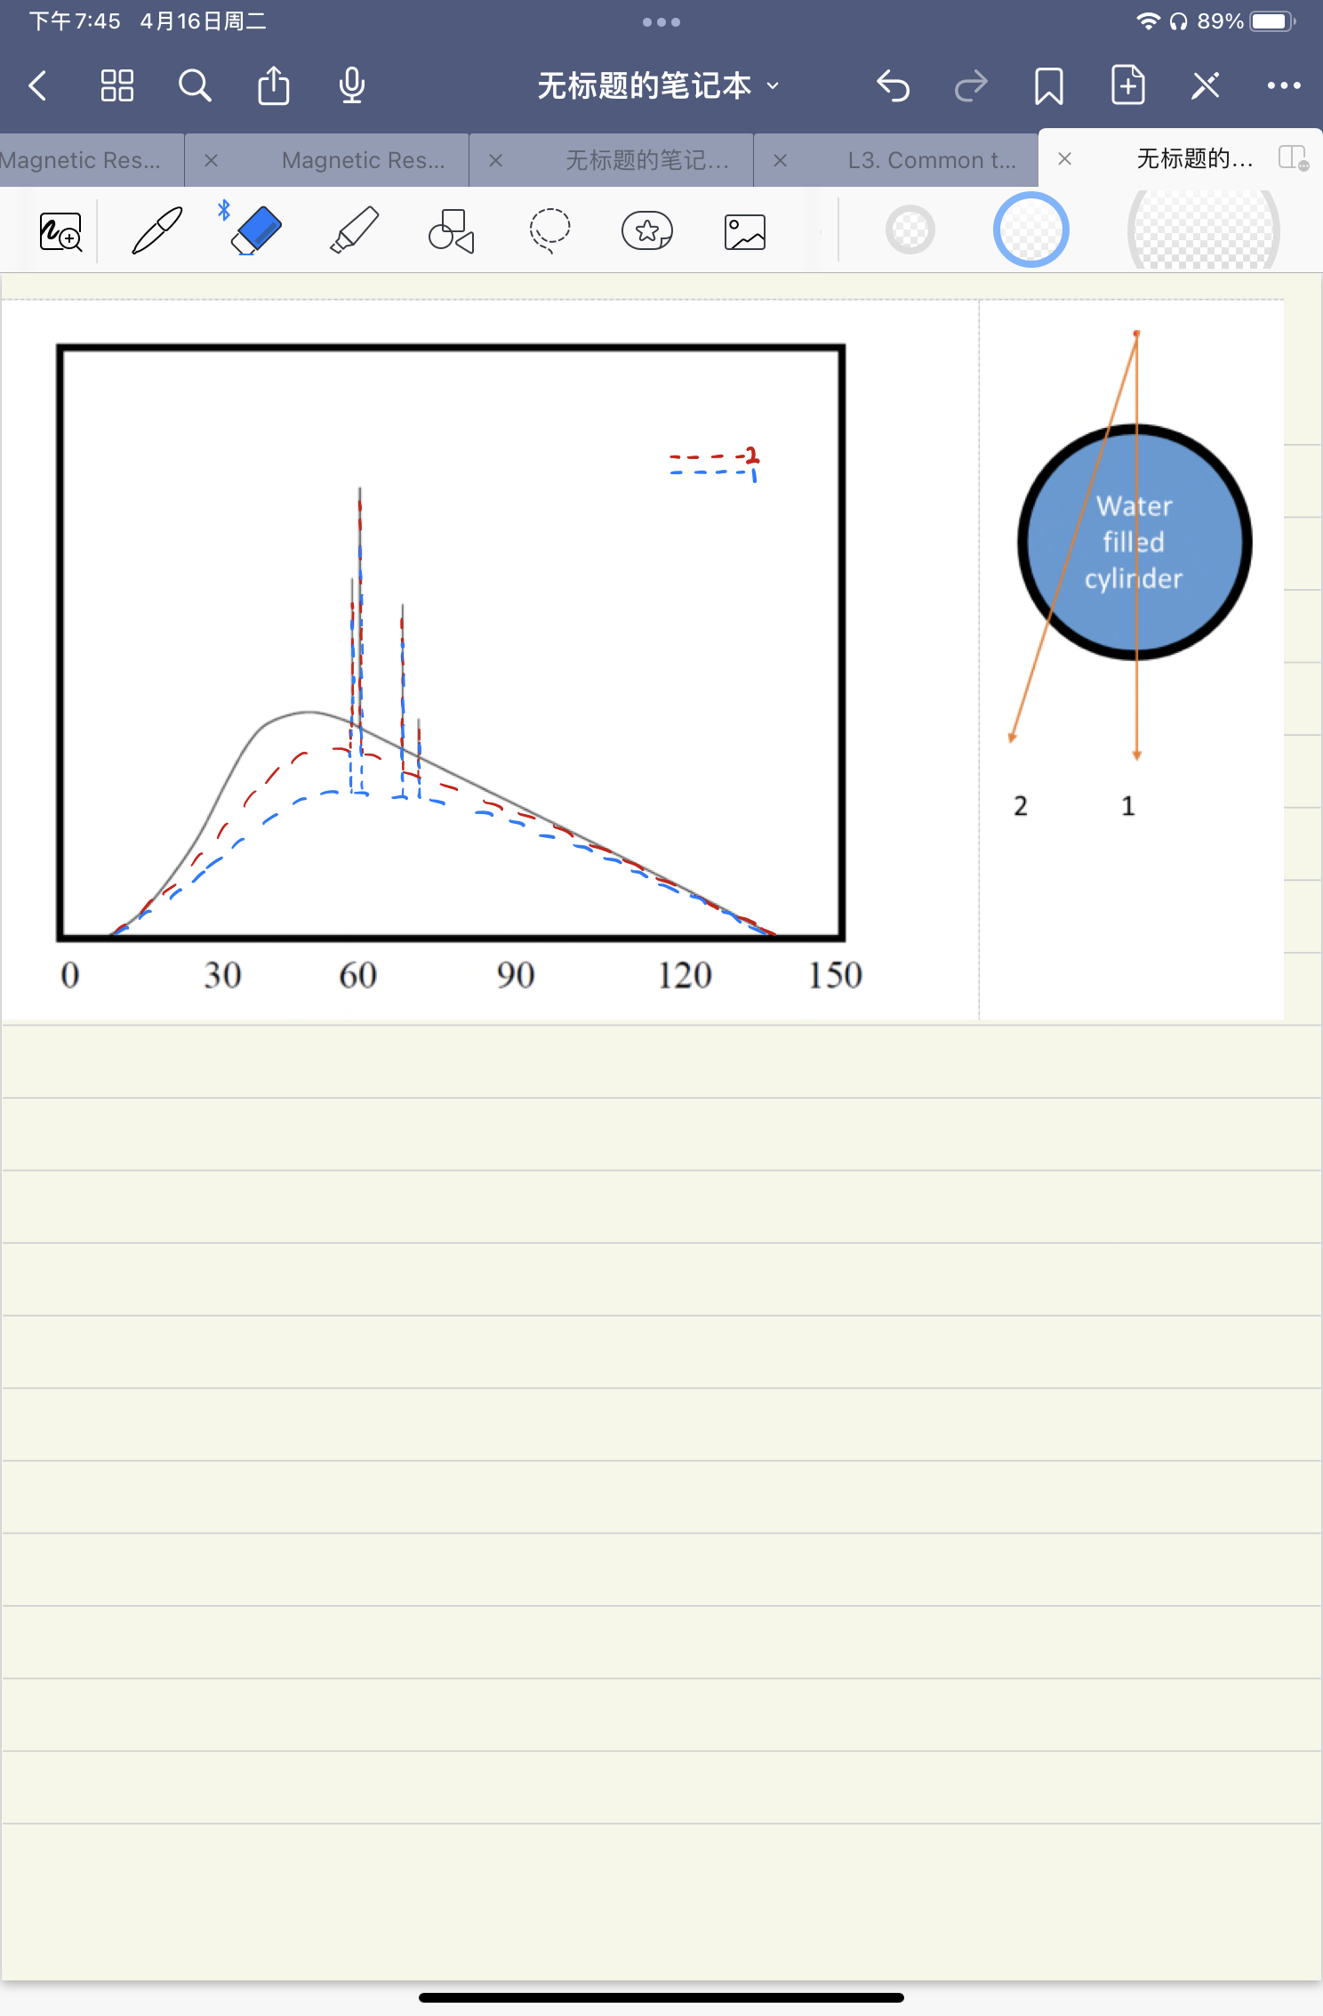

* 1. Use the following figure, explain the physics principle of Bremsstrahlung radiation, and how does Bremsstrahlung radiation contribute to the X-ray spectrum of an X-ray tube.

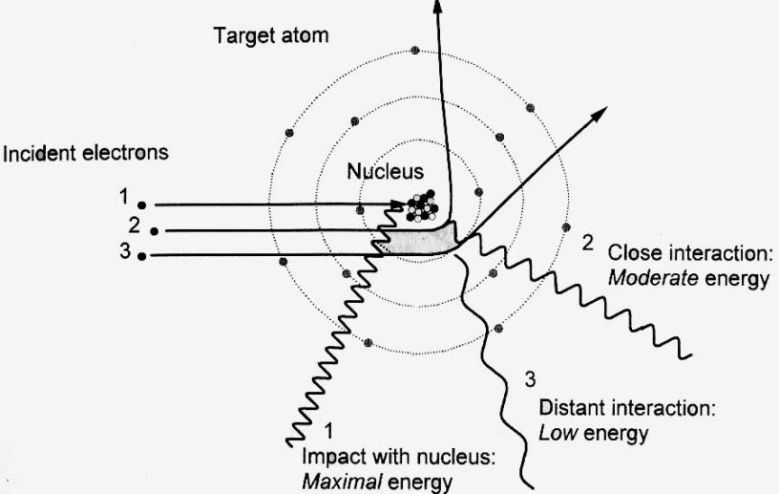

The physics principle :

1、When the incident electrons approach the atomic nucleus, they are accelerated by the electric field surrounding the nucleus.

2、When electrons are deflected by the electric field of the atomic nucleus, they lose kinetic energy. According to the law of conservation of energy, the lost energy is emitted in the form of electromagnetic radiation, known as Bremsstrahlung.

3、Emission of X-rays: The sudden change in the electron's velocity results in the emission of X-rays. These X-rays have a continuous spectrum ranging from low to high energies.

The contribute to the X-ray spectrum of an X-ray tube:

1、Production of X-rays: In an X-ray tube, electrons emitted by the cathode are accelerated towards the anode. When these electrons interact with the metal target, they undergo rapid deceleration due to the strong electric field of the atomic nuclei in the target material.

2、Bremsstrahlung Radiation: The deceleration of electrons in the target material leads to the emission of Bremsstrahlung radiation.

3、X-ray Spectrum: The X-ray spectrum produced by Bremsstrahlung radiation typically consists of a broad band of energies, ranging from the maximum energy determined by the accelerating voltage applied to the tube down to zero energy.

* 1. What is characteristic X-ray of an X-ray tube? Please explain the physics principle behind characteristic X-ray.

When high-speed electrons collide with a material, inner-shell electrons in the material create vacancies. When outer-shell electrons transition to these vacancies, they emit X-rays. Different materials have different X-ray wavelengths, hence they are called characteristic X-rays.

The physics principle:

1. Excitation of Atoms: When these electrons collide with the target material, they can knock out inner-shell electrons from the atoms, thus exciting the atoms from lower energy levels to higher energy levels.
2. Electron Rearrangement: Due to the ejection of inner-shell electrons, there is a rearrangement of the electron structure within the atom. This rearrangement causes outer-shell electrons to fill the vacancies left by the ejected electrons, and these outer-shell electrons are now at higher energy levels.
3. Energy Release: When outer-shell electrons fill the vacancies left by the ejected electrons, they release energy.
4. Each element has its unique atomic structure, and therefore, it also has unique characteristic X-ray energy levels.
   1. Is the following statement correct? Explain why.

Statement: The total Bremsstrahlung output of an x-ray tube depends on both the anode material and the anode voltage.

The statement is correct.

Anode Material:

Different anode materials have different atomic structures and nuclear charges, which affect the interaction between the electron beam and the anode material. They produce varying degrees of Bremsstrahlung radiation when receiving the electron beam.

Anode Voltage: The anode voltage determines the extent to which electrons are accelerated in the X-ray tube. Higher anode voltages result in electrons with greater kinetic energies, thereby leading to more energetic collisions with the anode material. Consequently, higher energy Bremsstrahlung radiation is produced upon collision with the anode material.

* 1. Based on the following graph, explain the line focusing principle, focal spot area, and effective focal spot.



The line focusing principle:

To achieve good X-ray image quality, a small focal spot is required. The line focus principle achieves this by angulating the anode surface, resulting in a significant decrease in the focal spot size, thus enhancing the X-ray image quality.

Focal spot area:

The focal spot area refers to the specific area of the target on the X-ray tube upon which the electron beam is directed. When the electron beam hits this area, it interacts with the target material, resulting in the production of X-rays.

The effective focal spot:

The effective focal spot is the actual focal spot size obtained after adjusting the angle of the anode surface according to the line focus principle,effective focal spot size = actual focal spot size * sin anode angle.

7.

****Based on the following graph, explain the cause of anode heel effect in an x-ray tube, and sketch out a possible x-ray intensity curve at the detector that shows the anode heel effect.

The cause of anode heel effect:

The anode heel effect refers to the phenomenon where the X-ray intensity near one end of the anode target in the axial direction of the X-ray tube output window is significantly lower than that near the cathode end. This is because the anode metal target surface is not perpendicular to the high-energy electrons. When high-energy electrons bombard the target metal, they interact with the metal atoms, resulting in bremsstrahlung radiation and the production of X-ray photons. When these photons exit the target surface, the target metal near the anode end is thicker, causing stronger attenuation of the photons, while the target metal near the cathode end is thinner, resulting in weaker attenuation of the photons。