Lab 3 – Timing Optimizations

# Optimization 1:

Figure - Summary of Paths

Critical Path: FIFO -> mult_out

Figure - Statistics showing Cell Data as 68% of the delay

Figure - Data Arrival Path Showing dataout[17] with 3.076 delay

* Can infer the longest path of 3.076 is talking about the output data from the multiplier
* Can infer it is talking about the FIFO read data coming into the multiplier and the output from the multiplier.

After Optimization:

* The same paths still had the worst slack, so I registered the rd_data output which increased the clock again.

After optimization:

# Optimization 2:

Figure - Summary of Paths and Statistics for Optimization 3

### Critical Path:

* total_count_r -> total_count_r
* Since this signal only gets updated occasionally, it is considered a multicycle path.

### Code Changed:

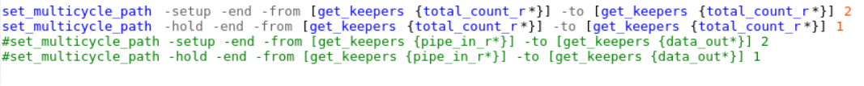

After Optimization:

# Optimization 3:

Summary of Paths and Statistics for Optimization 4

Figure - Path of Longest Slack

Critical Path: IC and CELL of multiply.

### Code Changed:

* Registered the fifo_rd_data signal

After Optimization:

# Optimization 4:

Summary of Paths and Statistics for Optimization 5

### Critical Path:

* Count_r

### Code Changed:

* Removed one bit from count_r, used the almost full signal instead of FULL, removed the rd_en, since valid_rd is only based on !empty

After Optimization:

# Optimization 5:

Summary of Paths and Statistics for Optimization 6



Applied faster clock constraint

### Critical Path:

* Total_count_r

### Code Changed:

* Increased the multicycle clock path by 1 temporarily to find more bottlenecks

# List of Code Changes

1. Got rid of read during write behavior and optimized the counter
2. Registered the rd_data output
3. Set up multicycle paths